Multi-Step Ratio and Percent Problems

Lesson 1

The following pages contain workspace where students can record their work and answers for the eight Ratio and Percent Task Cards. The cards may be completed in any order, but they should be correlated to the matching numbered workspaces. Also provided with this lesson is an Instructional Activity Supplement containing the eight Ratio and Percent Task Cards.

|  |  |
| --- | --- |
| **Show all of your work for each task card in the spaces below. Explain each solution.** | |
| Ratio and Percent Task Card #1 | Ratio and Percent Task Card #2 |
| Ratio and Percent Task Card #3 | Ratio and Percent Task Card #4 |

|  |  |
| --- | --- |
| **Show all of your work for each task card in the spaces below. Explain each solution.** | |
| Ratio and Percent Task Card #5 | Ratio and Percent Task Card #6 |
| Ratio and Percent Task Card #7 | Ratio and Percent Task Card #8 |

Multi-Step Ratio and Percent Problems

INSTRUCTIONAL ACTIVITY SUPPLEMENT

Lesson 1

The following pages contain eight Ratio and Percent Task Cards. The pages need to be cut along the lines to yield four cards per page. Students should complete the task for each situation. The cards may be completed in any order. Also provided with this lesson is an Instructional Activity Student Handout where students can record their answers as they complete each card.

|  |  |  |
| --- | --- | --- |
| 1. \\cfs.home.ku.edu\aai_general\Projects\LMFA Resources\Math\7th Grade\7.RP.3\images\7.RP.3_Lesson_1_IAS\7.RP.3_Lesson_1_IAS-01.jpg24% of students saw the new movie during opening weekend. If there are 725 students, how many saw the movie? | 1. The width of a rectangular room is 75% of its length. If the length is 24 inches, what is the perimeter of the room?   \\cfs.home.ku.edu\aai_general\Projects\LMFA Resources\Math\7th Grade\7.RP.3\images\7.RP.3_Lesson_1_IAS\7.RP.3_Lesson_1_IAS-02.jpg | |
| 1. \\cfs.home.ku.edu\aai_general\Projects\LMFA Resources\Math\7th Grade\7.RP.3\images\7.RP.3_Lesson_1_IAS\7.RP.3_Lesson_1_IAS-03.jpg27 students chose chocolate chip cookies as their favorite. How many students were surveyed? | 1. The Music and More Store is having a 60% off sale. If you save $36 on an album collection, what was the original cost? | |
| 1. Four magazines cost $11.20 each with a yearly 12-issue subscription. How much is the full year subscription? | 1. 30% of your monthly budget goes to rent. If you pay $450 in rent, how much is your monthly budget? |
| 1. 105 minutes is what percent of a two-hour, 20-minute-long movie? | 1. When six children share one bag of candy, each child gets 12 pieces. If the same bag of candy is shared among nine children, how many pieces does each child get? |

Multi-Step Ratio and Percent Problems

Lesson 2

On a day trip to the lake, you notice that percentages are found all around. After your recent studies with ratio and percent, you feel ready to tackle these problem-solving situations. Show your work and explain your answers for each of the following percent situations.

1. When arriving at the lake, you find that your group is large enough to qualify for the group day-use fee. The regular fee for day use is $9 per person, but with your group of 14, a discount of 30% is applied. What is the total cost for your group to visit the lake for the day?
2. 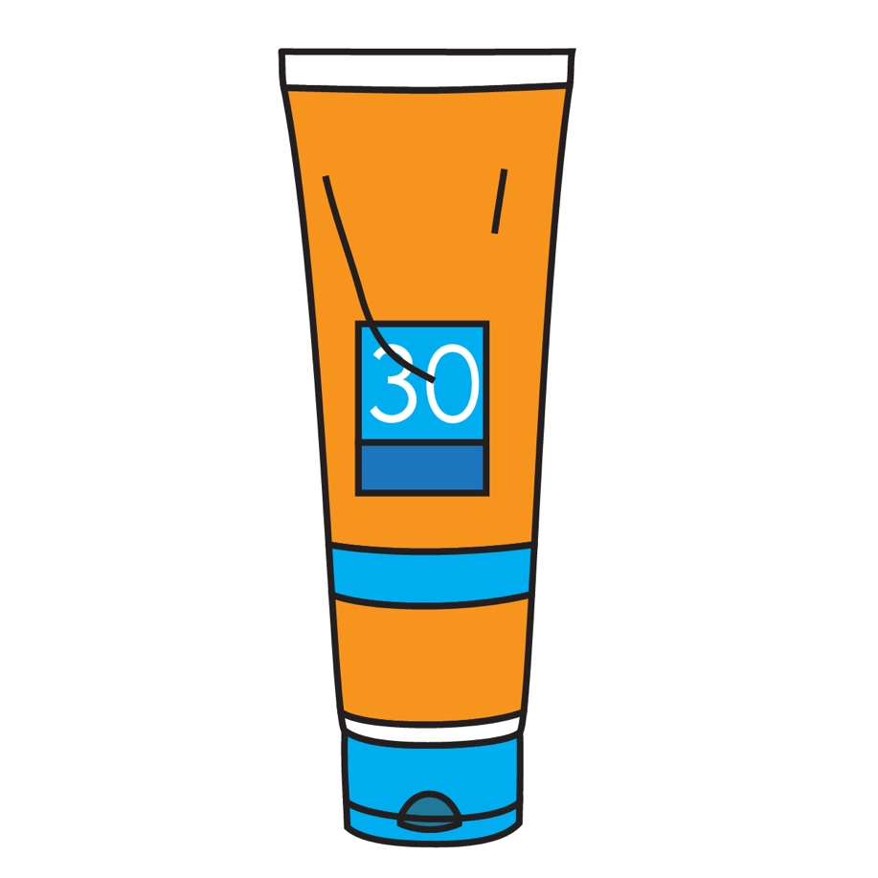Once your group has chosen a spot on the sand to relax, you start to unpack your beach bag. That’s when you notice you forgot to bring sunscreen. You had made a mental note to bring sunscreen because you know the markup on sunscreen at the Snack Shack at the lake is 50% compared to the stores in town. Yesterday you bought a brand-new bottle of sunscreen in town for $6.68. To the nearest dollar, how much will it cost you to buy sunscreen from the Snack Shack at the lake?
3. You and a friend head over to the Snack Shack to find some sunscreen. There you see a stack of sunhats on sale for 45% off. After finding one you like, you check the price tag. If the sunhat was originally $24.99, how much will it cost when discounted?
4. You want to buy both the sunscreen and sunhat, but you know sales tax will also be included. If sales tax is 6.75% at the lake, what will be your total purchase price?
5. After enjoying a morning of sun, you are ready for lunch. While some members of your group packed a picnic lunch, you planned to eat at the Lakeside Café. Your small group gets a table for five at the café. Three members of the group order the pizza lunch special for $7.49 each. You and another friend order pasta for $8.49 and a sandwich for $6.99. Everyone orders a soda for $1.99. At the Lakeside Café, tax is included, but tips for the server are not. After a discussion, your group decides to leave an 18% tip. How much money will your group leave as a tip?
6. After an afternoon of sand and surf, you are ready to head home. Before leaving, you treat yourself to an ice cream. Waiting in line, you overhear the ice cream man talking about his profits. He makes a 40% profit from his total sales. Today has been a good day, and he has sold $180 just this afternoon. How much profit has the ice cream man made this afternoon?

Multi-Step Ratio and Percent Problems

Lesson 3

The following pages contain work pages where students can record their answers as they complete each task for the Percent Error Analysis cards. Students have three tasks on each card: identify and describe the error, rework the problem, and provide a tip to prevent the error in the future. The cards may be completed in any order. Also provided with this lesson is an Instructional Activity Supplement containing 16 Percent Error Analysis cards.

|  |  |
| --- | --- |
| Percent Error Analysis Problem #1  Notes: | Identify and describe the error. |
| Rework the problem. | Here’s a tip… |

|  |  |
| --- | --- |
| Percent Error Analysis Problem #2  Notes: | Identify and describe the error. |
| Rework the problem. | Here’s a tip… |

|  |  |
| --- | --- |
| Percent Error Analysis Problem #3  Notes: | Identify and describe the error. |
| Rework the problem. | Here’s a tip… |

|  |  |
| --- | --- |
| Percent Error Analysis Problem #4  Notes: | Identify and describe the error. |
| Rework the problem. | Here’s a tip… |
| Percent Error Analysis Problem #5  Notes: | Identify and describe the error. |
| Rework the problem. | Here’s a tip… |

|  |  |
| --- | --- |
| Percent Error Analysis Problem #6  Notes: | Identify and describe the error. |
| Rework the problem. | Here’s a tip… |
| Percent Error Analysis Problem #7  Notes: | Identify and describe the error. |
| Rework the problem. | Here’s a tip… |

|  |  |
| --- | --- |
| Percent Error Analysis Problem #8  Notes: | Identify and describe the error. |
| Rework the problem. | Here’s a tip… |
| Percent Error Analysis Problem #9  Notes: | Identify and describe the error. |
| Rework the problem. | Here’s a tip… |

|  |  |
| --- | --- |
| Percent Error Analysis Problem #10  Notes: | Identify and describe the error. |
| Rework the problem. | Here’s a tip… |
| Percent Error Analysis Problem #11  Notes: | Identify and describe the error. |
| Rework the problem. | Here’s a tip… |

|  |  |
| --- | --- |
| Percent Error Analysis Problem #12  Notes: | Identify and describe the error. |
| Rework the problem. | Here’s a tip… |
| Percent Error Analysis Problem #13  Notes: | Identify and describe the error. |
| Rework the problem. | Here’s a tip… |

|  |  |
| --- | --- |
| Percent Error Analysis Problem #14  Notes: | Identify and describe the error. |
| Rework the problem. | Here’s a tip… |
| Percent Error Analysis Problem #15  Notes: | Identify and describe the error. |
| Rework the problem. | Here’s a tip… |

|  |  |
| --- | --- |
| Percent Error Analysis Problem #16  Notes: | Identify and describe the error. |
| Rework the problem. | Here’s a tip… |

Multi-Step Ratio and Percent Problems

INSTRUCTIONAL ACTIVITY SUPPLEMENT

Lesson 3

The following pages contain 16 Percent Error Analysis cards. Students have three tasks on each card: identify and describe the error, rework the problem, and provide a tip to prevent the error in the future. The cards may be completed in any order. Also provided with this lesson is an Instructional Activity Student Handout where students can record their answers as they complete each task for each card.

**Percent Error Analysis #1**

Look at the percent situation below. Identify and describe the error in the worked problem. Then, provide a tip to help the student avoid this error in the future. Finally, correctly rework the problem.

|  |  |
| --- | --- |
| Giselle is shopping for a party dress. Her favorite is $79.99 and on sale for 30% off. Giselle also has a coupon for an additional 20% off. Doing some quick calculations, Giselle decides she will save 50% on her dress. Perfect! | Identify and describe the error. |
|  |
| Rework the problem. |  |
|  | Here’s a tip… |

**Percent Error Analysis #2**

Look at the percent situation below. Identify and describe the error in the worked problem. Then, provide a tip to help the student avoid this error in the future. Finally, correctly rework the problem.

|  |  |
| --- | --- |
| Adonis is shopping for a new pair of shorts. He finds a pair of shorts regularly priced $35 that are on sale for 40% off. Adonis calculates that he will pay $14. | Identify and describe the error. |
|  |
| Rework the problem. |  |
|  | Here’s a tip… |

**Percent Error Analysis #3**

Look at the percent calculation below. Identify and describe the error in the worked problem. Then, provide a tip to help the student avoid this error in the future. Finally, correctly rework the problem.

|  |  |
| --- | --- |
| Cam is watching a pair of boots on an online auction site. The price of the boots increased from $55 to $66. Cam does the following calculation to find the percent of increase. | Identify and describe the error. |
|  |
| Rework the problem. |  |
|  | Here’s a tip… |

**Percent Error Analysis #4**

Look at the percent calculation below. Identify and describe the error in the worked problem. Then, provide a tip to help the student avoid this error in the future. Finally, correctly rework the problem.

|  |  |
| --- | --- |
| Vic ruined his baseball glove in the rain. When looking for a new one, he finds a glove that has decreased from $54 to $36.  Vic does the following calculation to find the percent of decrease. | Identify and describe the error. |
|  |
| Rework the problem. |  |
|  | Here’s a tip… |

**Percent Error Analysis #5**

Look at the percent calculation below. Identify and describe the error in the worked problem. Then, provide a tip to help the student avoid this error in the future. Finally, correctly rework the problem.

|  |  |
| --- | --- |
| Jay decreased his time in the mile run from 10 minutes to 8 minutes. Jay calculated the following to tweet out his achievement.  #-20%decrease! | Identify and describe the error. |
|  |
| Rework the problem. |  |
|  | Here’s a tip… |

**Percent Error Analysis #6**

Look at the percent calculation below. Identify and describe the error in the worked problem. Then, provide a tip to help the student avoid this error in the future. Finally, correctly rework the problem.

|  |  |
| --- | --- |
| Ben’s weekly salary increased from $200 to $260. He is so excited to calculate his percent of change.  230% increase! | Identify and describe the error. |
|  |
| Rework the problem. |  |
|  | Here’s a tip… |

**Percent Error Analysis #7**

Look at the percent calculation below. Identify and describe the error in the worked problem. Then, provide a tip to help the student avoid this error in the future. Finally, correctly rework the problem.

|  |  |
| --- | --- |
| Cate had $2,450.80 in her bank account. Currently, she has $1,973.40 in her account. In her financial records, she lists a 19% increase based on her calculation.  = 0.19 | Identify and describe the error. |
|  |
| Rework the problem. |  |
|  | Here’s a tip… |

**Percent Error Analysis #8**

Look at the percent calculation below. Identify and describe the error in the worked problem. Then, provide a tip to help the student avoid this error in the future. Finally, correctly rework the problem.

|  |  |
| --- | --- |
| The jewelry store had a watch sale. The watch Jeremy wants is priced $75 after a 40%-off discount. He calculates the original price below.  $75 × 0.4 = $30 discount  $75 + $30 = $105 original price | Identify and describe the error. |
|  |
| Rework the problem. |  |
|  | Here’s a tip… |

**Percent Error Analysis #9**

Look at the percent situation below. Identify and describe the error in the worked problem. Then, provide a tip to help the student avoid this error in the future. Finally, correctly rework the problem.

|  |  |
| --- | --- |
| A car dealer raised the price of a car from $10,500 to $12,000.  Evie decided that the percent increase is 12.5% because $1500 is 12.5% of $12,000. | Identify and describe the error. |
|  |
| Rework the problem. |  |
|  | Here’s a tip… |

**Percent Error Analysis #10**

Look at the percent situation below. Identify and describe the error in the worked problem. Then, provide a tip to help the student avoid this error in the future. Finally, correctly rework the problem.

|  |  |
| --- | --- |
| Steven bought three bags of kiwis. Each bag had a label saying “15% off”.  Steven figures that altogether he saves 45%. | Identify and describe the error. |
|  |
| Rework the problem. |  |
|  | Here’s a tip… |

**Percent Error Analysis #11**

Look at the percent situation below. Identify and describe the error in the worked problem. Then, provide a tip to help the student avoid this error in the future. Finally, correctly rework the problem.

|  |  |
| --- | --- |
| Marcus earns $280 per week. He has just learned that his boss is giving him a 26% pay raise.  Marcus is already starting to plan how he will spend his $306 per week! | Identify and describe the error. |
|  |
| Rework the problem. |  |
|  | Here’s a tip… |

**Percent Error Analysis #12**

Look at the percent situation below. Identify and describe the error in the worked problem. Then, provide a tip to help the student avoid this error in the future. Finally, correctly rework the problem.

|  |  |
| --- | --- |
| A newly released movie cost $24.99. Jaina waited to buy it until the price dropped. Now it is $19.99.  Jaina now says she won’t buy the movie yet because it has only decreased in price by 5%. | Identify and describe the error. |
|  |
| Rework the problem. |  |
|  | Here’s a tip… |

**Percent Error Analysis #13**

Look at the percent situation below. Identify and describe the error in the worked problem. Then, provide a tip to help the student avoid this error in the future. Finally, correctly rework the problem.

|  |  |
| --- | --- |
| Dylan is saving to buy the newest video game. His dad says he needs to increase his lawn mowing business by 20% to afford the video game.  “That’s 20 more customers!” exclaims Dylan. Then his dad corrects him. | Identify and describe the error. |
|  |
| Rework the problem. |  |
|  | Here’s a tip… |

**Percent Error Analysis #14**

Look at the percent situation below. Identify and describe the error in the worked problem. Then, provide a tip to help the student avoid this error in the future. Finally, correctly rework the problem.

|  |  |
| --- | --- |
| Calia is examining population data for a school report. She finds that two different states both had population increases of 13%. Calia then reads that the first state increased by 500,000 people, so she decides the other state must have also. | Identify and describe the error. |
|  |
| Rework the problem. |  |
|  | Here’s a tip… |

**Percent Error Analysis #15**

Look at the percent situation below. Identify and describe the error in the worked problem. Then, provide a tip to help the student avoid this error in the future. Finally, correctly rework the problem.

|  |  |
| --- | --- |
| Imari works at an electronics store. She knows that most items at her store are marked up by 40%. So, she decides she can discount items by 40% without losing money for the store. | Identify and describe the error. |
|  |
| Rework the problem. |  |
|  | Here’s a tip… |

**Percent Error Analysis #16**

Look at the percent situation below. Identify and describe the error in the worked problem. Then, provide a tip to help the student avoid this error in the future. Finally, correctly rework the problem.

|  |  |
| --- | --- |
| Ethan bought a collectible trading card for $4. He wants to sell it and earn a 100% profit. To attract customers Ethan prices it at $12 and then marks a 50% discount. | Identify and describe the error. |
|  |
| Rework the problem. |  |
|  | Here’s a tip… |

Multi-Step Ratio and Percent Problems

Lesson 4

The following pages contain work pages where students can record their reasoning as they make decisions for the “Would You Rather…” cards. The cards may be completed in any order, but they should be correlated to the matching numbered work spaces. Also provided with this lesson is an Instructional Activity Supplement containing 10 “Would You Rather…” cards.

|  |  |
| --- | --- |
| **Would You Rather…** | **#1** |
| **Explain your choice with mathematics.**  I would rather  because | |

|  |  |
| --- | --- |
| **Would You Rather…** | **#2** |
| **Explain your choice with mathematics.**  I would rather  because | |

|  |  |
| --- | --- |
| **Would You Rather…** | **#3** |
| **Explain your choice with mathematics.**  I would rather  because | |

|  |  |
| --- | --- |
| **Would You Rather…** | **#4** |
| **Explain your choice with mathematics.**  I would rather  because | |

|  |  |
| --- | --- |
| **Would You Rather…** | **#5** |
| **Explain your choice with mathematics.**  I would rather  because | |

|  |  |
| --- | --- |
| **Would You Rather…** | **#6** |
| **Explain your choice with mathematics.**  I would rather  because | |

|  |  |
| --- | --- |
| **Would You Rather…** | **#7** |
| **Explain your choice with mathematics.**  I would rather  because | |

|  |  |
| --- | --- |
| **Would You Rather…** | **#8** |
| **Explain your choice with mathematics.**  I would rather  because | |

|  |  |
| --- | --- |
| **Would You Rather…** | **#9** |
| **Explain your choice with mathematics.**  I would rather  because | |

|  |  |
| --- | --- |
| **Would You Rather…** | **#10** |
| **Explain your choice with mathematics.**  I would rather  because | |

Multi-Step Ratio and Percent Problems

INSTRUCTIONAL ACTIVITY SUPPLEMENT

Lesson 4

The following pages contain 10 “Would You Rather…” cards. Students have two options to choose from in a percent problem-solving situation. Students will need to consider and calculate for each of the two options as they are instructed to explain their choice using mathematics. The cards may be completed in any order. Also provided with this lesson is an Instructional Activity Student Handout where students can record their answers as they make a decision for each card.

|  |  |  |
| --- | --- | --- |
| **Would You Rather…** |  | **#1** |
| have the interest earned on $100 at a simple interest rate of 4% for 10 years? | **OR** | have the interest earned on $90 at a simple interest rate of 10% for four years? |

**Explain your choice with mathematics.**

I would rather

because

|  |  |  |
| --- | --- | --- |
| **Would You Rather…** |  | **#2** |
| buy a used $50 video system marked up by 80%? | **OR** | buy a used $80 video system marked up by 50%? |

**Explain your choice with mathematics.**

I would rather

because

|  |  |  |
| --- | --- | --- |
| **Would You Rather…** |  | **#3** |
| buy a $136 bike on sale for 30% off? | **OR** | buy a $136 bike on sale for $50 off? |

**Explain your choice with mathematics.**

I would rather

because

|  |  |  |
| --- | --- | --- |
| **Would You Rather…** |  | **#4** |
| be a server earning an 18% tip on a $60 bill? | **OR** | be a server earning a 20% tip on a $55 bill? |

**Explain your choice with mathematics.**

I would rather

because

|  |  |  |
| --- | --- | --- |
| **Would You Rather…** |  | **#5** |
| pay 9.5% taxes on $250? | **OR** | pay 8.8% taxes on $280? |

**Explain your choice with mathematics.**

I would rather

because

|  |  |  |
| --- | --- | --- |
| **Would You Rather…** |  | **#6** |
| pay 4% ATM fees on $250? | **OR** | pay 3% ATM fees on $375? |

**Explain your choice with mathematics.**

I would rather

because

|  |  |  |
| --- | --- | --- |
| **Would You Rather…** |  | **#7** |
| be a salesperson earning 2% commission on a sale of $2200? | **OR** | be a salesperson earning 10% commission on a sale of $560? |

**Explain your choice with mathematics.**

I would rather

because

|  |  |  |
| --- | --- | --- |
| **Would You Rather…** |  | **#8** |
| own a flock of 25 chickens that increases by 160%? | **OR** | own a flock of 50 chickens that increases by ? |

**Explain your choice with mathematics.**

I would rather

because

|  |  |  |
| --- | --- | --- |
| **Would You Rather…** |  | **#9** |
| buy t-shirts at a “Buy One Get One Free” sale? | **OR** | buy t-shirts at a 60%-off sale? |

**Explain your choice with mathematics.**

I would rather

because

|  |  |  |
| --- | --- | --- |
| **Would You Rather…** |  | **#10** |
| make a purchase with a $5-off coupon and a 10% discount? | **OR** | make a purchase with a 15%-off coupon? |

**Explain your choice with mathematics.**

I would rather

because

Multi-Step Ratio and Percent Problems

Lessons 1 – 4

1. 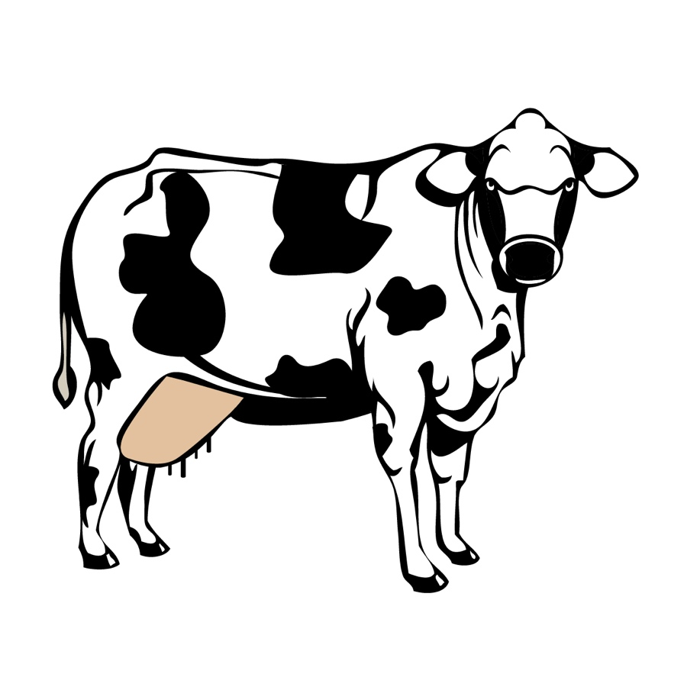A rancher’s herd of dairy cattle is 10% smaller than it was the previous year. The rancher figured out that if each cow can increase milk production by 10%, then milk production will be the same as last year.
   1. Do you agree with the rancher? Why or why not?
   2. Test the rancher’s reasoning using two example dairy cattle herd sizes. Assume each cow produces six gallons of milk per day.
   3. Do you still agree with your answer from 1.a.? Why or why not?

* 1. Describe which value you would use when calculating the 10% herd size decrease from the previous year.
  2. Describe which values you would use when calculating the 10% increase in milk production.

1. 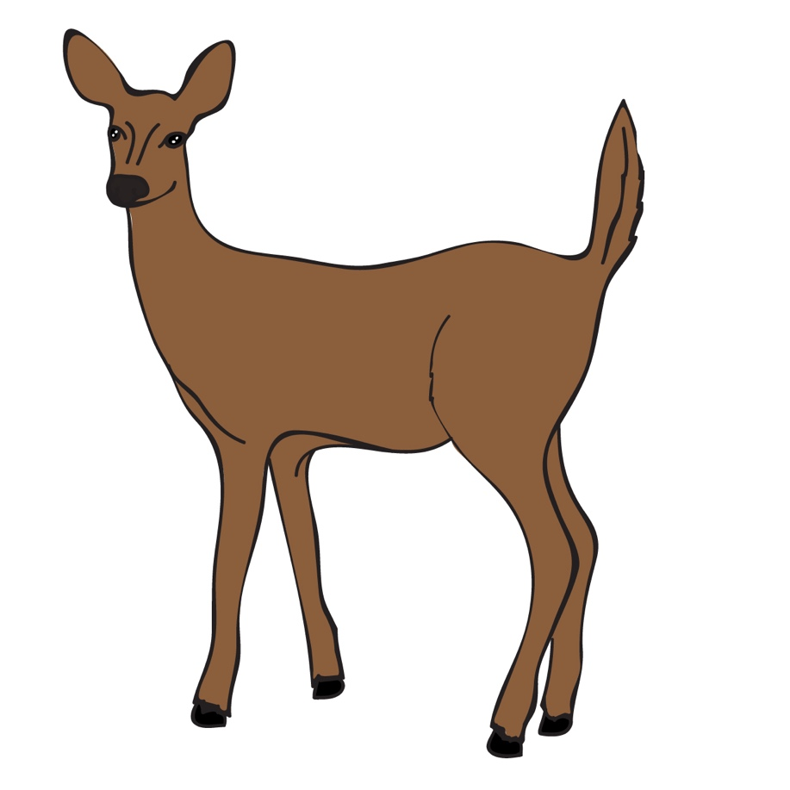Mario read that the population of deer in a nature reserve increases by 20% each year. He declared that the population would, therefore, double after five years.
   1. What mistake in reasoning about percentages did Mario make?
   2. Using two example deer populations, explain why Mario’s reasoning is incorrect.

* 1. What does it mean for a population to “double” in terms of percent?
  2. How do you think Mario came up with this percent based on what he read?

1. An increase of 36 orchestra students represents a 90% increase to the orchestra size.
   1. Should the original value be more or less than 36? Explain your reasoning.

* 1. What is the original orchestra size? Explain your answer.
  2. What is the final orchestra size? Explain your answer.

1. Describe and correct the error in finding the percent increase from an initial value of 14 to a new value of 26.
2. 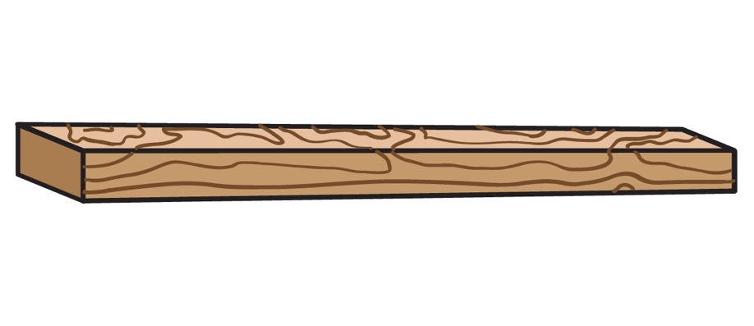Amelia cut a wood plank into three parts. Part A is 71 centimeters long, and Part B is 41 centimeters long. Part C is the remaining length.

* 1. How do Parts A and B compare to the original wood plank? Describe in words and a ratio.

* 1. If the total length of A and B is 70% of the length of the original wood plank, what is the length of Part C? Explain your answer.

1. 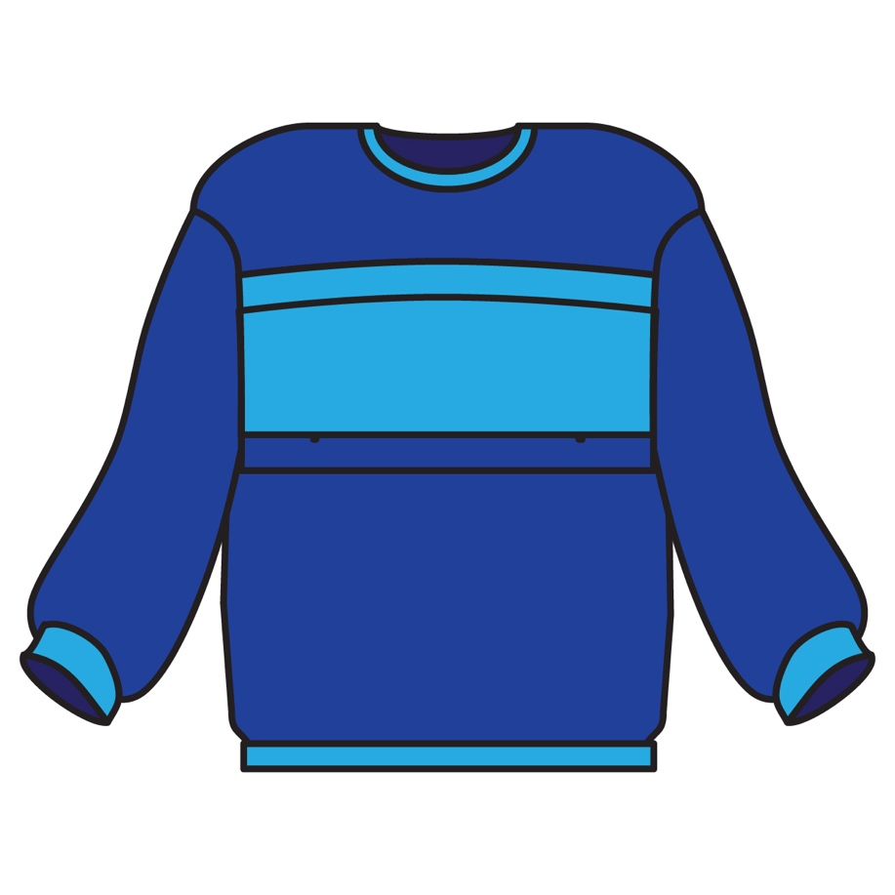A $45 sweater is on sale with a 15% discount. Sales tax is 6%.
   1. How much, in dollars, is the discount on the sweater?
   2. What is the price of the sweater after the discount?
   3. How much sales tax will be charged on the discounted sweater?
   4. What will be the total cost, including tax? Explain your answer.
2. 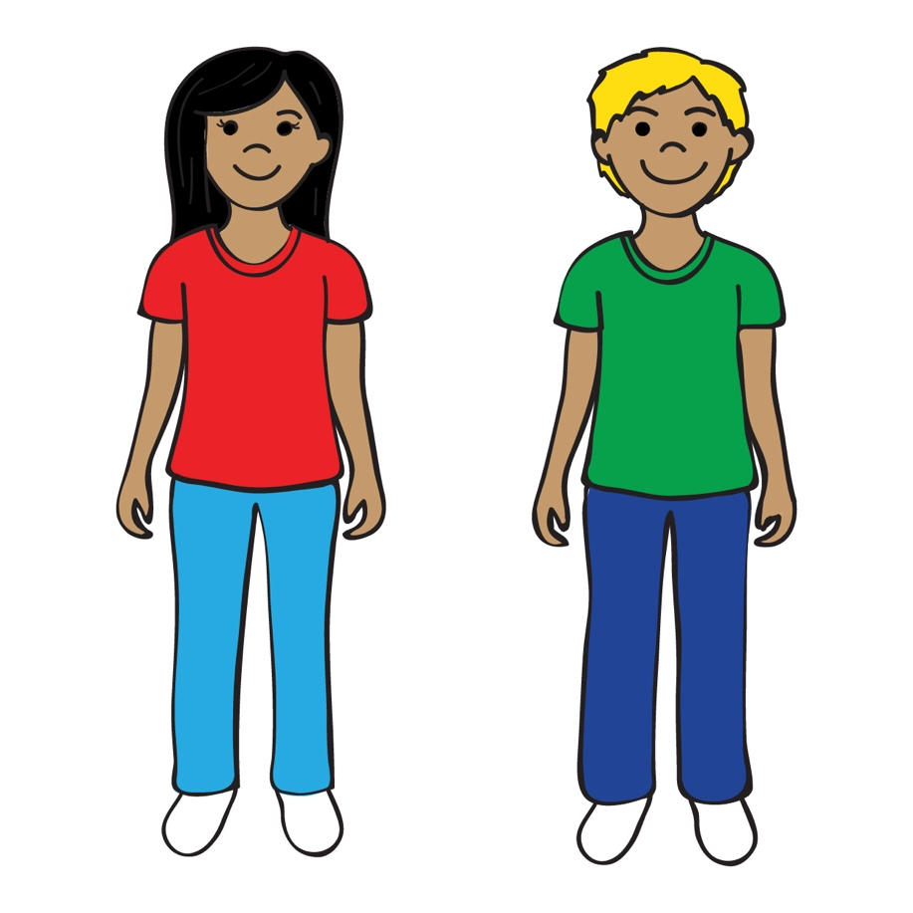There were 28 boys and 25 girls in a math club last year. This year the number of boys increased by 25%, but the number of girls decreased by 20%. Was there an increase or decrease in overall membership? Explain your reasoning.