Probabilities of Compound Events

INSTRUCTIONAL ACTIVITY SUPPLEMENT

Lesson 1

|  |  |  |  |  |
| --- | --- | --- | --- | --- |
|  | | Gender Results | | |
| One Baby | Twins | Triplets |
| Trial | 1 |  |  |  |
| 2 |  |  |  |
| 3 |  |  |  |
| 4 |  |  |  |
| 5 |  |  |  |
| 6 |  |  |  |
| 7 |  |  |  |
| 8 |  |  |  |
| 9 |  |  |  |
| 10 |  |  |  |
| 11 |  |  |  |
| 12 |  |  |  |
| 13 |  |  |  |
| 14 |  |  |  |
| 15 |  |  |  |
| 16 |  |  |  |
| 17 |  |  |  |
| 18 |  |  |  |
| 19 |  |  |  |
| 20 |  |  |  |

|  |  |  |
| --- | --- | --- |
| **One Baby** | **B** | **G** |
| Theoretical probability |  |  |
| Experimental probability |  |  |

|  |  |  |  |  |
| --- | --- | --- | --- | --- |
| **Twins** | **BB** | **BG** | **GB** | **GG** |
| Theoretical probability |  |  |  |  |
| Experimental probability |  |  |  |  |

Probabilities of Compound Events

Lesson 2

## What’s the Difference?: Possible Outcomes

Use the following table to determine the difference for each combination of two rolls of a standard, six-sided number cube, then answer the questions below.

|  |  |  |  |  |  |  |  |
| --- | --- | --- | --- | --- | --- | --- | --- |
|  | | **Result of Second Roll** | | | | | |
| **1** | **2** | **3** | **4** | **5** | **6** |
| **Result of First Roll** | **1** |  |  |  |  |  |  |
| **2** |  |  |  |  |  |  |
| **3** |  |  |  |  |  |  |
| **4** |  |  |  |  |  |  |
| **5** |  |  |  |  |  |  |
| **6** |  |  |  |  |  |  |

1. If Player A wins when the difference is 0, 1, or 2, and Player B wins when the difference is 3, 4, or 5, is this a fair game? Explain your reasoning.

1. What is the theoretical probability that Player A will win using these rules? What is the theoretical probability Player B will win using these rules?

1. Describe how the rules could be changed so that the game is fair. Provide theoretical probabilities to support your response.

## spin and win: Possible Outcomes

In the following space, create a tree diagram to model the possible outcomes for the “Spin and Win” game. Include the theoretical probabilities on each branch and write the prize won at the bottom of each branch, along with its probability.

Determine the theoretical probability of spinning and landing on each of the following prizes:

spin and win: tree diagram

* Candy bar
* T-shirt
* Water bottle

Probabilities of Compound Events

INSTRUCTIONAL ACTIVITY SUPPLEMENT

Lesson 2

## What’s the Difference?: Score sheet

|  |  |
| --- | --- |
| Number of Wins (Tally) | |
| **Player A** (Difference of 0, 1, or 2) | **Player B** (Difference of 3, 4, or 5) |
|  |  |

## spin and win: Game Board

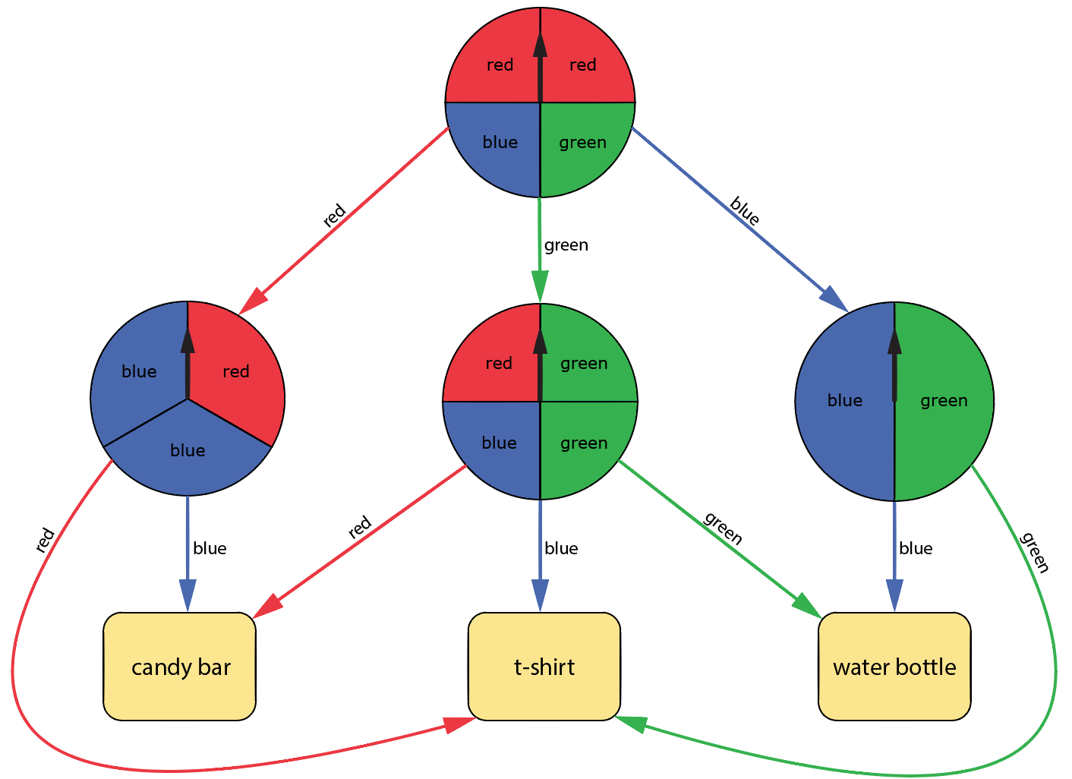A radio station is at a local store giving away prizes. They have set up a series of spinners to determine the prizes people will win, but there is a catch. Before you spin the first spinner, you must correctly guess the prize, then land on that prize in order to win. Which prize should you guess to have the best chance of winning?

## spin and win: spinners

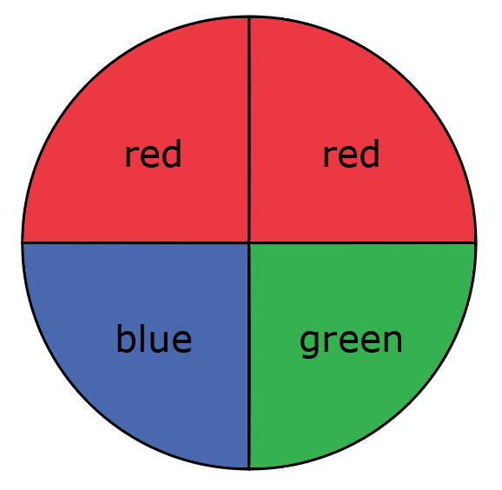

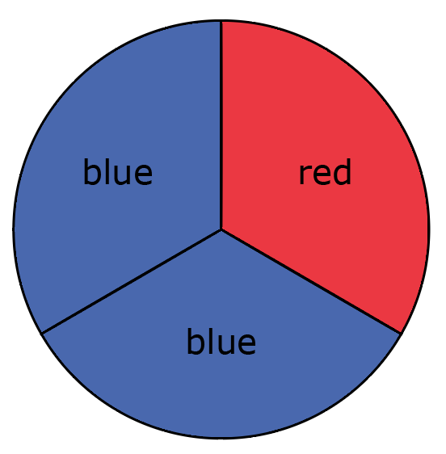 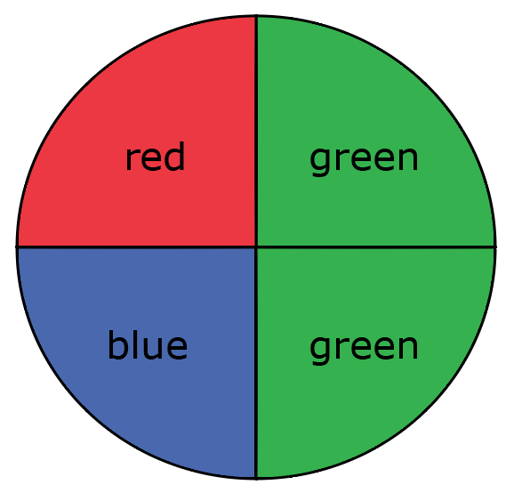 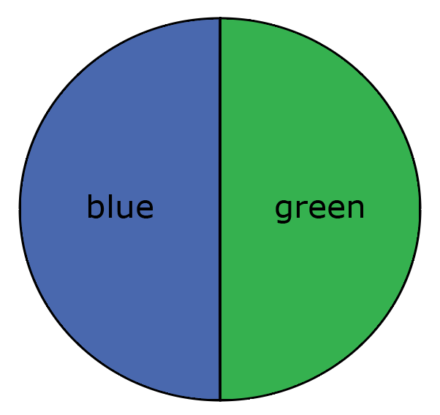

## spin and win: score sheet

|  |  |  |
| --- | --- | --- |
| prize outcomes (Tally) | | |
| **candy bar** | **t-shirt** | **water bottle** |
|  |  |  |

Probabilities of Compound Events

Lesson 3

|  |  |
| --- | --- |
| Trial | Outcome (Gender, Eye Color) |
| 1 |  |
| 2 |  |
| 3 |  |
| 4 |  |
| 5 |  |
| 6 |  |
| 7 |  |
| 8 |  |
| 9 |  |
| 10 |  |
| 11 |  |
| 12 |  |
| 13 |  |
| 14 |  |
| 15 |  |
| 16 |  |
| 17 |  |
| 18 |  |
| 19 |  |
| 20 |  |
| 21 |  |
| 22 |  |
| 23 |  |
| 24 |  |
| 25 |  |
| 26 |  |
| 27 |  |
| 28 |  |
| 29 |  |
| 30 |  |

1. What is the experimental probability of having a boy with any eye color? Explain how you arrived at your answer.
2. What is the experimental probability of having a girl with blue or green eyes? Explain how you arrived at your answer.
3. What is the experimental probability of having a child (girl or boy) with brown eyes? Explain how you arrived at your answer.

1. Recall that for the purposes of this simulation, the theoretical probability of having a boy is $\frac{1}{2}$, the theoretical probability of having a girl is $\frac{1}{2}$, the theoretical probability of having a child with brown eyes is $\frac{1}{3}$, the theoretical probability of having a child with green eyes is $\frac{1}{3}$, the theoretical probability of having a child with blue eyes is $\frac{1}{6}$, and the theoretical probability of having a child with hazel eyes is $\frac{1}{6}$. Create a tree diagram with theoretical probabilities for the compound event of a child’s gender and eye color.

1. What is the theoretical probability of having a boy with any eye color? Explain how you arrived at your answer.
2. What is the theoretical probability of having a girl with blue or green eyes? Explain how you arrived at your answer.

1. What is the theoretical probability of having a child (girl or boy) with brown eyes? Explain how you arrived at your answer.

1. Design and conduct a simulation to model the following scenario and answer this question:

A cereal company puts one toy in each of their cereal boxes. There are three different toys and each toy is equally likely in each cereal box. What is the experimental probability that you get one of each toy after buying exactly three boxes of cereal?

|  |  |
| --- | --- |
| trial | Outcome (3 toys) |
| 1 |  |
| 2 |  |
| 3 |  |
| 4 |  |
| 5 |  |
| 6 |  |
| 7 |  |
| 8 |  |
| 9 |  |
| 10 |  |
| 11 |  |
| 12 |  |
| 13 |  |
| 14 |  |
| 15 |  |
| 16 |  |
| 17 |  |
| 18 |  |
| 19 |  |
| 20 |  |
| 21 |  |
| 22 |  |
| 23 |  |
| 24 |  |
| 25 |  |
| 26 |  |
| 27 |  |
| 28 |  |
| 29 |  |
| 30 |  |

Experimental probability of getting one of each toy if you buy exactly three boxes of cereal: __________

1. Describe how you conducted the simulation in Question 8. What materials did you use? How did you assign outcomes to specific events?
2. Create a tree diagram to determine the theoretical probability of getting one of each toy if you buy exactly three boxes of cereal.

Theoretical probability of getting one of each toy if you buy exactly three boxes of cereal: __________

Probabilities of Compound Events

Lessons 1 – 3

1. 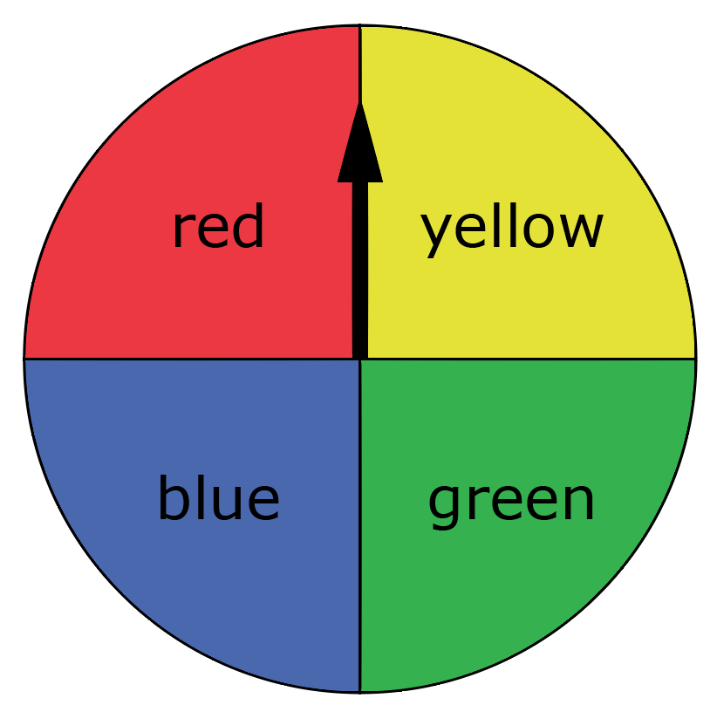Consider flipping a coin (with heads on one side, tails on the other) and spinning the following spinner.

* 1. Are these independent or dependent events? Explain your reasoning.
  2. Create a tree diagram with theoretical probabilities along the branches to model flipping the coin then spinning the spinner.
  3. What is the sample space for this compound event?
  4. What is the theoretical probability of flipping heads and spinning blue? Explain how you determined your answer.

* 1. What is the theoretical probability of flipping tails and spinning either yellow or green? Explain how you determined your answer.

1. Consider a bag with four blue candies, four red candies, and two purple candies, where one candy will be drawn and kept out of the bag, then a second candy will be drawn.
   1. Are these independent or dependent events? Explain your reasoning.
   2. Create a tree diagram with theoretical probabilities along the branches to model selecting two candies from the bag if you do not replace the first candy that is drawn.
   3. What is the sample space for this compound event?
   4. Which outcome(s) in the sample space represents drawing two blue candies? What is the theoretical probability of drawing two blue candies? Explain how you determined your answer.
   5. Which outcome(s) in the sample space represents drawing one red candy and one purple candy in any order? What is the theoretical probability of drawing one red candy and one purple candy in any order? Explain how you determined your answer.
2. You are going to play a game with your friend where you roll two standard, six-sided number cubes and determine the sum. Player A wins if the sum is 2, 3, 4, 10, 11, or 12. Player B wins if the sum is 5, 6, 7, 8, or 9. Is this a fair game? Justify your reasoning by showing your work and providing theoretical probabilities.

1. Your state recently reported that only two out of five people pass the written driving test on their first attempt. In the following questions, you will conduct a simulation and determine the likelihood that three randomly selected people who have taken the written driving test failed the test on their first attempt.
   1. Describe the design of a simulation that you can conduct to model the described scenario. Be sure to include what each outcome of the simulation represents in the context of the problem.
   2. Conduct 30 trials of the simulation and record the results of each trial in the following table.

|  |  |  |  |
| --- | --- | --- | --- |
| Trial | Outcome | Trial | Outcome |
| 1 |  | 16 |  |
| 2 |  | 17 |  |
| 3 |  | 18 |  |
| 4 |  | 19 |  |
| 5 |  | 20 |  |
| 6 |  | 21 |  |
| 7 |  | 22 |  |
| 8 |  | 23 |  |
| 9 |  | 24 |  |
| 10 |  | 25 |  |
| 11 |  | 26 |  |
| 12 |  | 27 |  |
| 13 |  | 28 |  |
| 14 |  | 29 |  |
| 15 |  | 30 |  |

* 1. What outcome in the sample space represents that all three randomly selected people failed on their first attempt?
  2. What is the experimental probability that all three randomly selected people who have taken the written test failed on their first attempt? Explain how you determined your answer.
  3. Create a tree diagram with theoretical probabilities along the branches to model asking three people who have taken the written driving test whether they passed or failed on their first attempt.
  4. What is the theoretical probability that all three randomly selected people who have taken the written test failed on their first attempt?
  5. How does the theoretical probability compare to the experimental probability? Explain why you believe this is the case.