Rational vs. Irrational Numbers

INSTRUCTIONAL ACTIVITY SUPPLEMENT A

Lesson 1

|  |  |  |
| --- | --- | --- |
| Fraction: $\frac{11}{4}$ Decimal expansion:  ____________________ | Fraction: $\frac{-10}{2}$ Decimal expansion:  ____________________ | Fraction: $-\frac{1}{9}$ Decimal expansion:  ____________________ |
| Fraction: $\frac{8}{3}$ Decimal expansion:  ____________________ | Fraction:  Decimal expansion:  ____________________ | Fraction:  Decimal expansion:  ____________________ |
| Fraction:  Decimal expansion:  ____________________ | Fraction: $-\frac{5}{7}$ Decimal expansion:  ____________________ | Fraction: $\frac{15}{12}$ Decimal expansion:  ____________________ |
| Fraction: $\frac{21}{2}$ Decimal expansion:  ____________________ | Fraction: 4 $\frac{1}{11}$ Decimal expansion:  ____________________ | Fraction: –6 $\frac{2}{25}$ Decimal expansion:  ____________________ |
| Fraction: 5 $\frac{4}{15}$ Decimal expansion:  ____________________ | Fraction: 1 $\frac{11}{100}$ Decimal expansion:  ____________________ | Fraction: –3 $\frac{3}{5}$ Decimal expansion:  ____________________ |

Rational vs. Irrational Numbers

INSTRUCTIONAL ACTIVITY SUPPLEMENT B

Lesson 1

10.5

0.3

–2.75

–0.125

7.46

Rational vs. Irrational Numbers

INSTRUCTIONAL ACTIVITY SUPPLEMENT

Lesson 2



Rational vs. Irrational Numbers

Lessons 1 & 2

1. Provide five **rational** numbers and explain how you know these numbers are rational. Provide a variety of answers. Provide more than one form or type of rational number.

1. Provide five **irrational** numbers and explain how you know these numbers are irrational.

1. Write the following decimal as a fraction in simplest form. Explain your reasoning.

3.18

1. Write the following decimal as a fraction in simplest form. Show your work.

1.45454545…

1. Use the following right triangle to answer the questions provided.

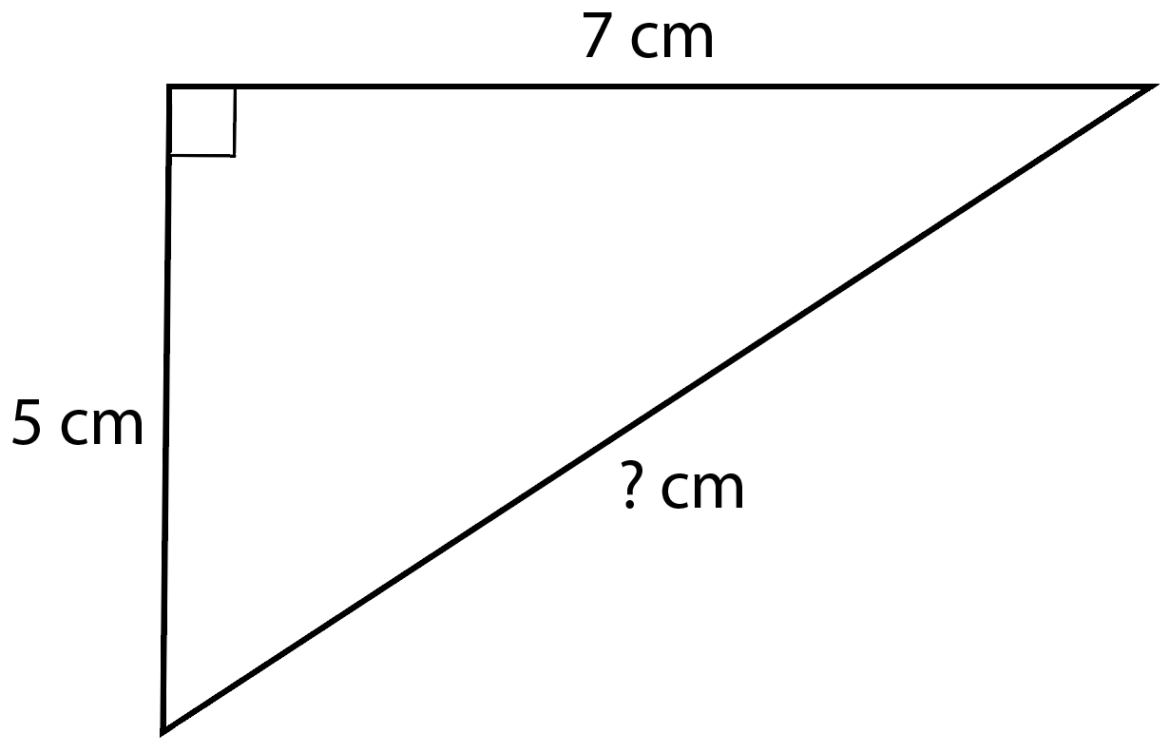

* 1. Determine the length of the hypotenuse. Show your work.
  2. Partition the number line provided such that each interval is one centimeter. Then cut out a triangle with the same dimensions as labeled in the triangle shown. Use the triangle to locate and label the length of the hypotenuse on the number line. Trace or glue the triangle you use to support your work.

1. Partition the number line provided such that each interval is one centimeter. Use a right triangle with leg lengths of eight centimeters and five centimeters to locate – $\sqrt{89}$ on the number line. Trace or glue the triangle you use to support your work.



1. Provide an irrational number located between 4.2 and 4.3 on the number line. Give your answer as a square root. Explain how you determined this number. You may use a calculator to help you.

1. Describe where $\sqrt{68}$ is located on a number line labeled with rational numbers to the hundredths place. Explain your reasoning.

1. Order the following values from least to greatest.

$\sqrt{18}$, –π, 0, – $\sqrt{23}$, $\sqrt{11}$, *e*, – $\sqrt{5}$