Recognizing and Creating Shapes

Lesson 1

1. Color in all the circles.

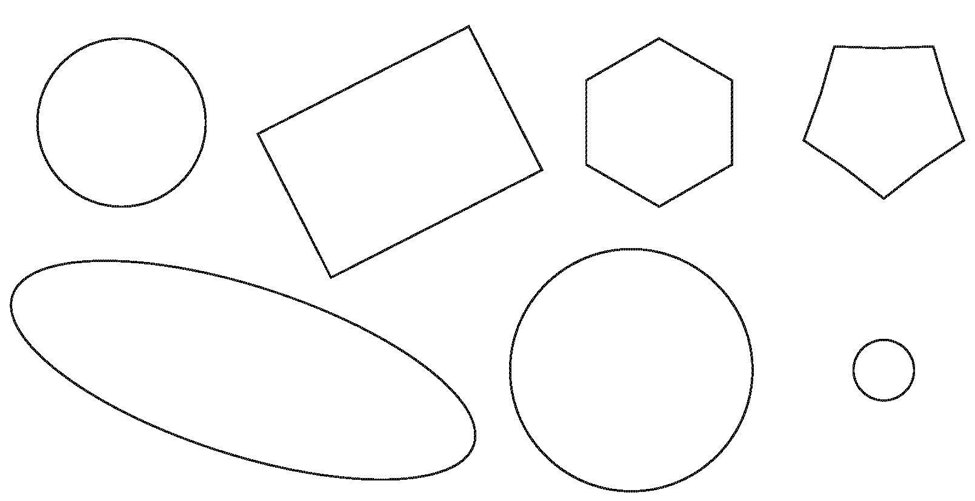

2. Color in all the triangles (shapes with 3 sides).

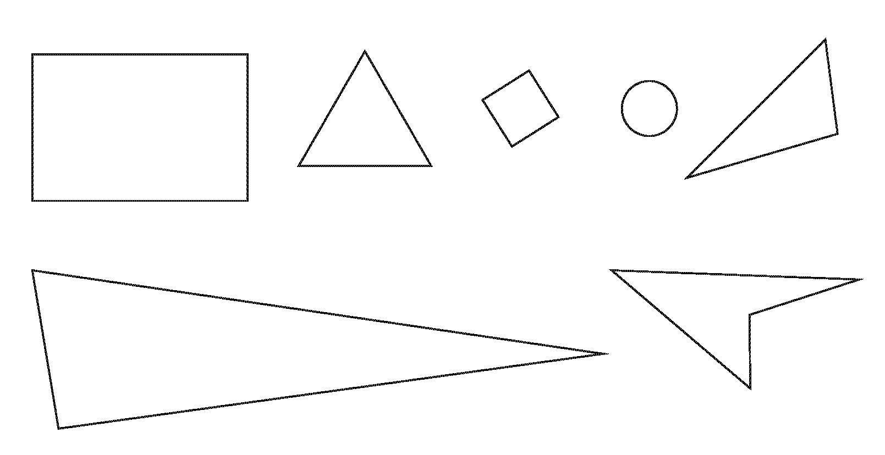

3. Color in all the quadrilaterals (shapes with 4 sides).

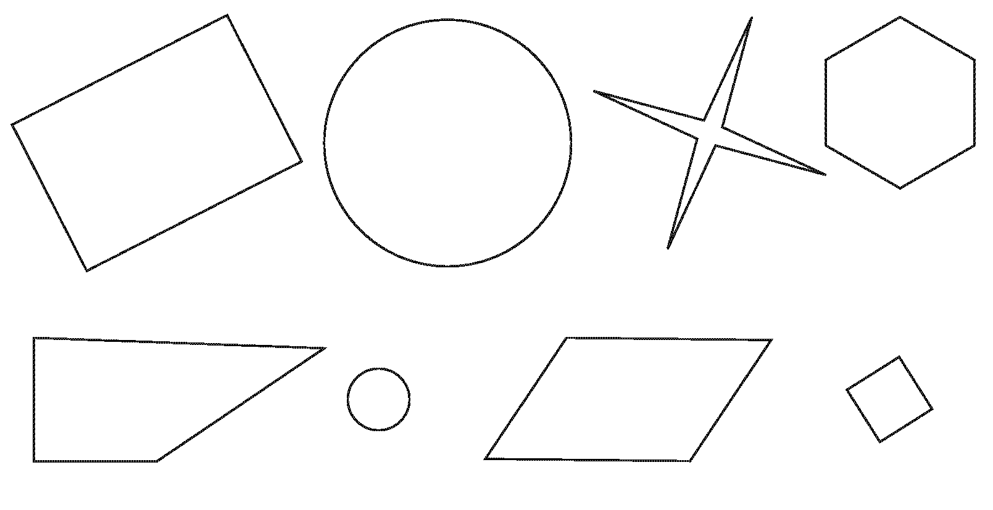

4. Color in all the pentagons (shapes with 5 sides).

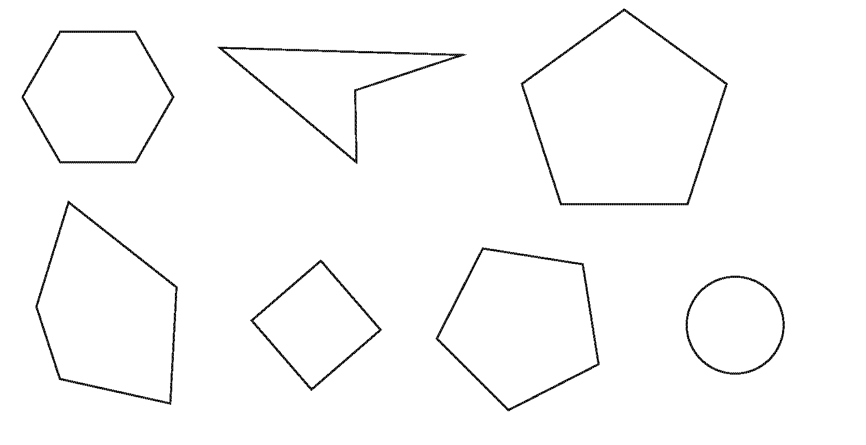

5. Color in all the hexagons (shapes with 6 sides).

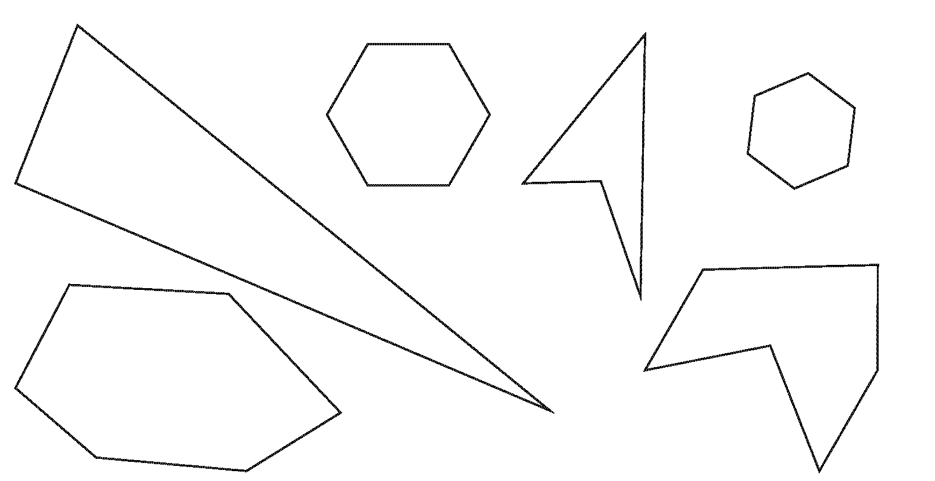

Recognizing and Creating Shapes

INSTRUCTIONAL ACTIVITY SUPPLEMENT

Lesson 1

Circle

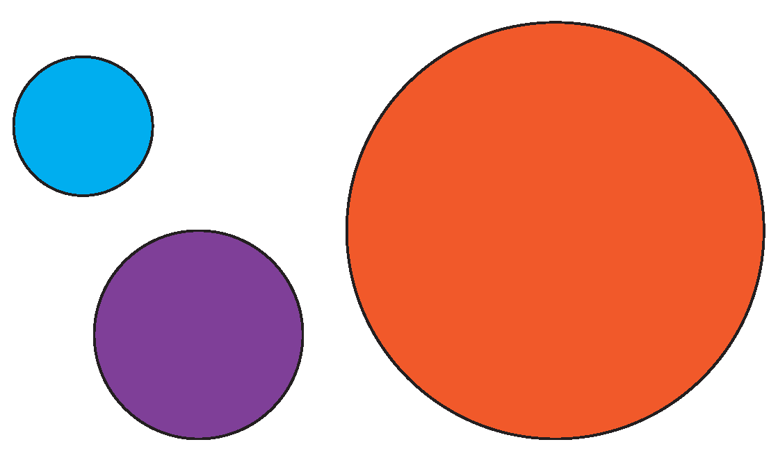

Triangle

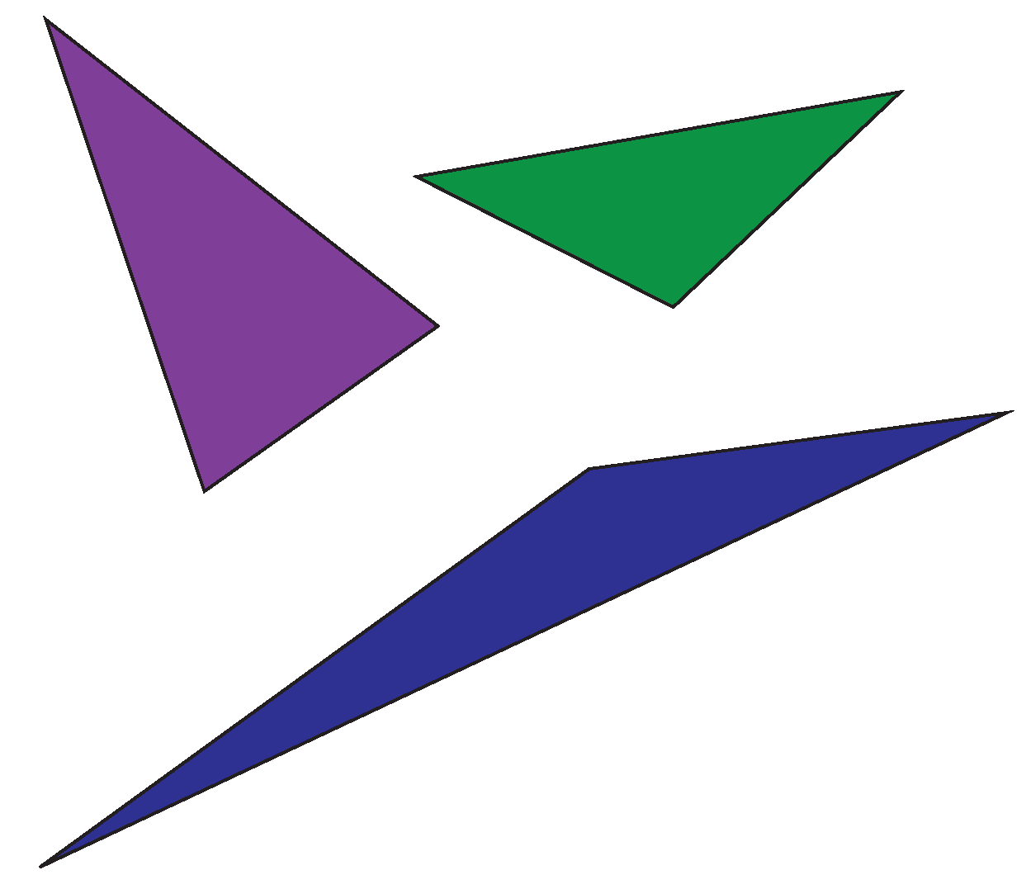

Quadrilateral

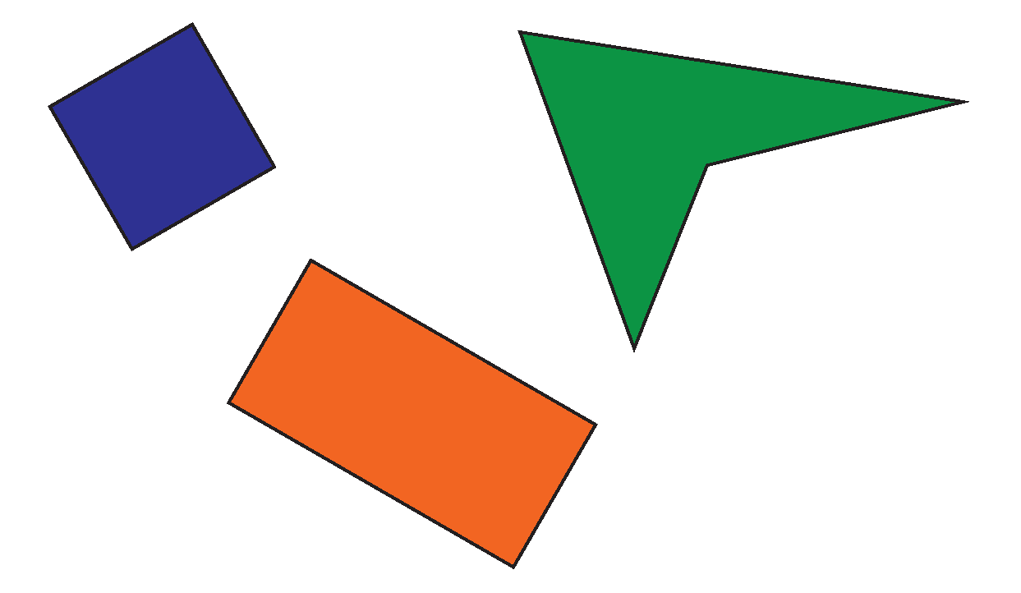

Pentagon

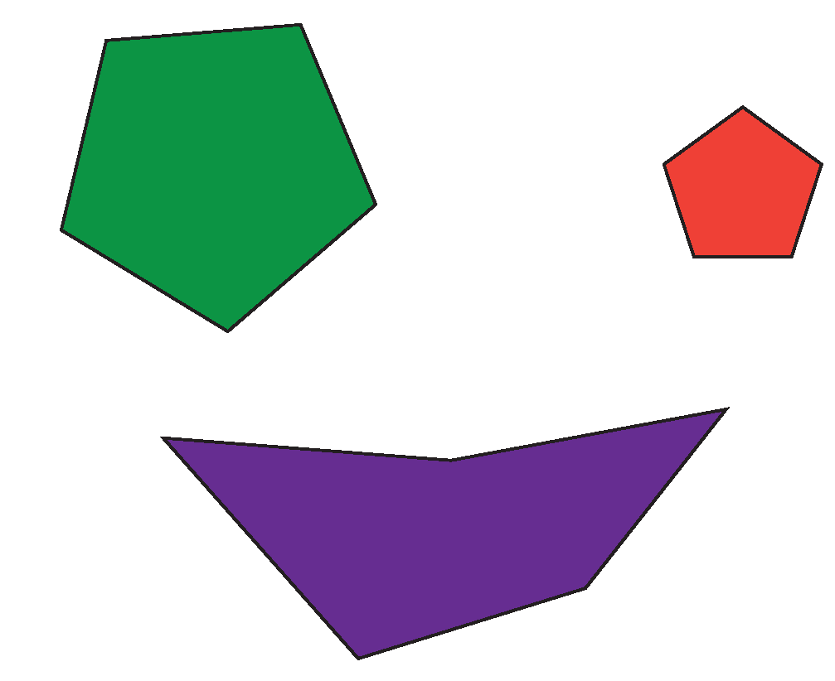

Hexagon

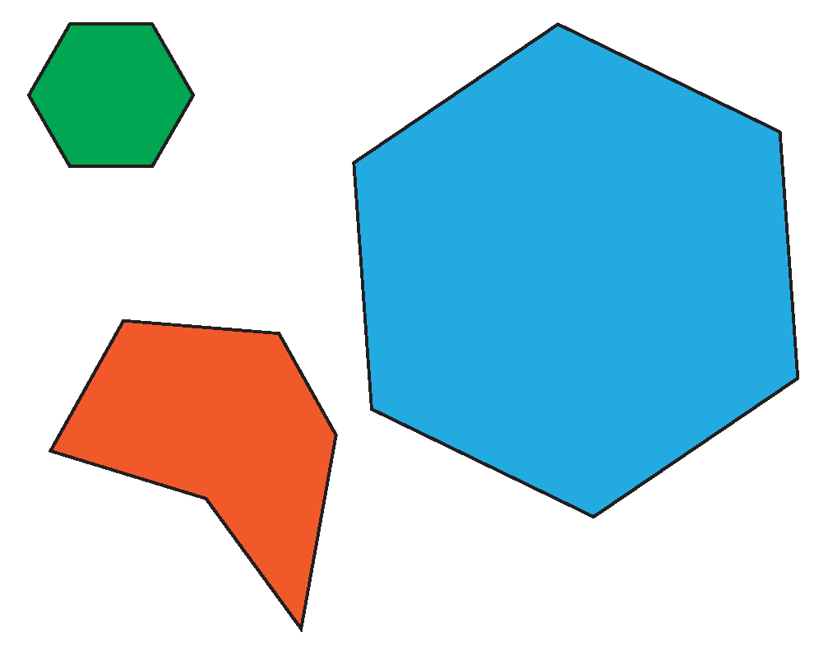

Recognizing and Creating Shapes

Lesson 2

Circle the **example**. Write why that shape is an example. Write why the other shape is not an example.

1. Square

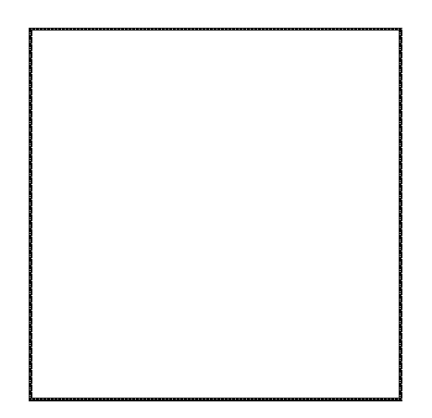 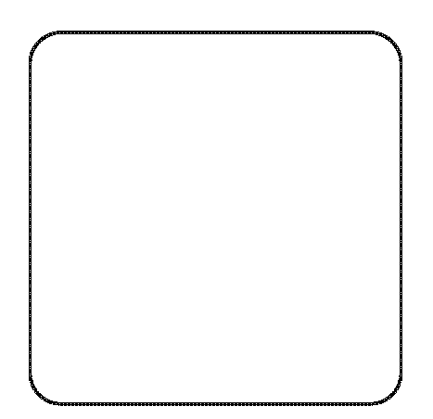

_______________________ _______________________

_______________________ _______________________

_______________________ _______________________

2. Triangle

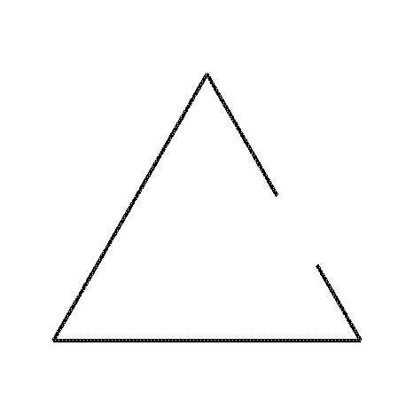 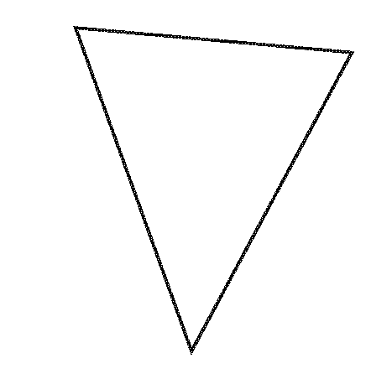

_______________________ _______________________

_______________________ _______________________

_______________________ _______________________

3. Hexagon (shape with 6 sides)

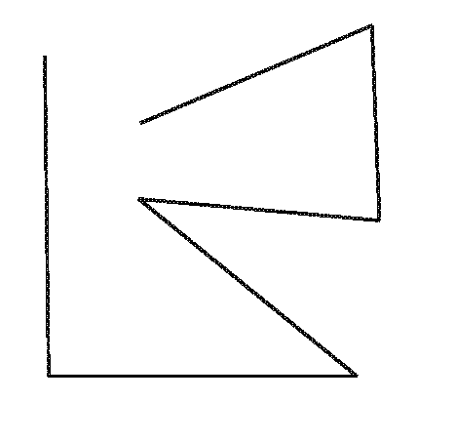 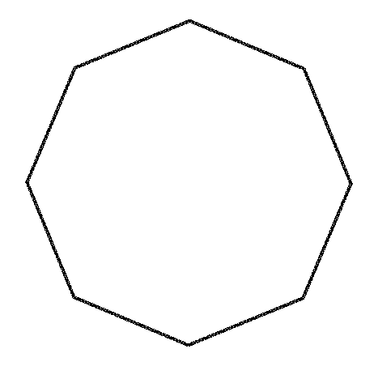

_______________________ _______________________

_______________________ _______________________

_______________________ _______________________

4. Triangle

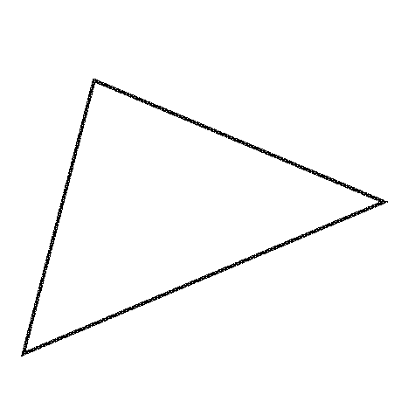 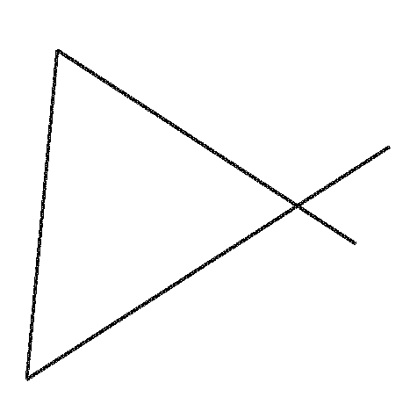

_______________________ _______________________

_______________________ _______________________

_______________________ _______________________

5. Rectangle

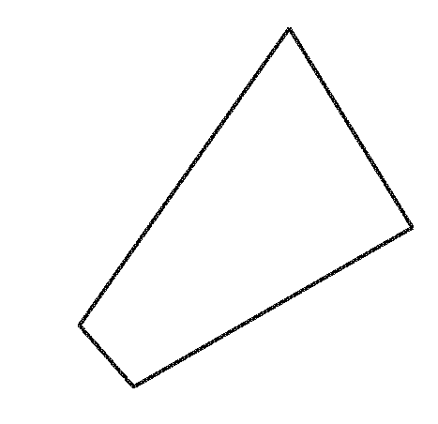 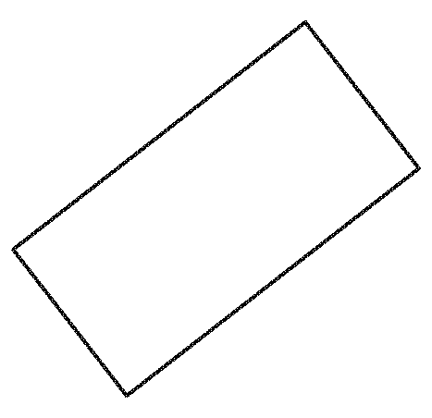

_______________________ _______________________

_______________________ _______________________

_______________________ _______________________

Recognizing and Creating Shapes

INSTRUCTIONAL ACTIVITY SUPPLEMENT A

Lesson 2

Teacher Shape Cards

|  |  |
| --- | --- |
|  |  |
|  |  |
|  |  |
|  |  |

Student Shape Cards

|  |  |  |
| --- | --- | --- |
|  |  |  |
|  |  |  |
|  |  |  |
|  |  |  |
|  |  |  |

Attribute Cards

|  |
| --- |
| Curved sides |
| 3 sides |
| 4 sides |
| 5 sides |
| 6 sides |
| Square corners |
| All sides the same length |
| 2 sides the same length |
| No sides the same length |

Recognizing and Creating Shapes

INSTRUCTIONAL ACTIVITY SUPPLEMENT B

Lesson 2

Teacher Shape Cards

|  |  |
| --- | --- |
|  |  |
|  |  |
|  |  |
|  |  |

Student Shape Cards

|  |  |  |
| --- | --- | --- |
|  |  |  |
|  |  |  |
|  |  |  |
|  |  |  |
|  |  |  |

Attribute Cards

|  |
| --- |
| Curved sides |
| 3 sides |
| 4 sides |
| 5 sides |
| 6 sides |
| Square corners |
| All sides the same length |
| 2 sides the same length |
| No sides the same length |

Recognizing and Creating Shapes

Lesson 3

1. Draw a triangle.

2. Draw a shape with four sides.

3. Draw a shape that has four sides and four corner angles.

What is the name of the shape you drew?

_______________________

4. Draw a shape that has five sides.

5. Draw a shape that has six sides.

6. Draw a square.

How do you know this is a square?

____________________________________________

Recognizing and Creating Shapes

INSTRUCTIONAL ACTIVITY SUPPLEMENT A

Lesson 3

Example Set

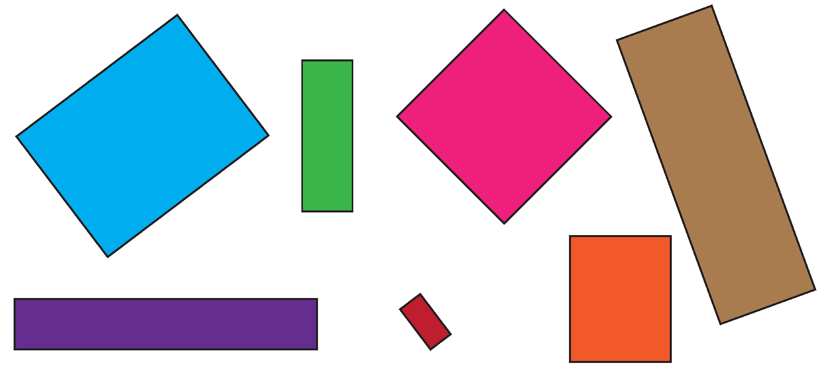

Non-Example Set

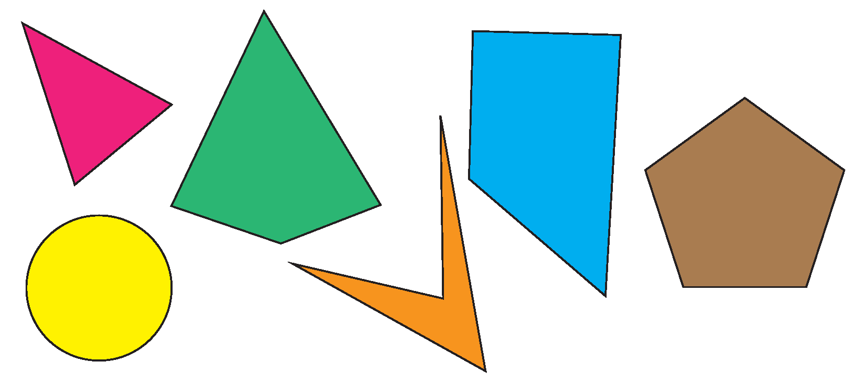

Mystery Set

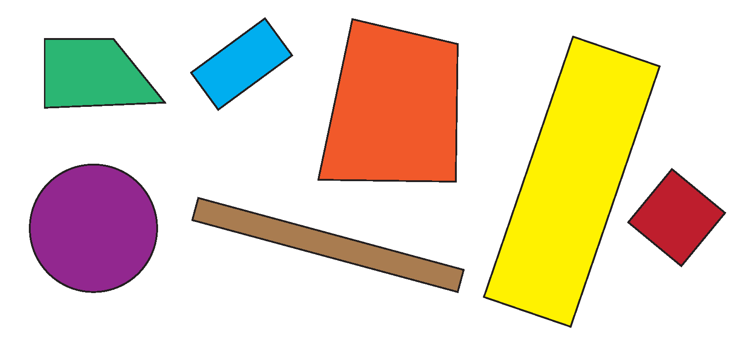

Example Set

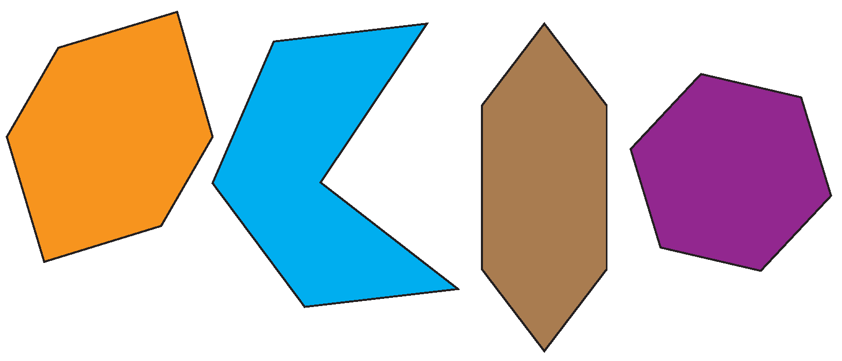

Non-Example Set

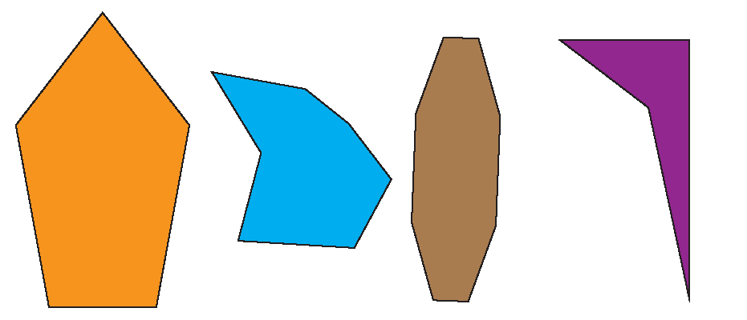

Mystery Set

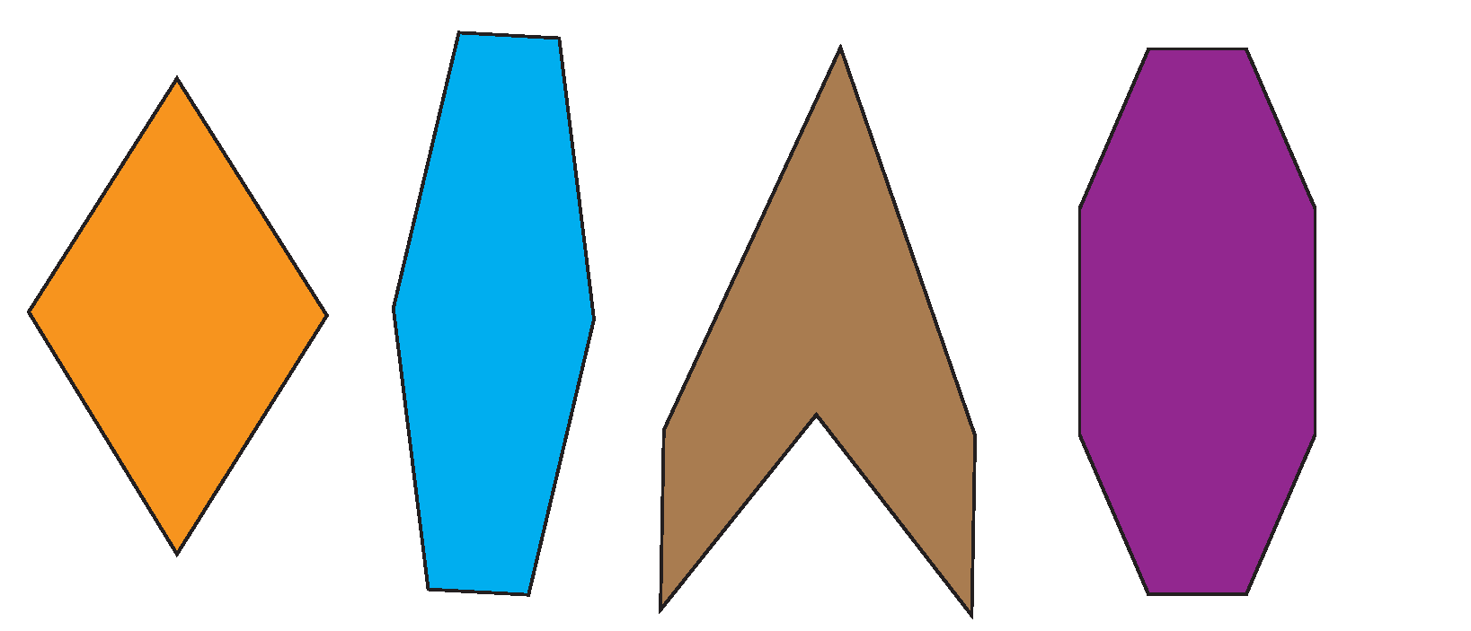

Example Set

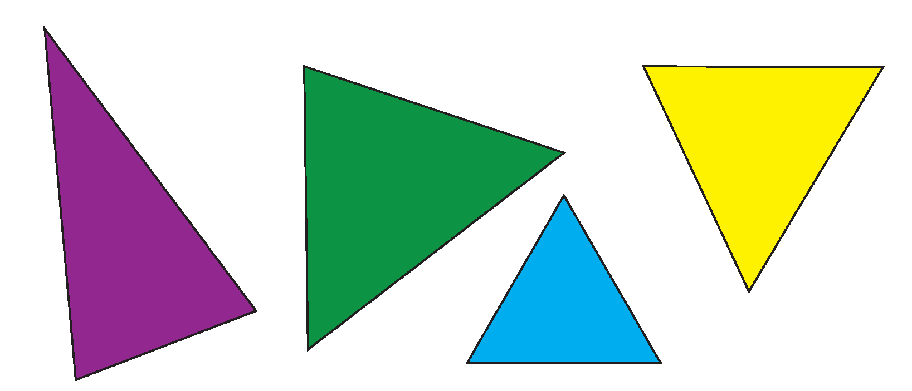

Non-Example Set

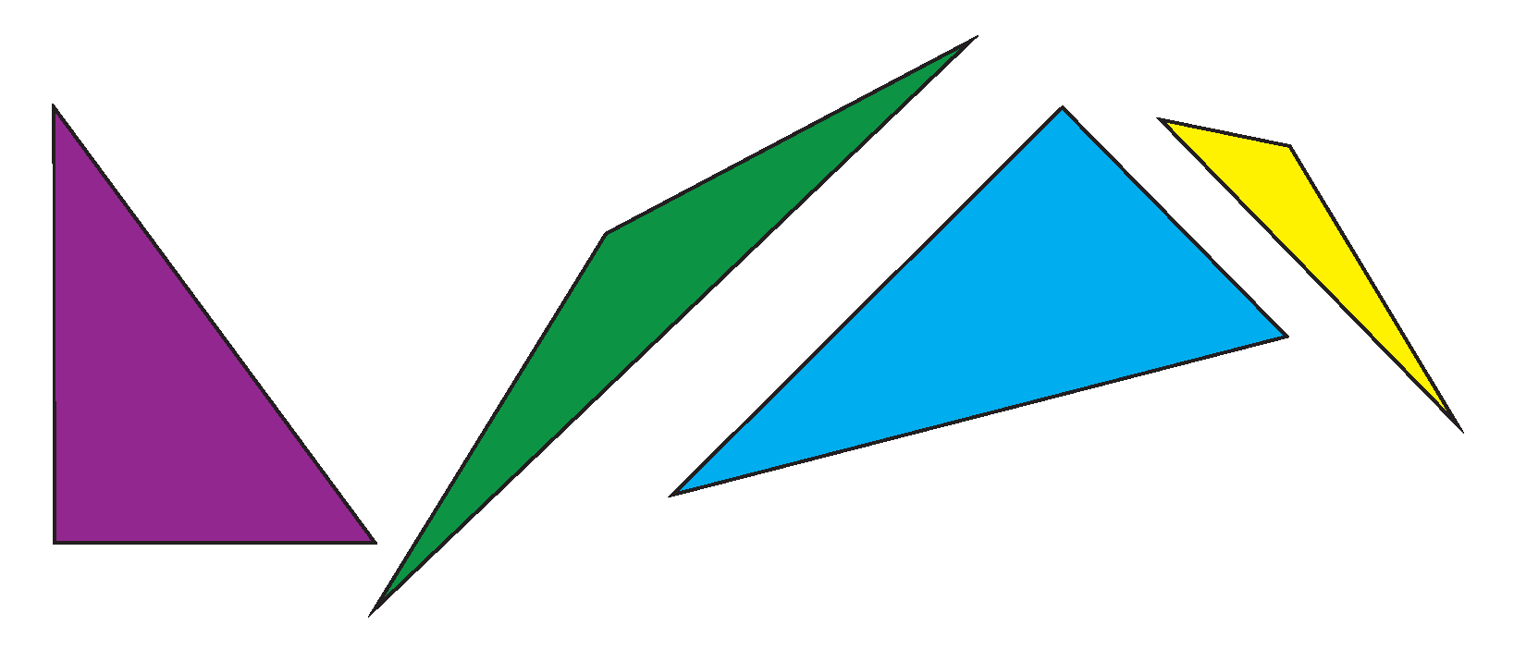

Mystery Set

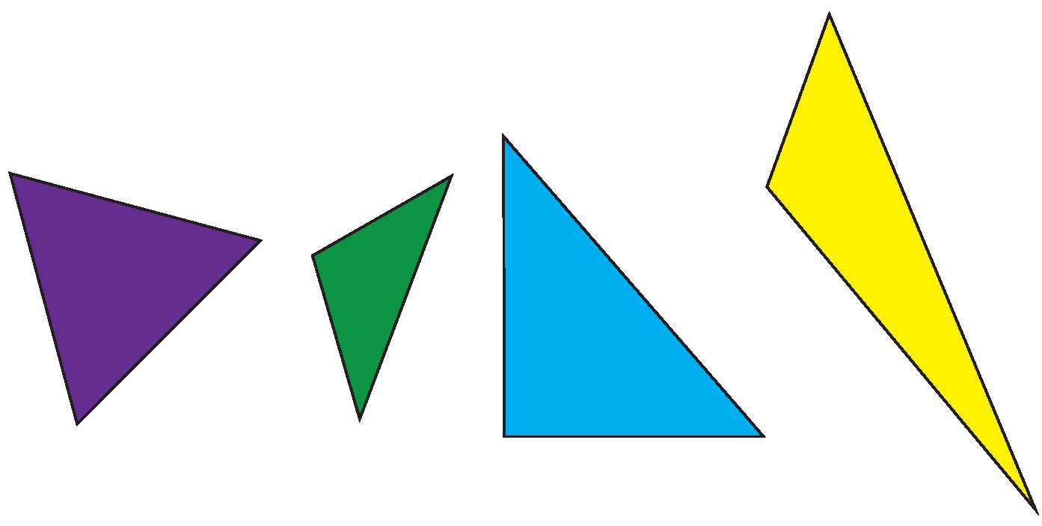

Station 1

Use the rubber bands and geoboard to make the shapes you see on the cards.

Station 3

Use the sticks to make the shapes you see on the cards.

Geoboard Cards

|  |  |  |
| --- | --- | --- |
|  |  |  |
|  |  |  |
|  |  |  |
|  |  |  |
|  |  |  |
| Make a shape with four sides | Make a square | Make a triangle |
| Make a hexagon | Make a pentagon | Make a rectangle |

Stick Cards

|  |  |  |
| --- | --- | --- |
|  |  |  |
|  |  |  |
|  |  |  |
|  |  |  |
|  |  |  |
| Make a shape with four sides | Make a square | Make a triangle |
| Make a hexagon | Make a pentagon | Make a rectangle |

Recognizing and Creating Shapes

INSTRUCTIONAL ACTIVITY SUPPLEMENT B

Lesson 3

Guess My Shape cards

|  |  |  |
| --- | --- | --- |
|  |  |  |
|  |  |  |
|  |  |  |
|  |  |  |
| A rectangle | A square | A triangle with 1 corner angle |
| A triangle with 3 angles the same size | A pentagon  (5 sides) | A hexagon  (6 sides) |
| A quadrilateral (4 sides) with only 2 corner angles | A quadrilateral  (4 sides) | A triangle  (3 sides) |

Name: _______________________

Shape Tracker

Does your shape have…

|  |  |  |  |  |
| --- | --- | --- | --- | --- |
| 1 corner angle? | 2 corner angles? | 3 corner angles? | 4 corner angles? | 1 angle that is larger than a corner angle? |
| all of the angles on the outside of the shape? | an angle on the inside of the shape? | 2 sides the same length? | 3 sides the same length? | 4 sides the same length? |
| 3 sides? | 4 sides? | 5 sides? | 6 sides? | no straight sides? |

Is your shape…

|  |  |  |  |  |
| --- | --- | --- | --- | --- |
| a  triangle? | a quadrilateral? | a  square? | a rectangle? | a pentagon? |
| a  hexagon? | a  circle? | not a shape? |  |  |

Recognizing and Creating Shapes

1. Circle or color in all of the circles.

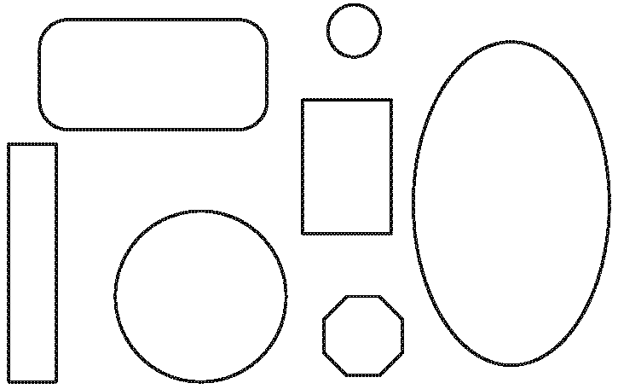

1. Circle or color in all of the rectangles.

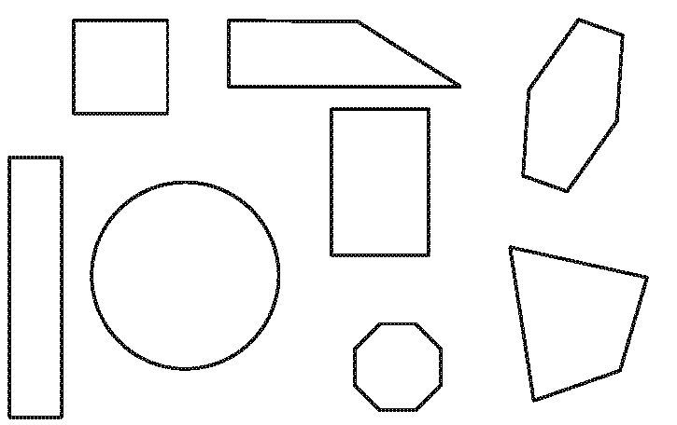

1. Circle the triangle. Explain why it is a triangle and why the other shape is not a triangle.

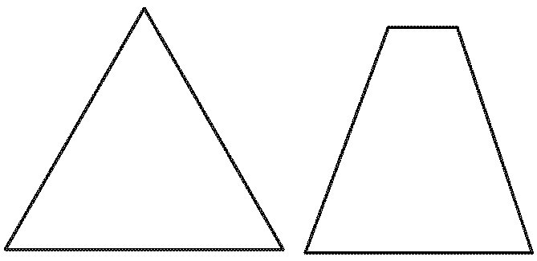

____________________________________________________

____________________________________________________

____________________________________________________

____________________________________________________

____________________________________________________

____________________________________________________

____________________________________________________

____________________________________________________

____________________________________________________

____________________________________________________

____________________________________________________

____________________________________________________

1. For each picture of a shape, circle the name of the shape, and explain how you know that is the name of the shape.
   1. 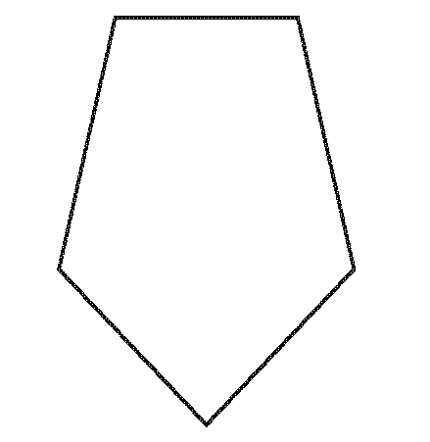 square

rectangle

triangle

pentagon

hexagon

_____________________________________________________________________________________

_____________________________________________________________________________________

_____________________________________________________________________________________

_____________________________________________________________________________________

_____________________________________________________________________________________

_____________________________________________________________________________________

_____________________________________________________________________________________

_____________________________________________________________________________________

_____________________________________________________________________________________

_____________________________________________________________________________________

_____________________________________________________________________________________

_____________________________________________________________________________________

* 1. 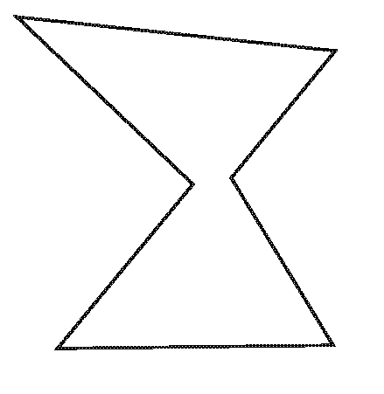   
      square

rectangle

triangle

pentagon

hexagon

_____________________________________________________________________________________

_____________________________________________________________________________________

_____________________________________________________________________________________

_____________________________________________________________________________________

_____________________________________________________________________________________

_____________________________________________________________________________________

_____________________________________________________________________________________

_____________________________________________________________________________________

_____________________________________________________________________________________

_____________________________________________________________________________________

_____________________________________________________________________________________

_____________________________________________________________________________________

1. Name and draw each of the shapes.
   1. A shape that has four sides, four corner angles, and all sides of the same length

Shape name: _______________________________________

Drawing:

* 1. A shape that has three sides, three angles, and two sides of the same length

Shape name: _______________________________________

Drawing:

* 1. A shape that has six sides and six angles

Shape name: _______________________________________

Drawing:

1. Write how the two shapes are the same and how they are different.

A

B

____________________________________________________

____________________________________________________

____________________________________________________

____________________________________________________

____________________________________________________

____________________________________________________

____________________________________________________

____________________________________________________

____________________________________________________

____________________________________________________

____________________________________________________