Summarizing a Poem

Student Handout

Lesson 1

**Poem Title:**

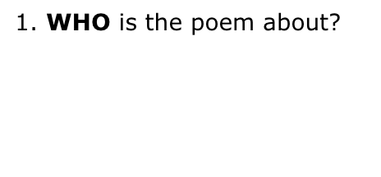

3. **WHAT** are the most important actions and objects in the poem?

4. **HOW** does the poem end? What lesson did you learn?

2. **WHERE** does the poem take place?

5. **SUMMARY:** Write a summary by combining the WHO, WHERE, WHAT, and HOW information.

Theme Organizer

Student Handout

Lesson 2

**Directions:** At the top of each shape, write a word that tells what the poem is about. Then list examples of each topic from the poem. Last, write a sentence on why each topic is important in the poem.

**__________________**

**__________________**

**__________________**

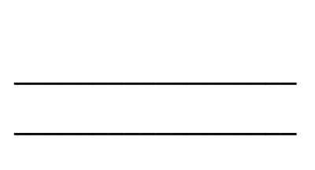

**__________________**

**__________________**

**__________________**



**__________________**

**__________________**

**__________________**



**__________________**

**__________________**

**__________________**

My Theme Drawing and Statement

Student Handout

**Directions:** Draw a picture of the most important idea, image, or scene in the poem. Underneath the picture, write a sentence that describes what the theme of the poem is.

|  |
| --- |
|  |

|  |
| --- |
|  |
|  |