Measuring Lengths and Creating Line Plots

Lesson 1

|  |  |  |
| --- | --- | --- |
| **Shorter Than the Length of String** | **About the Same Length** | **Longer Than the Length of String** |
|  |  |  |

Measuring Length and Creating Line Plots

INSTRUCTIONAL ACTIVITY SUPPLEMENT

Lesson 1

|  |  |  |
| --- | --- | --- |
| **Part of Tissue Box** | **Measurement Type** | **Picture** |
| Height | Length |  |
|  |  |  |
|  |  |  |
| **Part of Tissue Box** | **Measurement Type** | **Picture** |
|  |  |  |
|  |  |  |
|  |  |  |
|  |  |  |

Measuring Lengths and Creating Line Plots

Lesson 2

**Object #1:**

Length: __________________ Units: ______________________

**Object #2:**

Length: __________________ Units: ______________________

**Object #3:**

Length: __________________ Units: ______________________

**Object #4:**

Length: __________________ Units: ______________________

**Object #5:**

Length: __________________ Units: ______________________

**Object #6:**

Length: __________________ Units: ______________________

**Object #7:**

Length: __________________ Units: ______________________

**Object #8:**

Length: __________________ Units: ______________________

**Object #9:**

Length: __________________ Units: ______________________

**Object #10:**

Length: __________________ Units: ______________________

**Object #11:**

Length: __________________ Units: ______________________

**Object #12:**

Length: __________________ Units: ______________________

**Object #13:**

Length: __________________ Units: ______________________

**Object #14:**

Length: __________________ Units: ______________________

**Object #15:**

Length: __________________ Units: ______________________

Measuring Lengths and Creating Line Plots

Lesson 3

Measure the body parts on your body and write the length in inches.

|  |  |
| --- | --- |
| **Body Part** | **Length** |
| Your pinky finger |  |
| Your foot |  |
| Your arm span |  |

Measuring Lengths and Creating Line Plots

Lesson 4

|  |
| --- |
| Pinky finger data: |
| Pinky finger line plot: |
| Hair length data: |
| Hair length line plot: |
| Length from armpit to elbow data: |
| Length from armpit to elbow line plot: |
| Length from wrist to tip of middle finger data: |
| Length from wrist to tip of middle finger line plot: |

Measuring Lengths and Creating Line Plots

Lesson 1 – 4

1. 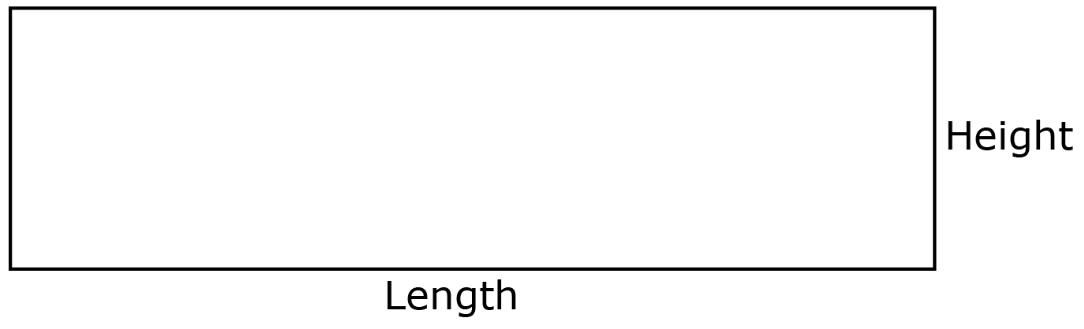Use the rectangle and a ruler to answer the following questions.  
     
     
     
     
     
   1. Measure the length of the rectangle to the nearest inch. Write your answer here.
   2. Measure the length of the rectangle to the nearest centimeter. Write your answer here.

* 1. Measure the height of the rectangle to the nearest inch. Write your answer here.

1. Circle the best unit to measure each object.
   1. 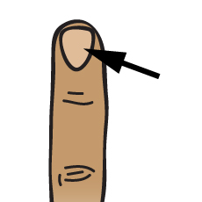Your fingernails  
        
        
      Miles Feet Centimeters
   2. 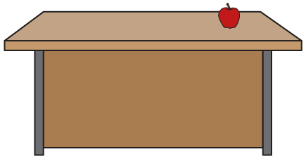The length of your teacher’s desk  
        
        
      Miles Feet Centimeters
   3. 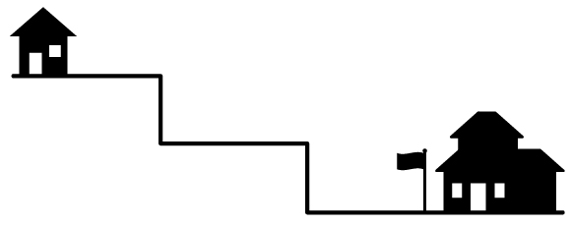The distance from your house to school  
        
        
      Miles Feet Centimeters
2. Measure the following images. Round to the nearest whole unit.
   1. Use a ruler to find the height of the pineapple to the nearest whole centimeter.

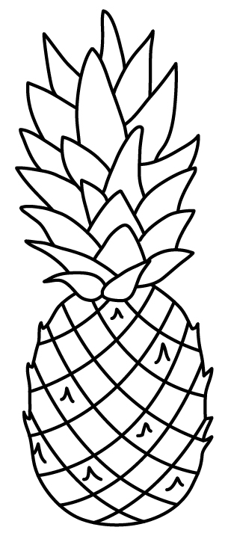

* 1. 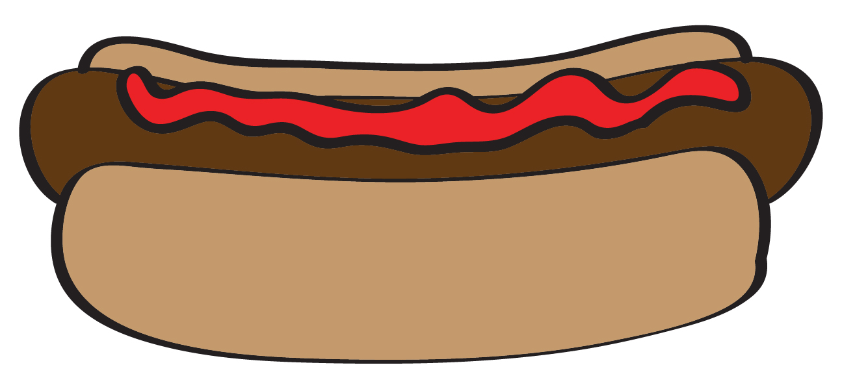Use a ruler to find the length of the hot dog to the nearest whole inch.
  2. Use a ruler to find the height of the tree to the nearest whole inch.

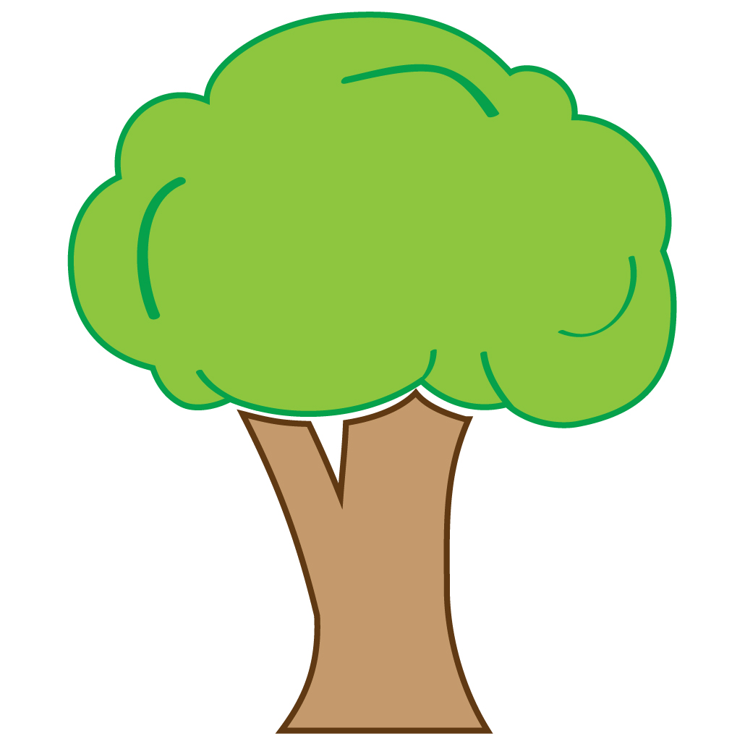

1. 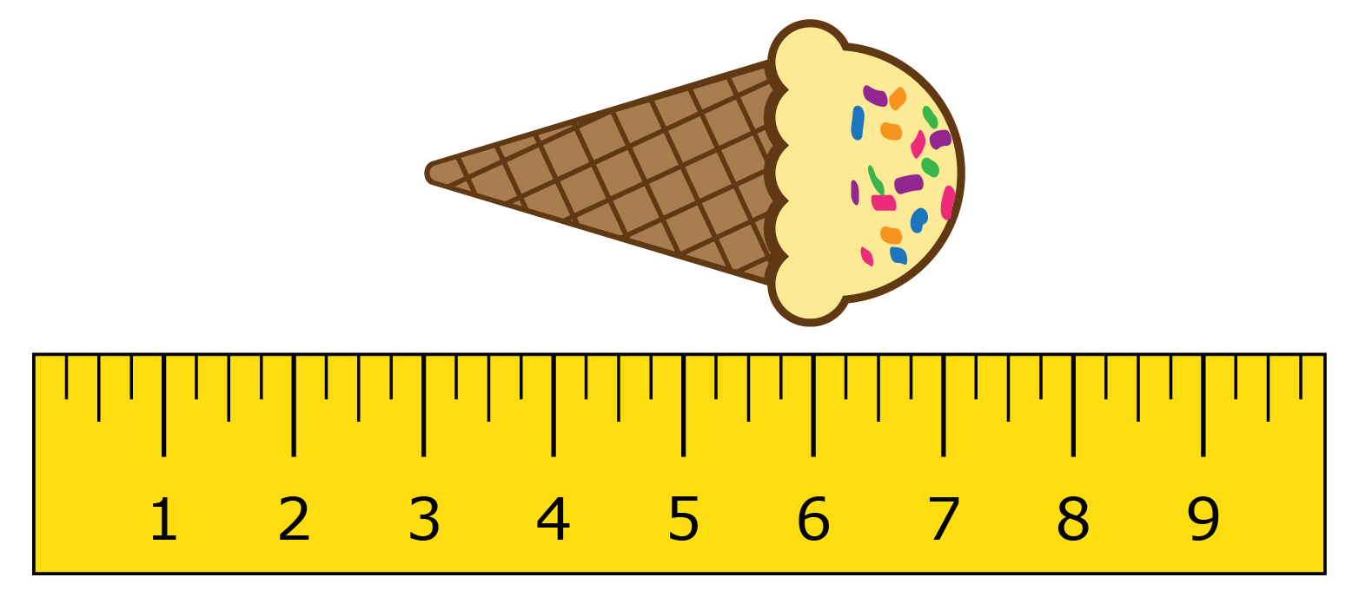Use the ruler shown to find the length of the ice cream cone to the nearest inch.

1. 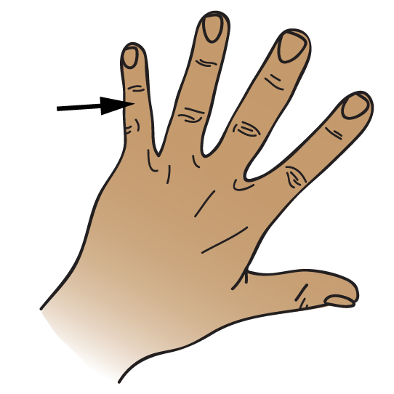 Use the line plot to answer the following questions.

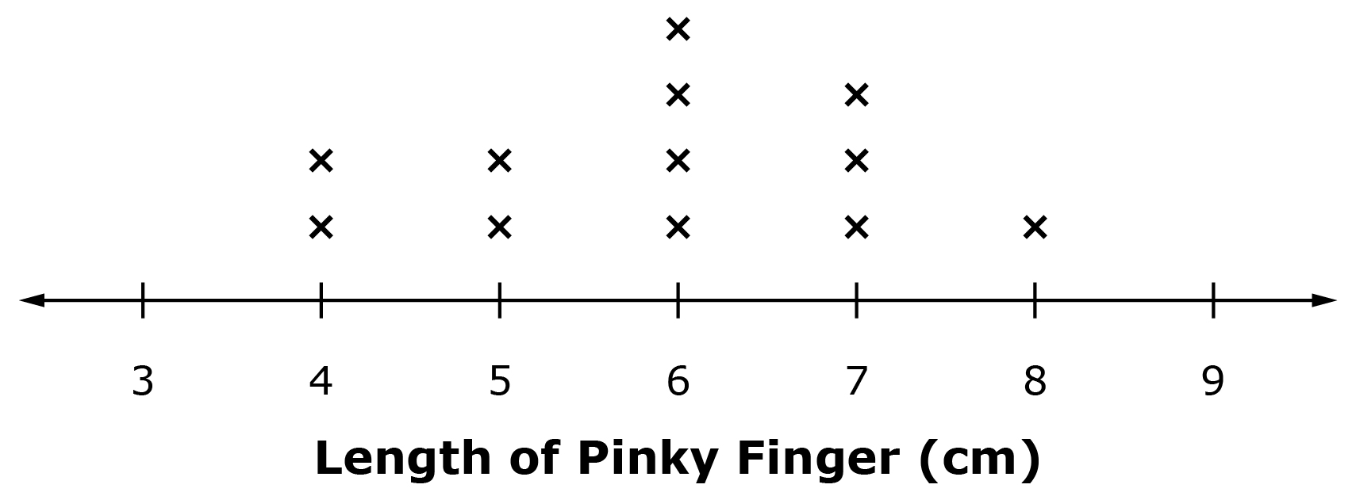

* 1. What is the shortest pinky finger length shown in the line plot?
  2. What is the longest pinky finger length shown in the line plot?
  3. What is the most common pinky finger length shown in the line plot?

1. 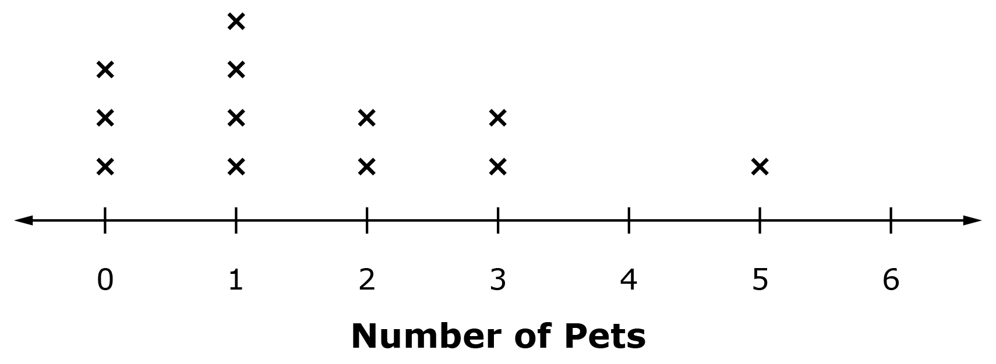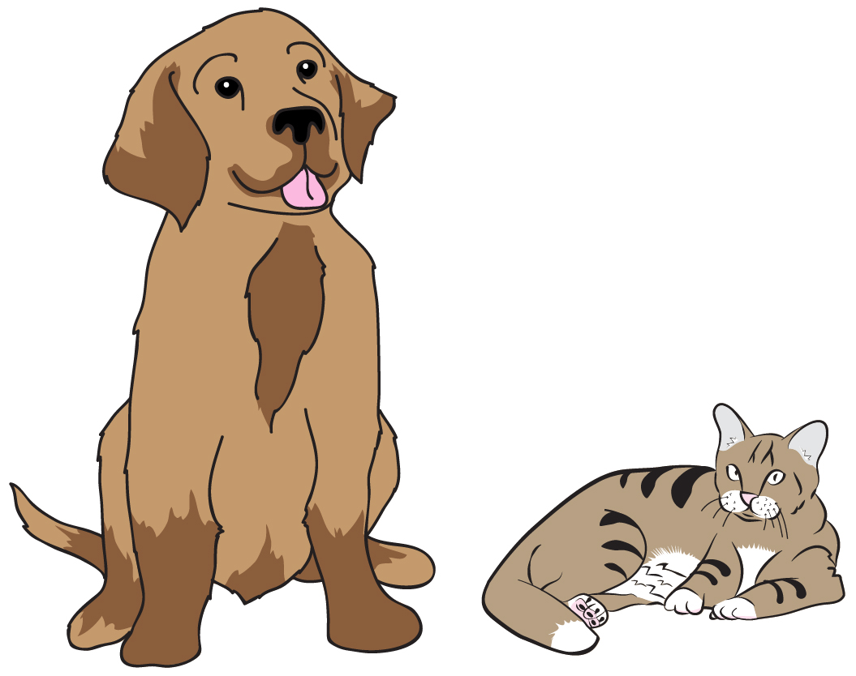Use the line plot to answer the following questions.  
     
     
     
     
     
     
     
   1. How many people shown in the line plot have 3 pets?
   2. How many people shown in the line plot have 0 pets?
   3. How many people are shown in the line plot?