3-Digit Numbers and Place Value

Lesson 3

For each problem, complete the missing parts.

|  |  |  |
| --- | --- | --- |
| hundreds | tens | ones |
|  |  |  |
| ____ hundreds | ____ tens | ____ ones |
| Numeral: |  |  |

|  |  |  |
| --- | --- | --- |
| hundreds | tens | ones |
|  |  |  |
| ____ hundreds | ____ tens | ____ ones |
| Numeral: | 306 |  |

|  |  |  |
| --- | --- | --- |
| hundreds | tens | ones |
|  |  |  |
| 4 hundreds | 3 tens | 0 ones |
| Numeral: |  |  |

|  |  |  |
| --- | --- | --- |
| hundreds | tens | ones |
|  |  |  |
| ____ hundreds | ____ tens | ____ ones |
| Numeral: | 698 |  |

|  |  |  |
| --- | --- | --- |
| hundreds | tens | ones |
|  |  |  |
| ____ hundreds | ____ tens | ____ ones |
| Numeral: |  |  |

|  |  |  |
| --- | --- | --- |
| hundreds | tens | ones |
|  |  |  |
| 4 hundreds | 13 tens | 22 ones |
| Numeral: |  |  |

3-Digit Numbers and Place Value

INSTRUCTIONAL ACTIVITY SUPPLEMENT

Lesson 2

|  |  |  |  |  |  |  |  |  |  |
| --- | --- | --- | --- | --- | --- | --- | --- | --- | --- |
|  |  |  |  |  |  |  |  |  |  |
|  |  |  |  |  |  |  |  |  |  |
|  |  |  |  |  |  |  |  |  |  |
|  |  |  |  |  |  |  |  |  |  |
|  |  |  |  |  |  |  |  |  |  |
|  |  |  |  |  |  |  |  |  |  |
|  |  |  |  |  |  |  |  |  |  |
|  |  |  |  |  |  |  |  |  |  |
|  |  |  |  |  |  |  |  |  |  |
|  |  |  |  |  |  |  |  |  |  |

|  |  |  |  |  |  |  |  |  |  |
| --- | --- | --- | --- | --- | --- | --- | --- | --- | --- |
|  |  |  |  |  |  |  |  |  |  |

|  |  |  |  |  |  |  |  |  |  |
| --- | --- | --- | --- | --- | --- | --- | --- | --- | --- |
|  |  |  |  |  |  |  |  |  |  |

|  |  |  |  |  |  |  |  |  |  |
| --- | --- | --- | --- | --- | --- | --- | --- | --- | --- |
|  |  |  |  |  |  |  |  |  |  |

|  |  |  |  |  |  |  |  |  |  |
| --- | --- | --- | --- | --- | --- | --- | --- | --- | --- |
|  |  |  |  |  |  |  |  |  |  |

|  |  |  |  |  |  |  |  |  |  |
| --- | --- | --- | --- | --- | --- | --- | --- | --- | --- |
|  |  |  |  |  |  |  |  |  |  |

|  |  |  |  |  |  |  |  |  |  |
| --- | --- | --- | --- | --- | --- | --- | --- | --- | --- |
|  |  |  |  |  |  |  |  |  |  |

|  |  |  |  |  |  |  |  |  |  |
| --- | --- | --- | --- | --- | --- | --- | --- | --- | --- |
|  |  |  |  |  |  |  |  |  |  |

|  |  |  |  |  |  |  |  |  |  |
| --- | --- | --- | --- | --- | --- | --- | --- | --- | --- |
|  |  |  |  |  |  |  |  |  |  |

|  |  |  |  |  |  |  |  |  |  |
| --- | --- | --- | --- | --- | --- | --- | --- | --- | --- |
|  |  |  |  |  |  |  |  |  |  |

|  |  |  |  |  |  |  |  |  |  |
| --- | --- | --- | --- | --- | --- | --- | --- | --- | --- |
|  |  |  |  |  |  |  |  |  |  |

|  |  |  |  |  |  |  |  |  |  |
| --- | --- | --- | --- | --- | --- | --- | --- | --- | --- |
|  |  |  |  |  |  |  |  |  |  |
|  |  |  |  |  |  |  |  |  |  |
|  |  |  |  |  |  |  |  |  |  |
|  |  |  |  |  |  |  |  |  |  |
|  |  |  |  |  |  |  |  |  |  |
|  |  |  |  |  |  |  |  |  |  |
|  |  |  |  |  |  |  |  |  |  |
|  |  |  |  |  |  |  |  |  |  |
|  |  |  |  |  |  |  |  |  |  |
|  |  |  |  |  |  |  |  |  |  |

|  |  |  |  |  |  |  |  |  |  |
| --- | --- | --- | --- | --- | --- | --- | --- | --- | --- |
|  |  |  |  |  |  |  |  |  |  |
|  |  |  |  |  |  |  |  |  |  |
|  |  |  |  |  |  |  |  |  |  |
|  |  |  |  |  |  |  |  |  |  |
|  |  |  |  |  |  |  |  |  |  |
|  |  |  |  |  |  |  |  |  |  |
|  |  |  |  |  |  |  |  |  |  |
|  |  |  |  |  |  |  |  |  |  |
|  |  |  |  |  |  |  |  |  |  |
|  |  |  |  |  |  |  |  |  |  |

|  |  |  |  |  |  |  |  |  |  |
| --- | --- | --- | --- | --- | --- | --- | --- | --- | --- |
|  |  |  |  |  |  |  |  |  |  |
|  |  |  |  |  |  |  |  |  |  |
|  |  |  |  |  |  |  |  |  |  |
|  |  |  |  |  |  |  |  |  |  |
|  |  |  |  |  |  |  |  |  |  |
|  |  |  |  |  |  |  |  |  |  |
|  |  |  |  |  |  |  |  |  |  |
|  |  |  |  |  |  |  |  |  |  |
|  |  |  |  |  |  |  |  |  |  |
|  |  |  |  |  |  |  |  |  |  |

Hundreds

tens

ones

|  |  |  |
| --- | --- | --- |
| 1 | 0 | 0 |
| 2 | 0 | 0 |
| 3 | 0 | 0 |
| 4 | 0 | 0 |
| 5 | 0 | 0 |

|  |  |  |
| --- | --- | --- |
| 6 | 0 | 0 |
| 7 | 0 | 0 |
| 8 | 0 | 0 |
| 9 | 0 | 0 |

|  |  |  |  |  |  |  |
| --- | --- | --- | --- | --- | --- | --- |
| 1 | 0 | 7 | 0 |  | 1 | 7 |
| 2 | 0 | 8 | 0 |  | 2 | 8 |
| 3 | 0 | 9 | 0 |  | 3 | 9 |
| 4 | 0 |  |  |  | 4 |  |
| 5 | 0 |  |  |  | 5 |  |
| 6 | 0 |  |  |  | 6 |  |

3-Digit Numbers and Place Value

Lessons 1 – 3

1. 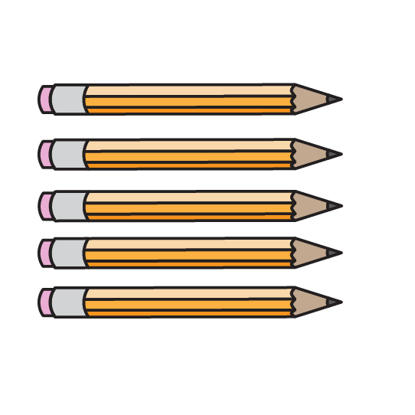Sandy has a bag of 100 pencils. The pencils are in groups of 10. How many groups of 10 make up the 100 total pencils in the bag?

1. 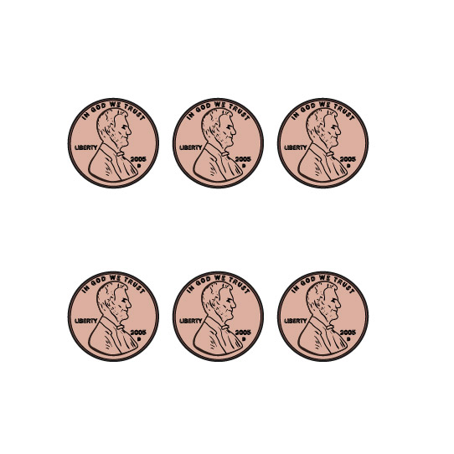Jerome has 700 pennies. How many hundreds are in the number 700?

1. Tanya models the number 238. She starts by showing the hundreds with base-ten models. Use words, numbers, or drawings to answer the following questions.
   1. How many hundreds should Tanya use?
   2. How much is left for Tanya to model with tens and ones?
2. 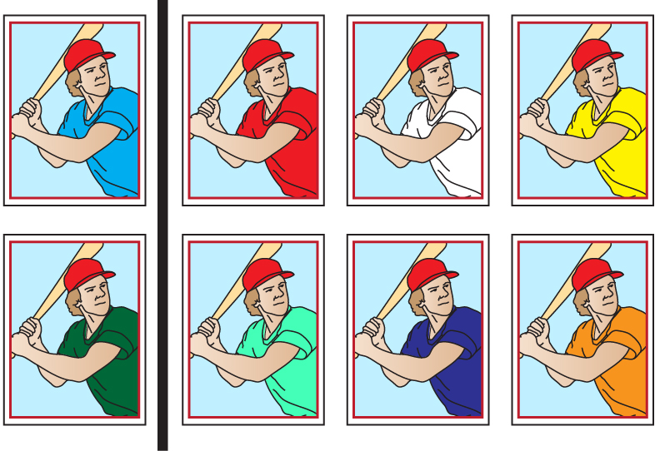Manuel has a lot of baseball cards. Manuel makes groups so he can count his baseball cards. Manuel has a group of five hundreds, one ten, and eight ones. How many baseball cards does Manuel have? Write the number in standard form.
3. Carson shows a number by drawing base-ten models.



Write the number in standard form.

1. Julia has 940 stickers. Write how many hundreds, tens, and ones make 940.

________ hundreds ________ tens ________ ones

1. 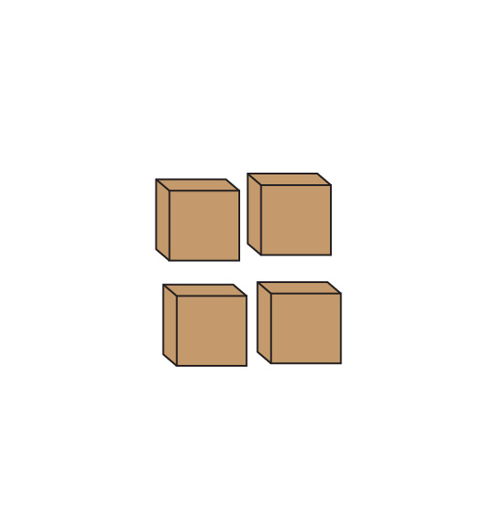Marco has 637 toy blocks.
   1. What is one way to show 637 by drawing base-ten models?
   2. What is a different way to show 637 by drawing base-ten models?
2. Ms. Kenney writes the number 893.
   1. What is the value of the 3?
   2. What is the value of the 8?
   3. What is the value of the 9?