Addition and Subtraction Within 100

Lesson 1

**Example: Addition**

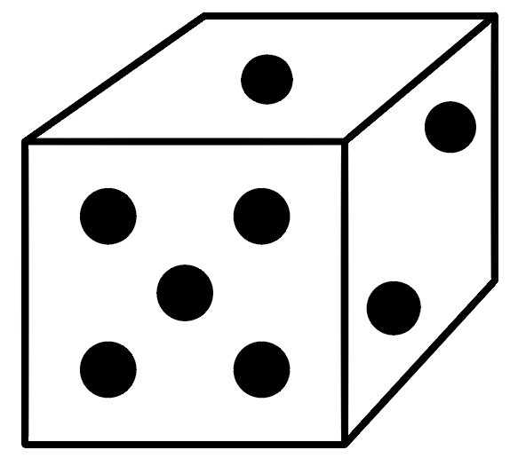Roll the number cube six times. Write each number in the Number Rolled column. Decide whether the number will represent tens or ones, and write the value in the Value Assigned column.

(For example, if you roll a 5 and decide it represents five tens, write “5” in Number Rolled and “50” in Value Assigned.)

Try to get the sum as close as possible to 100, without going over!

|  |  |
| --- | --- |
| **Number Rolled** | **Value Assigned** |
| 6 | 60 |
| 5 | 5 |
| 1 | 10 |
| 1 | 10 |
| 3 | 3 |
| 4 | 4 |
| **Sum** | 92 |

**Round 1: Addition**

Roll the number cube six times. Write each number in the Number Rolled column. Decide whether the number will represent tens or ones and write the value in the Value Assigned column.

Try to get the sum as close as possible to 100, without going over!

|  |  |
| --- | --- |
| **Number Rolled** | **Value Assigned** |
|  |  |
|  |  |
|  |  |
|  |  |
|  |  |
|  |  |
| **Sum** |  |

**Round 2: Addition**

Roll the number cube six times. Write each number in the Number Rolled column. Decide whether the number will represent tens or ones and write the value in the Value Assigned column.

Try to get the sum as close to 100 as possible!

|  |  |
| --- | --- |
| **Number Rolled** | **Value Assigned** |
|  |  |
|  |  |
|  |  |
|  |  |
|  |  |
|  |  |
| **Sum** |  |

**Round 3: Addition & Subtraction**

Roll the number cube six times. Write each number in the Number Rolled column. Decide whether the number will represent tens or ones and write the value in the Value Assigned column.

Try to get the result as close as possible to 100, without going over!

|  |  |
| --- | --- |
| **Number Rolled** | **Value Assigned** |
|  |  |
|  |  |
|  |  |
|  |  |
|  |  |
|  |  |
| **Result** |  |

**Round 4: Addition & Subtraction**

Roll the number cube six times. Write each number in the Number Rolled column. Decide whether the number will represent tens or ones and write the value in the Value Assigned column.

Try to get the result as close to 100 as possible!

|  |  |
| --- | --- |
| **Number Rolled** | **Value Assigned** |
|  |  |
|  |  |
|  |  |
|  |  |
|  |  |
|  |  |
| **Result** |  |

Addition and Subtraction Within 100

INSTRUCTIONAL ACTIVITY SUPPLEMENT

Lesson 1

|  |  |  |  |  |  |  |  |  |  |
| --- | --- | --- | --- | --- | --- | --- | --- | --- | --- |
|  |  |  |  |  |  |  |  |  |  |
|  |  |  |  |  |  |  |  |  |  |
|  |  |  |  |  |  |  |  |  |  |
|  |  |  |  |  |  |  |  |  |  |
|  |  |  |  |  |  |  |  |  |  |
|  |  |  |  |  |  |  |  |  |  |
|  |  |  |  |  |  |  |  |  |  |
|  |  |  |  |  |  |  |  |  |  |
|  |  |  |  |  |  |  |  |  |  |
|  |  |  |  |  |  |  |  |  |  |

Addition and Subtraction Within 100

Lesson 2

1. 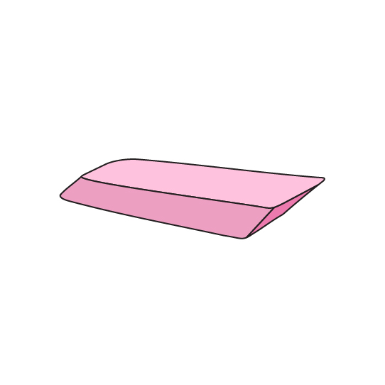Sam has 27 erasers. Jill gives Sam 35 erasers. How many erasers does Sam have now?
2. 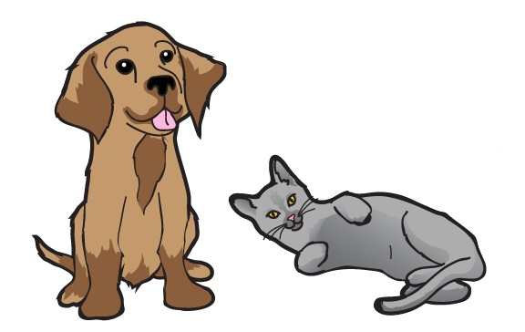There are 18 dogs and 33 cats at the vet’s office. How many more cats are at the vet’s office than dogs?
3. Jose had 72 pennies. Jose bought a piece of candy. Now he has 27 pennies. How many pennies did Jose spend on the piece of candy?
4. 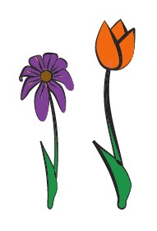Hazel has 64 purple and orange flowers. She has 17 orange flowers. How many purple flowers does Hazel have?

Addition and Subtraction Within 100

INSTRUCTIONAL ACTIVITY SUPPLEMENT

Lesson 2

|  |  |  |  |  |  |  |  |  |  |
| --- | --- | --- | --- | --- | --- | --- | --- | --- | --- |
|  |  |  |  |  |  |  |  |  |  |
|  |  |  |  |  |  |  |  |  |  |
|  |  |  |  |  |  |  |  |  |  |
|  |  |  |  |  |  |  |  |  |  |
|  |  |  |  |  |  |  |  |  |  |
|  |  |  |  |  |  |  |  |  |  |
|  |  |  |  |  |  |  |  |  |  |
|  |  |  |  |  |  |  |  |  |  |
|  |  |  |  |  |  |  |  |  |  |
|  |  |  |  |  |  |  |  |  |  |

­Addition and Subtraction Within 100

Lesson 3

1. 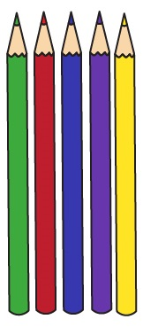Together, Shana and Kari have 88 colored pencils. How many colored pencils could Shana and Kari each have? Give more than one answer.
2. 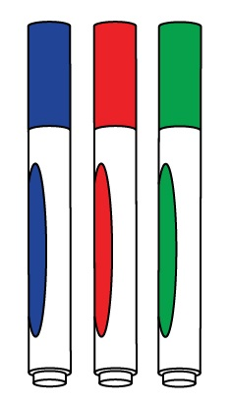Three friends—Hans, Isabella, and Cole—have a total of 79 markers. How many markers could each friend have? Give more than one answer.
3. 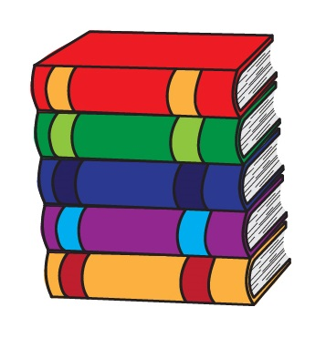Jerrod had a lot of books. He donated some of his books to the library. Now Jerrod has 36 books. How many books could Jerrod have started with, and how many books could Jerrod have donated to the library to end up with 36 books? Give more than one answer.

Addition and Subtraction Within 100

INSTRUCTIONAL ACTIVITY SUPPLEMENT

Lesson 3

|  |  |  |  |  |  |  |  |  |  |
| --- | --- | --- | --- | --- | --- | --- | --- | --- | --- |
|  |  |  |  |  |  |  |  |  |  |
|  |  |  |  |  |  |  |  |  |  |
|  |  |  |  |  |  |  |  |  |  |
|  |  |  |  |  |  |  |  |  |  |
|  |  |  |  |  |  |  |  |  |  |
|  |  |  |  |  |  |  |  |  |  |
|  |  |  |  |  |  |  |  |  |  |
|  |  |  |  |  |  |  |  |  |  |
|  |  |  |  |  |  |  |  |  |  |
|  |  |  |  |  |  |  |  |  |  |

Addition and Subtraction Within 100

Lessons 1 – 3

For each of the following questions, use words, pictures, and/or numbers to show your thinking.

1. 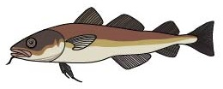A fish tank has 30 tiger barb fish and 20 cherry barb fish. How many fish are in the fish tank?

1. James has 46 high-bounce balls. Kyle has 30 high-bounce balls. How many more high-bounce balls does James have than Kyle?

1. 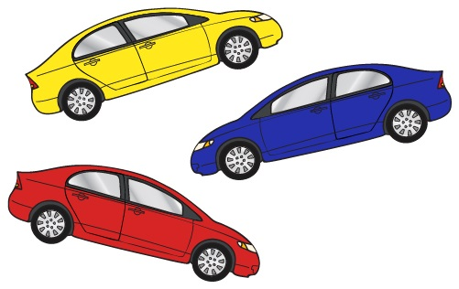Kate has toy cars. Her brother takes eight toy cars to play with. Kate counts 27 toy cars left. How many toy cars did Kate have to begin with?

1. 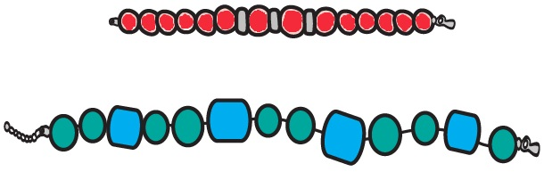A store sells red and blue bracelets. They have 61 bracelets total. How many red bracelets and how many blue bracelets could they have? Give three different answers.

1. Jackson, Emma, and Mia made a total of 72 paper airplanes. Jackson made 18 paper airplanes, and Emma made 37 paper airplanes. How many more paper airplanes did Emma make than Jackson?

1. Chloe is trying to add the following numbers.

_____ = 17 + 49 + 23

* 1. Write the two numbers you think Chloe should add first.
  2. Why did you choose those numbers?
  3. What is the answer to Chloe’s addition problem?