Using Repeated Addition to Solve Array Problems

Lesson 1

For each situation, draw an array, circle the rows, and write the corresponding addition equation.



A muffin tin contains 3 rows of 4 muffins.



An egg carton contains 3 rows of 6 eggs.

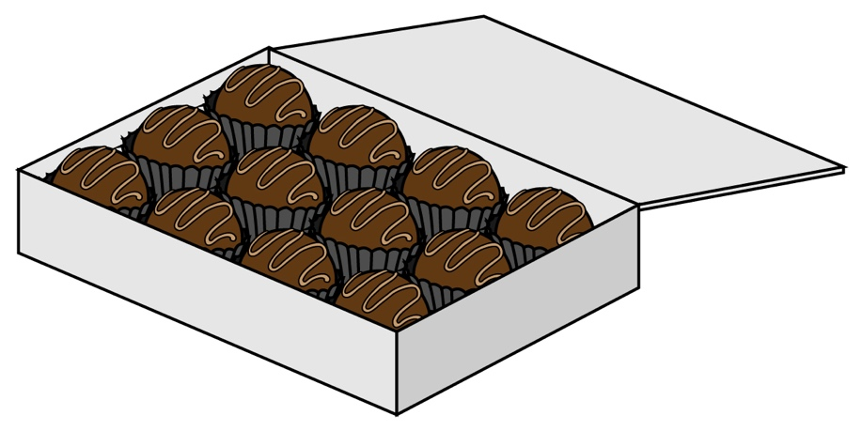A chocolate box contains four rows of three chocolates.



A pack of water bottles contains 5 rows of 3 water bottles.

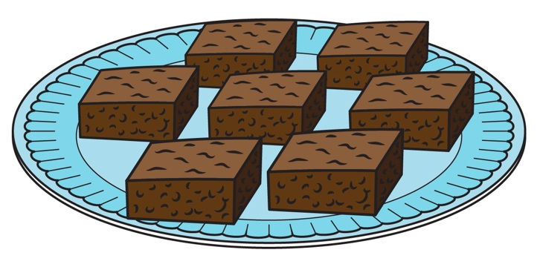A pan of brownies is cut into two rows of six brownies.

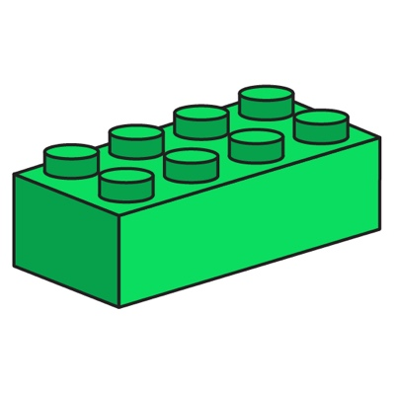A plastic building brick has 4 rows of 2 pegs.

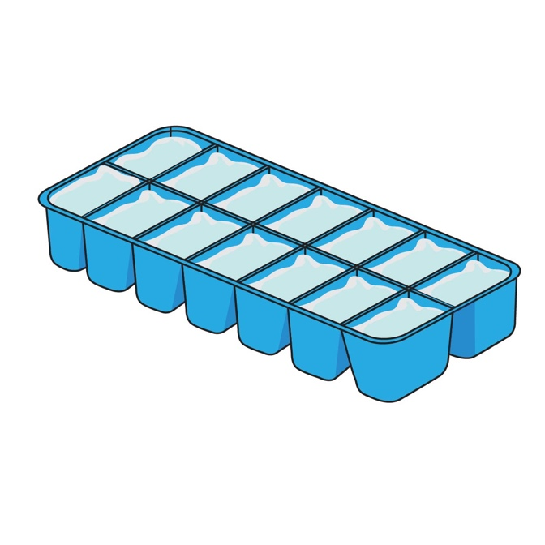

An ice tray has two rows of five ice cubes.

A window has 6 rows of 3 panes.

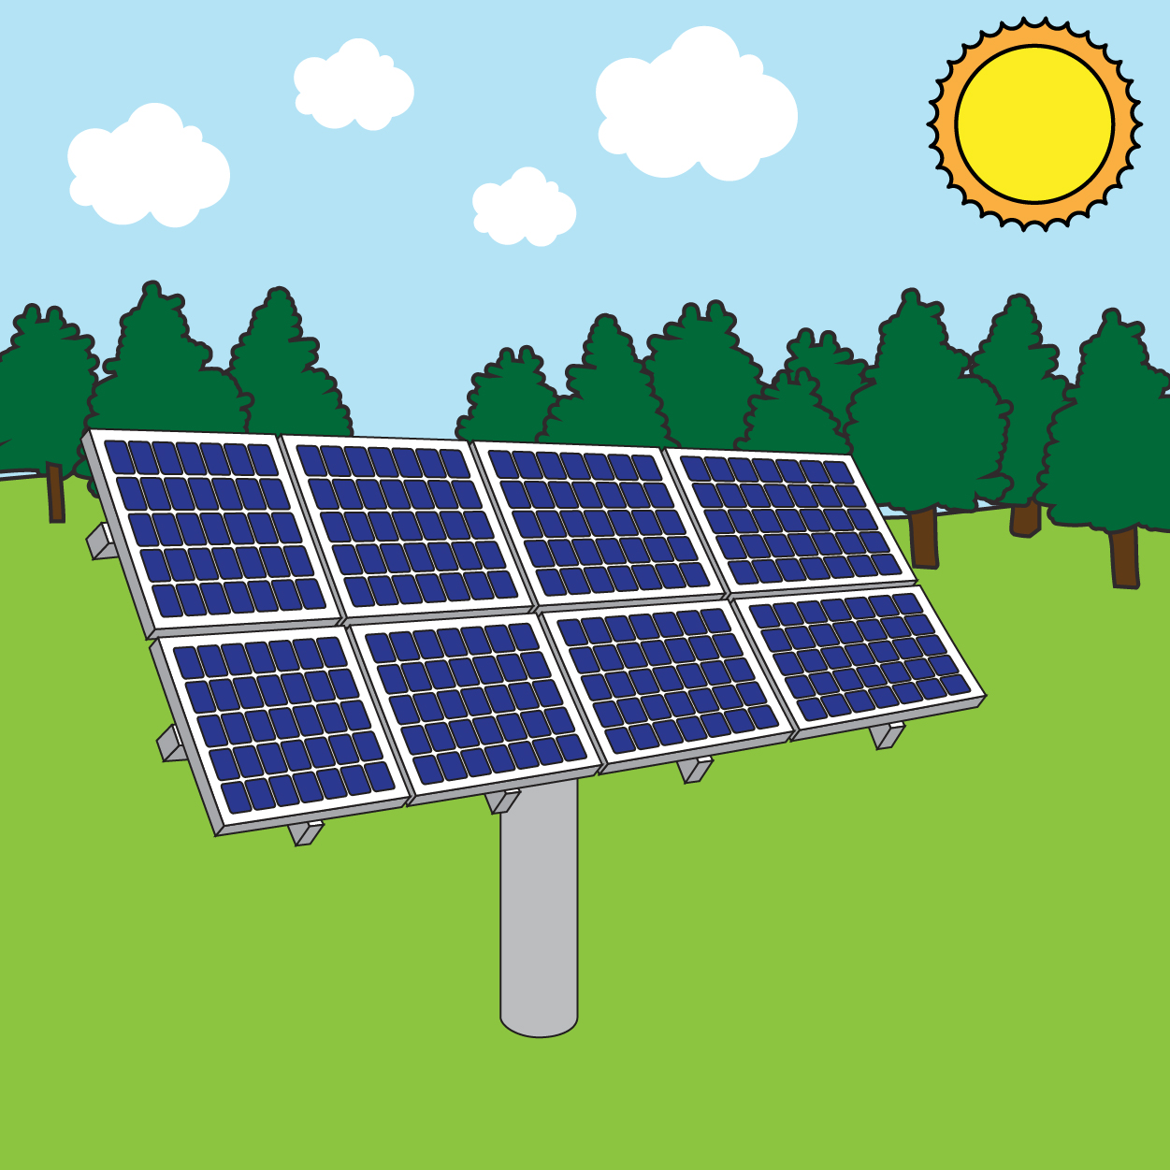A solar panel array has 3 rows of 5 panels.

Using Repeated Addition to Solve Array Problems

Lesson 2

Station 1

Array:  
  
  
  
  
  
  
  
  
  
Equation:

Station 2

Array:  
  
  
  
  
  
  
  
  
  
Equation: 4 + + =

Station 3

Array:  
  
  
  
  
  
  
  
  
  
Equation:

Station 4

Array:  
  
  
  
  
  
  
  
  
  
Equation:

Station 5

Array:  
  
  
  
  
  
  
  
  
  
Equation:

Station 6

Array:  
  
  
  
  
  
  
  
  
  
Equation:

Station 7

Array:

Station 8

Array:  
  
  
  
  
  
  
  
  
  
Equation:

Using Repeated Addition to Solve Array Problems

INSTRUCTIONAL ACTIVITY SUPPLEMENT

Lesson 2

*The following pages should be printed out for each station.*

Station 1

A marching band has three rows. Five people are in each row. Draw an array, and write an equation representing this situation.

Station 2

A muffin tin has three rows of four muffins. Draw an array, and write an equation representing this situation.

Station 3

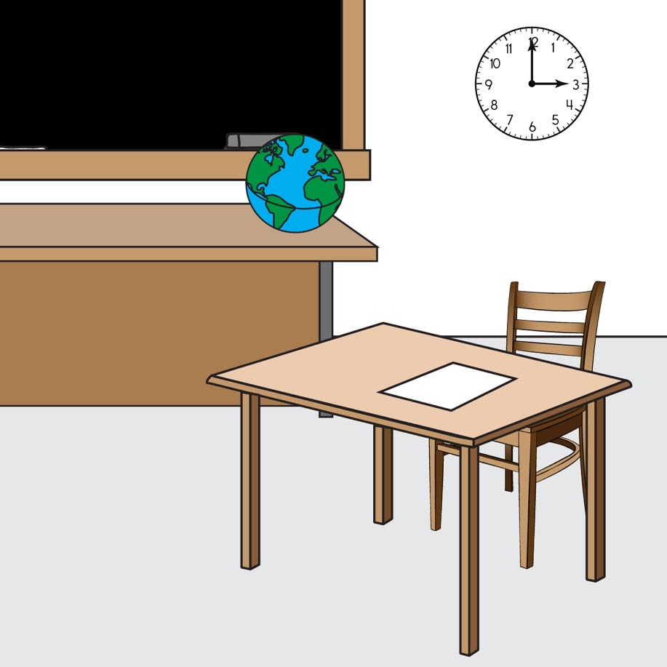A classroom has five rows of five desks. Draw an array, and write an equation representing this situation.

Station 4

An egg carton has two rows of six eggs. Draw an array, and write an equation representing this situation.

Station 5

A basketball team is running drills. The players are in 3 lines, and there are 3 players in each line. Draw an array, and write an equation representing this situation.

Station 6

A bookshelf has four shelves, each containing five books. Draw an array, and write an equation representing this situation.

Station 7

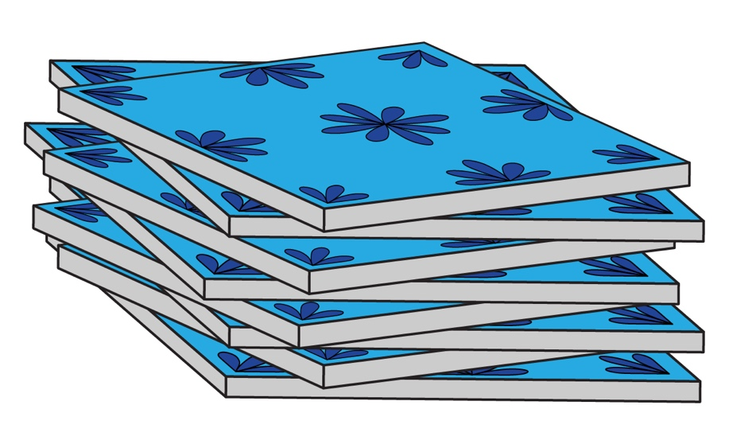A tile installer finds the total number of tiles he laid using the equation 3 + 3 + 3 + 3 + 3 = 15. Draw an array representing this situation.

Station 8

A baker just finished baking a pan of brownies and needs to cut it into twelve equally sized brownies. Show how to cut the brownies by drawing an array, and represent the situation with an equation.

Using Repeated Addition to Solve Array Problems

Lesson 1 – 2

1. Write a repeated-addition equation for each array.
2. Write a repeated-addition equation for each problem.
   1. Five students each make a stack of three pennies.
   2. 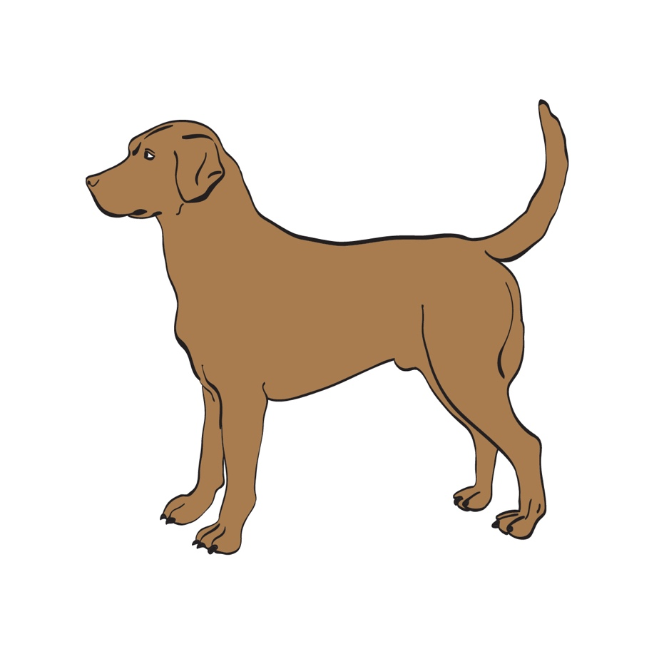Evan, Ryan, and Lily each have two dogs.
3. Mr. Hill put his students’ desks into three rows with four desks in each row.
   1. Draw an array to model this problem.
   2. Circle each **row** in the array, then write the number of desks next to each row to tell how many desks are circled.
   3. Write the repeated-addition equation for this problem.
4. 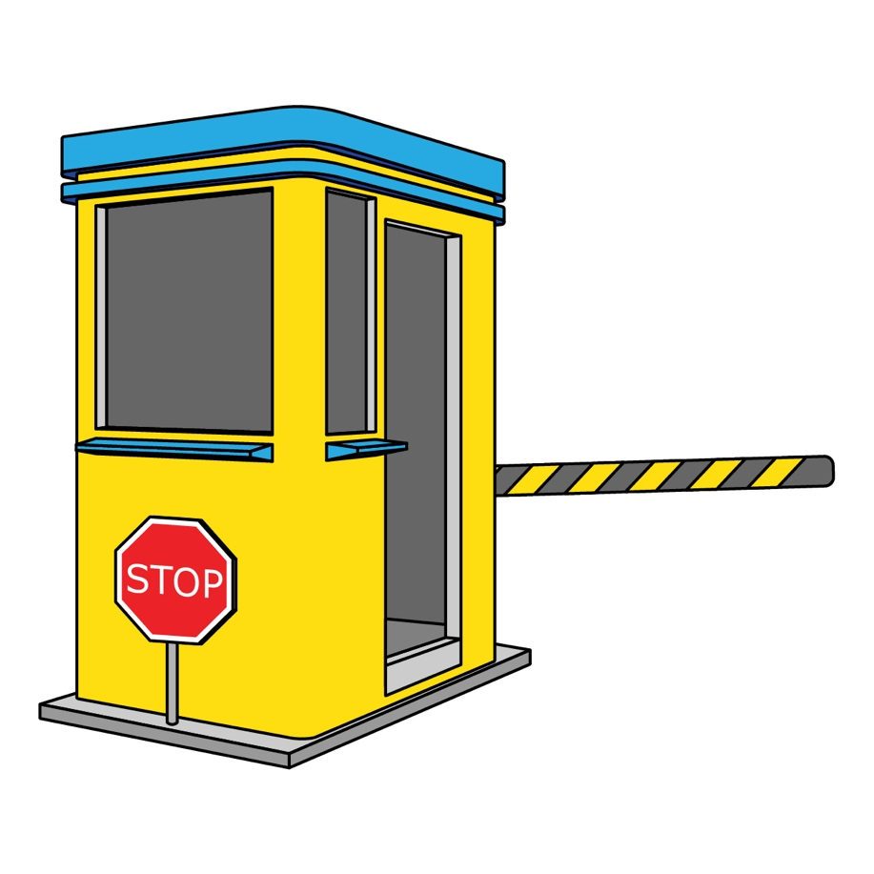Four highway tollbooths have two cars in each line.
   1. Draw an array to model this problem.

* 1. Write the repeated-addition equation for this problem.

1. You have 14 business cards and set them out into rows, as shown below. Does this make an array? Explain why or why not.
2. The first row of an array is given.
   1. Complete the array by drawing the next two rows.
   2. Fill in the blanks.  
        
      3 rows of ______ = 5 rows of ______

______ + ______ + ______ = ______  
  
______ + ______ + ______ + ______ + ______ = ______

* 1. How do you know that the equations in 6.b. show repeated addition?

1. Use the picture to answer the questions.  
     
     
     
     
     
   1. Draw circles around groups of three.
   2. Draw the objects in an array with equal **rows** of three.

* 1. Write a repeated-addition equation to match the array.

1. Use the following expression to answer the questions.

3 + 3 + 3 + 3

* 1. How many addends are there?
  2. What is the value of each addend?
  3. Draw an array for this expression.

* 1. Find the sum. Show your work.

3 + 3 + 3 + 3 =