Analyzing Scaled Graphs

INSTRUCTIONAL ACTIVITY SUPPLEMENT

Lesson 1

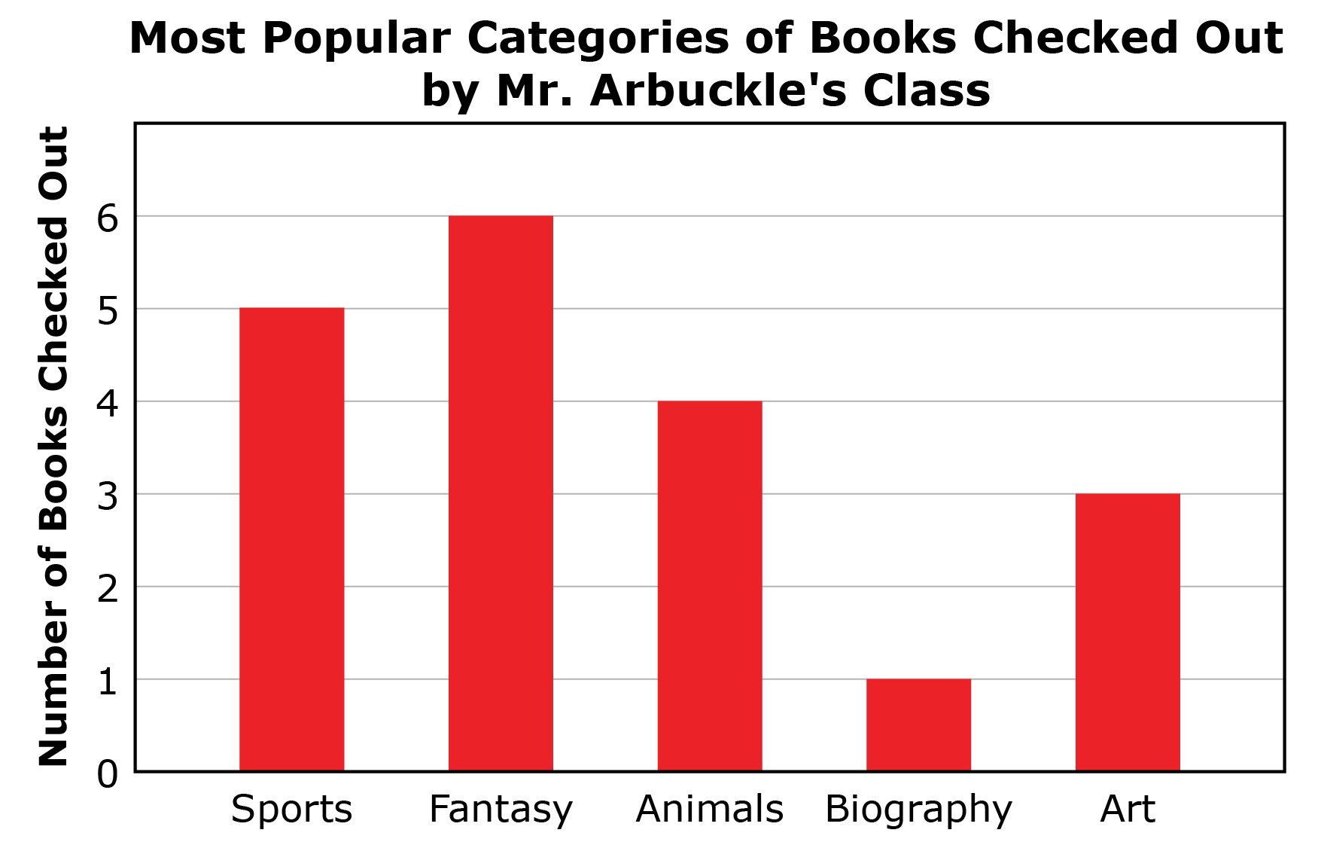

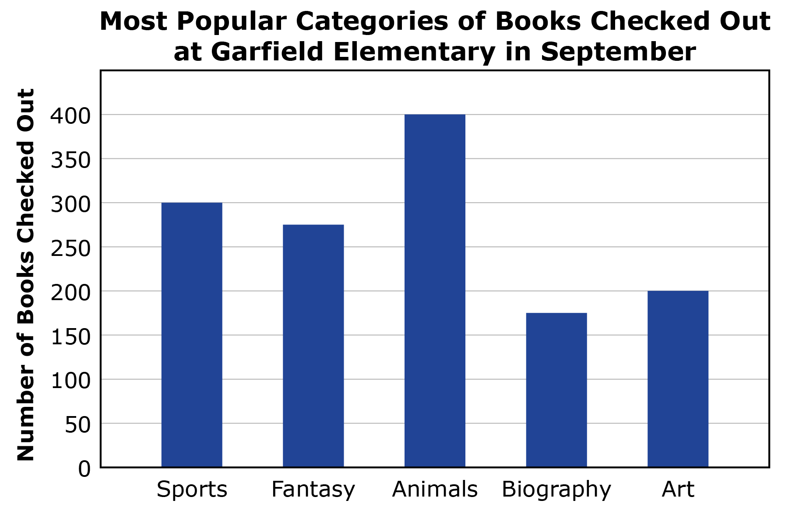

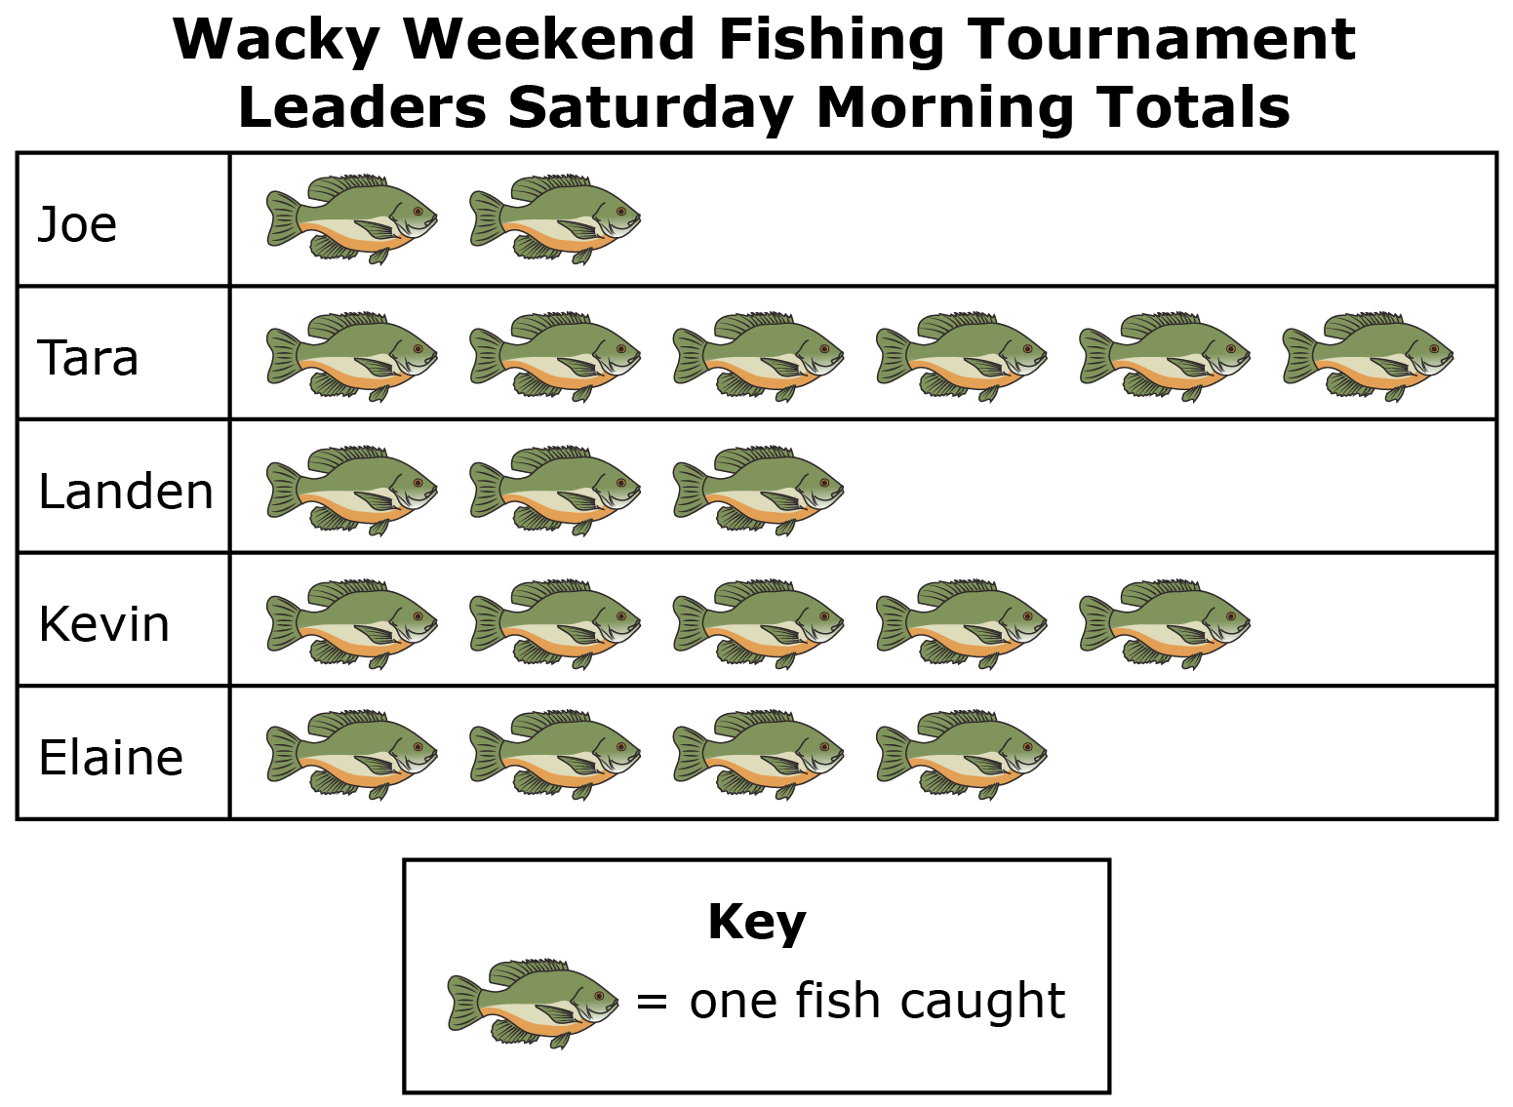

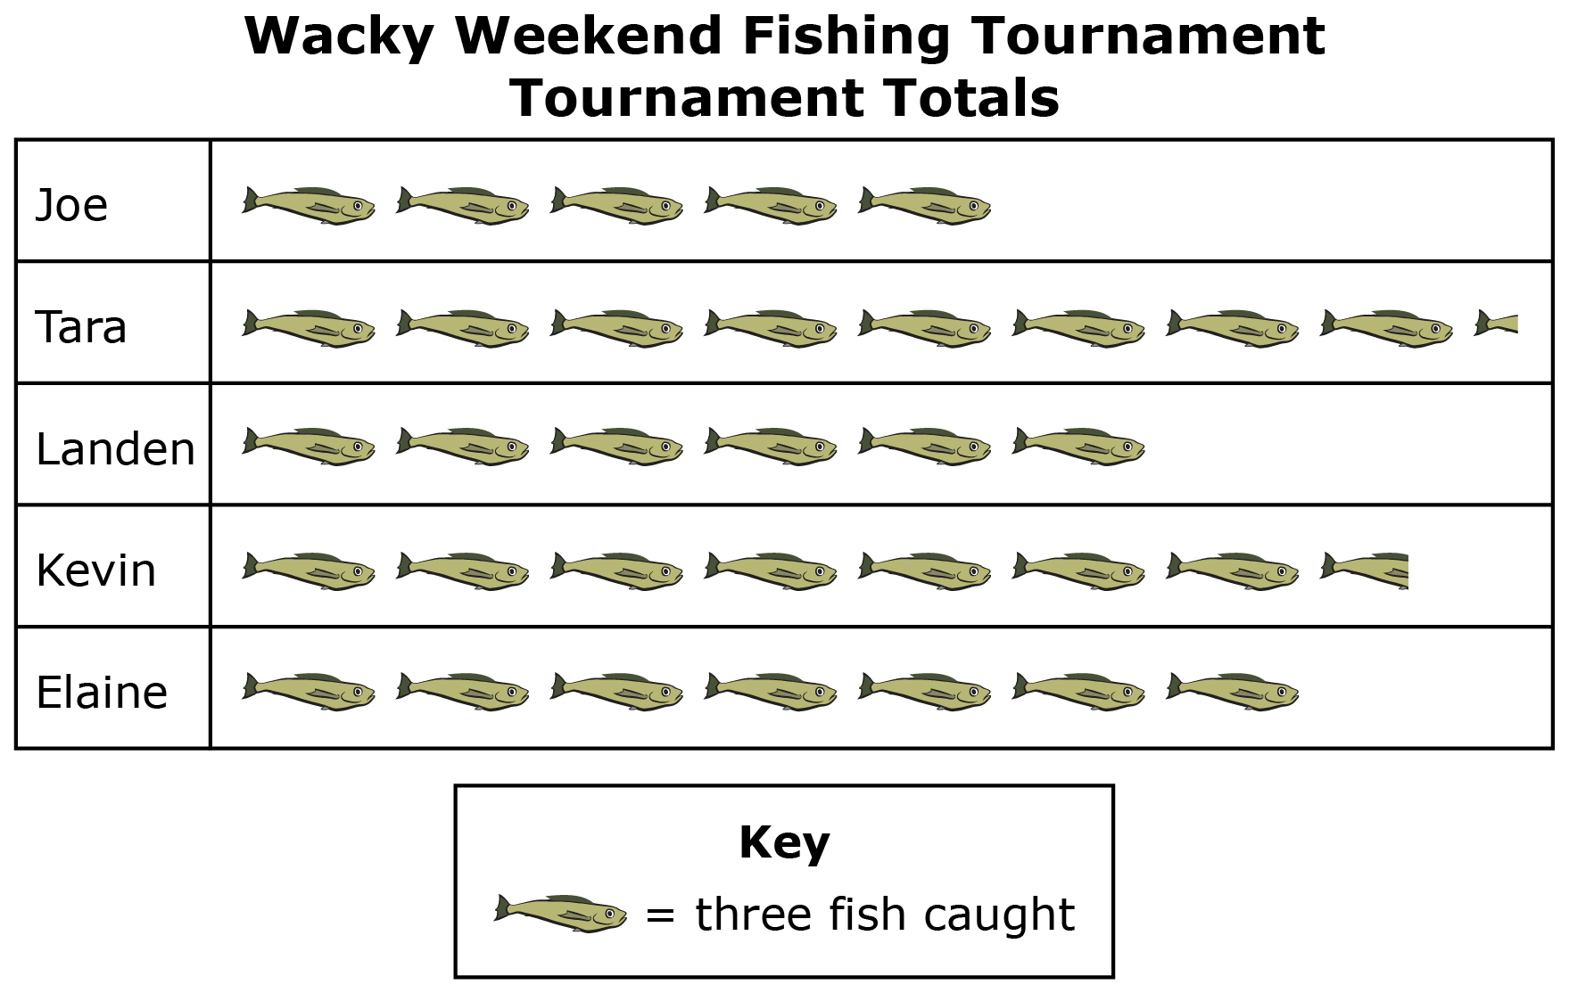

Analyzing Scaled Graphs

Lesson 2

|  |  |
| --- | --- |
| **Dog** | **Number of Treats** |
| Bucky |  |
| Prince |  |
| Gloria |  |
| Steve |  |
| Duchess |  |
| Leo |  |

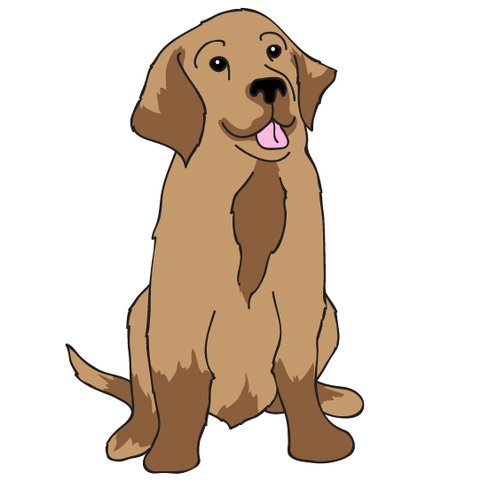**Data Set 1:** The Humane Society tracked the number of dog biscuits given to six of its dogs over a two-week period.

**Data Set 2:** Shaved ice was a popular treat at the school carnival. The data table below shows the six types and numbers of shaved ice served.

|  |  |
| --- | --- |
| **Flavor** | **Number Served** |
| Cherry | 72 |
| Blue Raspberry | 80 |
| Grape | 60 |
| Lime | 70 |
| Tropical Punch | 95 |
| Coconut | 50 |

**Scaled Bar Graph:** I chose data set ____ because

|  |  |  |  |  |  |
| --- | --- | --- | --- | --- | --- |
|  |  |  |  |  |  |
|  |  |  |  |  |  |
|  |  |  |  |  |  |
|  |  |  |  |  |  |
|  |  |  |  |  |  |
|  |  |  |  |  |  |
|  |  |  |  |  |  |

**Scaled Pictograph:** I chose data set ____ because

|  |  |
| --- | --- |
|  | |
|  |  |
|  |  |
|  |  |
|  |  |
|  |  |
|  |  |
|  | |

Analyzing Scaled Graphs

Lessons 1 – 3

1. Pete’s soccer camp is trying to decide on a camp mascot. The results of a camper survey are shown in the pictograph.

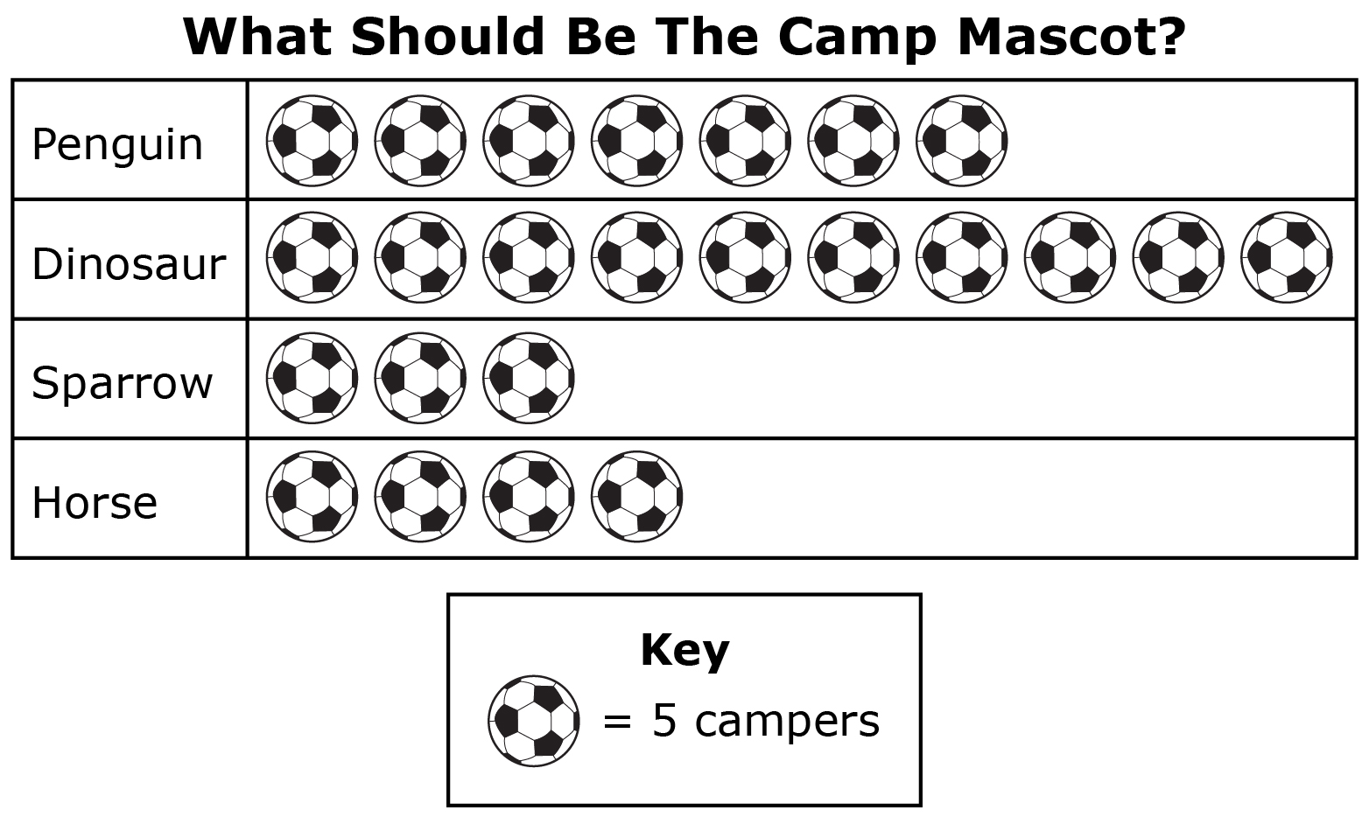

* 1. How many campers answered the survey?
  2. Which mascot choice is the most popular? Explain your answer.
  3. How many more votes did the most popular choice receive than the least popular choice?

* 1. Did the two least popular choices receive more votes together than the most popular choice? Explain your answer.

1. The students at Southern Elementary School earned a reward day. They voted on how to celebrate their day. The results are shown in the following bar graph.

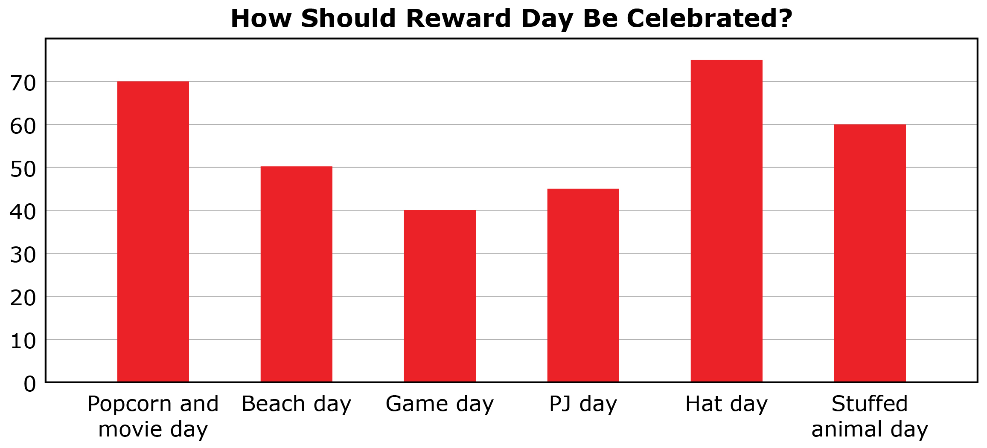

* 1. How many students voted?

* 1. Rank the Reward Day options in order from most popular to least popular.

* 1. How many more students voted for Hat Day than PJ Day?
  2. How many more students voted for the top 3 choices than the bottom 3 choices?

1. Treya bought 2 party packs for her birthday party. Each pack includes 8 party horns, 16 napkins, 10 plates, and 5 balloons.
   1. Create a bar graph to show how many of each party item Treya has.

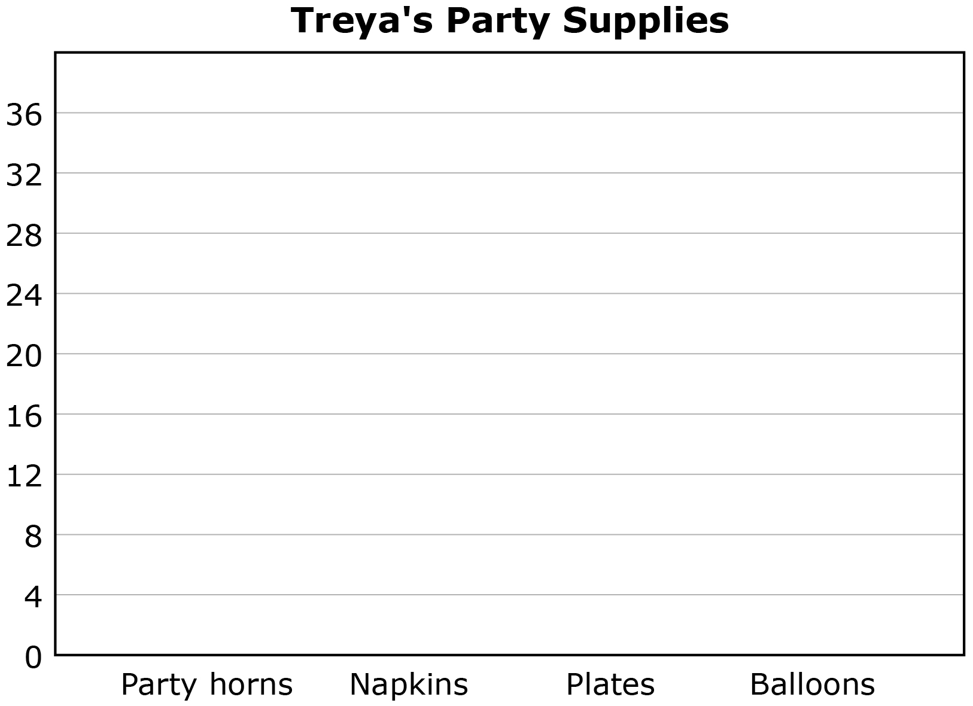

* 1. How many party supplies does Treya have in total?
  2. Which party item does Treya have the most of?
  3. Which party item does Treya have the fewest of?
  4. How many more of the most numerous item does Treya have compared to the least numerous item?
  5. Treya invited 20 people. Does she have enough party horns for everyone? If not, how many more does Treya need?

1. The students in Miss King’s class voted on their favorite superhero. Their vote results are shown in the following table.

|  |  |  |  |  |
| --- | --- | --- | --- | --- |
| **Superhero** | Batman | Superman | Wonder Woman | Spider-Man |
| **Number of Votes** | 18 | 16 | 14 | 15 |

* 1. Create a pictograph for the vote results.

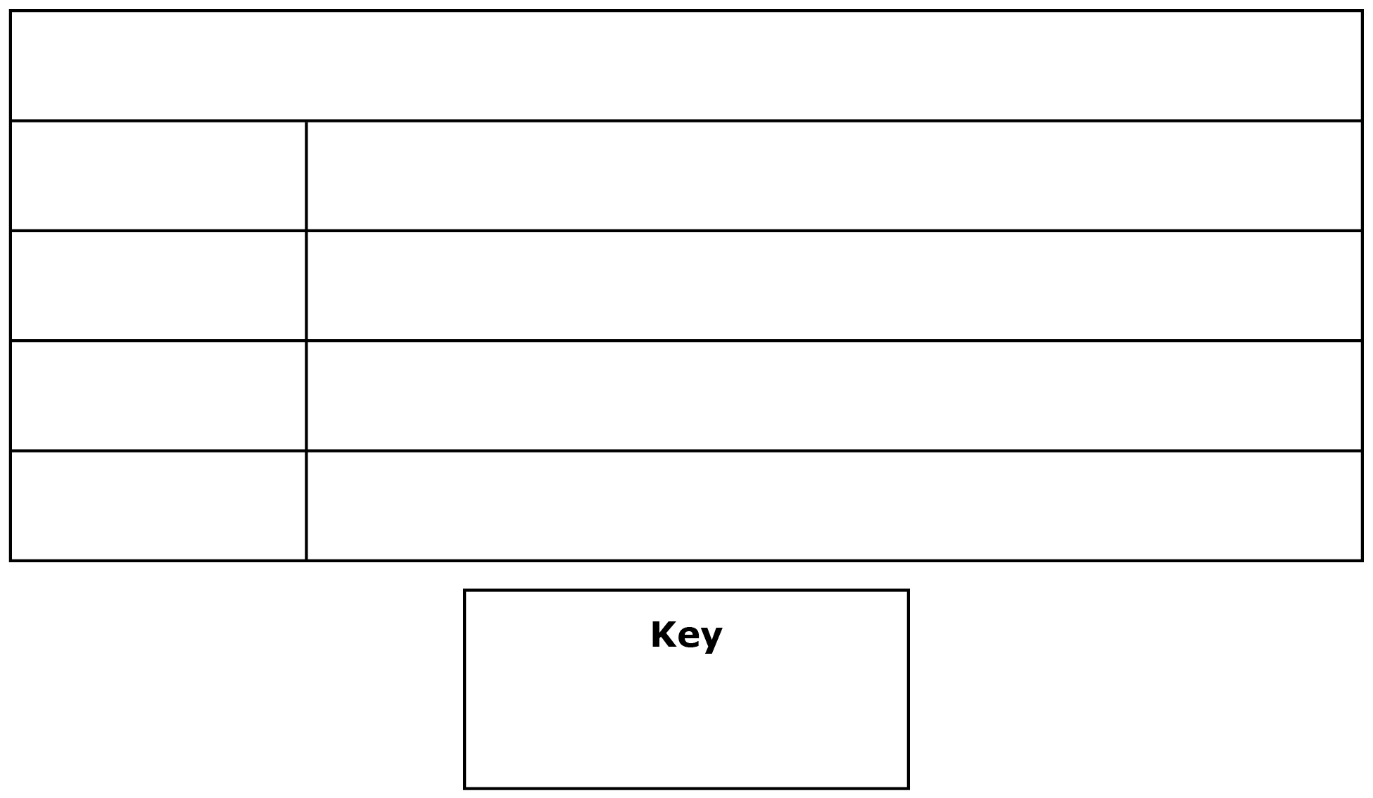

* 1. How many students voted?
  2. Which two superheroes were the most popular?
  3. Some students wanted to vote for the Joker, but the class decided that he was not a superhero. 12 students fewer than the combined total for Batman and Superman would have voted for the Joker. How many students wanted to vote for the Joker?
  4. Some of the students were disappointed that Wonder Woman was not the most popular superhero. How many more votes did Wonder Woman need to become the most popular superhero choice?

1. Which of the following bar graphs correctly displays the data in the table? Explain your choice.

|  |  |  |  |  |
| --- | --- | --- | --- | --- |
| **Name of Student** | Chrisi | Jeff | Nick | Tammy |
| **Number of Cousins** | 6 | 10 | 15 | 3 |

A)

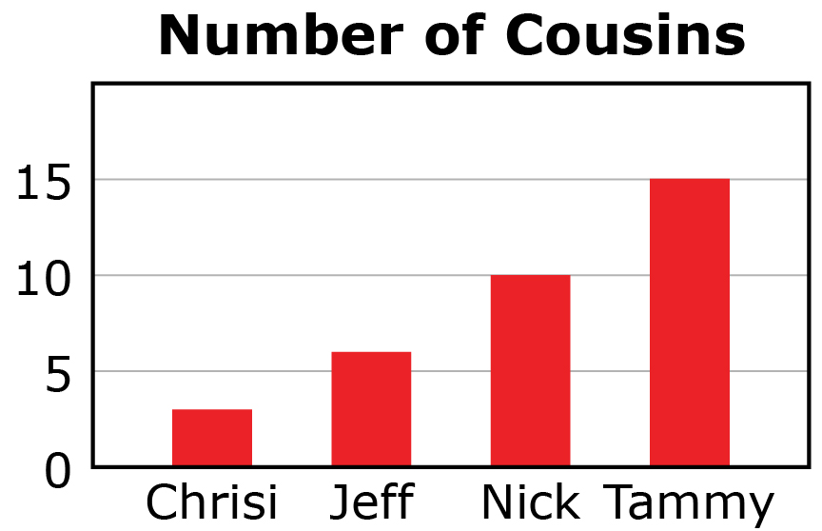

B)

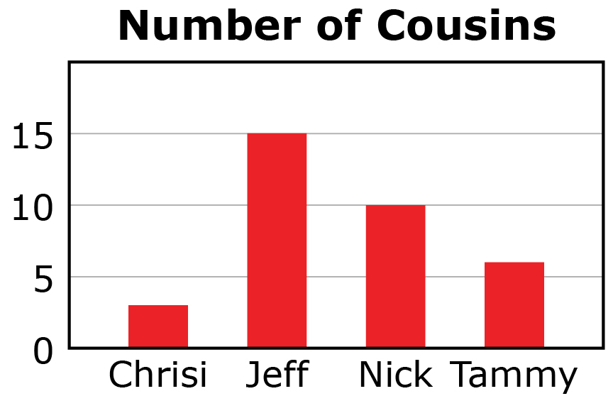

C)

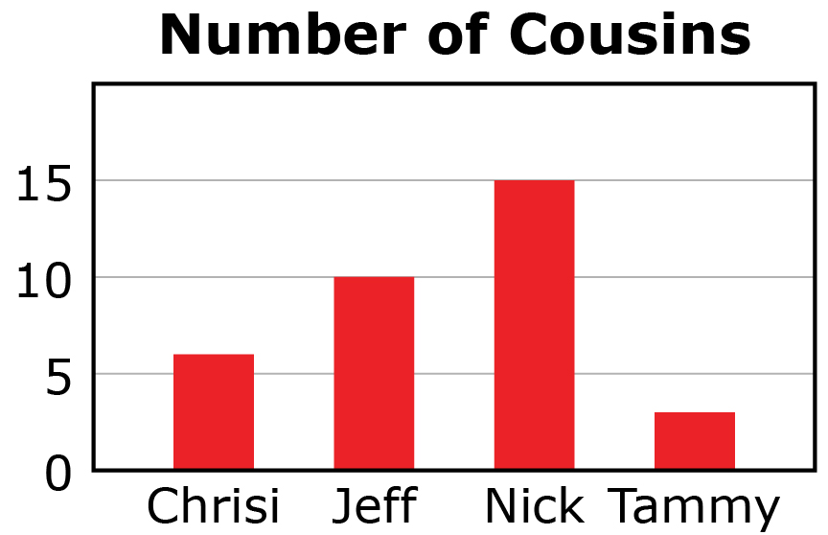

1. Drew has 8 video games, Justin has 6 video games, Tori has 4 video games, and Kelsi has 10 video games. Which pictograph correctly shows the data about video games? Explain your choice.

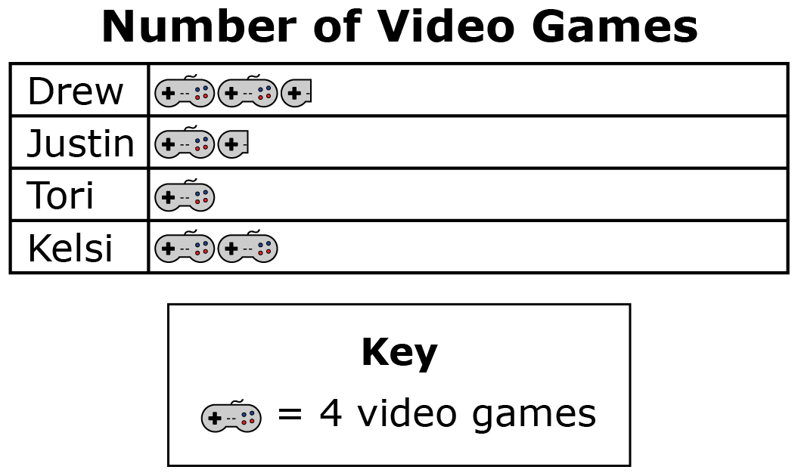

A)

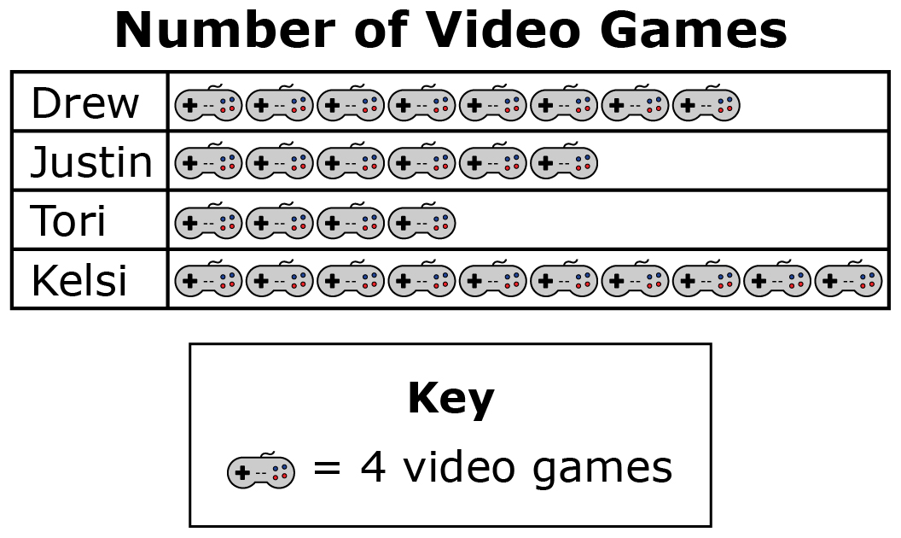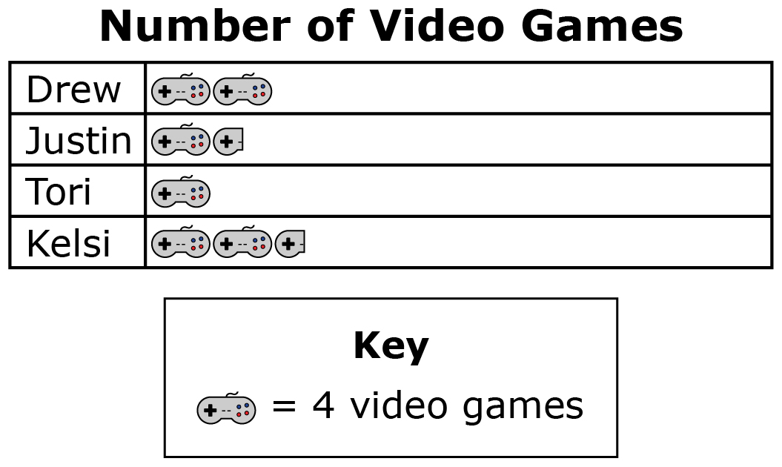

B)

C)