Module-2: EC2 and EFS Assignment – 3

The Assignment
Create an EFS and connect it to 3 different EC2 instances. Make sure that all instances have different Operating System. For instance, Ubuntu, Red Hat Linus and Amazon Linux 2.

Submission
Proof of EFS attached to Amazon Linux instance.
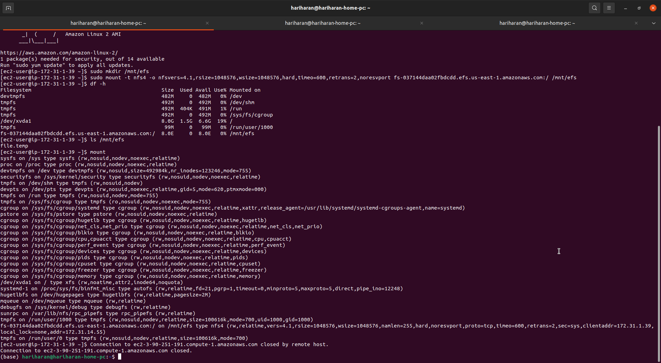

Proof of EFS attached to RHEL instance.
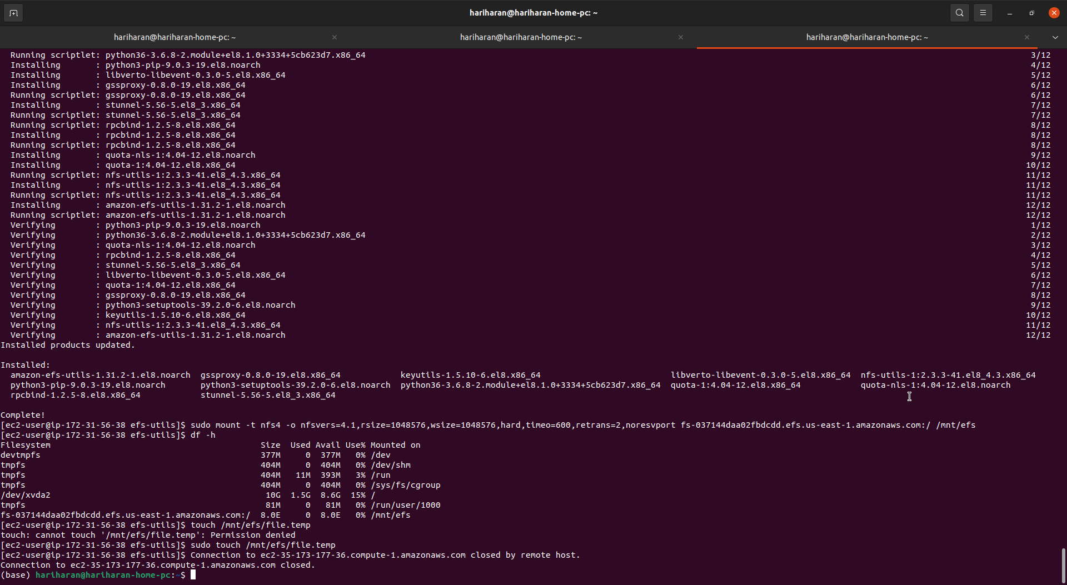

Proof of EFS attached to Ubuntu instance.
