AWS Solutions Architect Training

Assignment 2: EC2 and EBS Assignment

Instructions
- Launch a Linux EC2 instance
- Create an EBS volume with 20gb of storage and attach it to the created EC2 instance.
- Resize the attached volume and make sure it reflects in the connected instance.

Implementation
- Lauching an EC2 instance
An Ubuntu VM was already created as a new EC2 instance as part of Assignment-1. I resued the same instance for this assignment.
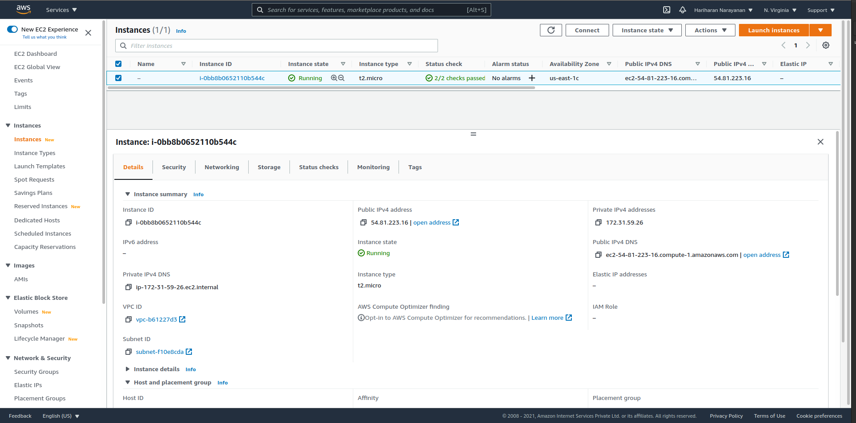

- Creating an EBS volume of size 20gb
  - Open Volumes Window in AWS console. Verify that default volume is present.
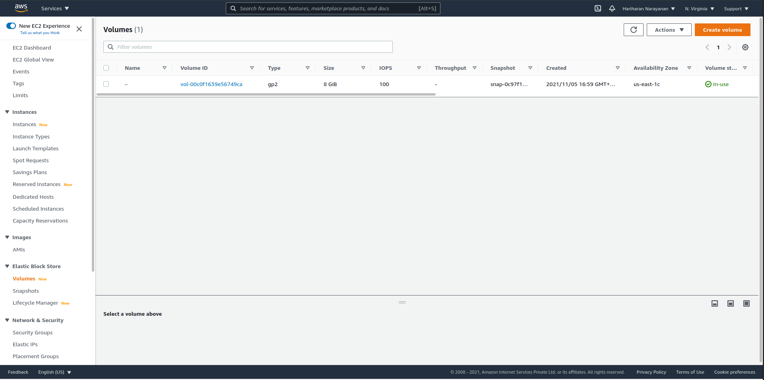

  - Create new volume by clicking on “Create Volume” button in above image.
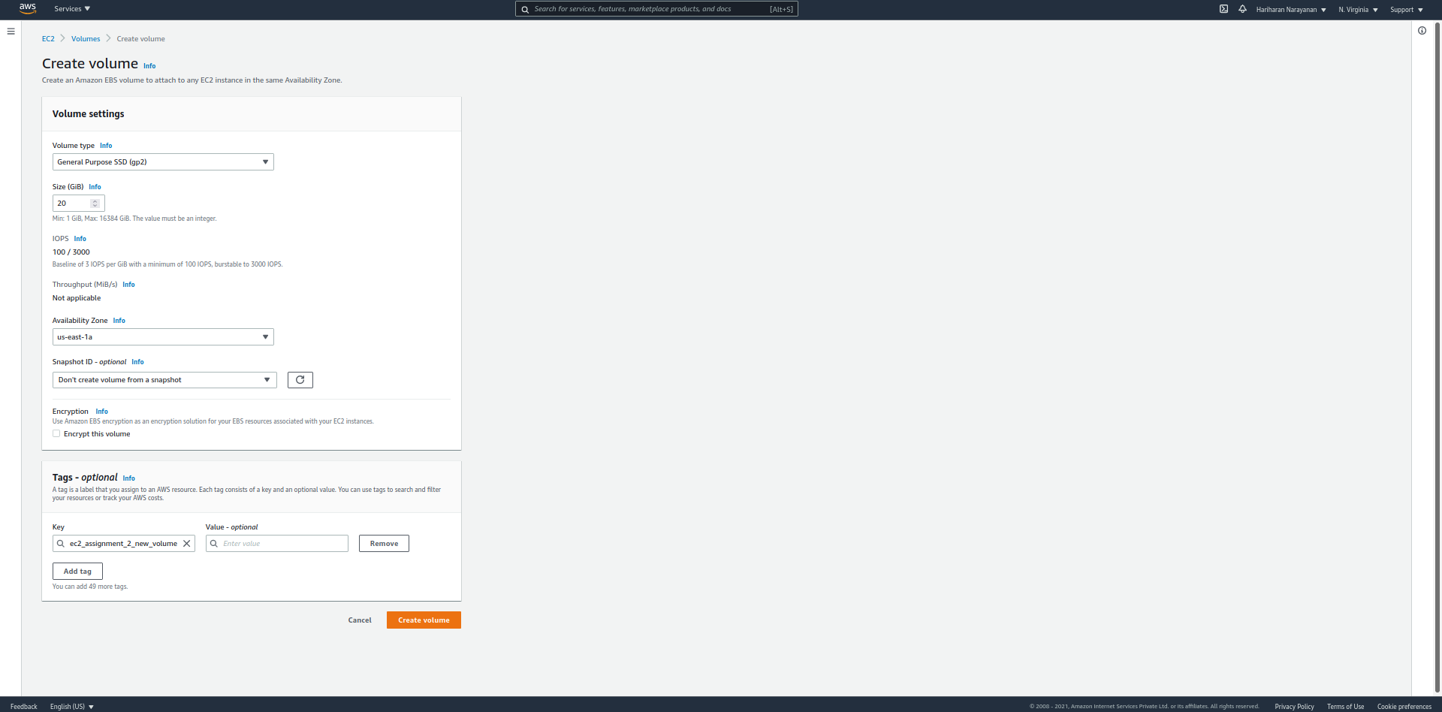
  - Verify in Volumes window that new volume is created. Wait until it’s Volume Status value changes to Available.
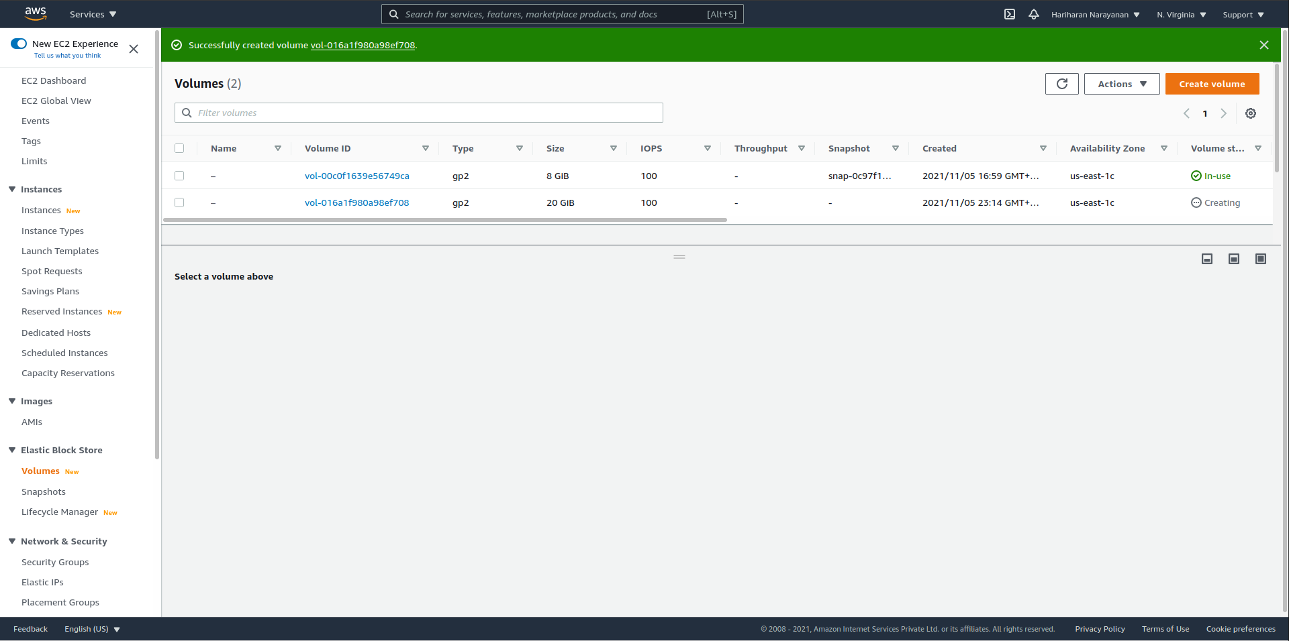
- Attaching the EBS volume to the EC2 instance created in (1)
  - Right-click on the 20gb volume in Volumes window. Select Attach Volume.

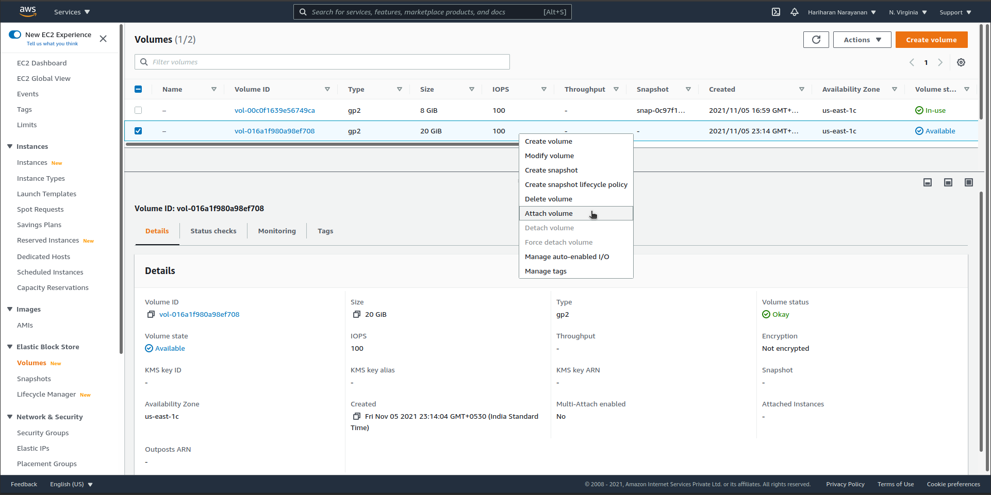

  - Select the instance-id of the EC2 instance from the drop-down list created in (1). Leave the device name to the default value of /dev/sdf. Select Attach Volume.

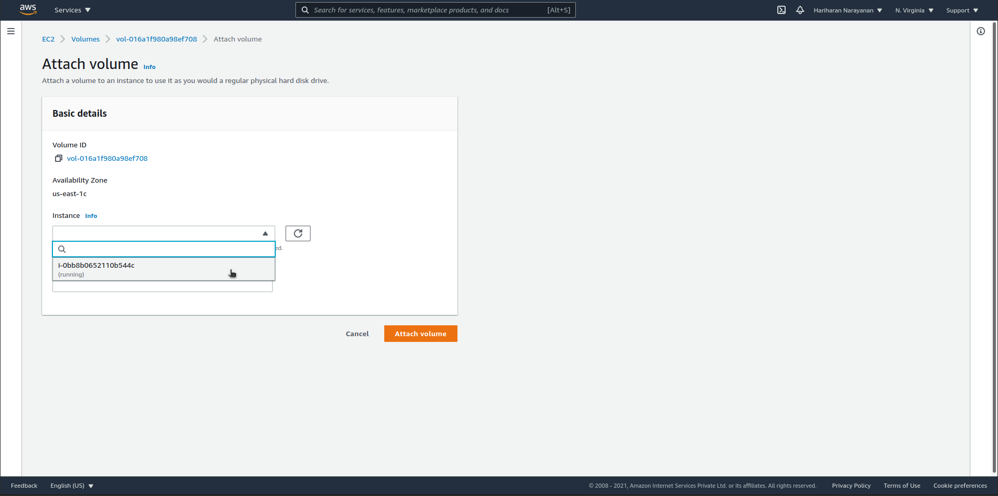

  - Go back to Volumes window and validate that new 20gb volume is attached to the same insatnce (refer column Attached Instances) as selected.

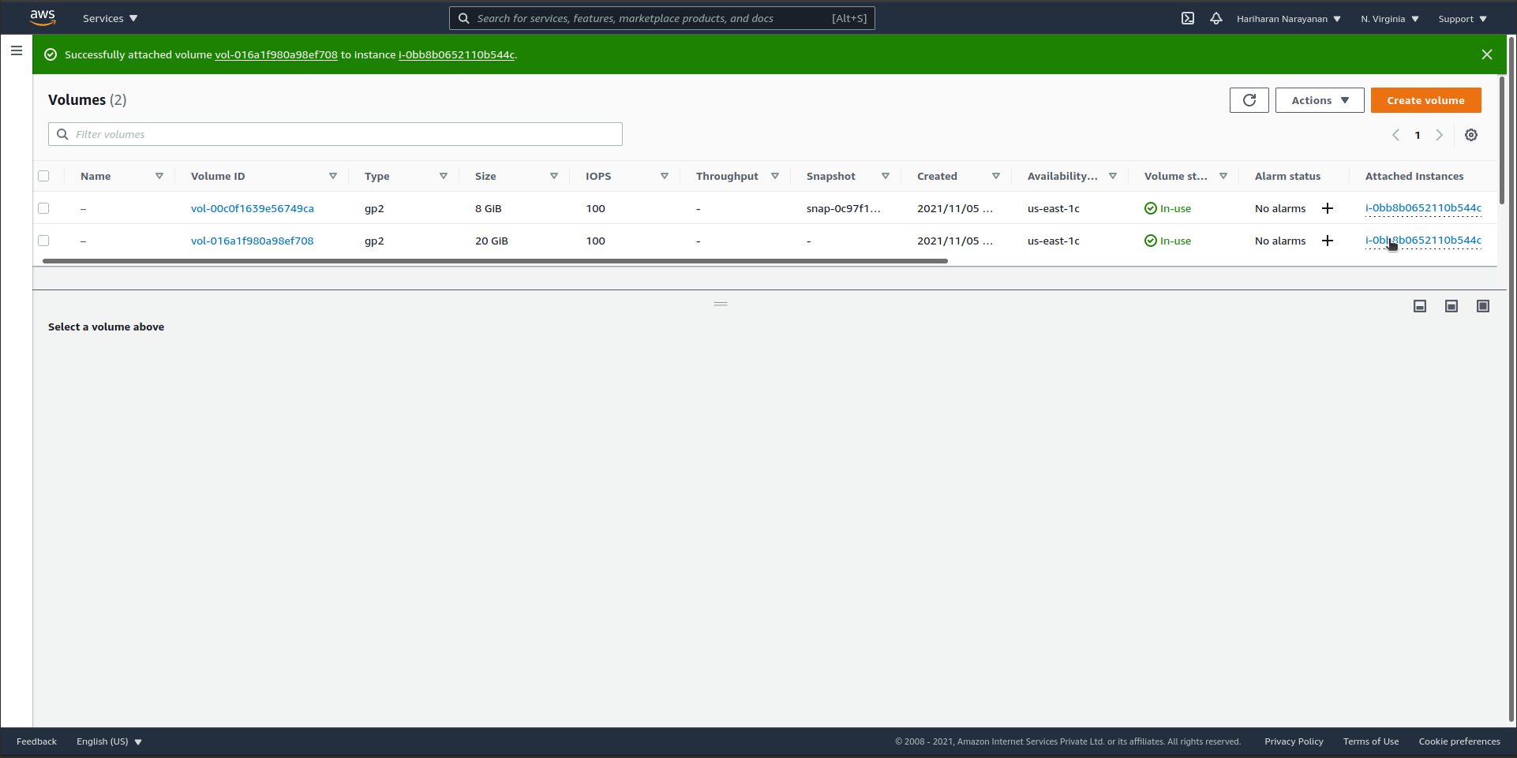
- Resizing the volume
  - Select the new 20gb volume created in (3) and select Actions > Modify Volume.
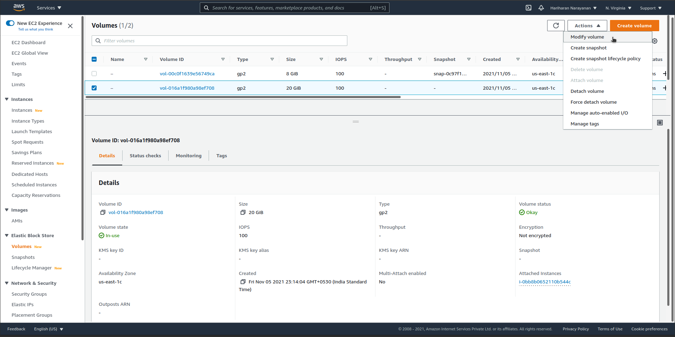
  - In the Modify Volume window, change size to 25gb and select Modify.

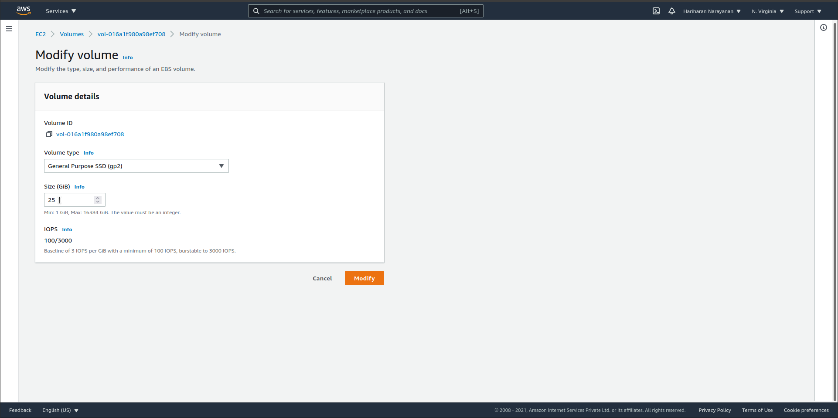

  - Click Modify in the new pop-up window.
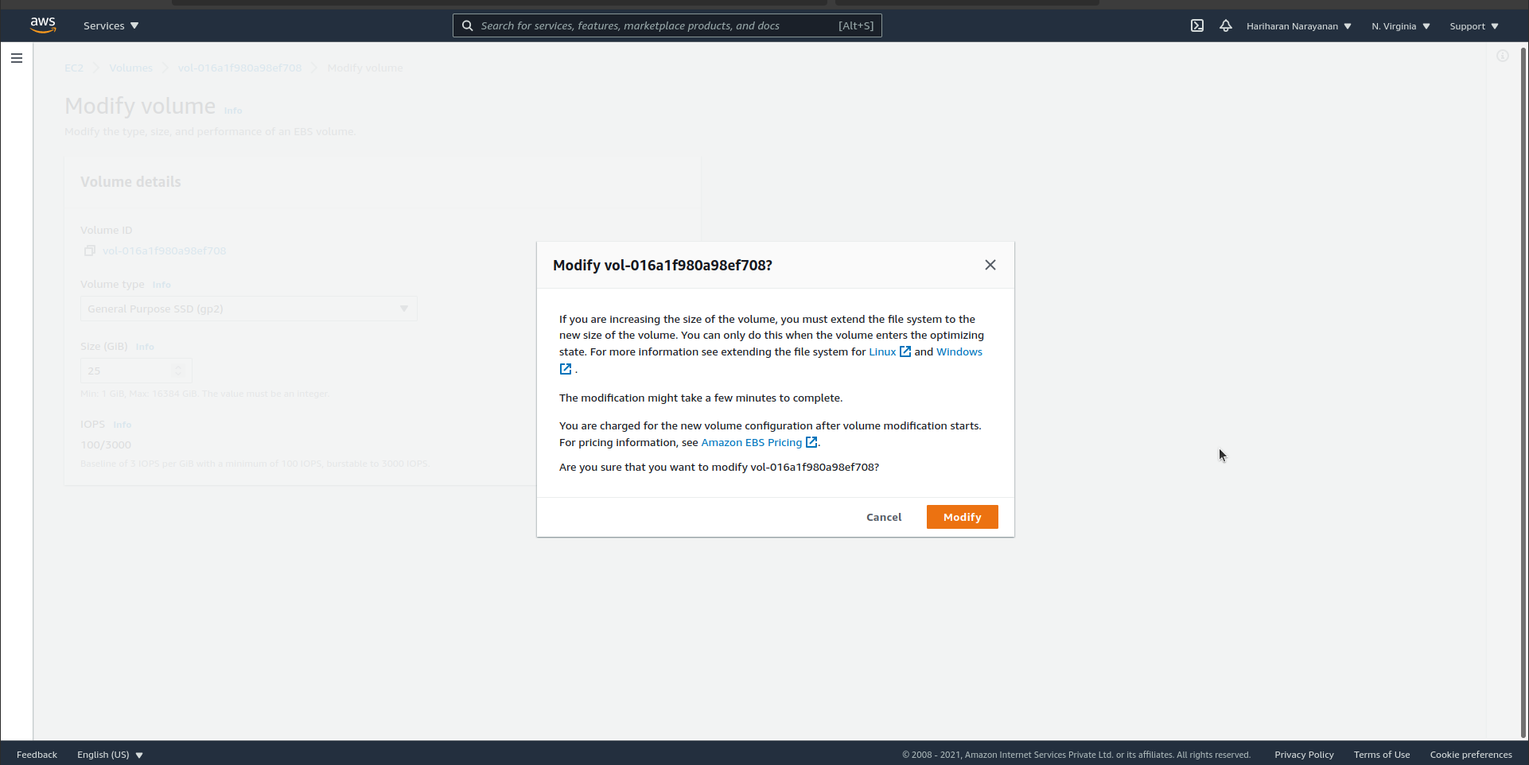
- Validating that the new size reflects in the connected instance
  - Open Volumes window and verify that the new size (25gb) is reflecting correctly.
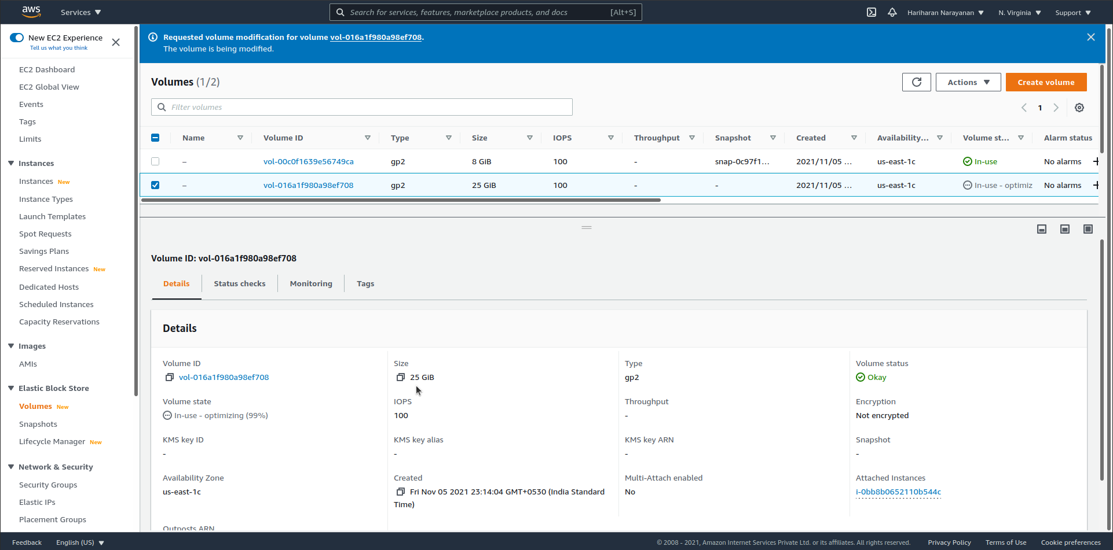
This is the end of the assignment.

