# EDS

## IDE: type eclipse & in the console for GUI

* Import existing example project

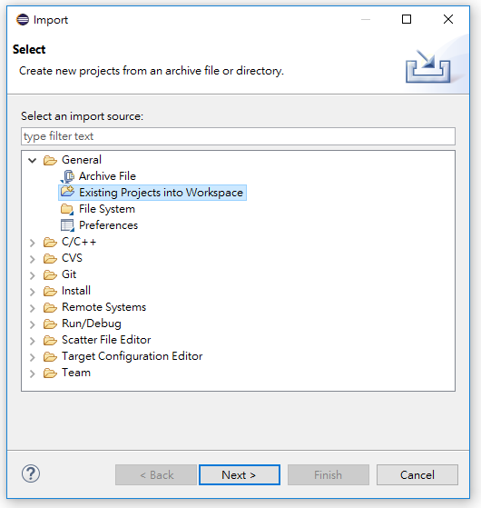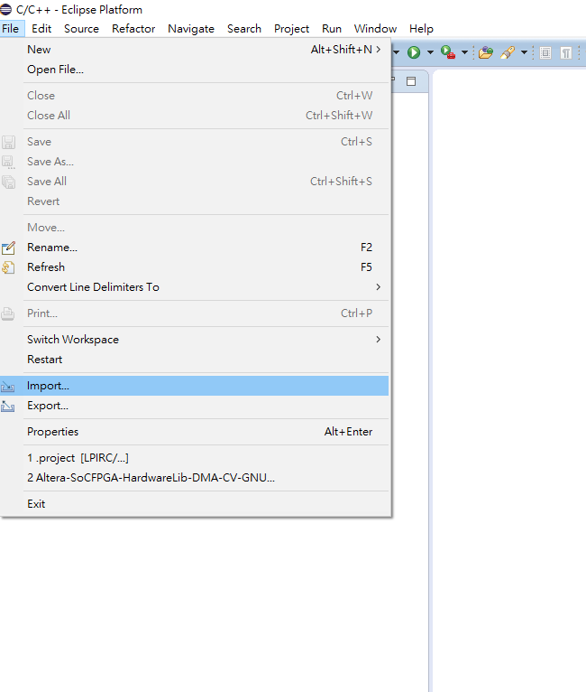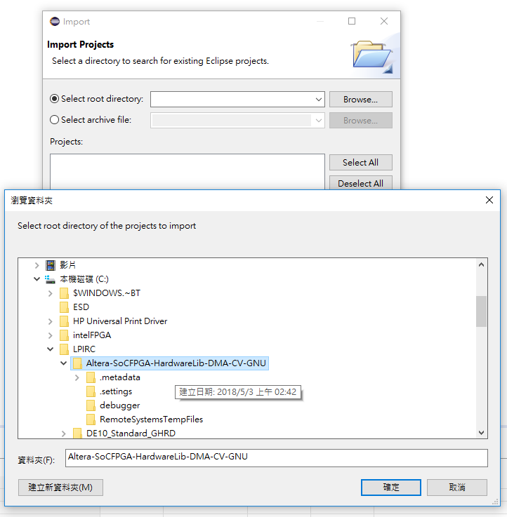

workspace should be of same directory as the project

## MISC:

* Send file onto the board via router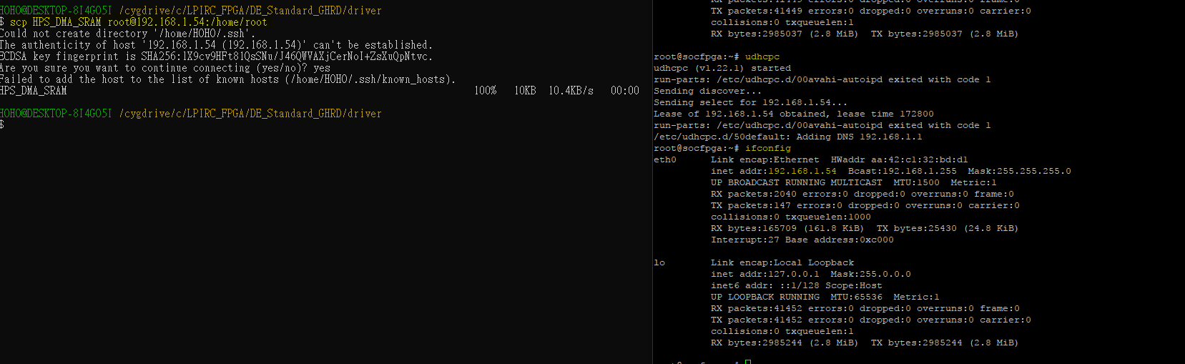

## Drivers:

* Can’t find drivers? First look at the make file, find the file hierarchy.

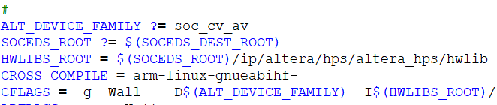

* DMA driver manuel: [https://www.altera.com/documentation/sfo1400787952932.html#iga1401397703359](https://www.altera.com/documentation/sfo1400787952932.html%23iga1401397703359)

# QSYS

# Putty

## MISC:

* Setting: sometimes it doesn’t connect by clicking on “open” under this tab

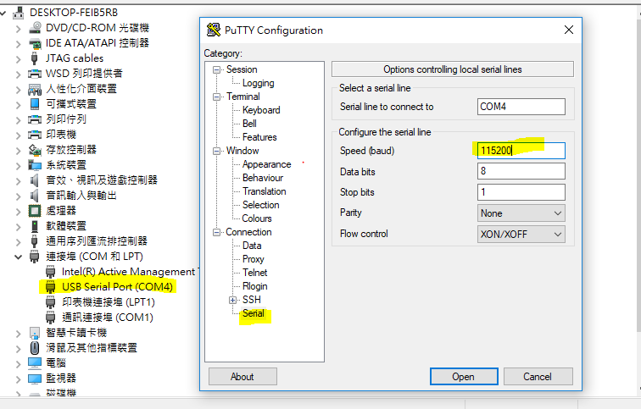

Connect: Instead, connect under Session tab.

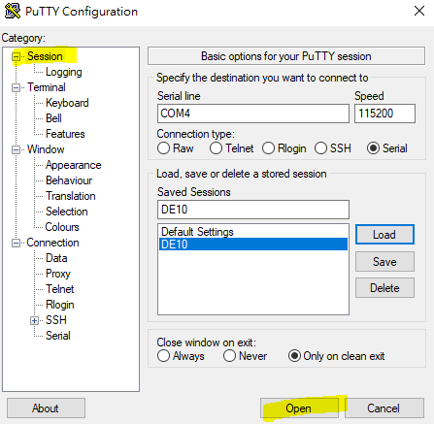

# MISC

* Use wins+Windows + Shift + S (Windows 10 only) to capture a region, images are to copied to the clipboard, especially useful when you want a image of a active tab like such:

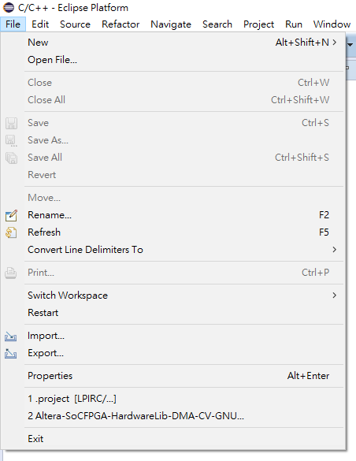

## Resources:

* Intel FPGA examples: [https://www.altera.com/support/support-resources/design-examples.html#socdesignexamples](https://www.altera.com/support/support-resources/design-examples.html%23socdesignexamples)