SYSTEM REQUIREMENTS SPECIFICATION (SRS)
Project: QuizMaster Online Examination Platform | Version: 1.2 | Date: August 21, 2026
Document Title: | Software Requirements Specification - QuizMaster | Issue Date: | August 21, 2026
Version: | 1.2 | Status: | Developed
Official GitHub repository: QuizMaster
Team Members:
Name | Position | Student ID
Nguyễn Hữu Phúc | Leader | 079206004755
Lã Duy Bảo | Member | 075207006752
Lê Trần Bình Trọng | Member | 052206003879
Phạm Nguyễn Việt Đức | Member | 058206008773
Nguyễn Khánh Hậu | Member | 08320600033
Document History
Date | Version | Description of Change | Author
10/08/2026 | 1.0 | Initial draft of the online quiz examination system specification. | All team members
17/08/2026 | 1.1 | Addition of use cases, including description and diagram. | All team members
21/08/2026 | 1.2 | Addition of dataflow diagram, class diagram and design initiative. | All team members
I. SYSTEM OVERVIEW
The QuizMaster Online Examination System serves educational institutions, testing centers, and enterprises to conduct competency evaluations, periodic tests, and certification assessments with the following core functional subsystems:
1. Student / Candidate Subsystem
- Browse & Search Exams: Browse subject categories, search public practice tests, or join official exams by entering an Exam Code/Password.
- Online Exam Taking:
- User-friendly exam interface displaying question lists, real-time countdown timer, and a question navigation palette (answered, unanswered, flagged for review).
- Automatic background saving (Auto-save) after every option selection to prevent data loss during unexpected network drops.
- Anti-cheat protection: tab switch / window blur detection, warning modal, and automatic test submission upon timer expiration.
- View Results & Exam History: Instant display of final scores, accuracy rate, score breakdown, performance history, and detailed answer explanations (if permitted).
- Account Management: Self-registration, personal profile update, password change, and secure password recovery via email verification.
2. Teacher / Examiner Subsystem
- Question Bank Management: Create and classify questions by subject, topic, and difficulty level (Easy, Medium, Hard, Expert). Supports multiple choice (single/multiple select), True/False, and fill-in-the-blank. Supports bulk import/export via Excel (.xlsx) / CSV.
- Exam Creation & Publishing: Configure static exams (fixed question sets) or dynamic exams (randomized generation based on a predefined difficulty matrix). Set duration, exam access windows, question shuffling, and option shuffling per candidate.
- Analytics & Reporting: View candidate lists, overall score distribution, pass/fail ratios, and question discrimination index (identifying most missed questions for curriculum improvement).
3. Administrator Subsystem
- User & Role Management: Manage candidate and instructor accounts, role-based access control (RBAC), and account activation/lock.
- Academic Structure Management: Manage subjects, departments, academic terms, and assign candidate cohorts to virtual exam rooms.
- System Monitoring & Proctoring Logs: Monitor server metrics, inspect operational audit logs, and review candidate proctoring violation logs during active sessions.
II. GLOSSARY
Term | Definition & System Context
Question Bank | A centralized repository of categorized assessment items tagged with subjects, topics, and Bloom's cognitive taxonomy levels.
Exam Matrix | A blueprint defining the quota of questions to extract from the Question Bank across topics and difficulty tiers to generate balanced tests.
Shuffled Exam | An exam variant where the sequence of questions and the order of answer choices (A, B, C, D) are randomized uniquely for each candidate.
Exam Attempt | A single, tracked test-taking session for a specific exam, recording start time, submission time, duration, responses, and final score.
Proctoring Log | Audit trail capturing suspicious test-taker behavior such as tab switching, window resizing, blur events, or network disconnects.
III. SUPPLEMENTARY SPECIFICATIONS
- Usability: Fully responsive UI tailored for Desktops, Tablets, and Mobile devices. Distraction-free exam mode, high-contrast typography, and optional Dark Mode theme.
- Reliability: 99.9% system availability (Uptime). Dual auto-save mechanism running every 10 seconds locally (LocalStorage) and remotely (Server API) to prevent session loss.
- Performance: Capability to handle 1,000 concurrent submissions during peak exam windows with sub-1.5-second response latency. Database scalable to 500,000+ questions and 2,000,000+ completed attempts.
- Security:
- User’s information protected with industry-standard encryption algorithms.
- Correct answer keys remain obfuscated and restricted on the server until grading execution.
- Mitigation against OWASP Top 10 vulnerabilities (SQL Injection, XSS, CSRF, DDoS, Brute Force).
- Stateless API authorization via JWT (JSON Web Tokens) paired with short-lived access tokens and secure refresh mechanisms.
- Design Constraints: Built a full-stack web application with a modern frontend, scalable backend, and cached database on a Linux server.
IV. USE-CASE DIAGRAM & DETAILED SPECIFICATIONS
1. Actor & Use-Case Catalogs
Actor | Role & Description
Guest | Unauthenticated visitor; can view public syllabus overviews and access registration/login pages.
Student (Candidate) | Authenticated test-taker: browses exams, takes timed tests, submits answers, reviews results, and updates profile.
Teacher (Examiner) | Subject matter expert: manages question banks, compiles exam blueprints, schedules exam sessions, and reviews analytics.
Administrator | System operator: oversees user accounts, RBAC permission matrices, system health, and security/audit logs.

No. | Use-Case Name | Description | Primary Actor
1 | Browse & Search Exam | Search and browse tests by subject (category), keyword and exam access code  Sort tests by date and popularity | Guest, Student
2 | Take Exam | Enter examination room and answer questions under active countdown  Background protocol for auto-save and anti-cheat | Student
3 | Submit Exam & Auto Grade | Submit completed paper and trigger immediate automatic scoring  Force-submit on time expiration | Student
4 | View Exam History & Analytics | Review past performance, scores, and detailed item analysis | Student
5 | Manage Question Bank | Create, update, delete, and import/export questions | Teacher, Admin
6 | Manage Exam & Test | Manage exams, personnel  Set schedule, access method and shuffling configuration | Teacher, Admin
7 | View Exam Statistics | View analytic attributes through built-in dynamic graphical visualization using API | Teacher, Admin
8 | Manage User & Roles | Manage over all accounts (role, permission and status) | Admin
9 | Login & Logout | Authenticate and securely terminate sessions | All Actors
10 | Register Account | Candidate self-registration workflow | Guest
11 | Reset Password | Secure password recovery via email token link | All Actors
12 | Update Profile | Update user information, avatar, and password | Student, Teacher, Admin
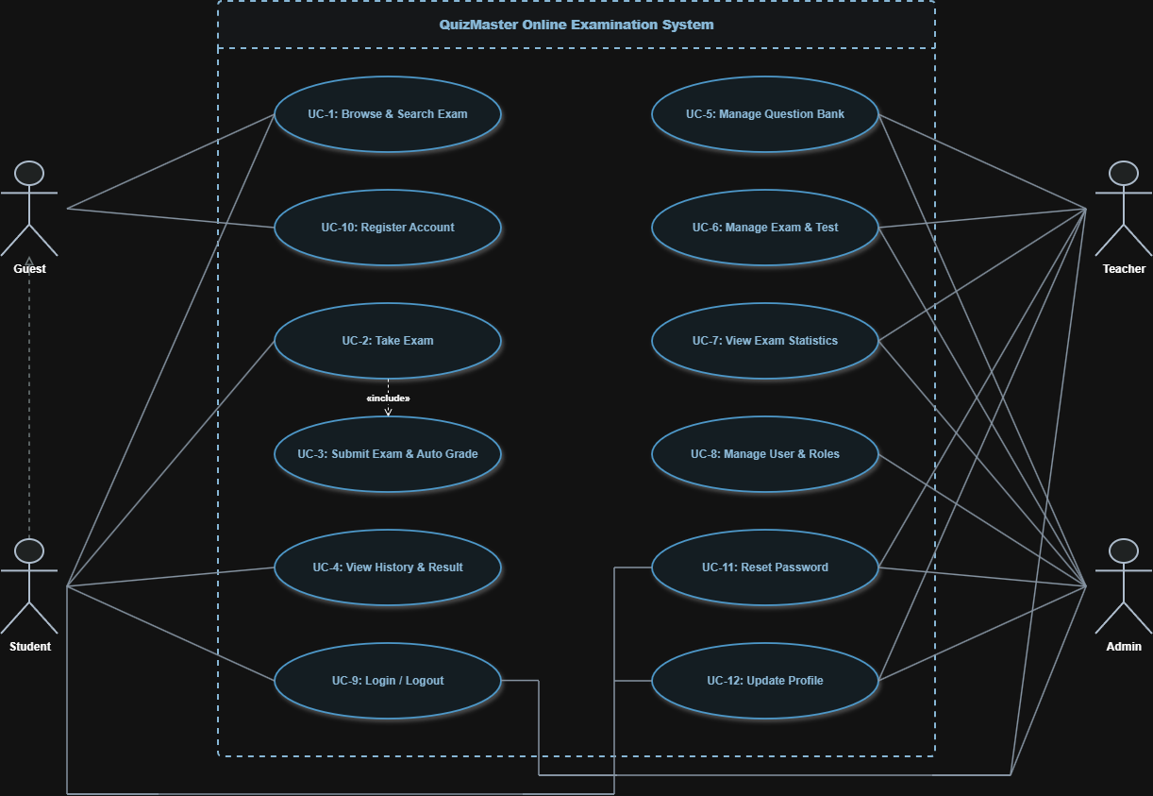
General Use Case Diagram
2. Detailed Specifications for Core Use-Cases
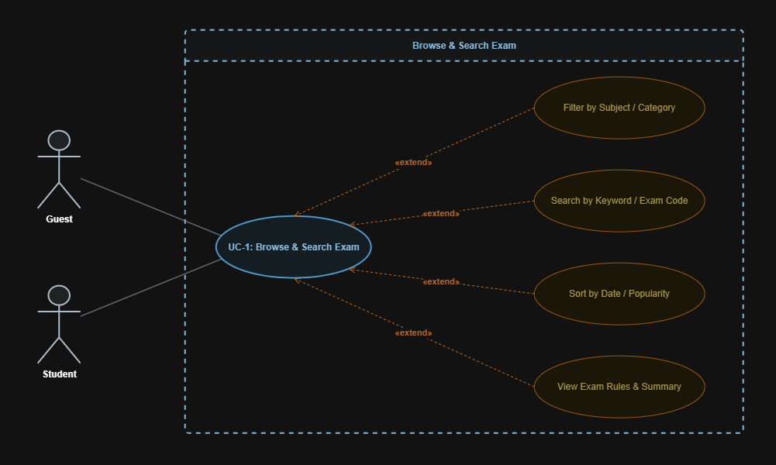
UCD 1 & 2
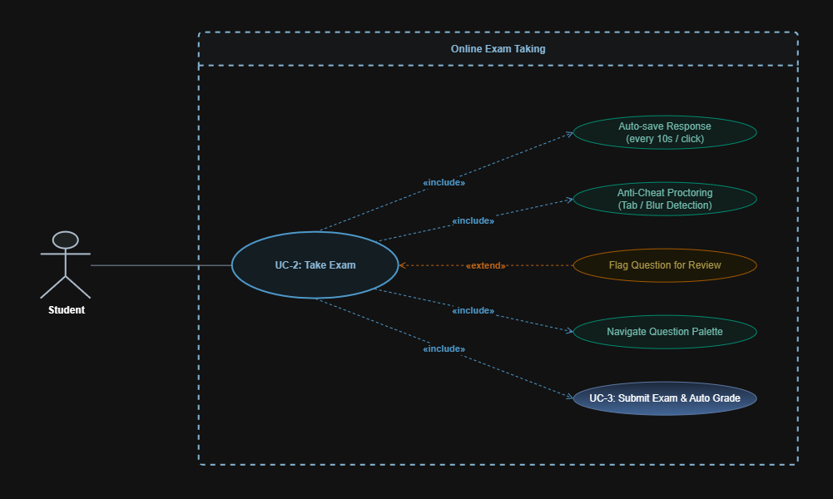
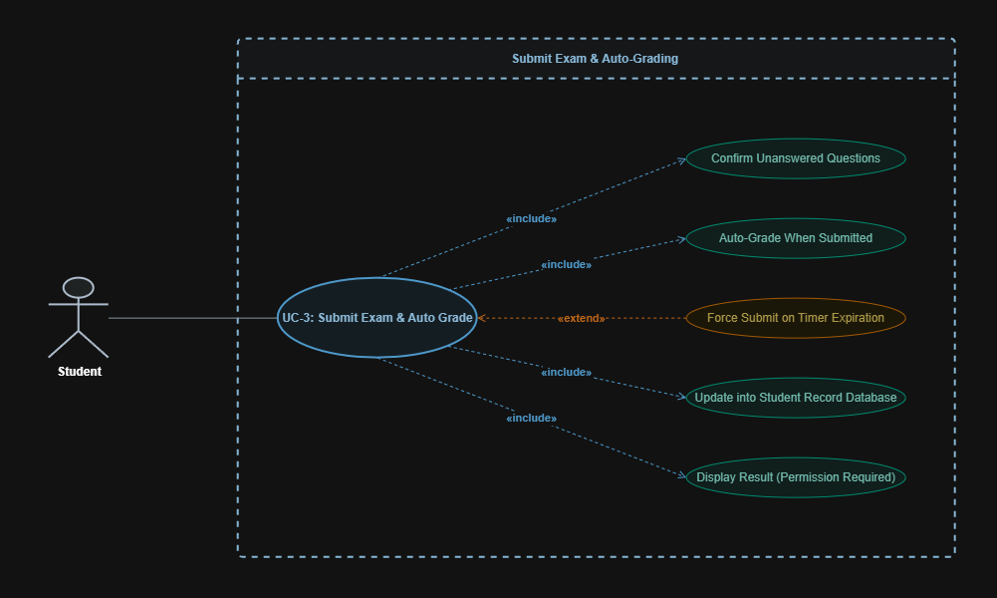
UCD 3
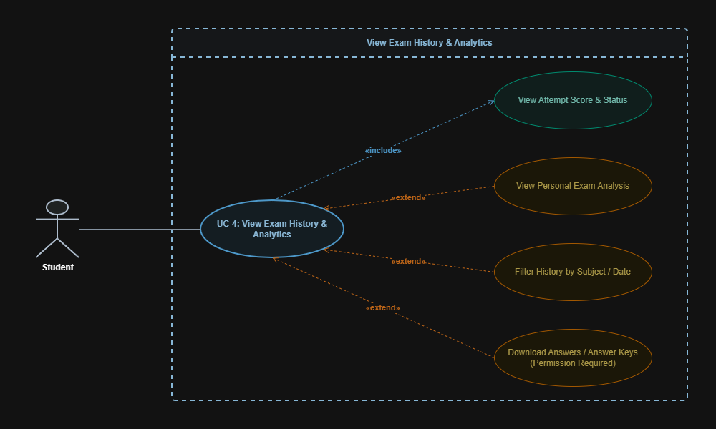
UCD 4
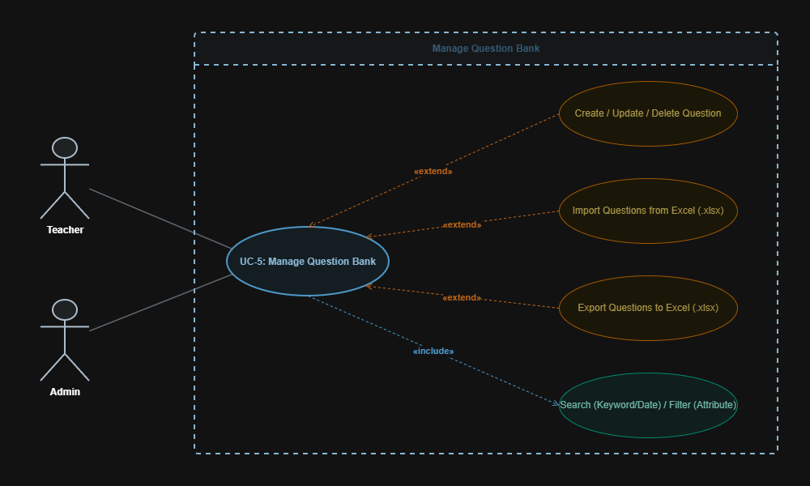
UCD 5
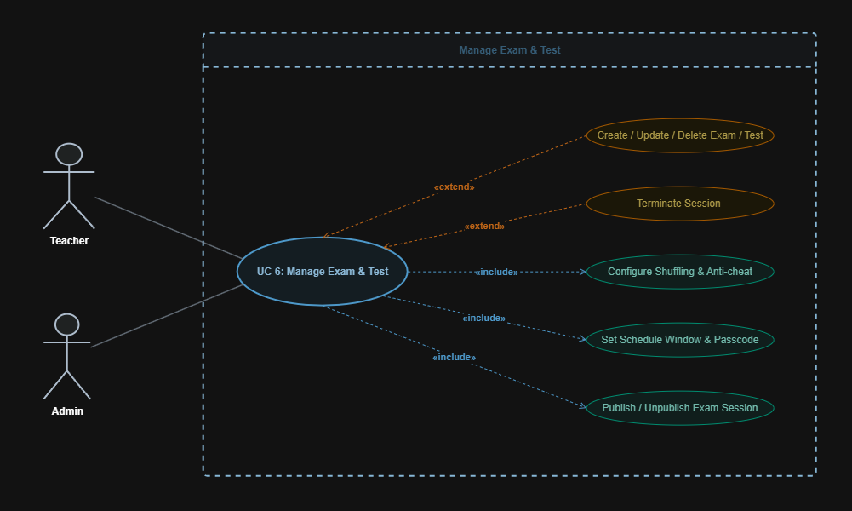
UCD 6
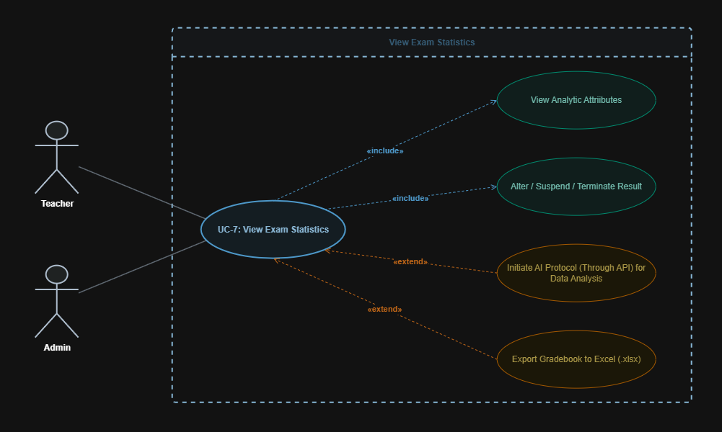
UCD 7
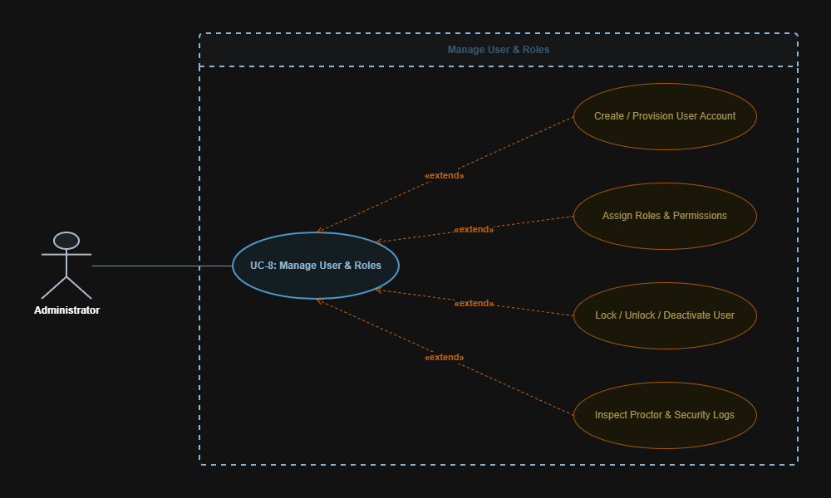
UCD 8
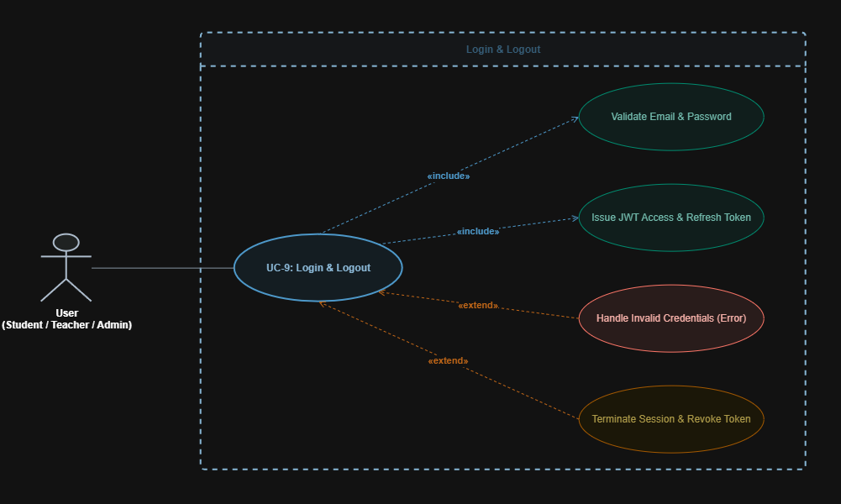
UCD 9
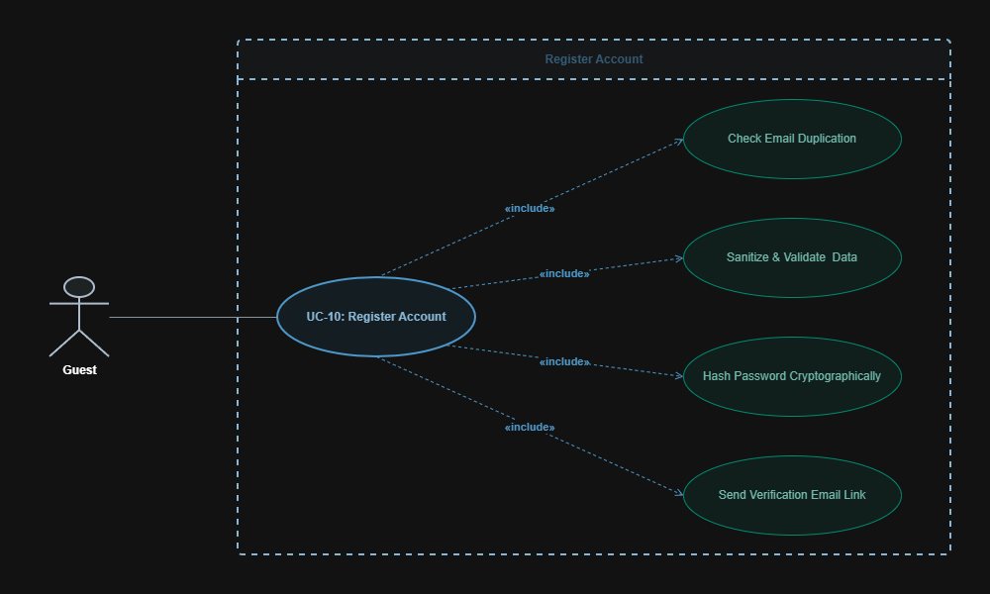
UCD 10
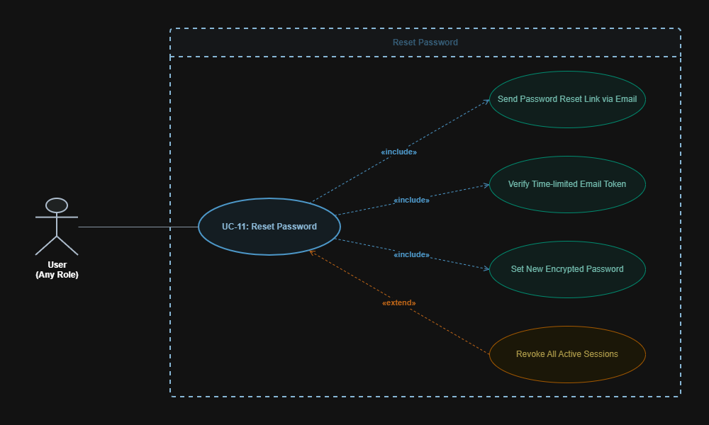
UCD 11
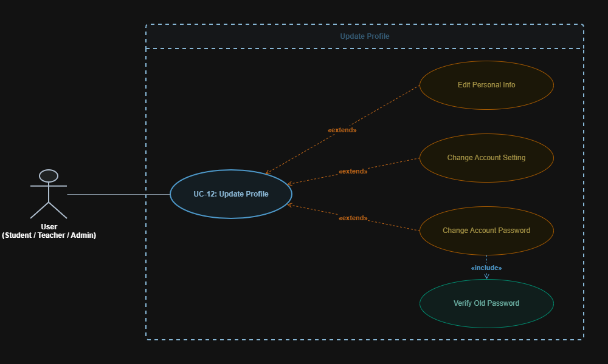
UCD 12
V. DATA FLOW DIAGRAM
The QuizMaster Online Examination System dataflow design ensures efficient movement through scalable components, maintaining high throughput, low latency, and stable environment.
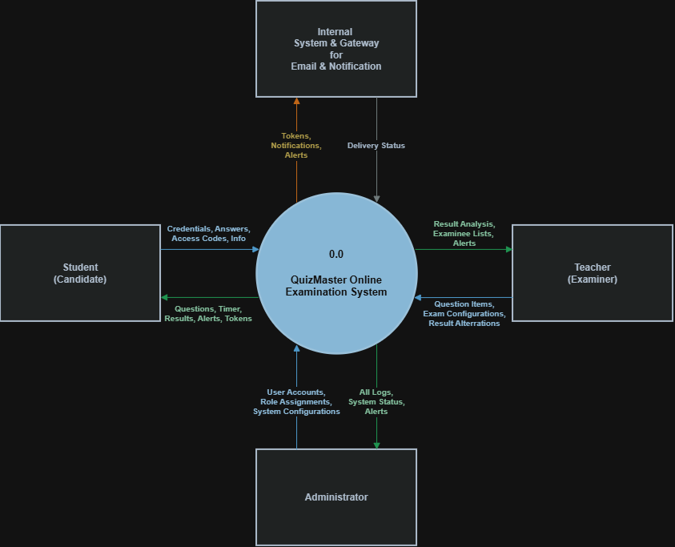
Data Flow Diagram Level 0 & Level 1
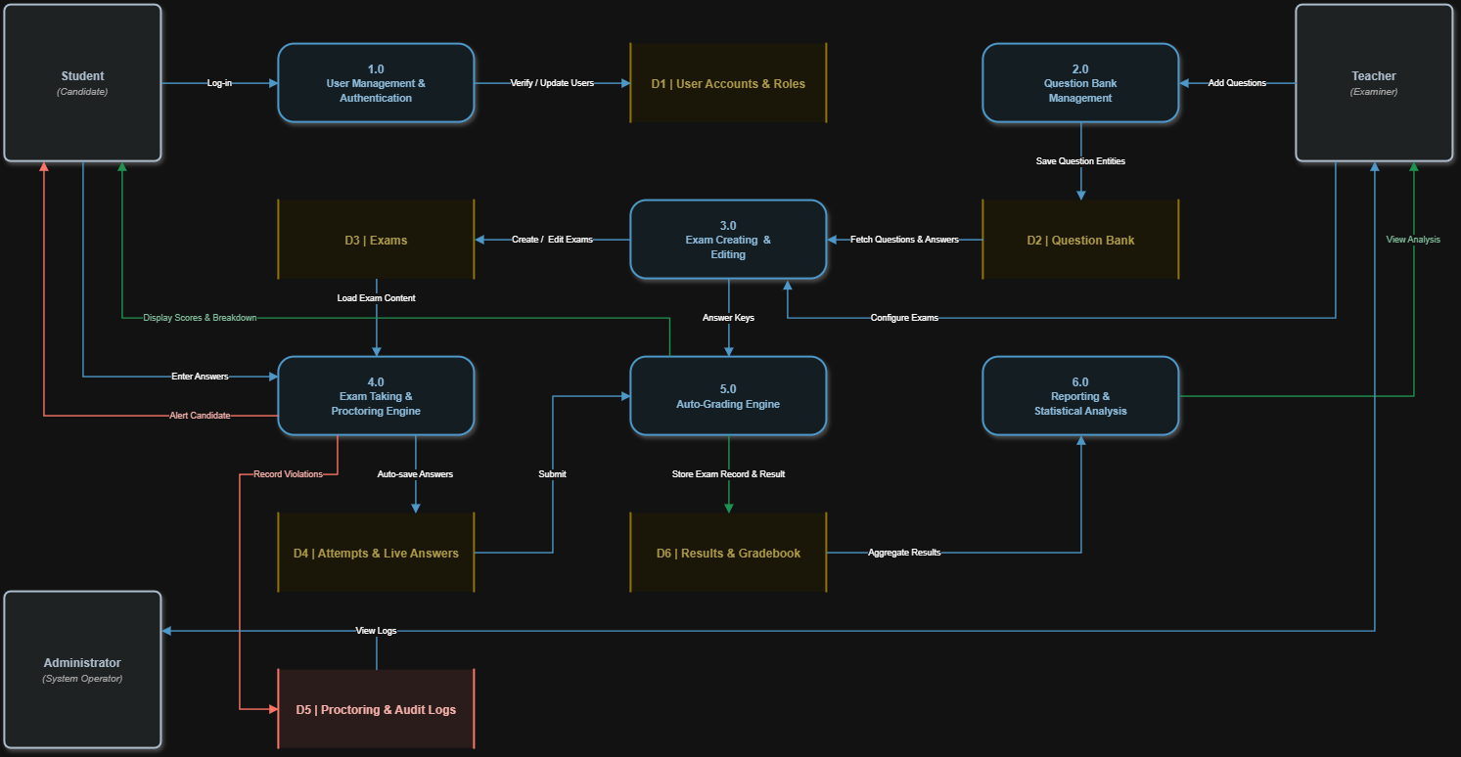
VI. ARCHITECTURAL DESIGN & CLASS DIAGRAM
The QuizMaster Online Examination System technical-class design clearly illustrates system structure, map relationships precisely, and balance detail with readability, helping developers easily understand, maintain, and scale complex software architectures efficiently.
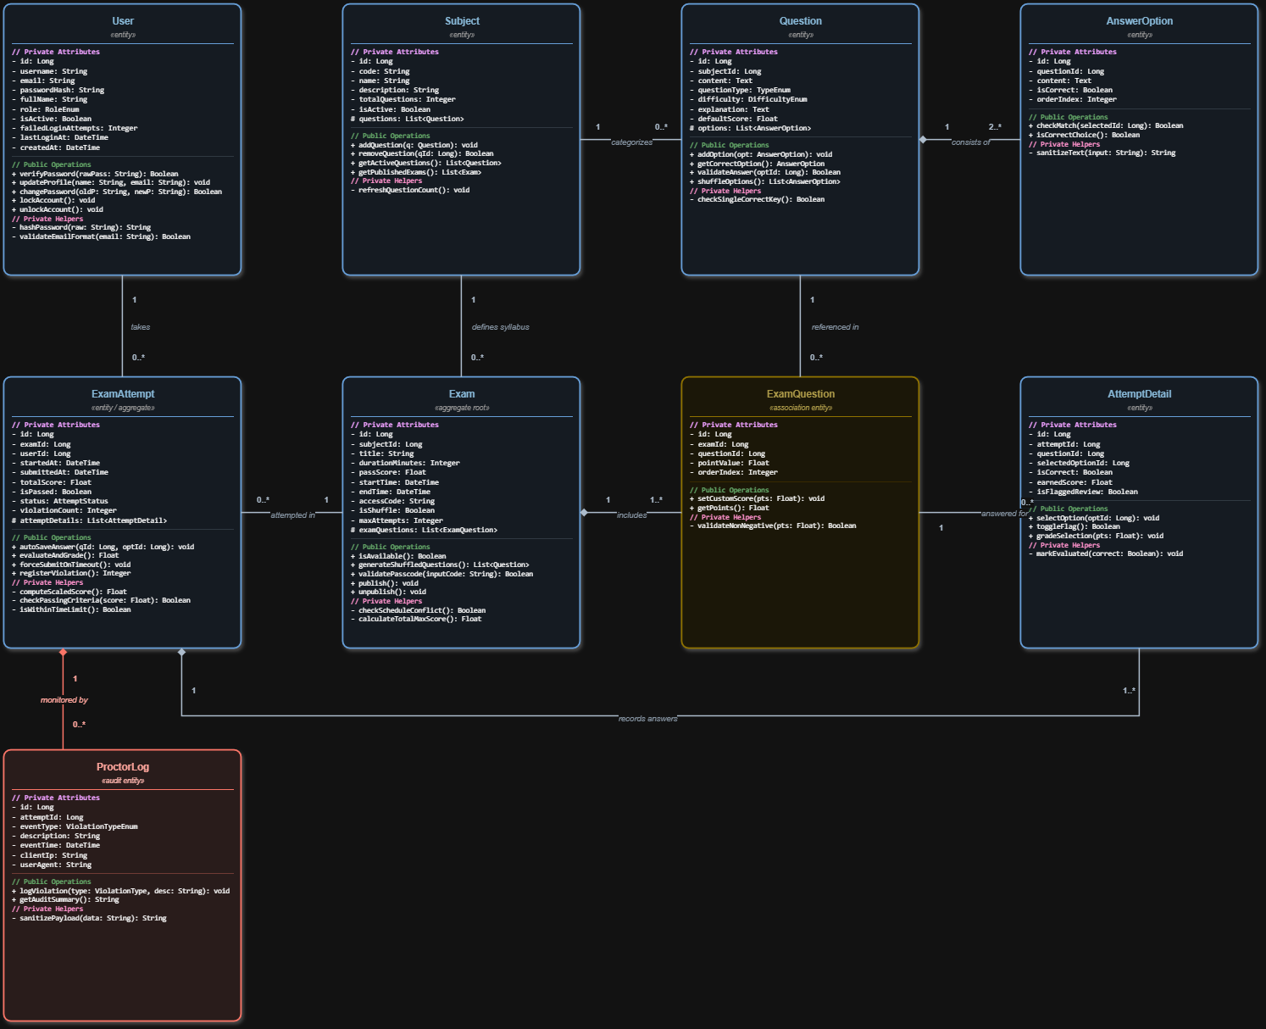

Class Diagram
VII. ARCHITECTURAL DESIGN & CLASS DIAGRAM
The QuizMaster platform uses a role-based, distraction-free interface design structured into three primary portals to ensure accessibility across desktop, tablet, and mobile devices.
1. Candidate Examination Portal (Student UI)
- Distraction-Free Exam Runner: Clean layout with a centralized item pane supporting rich media, syntax-highlighted code blocks, and LaTeX mathematical formatting.
- Synchronized Countdown & Status Bar: Fixed-top header displaying a synchronized server-side timer (turning amber at 5 minutes and pulsing red at 1 minute), network ping indicator, and instant "Auto-Saved" status badges.
- Interactive Question Palette: Collapsible right-hand grid showing item statuses via distinct color tags: Answered (Blue), Unanswered (Light Gray), and Flagged for Review (Amber).
- Post-Exam Score Dashboard: Detailed performance breakdown displaying raw scores, percentages, passing badges, and itemized answer key explanations (if permitted by exam policies).
- Proctoring Overlay: Enforces full-screen mode and renders modal warnings upon window blur or tab-switching detection before triggering auto-submission.
2. Instructor Assessment Workspace (Teacher UI)
- Question Bank Manager: Filterable data tables with multi-criteria search (by subject, topic, cognitive difficulty, and question type), inline editing, and drag-and-drop batch Excel (.xlsx) file ingestion.
- Dynamic Exam Blueprint Builder: Interactive matrix configurator allowing instructors to set difficulty distributions, timer durations, randomize item/option orders, and configure retake rules.
- Statistical Analysis Viewing: Viewing panel generated upon viewing allowing instructors to change between different types of graphical visualization, sortable by analytic attributes.
3. Administrative Control Center (Admin UI)
- User & RBAC Management: Data grid for provisioning user accounts, toggling account lock states, and managing granular permission matrices.
- Live Proctoring & Audit Console: Real-time event feed streaming candidate focus violations, IP mismatches, and abnormal session terminations.
- System Telemetry Panel: Monitoring dashboard displaying API throughput, active session counts, Redis buffer health, and database connection pool statuses.

