SYSTEM REQUIREMENTS SPECIFICATION (SRS)
Project: QuizMaster Examination Platform | Version: 1.2 | Date: August 21, 2026
Document Title: | Software Requirements Specification - QuizMaster | Issue Date: | August 21, 2026
Version: | 1.2 | Status: | Developed
Official GitHub repository: QuizMaster
Team Members:
Name | Position | Student ID
Nguyễn Hữu Phúc | Leader | 079206004755
Lã Duy Bảo | Member | 075207006752
Lê Trần Bình Trọng | Member | 052206003879
Phạm Nguyễn Việt Đức | Member | 058206008773
Nguyễn Khánh Hậu | Member | 08320600033
Document History
Date | Version | Description of Change | Author
10/08/2026 | 1.0 | Initial draft of the online quiz examination system specification. | All team members
17/08/2026 | 1.1 | Addition of use cases, including description and diagram. | All team members
21/08/2026 | 1.2 | Addition of dataflow diagram, class diagram and design initiative. | All team members
I. SYSTEM OVERVIEW
The QuizMaster Online Examination System serves educational institutions, testing centers, and enterprises to conduct competency evaluations, periodic tests, and certification assessments with the following core functional subsystems:
1. Student / Candidate Subsystem
- Browse & Search Exams: Browse subject categories, search public practice tests, or join official exams by entering an Exam Code/Password.
- Exam Taking:
- User-friendly exam interface displaying question lists, real-time countdown timer, and a question navigation mechanic.
- Submit re-confirmation, warning for unanswered item(s).
- View Results & Exam History:
- Instant display of final scores on 4.0 Scale and/or 10.0 Scale.
- Displayed if permitted: accuracy rate, score breakdown.
- Account Management: Self-registration, personal profile update, password change, and secure password recovery via personal verification questions.
2. Teacher / Examiner Subsystem
- Question Bank Management:
- Create and classify questions by subject, topic, and difficulty level.
- Supports multiple choice (single/multiple select), True/False, and fill-in-the-blank.
- View Results & Exam History:
- Configure static exams (fixed question sets) or dynamic exams (randomized sequence).
- Set duration, exam access windows, question shuffling.
- Analytics & Reporting:
- View candidate lists with results
- View statistical analysis via chart (pie, column, and ect.), ratio (pass/fail, and ect.).
3. Administrator Subsystem
- User & Role Management: Supreme authority over all examiner/candidate account.
- Academic Structure Management: Manage subjects, departments, academic terms, etc.
- System Monitoring: Monitor server metrics, operational logs, and review system health information.
II. GLOSSARY
Term | Definition & System Context
Question Bank | A centralized repository of categorized assessment items tagged with subjects, topics, and Bloom's cognitive taxonomy levels.
Exam Blueprint | A blueprint defining the quota of questions to extract from the Question Bank across topics and difficulty tiers to generate balanced tests.
Exam Attempt | A single, tracked test-taking session for a specific exam, recording start time, submission time, duration, responses, and final score.
III. SUPPLEMENTARY SPECIFICATIONS
- Usability: Distraction-free exam mode, high-contrast UI, and optional Dark Mode theme.
- Reliability: 99.9% system availability (Uptime). Background system anti-freeze mechanic implemented.
- Performance: Database scalable to 1000+ questions and 500+ completed attempts.
- Security:
- User’s information protected with encryption algorithms, specifically by hashing with SHA-256.
- Answer keys remain obfuscated and restricted on the server until auto-grading execution.
- Enforce multi-factor authentication measure via multiple personal verification questions.
- Design Constraints:
- A full-stack application with a modern frontend, scalable backend.
- Main programming languages include C++ and Python with MySQL as Database Management System.
IV. USE-CASE DIAGRAM & DETAILED SPECIFICATIONS
- Actor & Use-Case Catalogs
Actor |  | Role & Description
Guest |  | Unauthenticated visitor, able to view public exam and access registration/login pages.
Student (Candidate) |  | Authenticated test-taker: browse exams, take timed tests, submit answers, review results, and update profiles.
Teacher (Examiner) |  | Authorized examiner: manage question banks, create exam, schedule exam sessions, and review analysis.
Administrator |  | System operator: oversee user accounts, system health, and server logs.
No. | Use-Case Name | Description | Primary Actor
1 | Browse & Search Exam | Search and browse exams by category and exam access codes  Sort tests by date and difficulty | Guest, Student
2 | Take Exam | Enter examination room and answer questions under active countdown | Student
3 | Submit Exam & Auto Grade | Submit completed attempts and initiate auto-grading  Force-submit on time expiration | Student
4 | View Exam History & Analysis | Review previous attempts, scores, and detailed item analysis | Student
5 | Manage Question Bank | Create, update and delete questions | Teacher, Admin
6 | Manage Exam & Test | Create, edit exams  Set schedule, access method and shuffling configuration | Teacher, Admin
7 | View Analysis | View statistical analysis through built-in dynamic graphical visualization | Teacher, Admin
8 | Manage User & Roles | Manage over all accounts (role, permission and status) | Admin
9 | Login & Logout | Authenticate user’s credential | All Actors
10 | Register Account | Candidate self-registration | Guest
11 | Reset Password | Secure password recovery via personal verification questions | Student, Teacher, Admin
12 | Update Profile | Update user information, avatar, and password | Student, Teacher, Admin
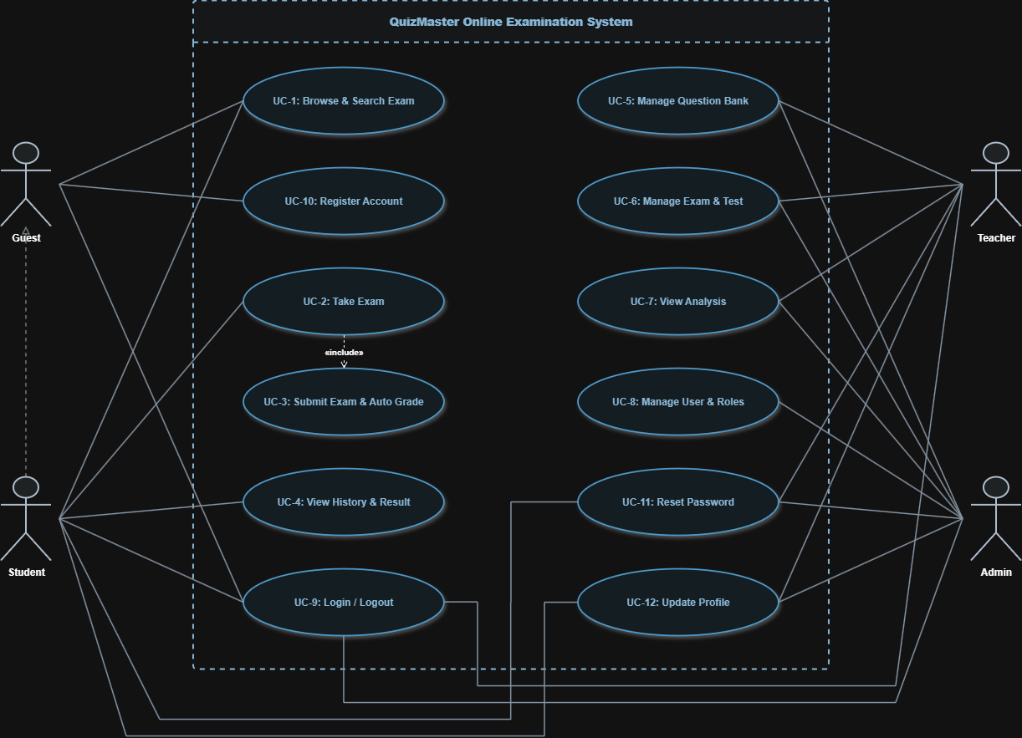

General Use-Case Diagram

- Detailed Specifications for Core Use-Cases
  - Use-case Browse & Search Exam:
    - Main event-flow
Use-Case starts when user using the search feature.
- User required to enter subject, date or exam code, searching protocol initiated immediately after “Enter” input.
- All items (exams) displayed accordingly.
- Navigate to pre-exam-taking interface as said exam is viewed.
    - Other event-flow
None
    - System status before Use-Case execution
None
    - System status after Use-Case execution
System displays the list or details of the found exam.
    - Extension Point
None
  - Use-case Take Exam:
    - Main event-flow
Use-Case starts when Student initiating an exam-taking attempt in pre-exam-taking interface.
- Enter exam-taking mode.
- All question items displayed and count-down timer started.
- Answer auto-saved when question changed.
    - Other event-flow
None
    - System status before Use-Case execution
User in pre-exam-taking interface.
    - System status after Use-Case execution
Enter exam-taking mode.
    - Extension Point
Linked to Use Case 03 – Submit Exam & Auto Grade, triggered when time expires or the exam submitted manually.
  - Use-case Submit Exam & Auto-Grade:
    - Main event-flow
Use-Case starts when the exam submitted manually or automatically due to time expiration.
- Exam submitted manually by “Submit” or automatic submission due to time expiration.
- Answer key fetched from database as auto-grading protocol initiated.
- Attempt saved into database along with result.
- Permitted result and analysis displayed .
    - Other event-flow
None
    - System status before Use-Case execution
System in exam-taking mode.
    - System status after Use-Case execution
Related date saved, attempt status updated to “submitted” and permitted information displayed.
    - Extension Point
None
  - Use-case View Exam History & Analysis:
    - Main event-flow
Use Case starts when the Student accesses the “Exam History” tab.
- Previous attempted exam displayed and sorted chronologically descending by default.
- Re-sorted immediately after “Enter” input if order option changed (chronological, category, etc.).
- Attempt detail (starting/ending exact time, duration, etc.), view-permitted result and related analysis displayed as viewed.
    - Other event-flow
None
    - System status before Use-Case execution
At any state except exam-taking mode.
    - System status after Use-Case execution
Navigated to “Exam History” tab.
    - Extension Point
None
  - Use-case Manage Question Bank:
    - Main event-flow
Use-Case starts when access-authorized user enters “Question Bank” tab.
- Available option for users: Creating, Editing, Deleting
- Protocol initiated:
- Creating: newly added question stored into database along with its answer(s) and related attributes after confirmation. Unique identification code generated.
- Editing: existing question opened for alteration, altered item saved into database. Unique identification code remains.
- Deleting: existing question purged from database along with its attributes and identification code.
- Final-step confirmation required for all protocol.
    - Other event-flow
Existing question searchable by identification code for Editing and Deleting protocol.
    - System status before Use-Case execution
None.
    - System status after Use-Case execution
Navigated to “Question Bank” tab.
    - Extension Point
None
  - Use-case Manage Exam & Test:
    - Main event-flow
Use-Case starts when access-authorized user enters “Exam & Test” tab.
- Available option for users: Creating, Editing, Deleting
- Protocol initiated:
- Creating: question manually picked or auto-fectch from datebase according to blueprint configurations, which then stored into database along with configurations (duration, access window, etc.) after confirmation. Exam identification code generated.
- Editing: existing exam opened for alteration of question or blueprint, altered exam saved into database. Exam identification code remains.
- Deleting: existing exam purged from database along with its attributes and identification code.
- Final-step confirmation required for all protocol.
    - Other event-flow
Existing exam searchable by identification code for Editing and Deleting protocol
    - System status before Use-Case execution
None.
    - System status after Use-Case execution
Navigated to “Exam & Test” tab.
    - Extension Point
None
  - Use-case View Analysis:
    - Main event-flow
Use-Case starts when access-authorized user enters “Analysis” tab.
- All exam displayed and sorted chronologically descending by default
- Re-sorted immediately after “Enter” input if order option changed (chronological, category, etc.).
- All exam detail displayed in chosen graphical visualization option as viewed.
    - Other event-flow
Existing exam searchable by identification code.
    - System status before Use-Case execution
None.
    - System status after Use-Case execution
Navigated to “Analysis” tab.
    - Extension Point
None
  - Use-case Manage User & Roles:
    - Main event-flow
Use-Case starts when access-authorized user enters “Personnel” tab.
- All active users displayed by default.
- Re-sorted immediately after “Enter” input if order option changed (chronological, category, etc.).
- Following protocol executable by Admin: Account Active Status Alteration, Role Assignment, etc.
- Altered account stored into database with its information.
    - Other event-flow
Existing account searchable by Unique ID.
    - System status before Use-Case execution
None.
    - System status after Use-Case execution
Navigated to “Personnel” tab.
    - Extension Point
None
  - Use-case Login & Logout:
    - Main event-flow
This Use-Case describe how a Guest log into the system.
- User navigated to Log-in interface.
- User required to enter Username and Password.
- Log-in credential verified and account status checked. .
- Access granted if credentials confirmed while in “Active” status, fail log-in attempt counter resets to 0 . .
    - Other event-flow
“Log-Out” button clicked:
- Session terminated.
- User logged out.
    - System status before Use-Case execution
None
    - System status after Use-Case execution
None
    - Extension Point
None
  - Use-case Register Account:
    - Main event-flow
This Use-Case describe a registration process.
- User navigated to Registration interface.
- User required to enter information and solve a CAPTCHA.
- Username and Password check for uniqueness, log-in credential then hashed and stored into database. .
- “Student” role issued.
    - Other event-flow.
Duplicate Credential (Username)
- If at step 3, Username found in database, error displayed as "An account with this email address already exists.”
- All input cleared, registering process resets.
    - System status before Use-Case execution
None
    - System status after Use-Case execution
None
    - Extension Point
None
  - Use-case Reset Password:
    - Main event-flow
Use-Case starts when Guest click “Reset Password” on “Profile” tab or at Log-in interface.
- User required to enter Username.
- Password-resetting protocol initiated with personal identification question(s) fetched from data base.
- If answered correctly, navigate user to password-reset interface which then requires new password input.
- New password hashed and stored into database
    - Other event-flow
None
    - System status before Use-Case execution
None
    - System status after Use-Case execution
None
    - Extension Point
None
  - Use-case Update Profile:
    - Main event-flow
Use-Case starts when User enter “Profile” tab.
- Current attributes displayed.
- User modifies one or more editable attributes.
- User clicks "Save Changes".
- Success indicator displayed
    - Other event-flow
None
    - System status before Use-Case execution
None
    - System status after Use-Case execution
None
    - Extension Point
None

V. DATA FLOW DIAGRAM
The QuizMaster Online Examination System dataflow design ensures efficient movement through scalable components, maintaining high throughput, low latency, and stable environment.
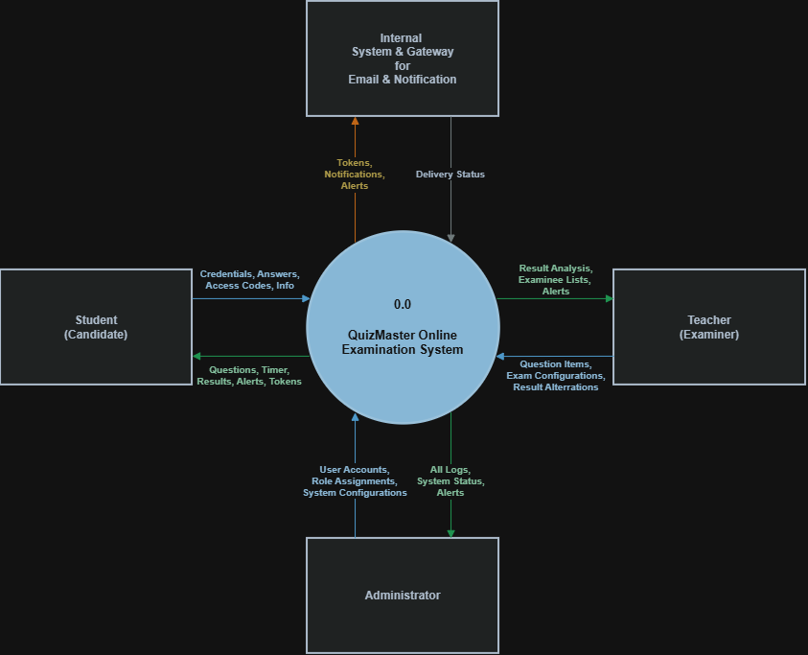
Data Flow Diagram Level 0 & Level 1
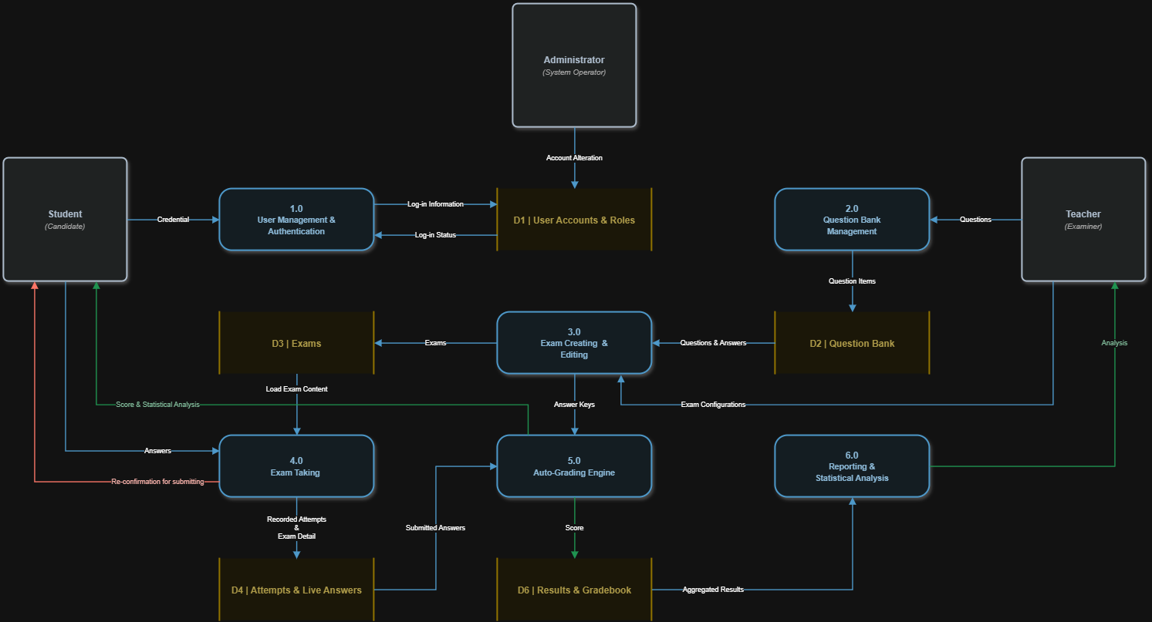
VI. CLASS DIAGRAM
The QuizMaster Online Examination System technical-class design clearly illustrates system structure, map relationships precisely, and balance detail with readability, helping developers easily understand, maintain, and scale complex software architectures efficiently.
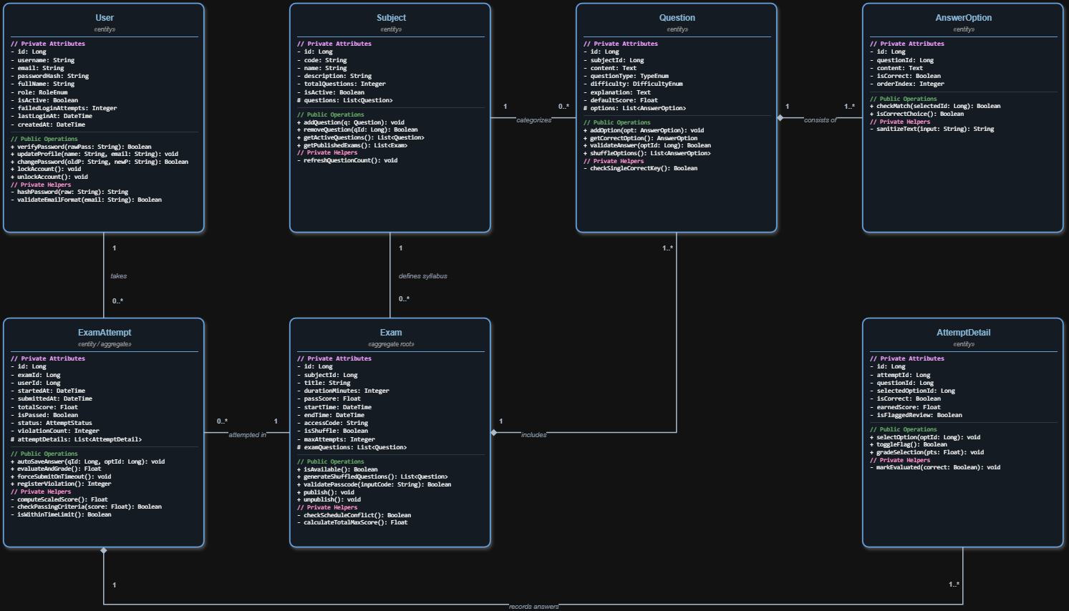

Class Diagram
VII. DATA MODEL
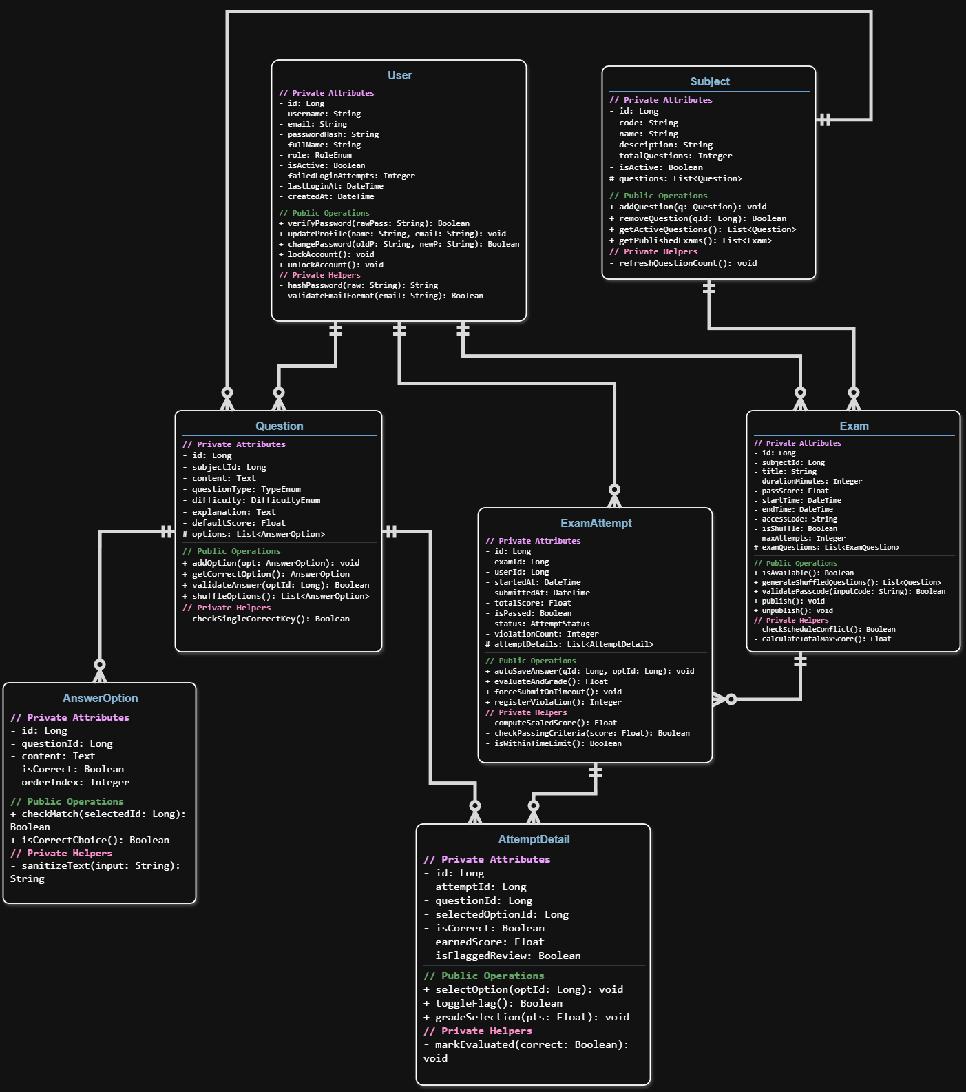

Data Model

VIII. DESIGN
The QuizMaster platform uses a role-based, distraction-free interface design structured into three primary portals to ensure accessibility.
1. Candidate Examination Portal (Student UI)
- Distraction-Free Exam Mode: Clean layout with a high-contrast color pallete, highlighted answer box, and back-and-forth navigation system.
- Synchronized Countdown: Fixed-top header displaying a count-down timer.
- Interactive Question Palette: Right-hand grid showing item statuses via distinct color tags: Answered (Blue), Unanswered (Light Gray), and Flagged for Review (Amber).
- Post-Exam Score Dashboard: Displaying raw scores, percentages, pass/fail status, and answer keys (if permitted by exam policies).
2. Instructor Workspace (Teacher UI)
- Question Bank Manager: Separate tab for managing question, along with option to alter its answer(s) and related attributes.
- Exam Create Panel: Separate tab for managing exam, along with option to alter its items and related configurations.
- Statistical Analysis Viewing: Visualization generated upon viewing allowing instructors to change between different types of graphical visualization, sortable by analytic attributes.
3. Administrative Control Center (Admin UI)
- User Account Management: Data grid for provisioning user accounts, toggling account status, and managing granular permission matrices.
- Server Operational Index: Real-time live-attempts, current logged-in user count, and database free storage.

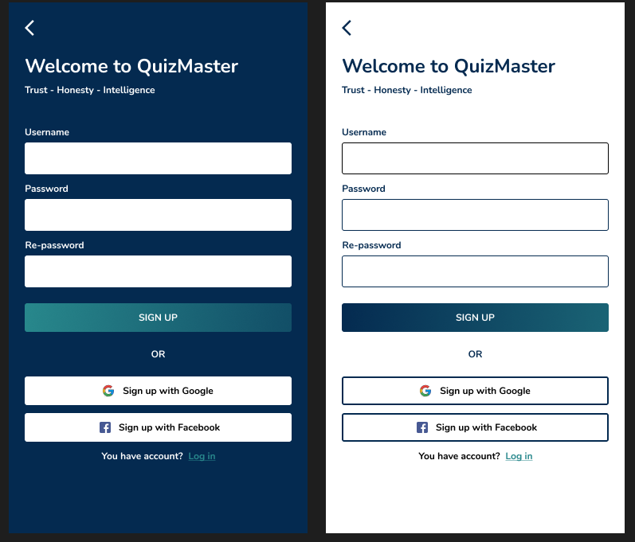

Log-In Interface

