

Switch Abstraction Interface

Change Proposal

|  |  |
| --- | --- |
| **Title** | **SAI TAM Enhancements for Monitoring Microbursts** |
| **Authors** | **Marvell Semiconductor Ltd.** |
| **Status** | **In Review** |
| **Type** | **Standards Track** |
| **Created** | **25 Feb 2017** |
| **SAI-Version** | **1.2** |

Contents

List of Changes 3

1 Overview 5

2 Proposal 5

2.1 TAM Microburst Objects 5

2.2 Microburst statistics 6

3 Specification 6

3.1 Addition to file saitam.h 6

3.1.1 Data Structures and Enumerations 6

3.1.2 API 10

3.2 Changes to saitypes.h 11

# List of Changes

|  |  |  |  |
| --- | --- | --- | --- |
| Version | Changes | Name | Date |
| 1 | Proposal for SAI TAM Enhancements for Monitoring Microbursts | Marvell Semiconductor Ltd. | 25 Feb 2017 |
| 2 | Update after SAI workshop |  |  |

License

© 2017 Microsoft Corporation, Dell Inc., Facebook, Inc, Broadcom Limited, Intel Corporation, Marvell Semiconductor Ltd., Mellanox Technologies Ltd.

You can review the signed copies of the Open Web Foundation Agreement Version 1.0 for this Specification at <http://opencompute.org/licensing/>, which may also include additional parties to those listed above.

Your use of this Specification may be subject to other third party rights. THIS SPECIFICATION IS PROVIDED "AS IS." The contributors expressly disclaim any warranties (express, implied, or otherwise), including implied warranties of merchantability, noninfringement, fitness for a particular purpose, or title, related to the Specification. The entire risk as to implementing or otherwise using the Specification is assumed by the Specification implementer and user. IN NO EVENT WILL ANY PARTY BE LIABLE TO ANY OTHER PARTY FOR LOST PROFITS OR ANY FORM OF INDIRECT, SPECIAL, INCIDENTAL, OR CONSEQUENTIAL DAMAGES OF ANY CHARACTER FROM ANY CAUSES OF ACTION OF ANY KIND WITH RESPECT TO THIS SPECIFICATION OR ITS GOVERNING AGREEMENT, WHETHER BASED ON BREACH OF CONTRACT, TORT (INCLUDING NEGLIGENCE), OR OTHERWISE, AND WHETHER OR NOT THE OTHER PARTY HAS BEEN ADVISED OF THE POSSIBILITY OF SUCH DAMAGE.

THE FOLLOWING IS A LIST OF MERELY REFERENCED TECHNOLOGY: Microprocessor technology, semiconductor manufacturing technology, operating system technology (including without limitation networking operating system technology), emulation technology, graphics technology, video technology, integrated circuit packaging technology and the like, compiler technologies, object oriented technology, optical/RF communications technology including chip I/O and driver technology, bus technology, memory chip technology (including, without limitation, NAND memory, NOR memory, resistive RAM (RRAM), seek scan probe (SSP) memory, nonvolatile memory (including without limitation, memory based on chalcogenide materials, phase change memory (PCM), one or more stacked layers of memory cells, embedded PCM memories, non-volatile cache memory, solid state drives, SRAM, embedded DRAM, ferro-electric memory, and polymer memory)) and/or health-related and medical technology. IMPLEMENTATION OF THESE TECHNOLOGIES MAY BE SUBJECT TO THEIR OWN LEGAL TERMS.

# Overview

SAI has “Telemetry and Analytics” (TAM) provision for retrieving statistics data in bulk, as well as introduces a notification mechanism for monitoring statistics using thresholds.

This document proposes a TAM enhancements for monitoring microbursts - retrieving statistics data on microbursts and microbursts durations. in bulk, as well as introduces a notification mechanism for monitoring statistics using thresholds. It uses the retrieving mechanism introduced in TAM Specification.

# Proposal

## TAM Microburst Objects

This document enhances TAM by adding Microburst objects, way to manage them and retrieving associated statistics.

The Microburst (uBurst) is an event in which a buffer-count (e.g., a queue length) crosses watermark A (from low to high) until it crosses watermark B (from high to low).

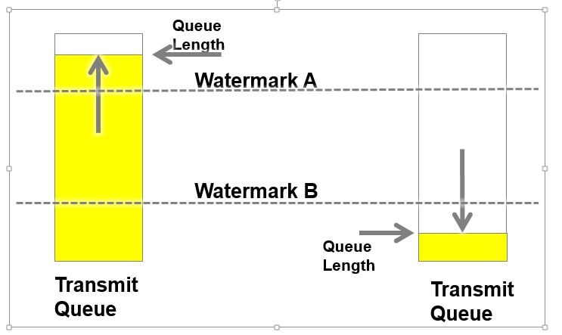

**Figure 1 Microburst Definition**

This spec supports microburst configuration via Microburst objects. Microburst objects are created via the **sai_tam_microburst_create_fn** API. The statistic associated with the threshold object and the associated breach levels are passed as attributes during the microburst object creation.

## Microburst statistics

Microburst Duration is the time (in us) of microburst event (from cross A until it crosses B).

Microburst Duration Statistics:

* Last microburst duration
* Longest microburst duration (peak)
* Shortest microburst duration (min)
* Average duration of all microbursts
* Number of microbursts
* Microburst Durations histogram

Microburst Durations histogram statistics contain numbers of microbursts according to their durations in user-defined intervals:

* Duration-bin-a - number of microbursts with duration from 0 us to ‘a’ us
* Duration-bin-b (from ‘a’ to ‘b’)
* Duration-bin-c (from ‘b’ to ‘c’)
* Duration-bin-d (‘c’ to any)

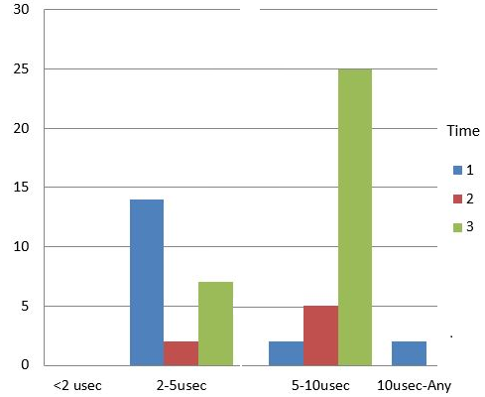

**Figure 2 Example of Microburst Duration Histogram**

# Specification

## Addition to file saitam.h

### Data Structures and Enumerations

/**

* @brief Enum defining statistics for microburst.

*/

typedef enum _sai_tam_microburst_stat_t

{

/** get/set last uBurst duration in us [uint64_t] */

SAI_TAM_MICROBURST_STAT_LAST_DURATION = 0x00000000,

/** get/set longest uBurst duration in us [uint64_t] */

SAI_TAM_MICROBURST_STAT_LONGEST_DURATION = 0x00000001,

/** get/set shortest uBurst duration in us [uint64_t] */

SAI_TAM_MICROBURST_STAT_SHORTEST_DURATION = 0x00000002,

/** get/set average uBurst duration in us [uint64_t] */

SAI_TAM_MICROBURST_STAT_AVERAGE_DURATION = 0x00000003,

/** get/set number of uBursts [uint64_t] */

SAI_TAM_MICROBURST_STAT_NUMBER = 0x00000004,

/** get/set number of uBursts histogram bin_a [uint64_t] */

SAI_TAM_MICROBURST_STAT_HISTOGRAM_BIN_A = 0x00000005,

/** get/set number of uBursts histogram bin_b [uint64_t] */

SAI_TAM_MICROBURST_STAT_HISTOGRAM_BIN_B = 0x00000006,

/** get/set number of uBursts histogram bin_c [uint64_t] */

SAI_TAM_MICROBURST_STAT_HISTOGRAM_BIN_C = 0x00000007,

/** get/set number of uBursts histogram bin_d [uint64_t] */

SAI_TAM_MICROBURST_STAT_HISTOGRAM_BIN_D = 0x00000008,

/** get/set histogram interval - value a [uint64_t] */

SAI_TAM_MICROBURST_STAT_HISTOGRAM_INTERVAL_A = 0x00000009,

/** get/set histogram interval - value b [uint64_t] */

SAI_TAM_MICROBURST_STAT_HISTOGRAM_INTERVAL_B = 0x0000000a,

/** get/set histogram interval - value c [uint64_t] */

SAI_TAM_MICROBURST_STAT_HISTOGRAM_INTERVAL_C = 0x0000000b,

/** Custom range base value */

SAI_TAM_MICROBURST_STAT_CUSTOM_RANGE_BASE = 0x10000000

} sai_tam_microburst_stat_t;

/**

* TAM Microburst Attributes.

*/

typedef enum _sai_tam_microburst_attr_t {

/**

* @brief Start of Attributes

*/

SAI_TAM_MICROBURST_ATTR_START,

/**

* @brief TAM Object

*

* @type sai_object_id_t

* @flags MANDATORY_ON_CREATE

*/

SAI_TAM_MICROBURST_ATTR_TAM_ID = SAI_TAM_MICROBURST_ATTR_START,

/**

* @brief Statistic for this microburst

*

* @type sai_tam_statistic_id_t

* @flags MANDATORY_ON_CREATE

*/

SAI_TAM_MICROBURST_ATTR_STATISTIC,

/**

* @brief Watermark Levels

*

* Breach levels for this microburst in number of bytes

*

* If not specified, the microburst is created without any

* levels, which is effectively disabling the microburst

* monitoring for the statistic

*

* @type uint64_t

* @flags CREATE_AND_SET

* @allownull true

*/

SAI_TAM_MICROBURST_ATTR_LEVEL_A,

SAI_TAM_MICROBURST_ATTR_LEVEL_B,

/**

* @brief Transporter Object

*

*

* @type sai_object_id_t

* @allownull true

*/

SAI_TAM_MICROBURST_ATTR_TRANSPORTER,

/**

* @brief Buffers/Statistics for inclusion in the snapshot

* Specifies the Statistics/Types for the snapshot.

* If not specified, all buffers tracked by

* the associated TAM object are included in the snapshot.

* When specified, the buffers requested for snapshot must be within the set

* tracked by the associated TAM object.

*

* @type sai_tam_statistic_id_list xxx

* @allownull true

*/

SAI_TAM_MICROBURST_ATTR_STAT_TYPES,

/**

* @brief End of Attributes

*/

SAI_TAM_MICROBURST_ATTR_END

} sai_tam_microburst_attr_t;

### API

/**

* Routine Description:

* @brief Create and return a microburst object

*

* This creates a microburst in the hardware with the associated statistic

* passed via the attributes.

*

* Arguments:

* @param[out] microburst_id - microburst object

* @param[in] attr_list – preferences for creating a microburst

*

* Return Values:

* @return SAI_STATUS_SUCCESS on success

* Failure status code on error

*/

typedef sai_status_t(*sai_tam_microburst_create_fn) (

_Out_ sai_object_id_t * microburst_id,

_In_ uint32_t attr_count,

_In_ sai_attribute_t * attr_list /* sai_tam_microburst_attr_t */

);

/**

* Routine Description:

* @brief Deletes a specified microburst object.

*

* Arguments:

* @param[in] microburst_id - microburst object to be removed.

*

* Return Values:

* @return SAI_STATUS_SUCCESS on success

* Failure status code on error

*/

typedef sai_status_t(*sai_tam_microburst_remove_fn) (

_In_ sai_object_id_t * microburst_id

);

/**

* Routine Description:

* @brief Get values for specified microburst attributes.

*

* Arguments:

* @param[in] microburst_id – microburst object id

* @param[in] attr_count - number of attributes

* @param[inout] attr_list - array of attributes

*

* Return Values:

* @return SAI_STATUS_SUCCESS on success

* Failure status code on error

*/

typedef sai_status_t(*sai_tam_microburst_attribute_get_fn) (

_In_ sai_object_id_t microburst_id,

_In_ uint32_t attr_count,

_Inout_ sai_attribute_t * attr_list

);

/**

* Routine Description:

* @brief Set microburst attribute value(s).

*

* Arguments:

* @param[in] microburst_id - microburst object id

* @param[in] attr_list - attribute

*

* Return Values:

* @return SAI_STATUS_SUCCESS on success

* Failure status code on error

*/

typedef sai_status_t(*sai_tam_microburst_attribute_set_fn) (

_In_ sai_object_id_t microburst_id,

_In_ uint32_t attr_count,

_In_ sai_attribute_t * attr_list

);

## Add to sai_tam_api_t:

/* Microburst object API */

sai_tam_microburst_create_fn tam_microburst_create;

sai_tam_microburst_remove_fn tam_microburst_remove;

sai_tam_microburst_attribute_set_fn tam_microburst_attribute_set;

sai_tam_microburst_attribute_get_fn tam_microburst_attribute_get;

## Changes to saitypes.h

The following are the changes to the saitypes.h file.

* The union **sai_object_type_t** is enhanced to include the following new object types:
  + **SAI_OBJECT_TYPE_TAM_MICROBURST**,