Coursework Route 1 (MySQL – Python)

Paragraph:
My database is for social media. It has User_accounts, Uploads, and Messenger entity sets where for every entity in uploads and messenger there must exist one entity in user_accounts. There can be many uploads or messenger for one user_account. Deleting the username entity in user_accounts automatically deletes related entities in uploads and messenger. User_accounts has 4 attributes one being username which is the primary key. Uploads has 5 attributes one of them being upload_number which is the primary key and a foreign key which is username. Messages has 5 attributes, message_ID being the primary key and a foreign key being username.
ERD:
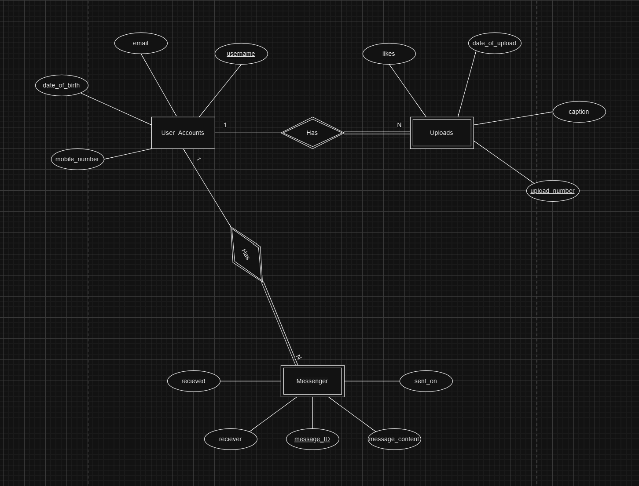
Normal Form:
Since all the table meets the required criteria for 1NF, 2NF and since there are no transitive dependencies for non-prime attributes all tables meet 3NF. User_Accounts is the only table that also meets the requirements for Boyce-Codd Normal Form.

