## **RIDOT BLUEBOOK INDEXING PROGRAM DOCUMENTATION PAGE**

## Main Description:

* The *RIDOT Bluebook Indexing Program* is designed to streamline access to both past and future editions of the RIDOT Bluebook PDFs. This program processes the information into an easy-to-use GUI, ensuring that retrieving data from any Bluebook year is convenient and efficient.

## Flowcharts:

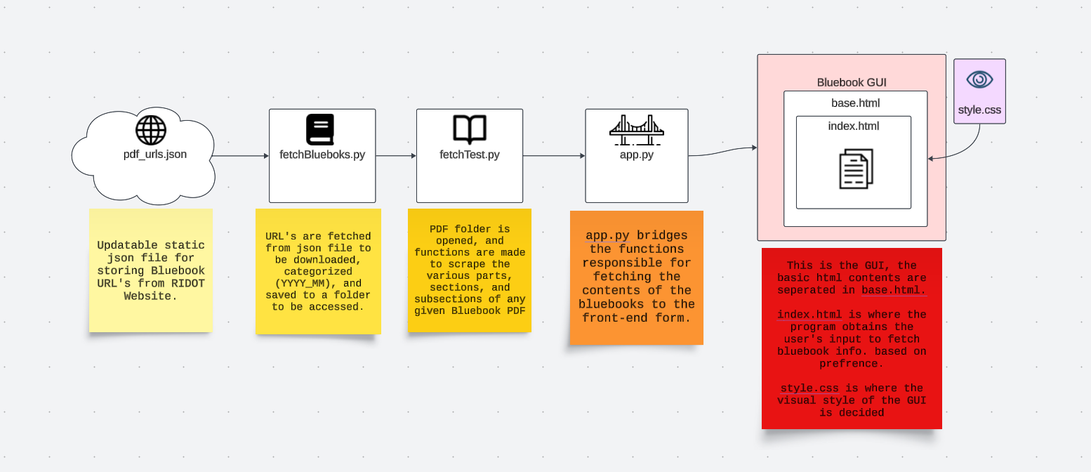

**This Flowchart illustrates the purpose of each file when the application is in use.**

## Functionality:

* **Web Stack:** 
  + *Flask:*Server used to host the web application
  + *Python:* Web functionalities are made with python scripts
  + *HTML:* Front-End functionalities are displayed as HTML Templates
  + *CSS:* Front-End Templates are styled with CSS files.
  + *JavaScript:* Front-End client-side functionalities are made with JavaScript.
* **PDF Fetch Functionality:**
  + *Downloading the PDF Files:*
  + *Re-Formatting PDF Files:*
  + *Storing PDF Files:*
* **Content Extraction Functionality:**
  + *Part Title Extraction:*
  + *Section Title Extraction:*
  + *Subsection Scanning:*
  + *Subsection Extraction:*
  + *Content Extraction:*
* **User Form Functionality:**
  + *Application Routing:*
  + *Front-End Form Requests:*

## Dependencies:

* **Libraries:**
  + *Fitz (PyMuPDF):* fetchTest.py specifically utilizes the PyMuPDF Library to carry out PDF scanning functionalities.

## Security:

* **Locality:**
* **Backend Flexibility:**

## Testing:

* **PDF Fetch Testing**
  + *fetchBluebook.py*
* **Content Extraction Testing:**
  + *fetchTest.py*
* **Unit Testing**
  + *unitTest.py*
* **Integration Testing**
  + *seleniumTest.py*

## History/Changes:

* ***Bluebook Info. App* (First Version)*:***
  + This version of the application is the most experimental version of the application
* **RIDOT Bluebook Index (Final Version)**
  + This was the second and final version of the application. This version was where I chose which web stack to use, and implemented the final functionality of the web app.

## Issues:

* **Future Bluebook PDF Formatting Changes?**
* **Where will it be Implemented?**
* **Will it require a back end?**
  + *If so, security improvements?*
* **Accounting for older bluebook versions?**
* **How implementing new bluebook versions will be managed?**

## Improvements:

* **Making a database to store future Bluebook PDF’s**
* **Security improvements**
* **Potential style changes**