Radar Target Generation and Detection

RADAR Specifications
First of all given RADAR specifications are written to the variables: MaxRange, RangeRes, MaxVel.

Chirp bandwidth is calculated by using the following formula:
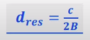

Chirp time is calculated by using the following formula:

Slope of the signal is calculated by using the following formula:


Modeling a target
A target is simulated in a loop, and transmit and received signals are modeled according to this moving target. Max range for the target is set to 200m since RADAR has range of 200m in maximum, and additionally target speed can be set to a value between [-70,70] since the RADAR has max speed of 70.

Transmit and receive signals are modeled by using the following equations respectively:
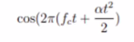
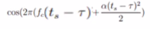

1D-FFT
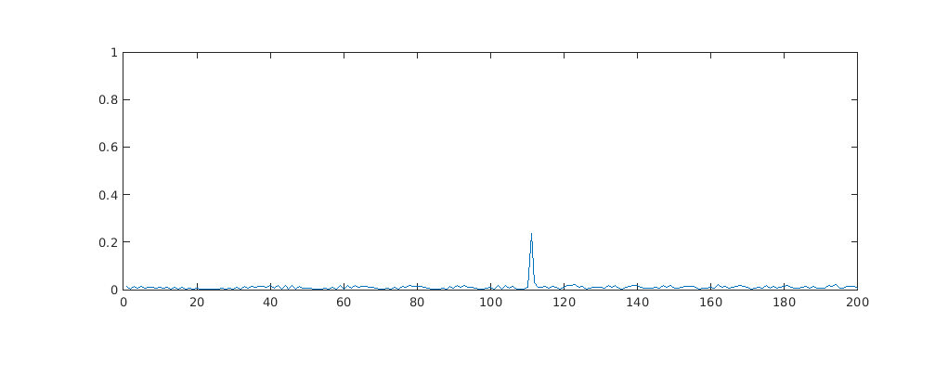
After obtaining the signals range measurement can be performed by using the output of 1-D FFT process. The output is shown in image below:

One can see that the range estimation is in the range of ~110m which is consistent with the given initial range in the code.

Range is calculated by using the shift in frequency, since shift in frequency changes with changing range.

2D-FFT
2D-FFT is used in order to obtain the Range-Doppler map. The output is given below the image:
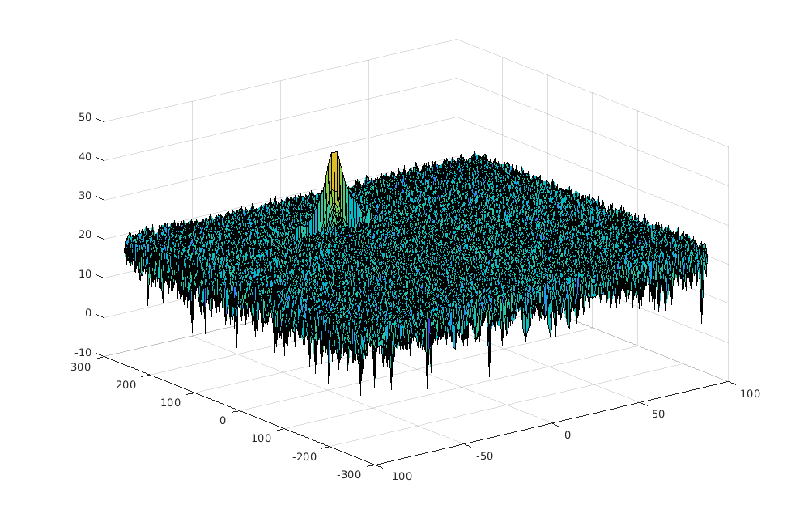

CFAR Implementation
CFAR is implemented in order to avoid from noise and apply adaptive thresholding.
Dimensions of training and guard cells for range and doppler axes are given as follows:
Tr = 16; Td = 8;
Gr = 8; Gd = 4
and offset is set to 6.
A window is created and moved along the 2D-FFT output. The dimensions are calculated by using the Tr, Td, Gr, and Gd, in range and doppler axes. In every iteration noise level is calculated for Cell Under Test (CUT) by summing the noise level in leading and lagging training cells. The difference of these two is the noise level. An offset is added to this noise level.
Noise level in CUT is checked against this calculated noise level. If the noise level is bigger from the calculated one, the noise level of CUT is set to 1 otherwise set to 0.
Moving the window overall window, target detection is performed and clutters are eliminated in this way.

