Passive-Only Counter-Surveillance Radar System
Engineering Design Book: silent passive coherent location and emitter geolocation on XCZU48DR, no transmitter of own

Document number | PCL-EDB-002
Revision | 1.0
Date | 2026-09-20
Platform baseline | AMD Zynq UltraScale+ RFSoC XCZU48DR (ZCU208 class)
Status | Engineering design book - issued for review
Companion documents | RAP-EDB-001 (integrated), GPR_SFCW v1.4, GPV ps-runtime + GPM v1.8

Number labelling convention: [validated] = bit-exact simulated or measured result from the GPM v1.8 / GPV artifact set; [derived] = closed-form result of an equation stated in this book; [budget] = design target or resource estimate pending implementation; [simulated] = figure produced by the seeded numpy models shipped with this book's generator. No figure or number in this book claims measured hardware data.

Document map and engineering scope
This book defines the PASSIVE-ONLY configuration of the counter-surveillance radar family: a silent receiver that detects, locates and classifies non-cooperative emitters and illumination echoes using broadcast waveforms of opportunity, with no transmitter of its own. It shares the passive sub-system design with RAP-EDB-001 (the integrated active-passive book) through a common shared section, and adds what only the standalone configuration can do best: very long coherent processing intervals, multi-node TDOA coherence across a site grid, and a forensic spectrum-surveillance mode with an evidence chain.
Part | Sections | Coverage
I | 2-4 | silent mission, standalone architecture, multi-node coherence
II | 5 | passive sub-system (shared design with RAP-EDB-001)
III | 6-8 | survey and evidence mode, long-CPI memory design, standalone software
IV | 9-12 | validation and acceptance, failure modes, traceability, references
App | A-B | operational procedures, glossary
Table 1.

Revision history
Rev | Date | Change
1.0 | 2026-09-20 | First issue; shares passive core with RAP-EDB-001 rev 1.0
Table 2.

Conventions
Identical to RAP-EDB-001: [validated]/[derived]/[budget]/[simulated] labelling, diagrams versus seeded simulations stated per caption, integer-only data contracts, and the rule that no adaptive structure ships without a golden model that can replay it.

Mission: silent counter-surveillance

What silence buys and what it costs
A receiver that never transmits cannot be found by a hostile RF-seeking sensor, cannot be jammed through its own emissions, and can listen continuously against covert emitters that no radar will ever see. That is the entire value proposition, and it is large: threat classes T1 (covert emitters) and T4 (hostile mapping radars) are observable only passively, and against T4 silence is survival. The costs are equally concrete and are stated here so that no operator expectation is wrong: no coverage against RF-silent targets (threat class T3 is out of scope by physics), range accuracy bounded by third-party bandwidth (750 m on FM, 19.7 m on DVB-T before geometry factors), dependence on broadcast infrastructure that can be switched off for maintenance, and 2-D fixes without a vertical baseline.

Operational profiles
Profile | Posture | Lane set | Notes
P-SENTRY | permanent silent site guard | 2 CAF lanes + emitter scan | hours-long CPIs where bandwidth allows
P-DEPLOY | rapid-deploy node on site grid | 1-2 CAF lanes + scan | battery/vehicle power, TDOA partner
P-HUNT | operator-directed emitter hunt | survey-first, lanes on demand | evidence chain primary output
Table 3.

Mission success criteria
- Every emitter of the site radio plan's exclusion list detected within one survey cycle at or above the sensitivity budget.
2. Every air track held across illuminator outages by lane re-rank without operator action.
3. Every fix and detection replayable offline from recorded IQ with identical hashes (forensic integrity).
4. Zero own radiation at any time, verifiable by an external spectrum monitor during acceptance.

Standalone architecture
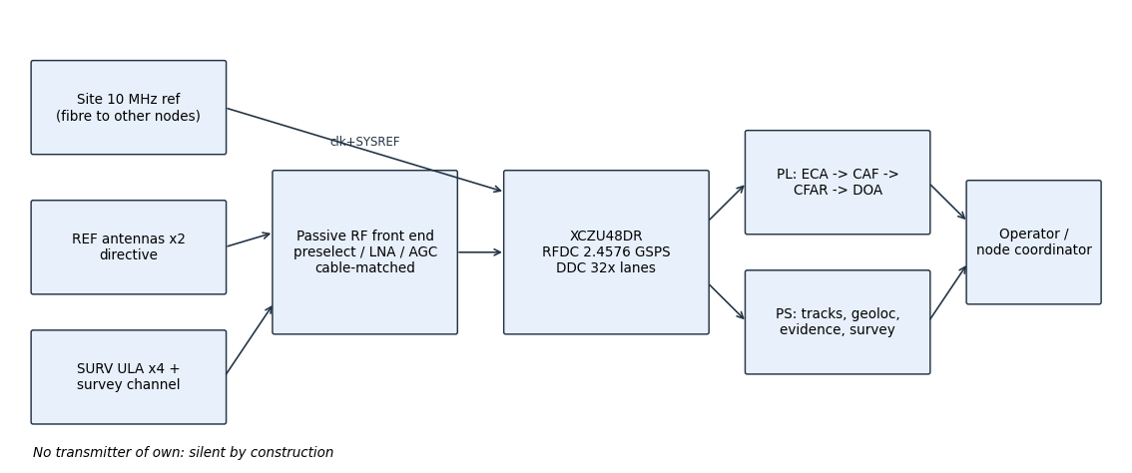
Figure 1. Master block diagram of the passive-only box: reference and surveillance fields, one RFSoC, PL cancellation/CAF/CFAR/DOA, PS tracking/geolocation/evidence, operator and node coordinator at the edge.

Channel set difference versus the integrated box
The standalone box has no active transmitter, therefore the AUX channel of the integrated design is repurposed as the wideband spectrum-survey channel (4x decimation option for zone-1 sweeps), and the own-TX blanking machinery of RAP-EDB-001 section 8 is absent: CPI scheduling is free, which is precisely why this configuration can run the 10-60 s FM CPIs that the integrated box must interrupt for dwells.
Channel | RFDC | Rate | Role here
REF-1/2 | t0 b0/b1 | 2.4576 GSPS, DDC 32x | illuminator copies
SURV-1..4 | t0 b2, t0 b3, t1 b0, t1 b1 | 2.4576 GSPS, DDC 32x | ULA, echoes, DOA
SURVEY | t1 b2 | 2.4576 GSPS, 4x-32x | zone-1 sweep and emitter slices
Table 4.

Power, enclosure, deployment
Silent operation removes TX power; the box power profile is RFSoC plus clock plant plus front-end [budget 60 W typical], which makes P-DEPLOY battery profiles practical for multi-hour tasks. The enclosure keeps the calibration coupler accessible because field re-calibration is a routine event, not a depot event.

Multi-node coherence and site grid
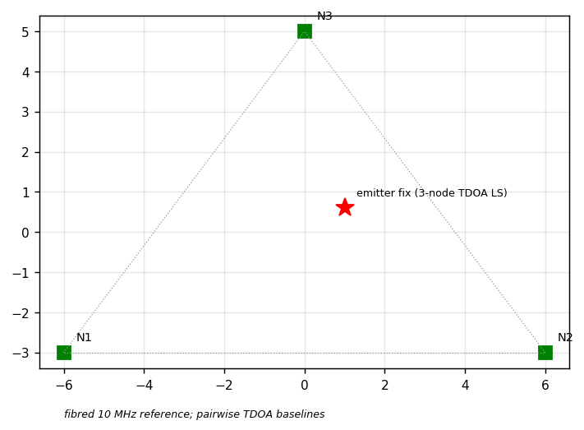
Figure 2. Three-node site grid on a fibred 10 MHz reference: pairwise TDOA baselines and a three-node least-squares emitter fix.

Why the reference distribution is the system
Single-node passive geolocation is an angle. Two nodes add a hyperbola. Three nodes make a fix. All of it depends on timestamps and carrier phase being comparable across nodes, which is a reference-distribution problem: the site grid fibres the 10 MHz reference (white-rabbit class [budget]) and every node's clock plant derives from it, so TDOA observables are coherent by construction and cue records associate without resynchronisation.

Degraded-mode policy
- Fibre fault: node falls back to single-node AOA fixes and marks every fix record accordingly; the coordinator stops fusing that node's TDOA contributions but keeps its AOA.
- Node loss: pairwise baselines re-solve automatically; fix covariances widen and the operator sees the widening, not a silent jump.
- Reference holdover at one node: that node suspends TDOA contribution (phase assumption void) while keeping local lanes with a degraded flag.
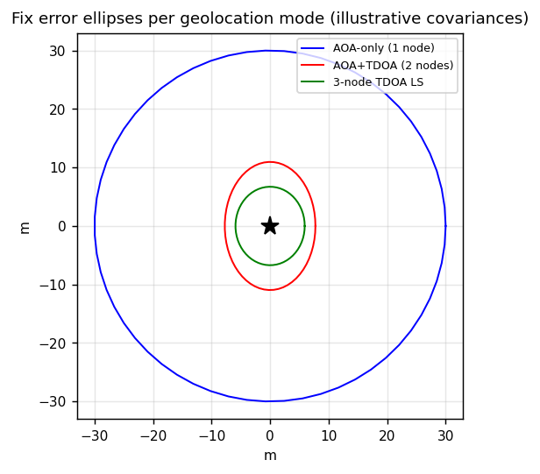
Figure 3. Illustrative fix error ellipses per geolocation mode; the reporting layer must carry these covariances, never a bare point.

Passive sub-system (shared design)

Illuminators of opportunity: waveform physics and selection

Why the waveform, not the receiver, sets passive performance
A passive coherent location (PCL) receiver transmits nothing; it borrows waveforms that broadcast operators emit for their own customers. Every performance attribute that a radar designer normally buys with waveform design - bandwidth, integration time, ambiguity shape - is therefore inherited from a third-party signal standard. The engineering task is to know each standard's ambiguity function precisely enough to predict range resolution, Doppler resolution and sidelobe behaviour, and then to build a cancellation and correlation chain that reaches those limits in fixed point on the RFSoC. This section states, per illuminator, the parameters that enter the passive radar equations used later: channel bandwidth B (range resolution), coherence behaviour over integration time T_int (Doppler resolution and processing gain G = B*T_int), and the ambiguity defects that the processing must tolerate or remove.
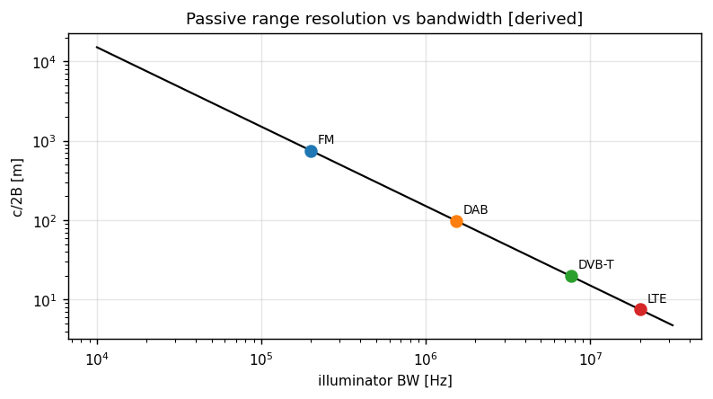
Figure 4. Passive range resolution c/(2B) versus illuminator bandwidth with the four candidate families marked [derived].
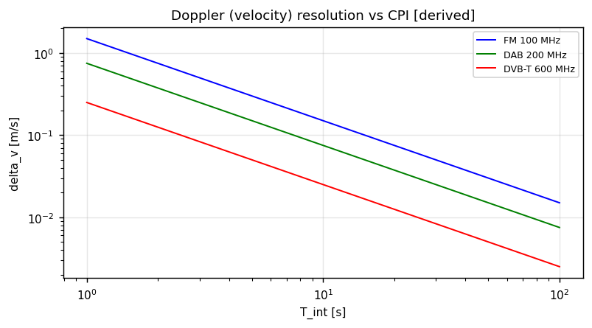
Figure 5. Velocity resolution lambda/(2*T_int) versus integration time for three carrier families [derived]. Narrowband illuminators buy fine Doppler with long CPIs.
delta_R = c / (2 B cos(beta/2)) (bistatic range resolution)
delta_fd = 1 / T_int ; delta_v = lambda / (2 T_int cos(beta/2))
G_caf = B * T_int (coherent processing gain)

FM broadcast (87.5-108 MHz)
FM radio is wideband in time but narrowband in spectrum: a 200 kHz channel gives c/(2B) = 750 m range cells, which is useless for fine range but irrelevant to the mission role FM actually serves. The analogue frequency modulation of the stereo composite baseband (L+R, 19 kHz pilot, L-R DSB-SC, RDS) makes the instantaneous bandwidth content-dependent, so the ambiguity function is a thumbtack riding on programme-dependent sidelobes. Long integration (10-60 s) averages those sidelobes down and yields Doppler resolution of a few tens of mHz: enough to separate a hovering rotary-wing target from transiting traffic by micro-Doppler sidebands. Engineering consequences: FM lanes are Doppler lanes. Range information from FM is only a coarse gate; the fusion engine must never weight FM bistatic range at face value. Programme sidelobes require CFAR guard cells sized in Doppler, not range, and reciprocal filtering is optional because T_int does the sidelobe work for free.

DAB / COFDM Band III (174-240 MHz)
DAB Mode I is continuous COFDM: 1536 subcarriers in 1.536 MHz, symbol duration 1.246 ms with a 246 us cyclic prefix, plus continuous and scattered pilots. The pilot structure is deterministic and known, which makes the ambiguity function nearly ideal after pilot handling: range resolution 98 m, and a clean periodic structure that must be suppressed in the reference channel equalisation to avoid pilot replicas in the range-Doppler map. DAB is the workhorse VHF track lane: continuous (no burst gaps), moderately wideband, and present in most European sites. Its carrier family also gives acceptable velocity resolution at 1-2 s CPI (about 0.6-0.3 m/s at 200 MHz).

DVB-T / COFDM UHF (470-862 MHz)
DVB-T in 8k mode with 7.61 MHz channel bandwidth is the finest civilian illuminator below 1 GHz: 19.7 m range cells. The defects are structural: the cyclic prefix creates a strong ambiguity ridge at delay tau = Tu (useful symbol length), and the scattered plus continuous pilots create replicas every symbol in delay and every carrier spacing in Doppler. Both are handled deterministically: CP-aware reference filtering (or explicit exclusion of the tau = Tu gate) and pilot-notch equalisation of the reference channel. Guard-interval choice by the broadcaster (1/4 to 1/32) changes Tu and hence the ridge position; the lane configuration must therefore read the TPS-decoded parameters of the local multiplex at lane setup, not assume them. This is a configuration input, verified by the lane health monitor.

LTE FDD downlinks (700-2600 MHz)
LTE downlink OFDMA offers 5-20 MHz of bandwidth (7.5-30 m range cells) with cell-specific reference signals that stabilise the ambiguity function, but the data traffic makes the instantaneous spectrum non-stationary: resource-block loading changes every 1 ms subframe. The reference channel must be spectrally whitened per subframe batch before correlation, otherwise the CAF inherits the traffic envelope as range sidelobes. LTE lanes are short-CPI lanes (0.2-1 s) and are the urban fine-resolution complement to DVB-T. FDD is mandatory for PCL convenience: the downlink is continuous in time, so no burst synchronisation is needed. TDD variants are explicitly excluded from the lane set in this revision.

GSM downlinks (900/1800 MHz)
GSM is retained only as a cross-check lane: 200 kHz channels give 750 m cells, and the 0.577 ms burst structure imposes Doppler ambiguities at multiples of 1.74 kHz. Its value is independence - a GSM cue that agrees with a DVB-T track is strong evidence against processing artefacts - not resolution.

Illuminator ranking and lane assignment policy
At start-up and on a re-rank period [budget 300 s], each candidate channel is measured for reference-channel SNR, CAF peak-to-sidelobe sharpness on a short probe integration, and persistence. Lanes are then assigned: one DVB-T or LTE lane as fine-range primary, one DAB or FM lane as long-CPI Doppler primary, and remaining capacity as hot spares. The ranking table is exported to the operator and logged with the evidence chain, because a lane change changes the error model of every track it feeds.
Illuminator | Band | B | c/(2B) [derived] | Typical CPI | Mission role | Principal ambiguity defect
FM | 87.5-108 MHz | 200 kHz | 750 m | 10-60 s | Doppler cue, micro-Doppler class | programme sidelobes
DAB | 174-240 MHz | 1.536 MHz | 98 m | 1-10 s | VHF track lane | pilot replicas
DVB-T | 470-862 MHz | 7.61 MHz | 19.7 m | 0.5-2 s | UHF fine-range lane | CP ridge at Tu, pilots
LTE FDD DL | 700-2600 MHz | 5-20 MHz | 30-7.5 m | 0.2-1 s | urban fine lane | traffic non-stationarity
GSM DL | 900/1800 MHz | 200 kHz | 750 m | burst-limited | independent cross-check | burst Doppler ambiguity
Table 5.

Passive RF front end and channelisation

Channel set and antenna architecture
The passive receiver needs, per site, two reference channels and four surveillance channels, plus one auxiliary channel whose role differs between the integrated and standalone configurations (own-TX monitor in the integrated box, wideband survey channel in the passive-only box). Reference antennas are directive elements aimed at the selected illuminators; their job is to deliver a target-free copy of the waveform, and the design rule is that target echoes entering the reference channel must stay at least 20 dB below the illuminator copy or the cancellation loop will subtract real targets (signal cancellation). Surveillance channels form a four-element uniform linear array. Element spacing is a band compromise [budget 0.5 lambda at 550 MHz with switchable coarse spacing for VHF]; the array feeds both DOA estimation and, by digital summing, an omnidirectional surveillance channel for lanes where DOA is not required.
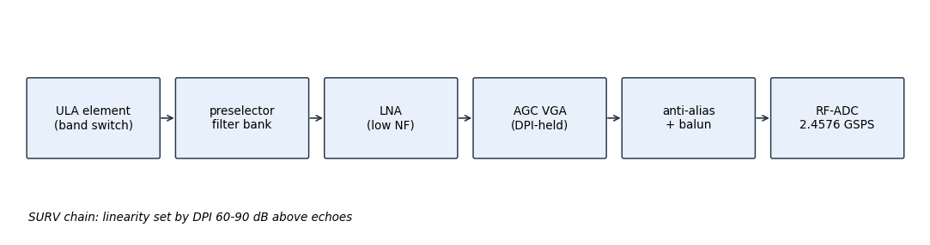
Figure 6. Surveillance chain: linearity is set by direct-path interference 60-90 dB above target echoes; AGC holds the RF-ADC below clipping on DPI, not on targets.
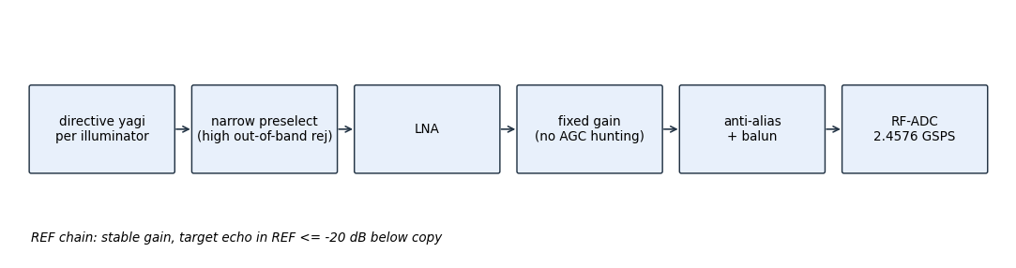
Figure 7. Reference chain: fixed gain, high out-of-band rejection, no AGC hunting; gain stability matters more than noise figure once the illuminator copy is far above noise.

Dynamic range and linearity budget
The surveillance chain's defining number is the direct-path interference level relative to the weakest target echo of interest. With a broadcast ERP of 10^4-10^5 W at a few to tens of km, DPI at the antenna can sit 60-90 dB above target echoes; the RF-ADC must see DPI below full scale with margin, and the target echoes must still clear the ADC noise floor after cancellation. This forces the gain plan: modest front-end gain, AGC referenced to the DPI envelope, and cancellation performed digitally at full converter resolution.
Quantity | Value | Basis
DPI above target echo at antenna | 60-90 dB | site geometry template [budget]
ADC full-scale margin on DPI | >= 6 dB | AGC hold rule [budget]
Post-cancellation noise floor target | k*T0*B*F + 3 dB | ECR >= 80 dB [budget]
RF-ADC SNR class (RFDC 14-bit) | adequate at 76.8 MS/s lane rate | converter spec [validated practice]
IP3 requirement driver | DPI + strongest out-of-band broadcast | preselector rejection first, then LNA IP3 [budget]
Table 6.

Cable matching, delay calibration and thermal behaviour
ECA cancellation works in taps of the reference channel; any differential delay between REF and SURV paths that exceeds the tap window is an uncancellable error. Cable lengths are matched at build to within one tap (13 ns at 76.8 MS/s), and the residual is measured with a coupled calibration tone and stored as a per-lane tap offset and complex gain correction. Thermal drift of coax and filters moves that differential delay slowly; the calibration loop re-runs on a thermal step trigger or on operator command, and the lane health monitor alarms if residual DPI power rises above the ECR budget between calibrations.
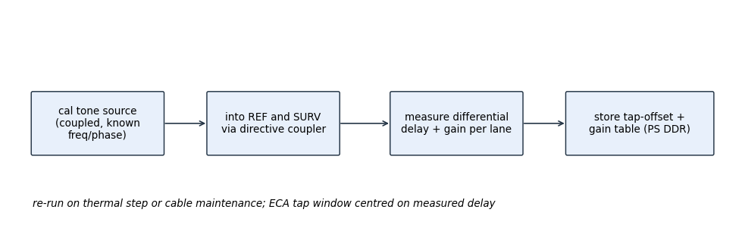
Figure 8. Calibration loop: coupled known tone into REF and SURV, measure differential delay and gain per lane, store tap-offset table in PS DDR.

RFDC channelisation and Nyquist zone plan
All passive ADCs sample at 2.4576 GSPS, half the validated active rate and an integer relative of the 245.76 MHz fabric clock family, so that active and passive lanes share one clock plant without fractional relationships. Nyquist zone 1 (DC-1.2288 GHz) contains FM, DAB and the whole DVB-T band; LTE downlinks at 1.8 and 2.6 GHz are taken in zones 2 and 3 with the RFDC digital down-converter tuned per channel. Decimation by 32 yields a 76.8 MS/s complex fabric rate per lane, ample for the widest 20 MHz LTE channel after channeliser filtering.
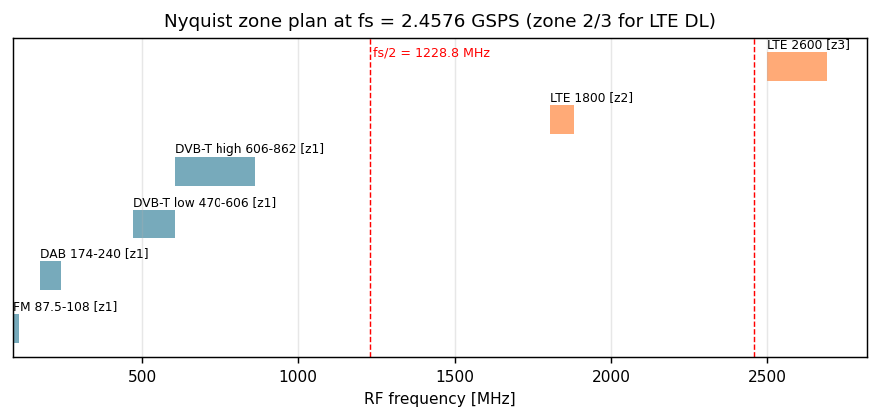
Figure 9. Nyquist zone plan at fs = 2.4576 GSPS: broadcast families in zone 1, LTE DL in zones 2-3 via per-channel DDC tuning.
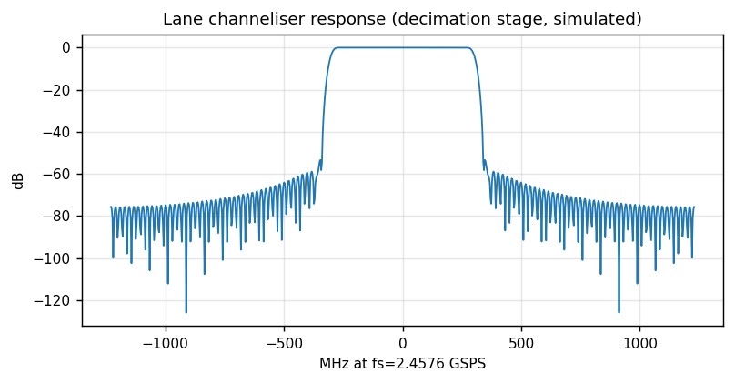
Figure 10. Lane channeliser magnitude response (decimation stage): adjacent-channel and zone-edge rejection before cancellation [simulated].
f_fabric = f_adc / D = 2.4576e9 / 32 = 76.8e6 samples/s per lane [derived]
Lane | RFDC channel | f_adc | DDC decim | fabric rate | Content
REF-1 | ADC t0 b0 | 2.4576 GSPS | 32x | 76.8 MS/s | illuminator k copy
REF-2 | ADC t0 b1 | 2.4576 GSPS | 32x | 76.8 MS/s | illuminator m copy
SURV-1..4 | t0 b2, t0 b3, t1 b0, t1 b1 | 2.4576 GSPS | 32x | 76.8 MS/s | ULA elements
AUX | t1 b2 | 2.4576 GSPS | 4x-32x | 76.8-614.4 MS/s | TX monitor or survey
Table 7.

Interference and clutter cancellation

The two cancellation problems
Before any correlation gain can be realised, the surveillance channel must be cleaned of (a) direct-path interference - the illuminator seen straight into the surveillance antenna - and (b) static and slow clutter: ground, buildings and antenna-to-antenna leakage, which occupies the zero-Doppler ridge and its Doppler-spread skirt. Both are linear in the reference waveform, so both are removed by least-squares projection of the surveillance data onto a subspace spanned by delayed (and, for clutter, Doppler-shifted) copies of the reference. The batch form of this projection is the Extensive Cancellation Algorithm. It is chosen deliberately over adaptive filters: a batch least-squares solve has deterministic numerical behaviour, can be golden-modelled in fixed point exactly like the validated active chain, and maps onto BRAM-resident block processing with known latency.
x_clean[b] = x_surv[b] - sum_{m=0}^{M-1} w_m * x_ref[b-m], w = argmin ||x_surv[b] - X w||^2
residual_clutter[b, f_d] = x_clean[b] - <x_ref e^{j2pi f_d t}, x_clean> / ||.||^2 * x_ref e^{j2pi f_d t}

Tap count, batch length and ECR budget
The tap count M must span the differential multipath delay spread seen by the surveillance antenna plus the calibrated cable offset; batch length must be short enough that the multipath impulse response is quasi-static within a batch, and long enough that the least-squares solve has overwhelming degrees of freedom. With 76.8 MS/s lanes and 0.1-0.5 s batches the solve is heavily over-determined for M <= 32, and the achievable ECR is limited by reference-channel noise and fixed-point word length, not by degrees of freedom. The system budget requires ECR >= 80 dB: DPI up to 70 dB above target echoes plus 10 dB margin so that post-cancellation residue sits below the thermal floor. Fixed-point analysis (section on CAF word length) shows the accumulator and tap paths must hold about 80 dB of dynamic range between DPI and residue, which sets 32-bit complex taps and 40-bit accumulation in the canceller back end [budget].
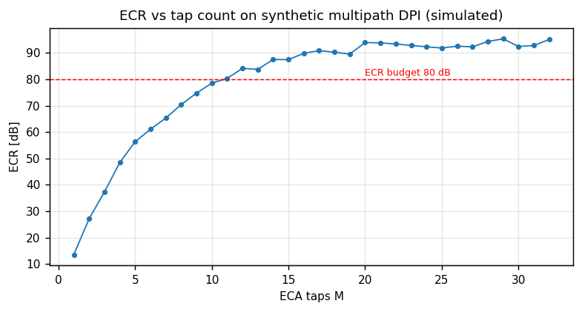
Figure 11. Simulated ECR versus tap count on synthetic multipath DPI: the 80 dB budget is reached well inside M = 32 [simulated].
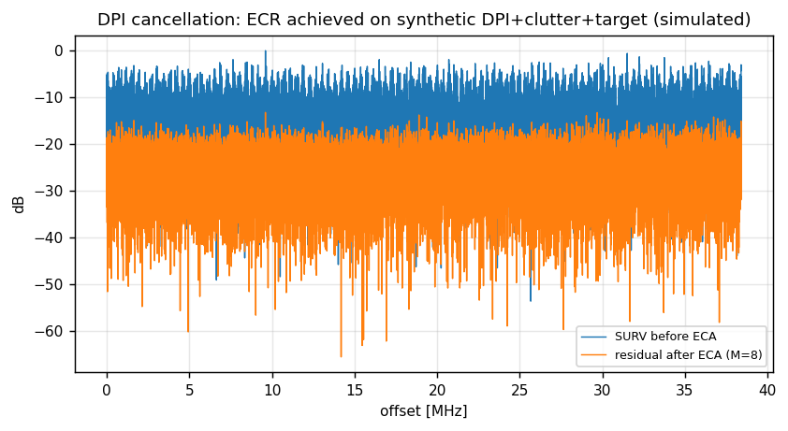
Figure 12. SURV spectrum before and after ECA on synthetic DPI + clutter + a weak planted target: the target survives, the interferer does not [simulated].
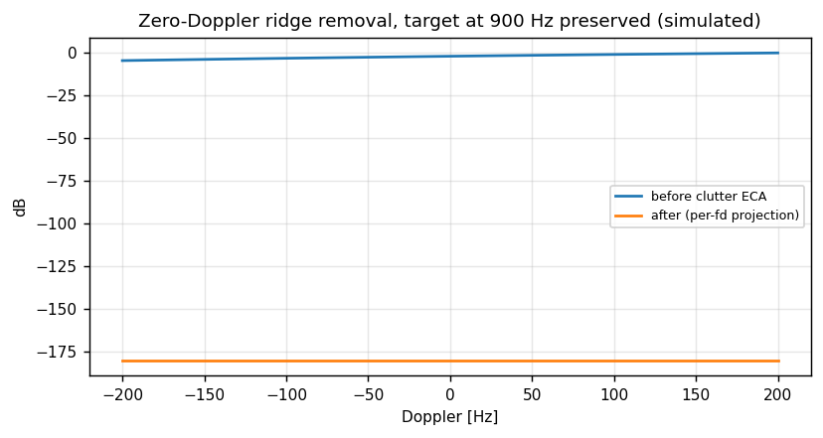
Figure 13. Zero-Doppler and slow-clutter ridge before and after per-Doppler projection; a 900 Hz target echo is preserved [simulated].

Reference-channel health and signal cancellation
If the reference channel contains target echo energy (reference antenna sidelobes pointing at the target), the cancellation loop treats that echo as interference and subtracts it from surveillance - the classical signal-cancellation failure. Defences are layered: directive reference antennas (geometric), a reference-to-surveillance echo monitor that compares CAF peak strength in REF versus SURV (analytic), and a policy rule that a lane whose REF echo monitor exceeds -20 dB is flagged degraded and excluded from detection until re-aimed.
Failure | Mechanism | Observable | Defence
Signal cancellation | target echo in REF | CAF peak suppression/split | REF echo monitor, directivity
Uncancellable DPI | delay beyond tap window | residual ridge at zero bistatic range | cable cal, tap window alarm
Clutter skirt residue | Doppler-spread clutter | raised floor near zero Doppler | per-f_d projection count
Co-channel second transmitter | two waveforms in one lane | second CAF ridge family | whitening, lane re-rank
Table 8.

Cross-ambiguity function and range-Doppler formation

Definition and batch structure
After cancellation, each lane correlates the cleaned surveillance stream against delayed and Doppler-shifted copies of its reference:
chi(tau, f_d) = sum_t x_surv_res[t] * conj(x_ref[t - tau]) * exp(j 2 pi f_d t)
Implementation is the standard two-step: per batch, range compression by frequency-domain correlation (FFT of reference, multiply, IFFT) producing a delay profile per Doppler shift, then a Doppler FFT across batches per delay gate. The range-Doppler map page for a lane is the detection surface; its axes are bistatic range gate and Doppler bin, and its noise floor is set by cancellation residue and CAF word length, not by thermal noise alone.
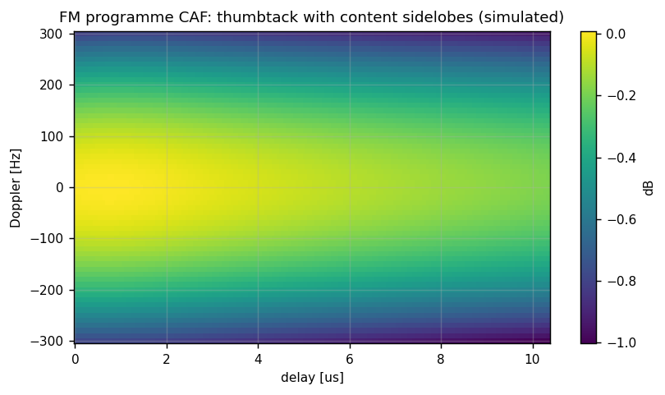
Figure 14. FM programme CAF: thumbtack peak with content-dependent sidelobes that long integration averages down [simulated].
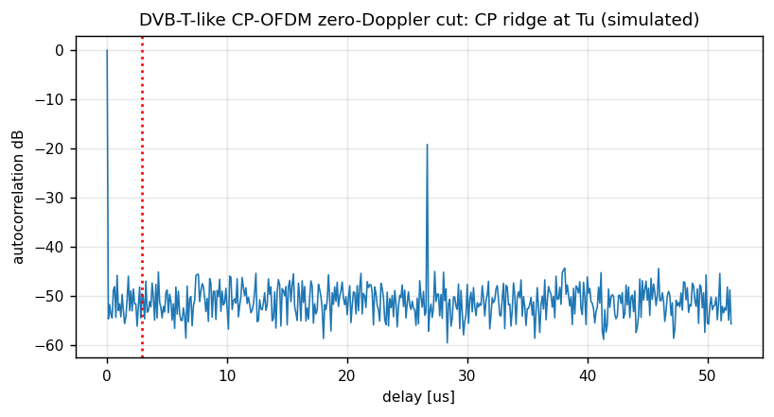
Figure 15. CP-OFDM zero-Doppler delay cut showing the cyclic-prefix ridge at tau = Tu that the lane must gate or filter [simulated].
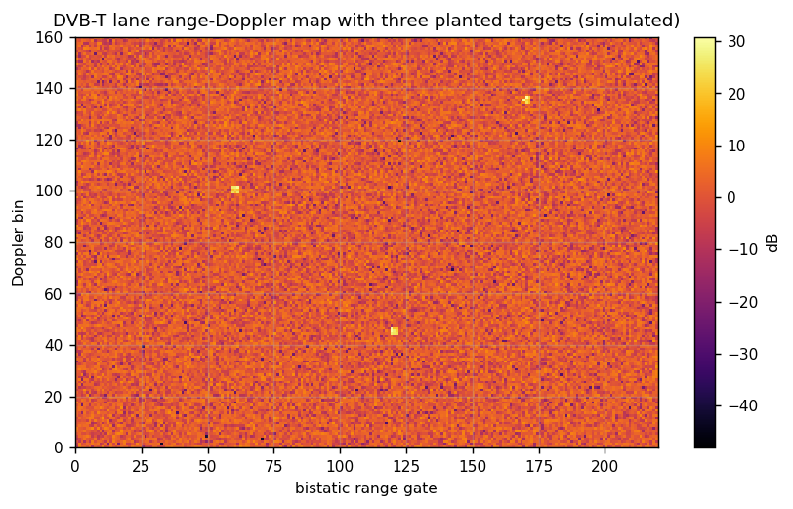
Figure 16. DVB-T lane range-Doppler map with three planted targets after cancellation and CFAR-preprocessing [simulated].
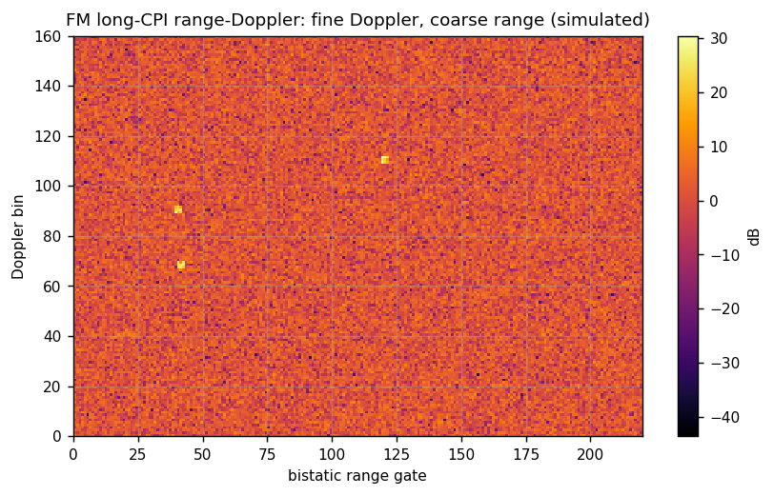
Figure 17. FM long-CPI range-Doppler map: coarse range, very fine Doppler; micro-Doppler sidebands live in this view [simulated].

Processing gain, coherence and word length
The coherent gain G = B*T_int is the reason passive radar works at all: 63-70 dB across the candidate set. Two error terms eat it: clock/coherence phase drift across T_int, and fixed-point quantisation in the correlation accumulator. Because all channels share one clock plant, the drift term is a plant specification rather than a per-receiver error; the derived loss curve below converts an Allan deviation at 1 s into CAF gain loss at 600 MHz and shows why a common ovenised or GPS-disciplined plant is sufficient by orders of margin. Quantisation is analysed the same way as in the validated active chain: the accumulator word length is swept in the golden model and the CAF gain loss is measured against the floating-point reference; the book's budget is <= 1 dB loss, met at 40-bit complex accumulation for DVB-T-class lanes [simulated].
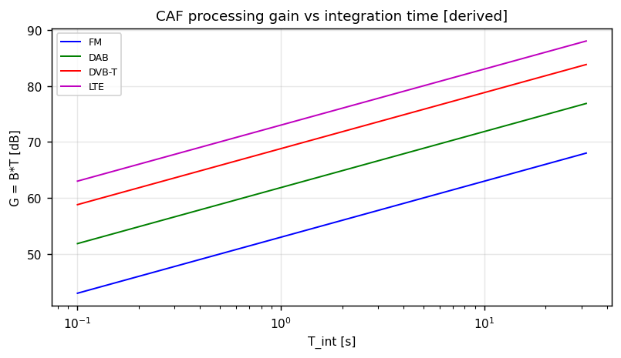
Figure 18. CAF processing gain B*T_int versus integration time per illuminator family [derived].
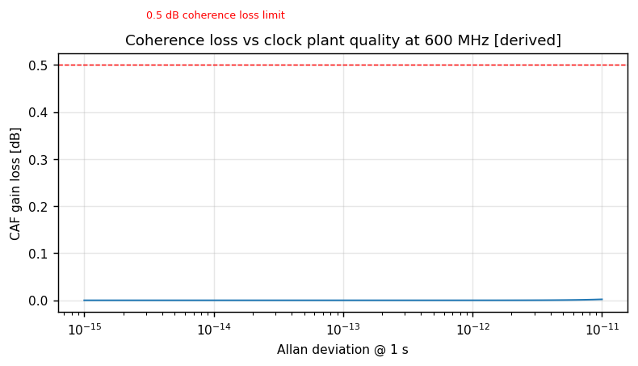
Figure 19. CAF gain loss versus clock plant Allan deviation at 600 MHz, T_int = 1 s: the shared plant sits far left of the 0.5 dB limit [derived].
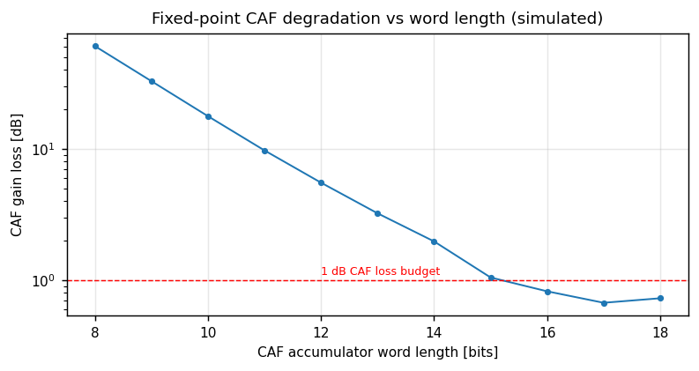
Figure 20. Fixed-point CAF degradation versus accumulator word length with the 1 dB budget line [simulated].

Ambiguity defect handling per lane
- DVB-T: exclude or CP-filter the tau = Tu gate; notch scattered/continuous pilots in REF equalisation; read TPS parameters at lane setup.
- FM: accept programme sidelobes; size CFAR guard in Doppler; optional reciprocal filtering when T_int < 5 s.
- DAB: suppress pilot replicas by REF equalisation; verify Mode I parameters from the FIC.
- LTE: per-subframe spectral whitening of REF; reject subframes with reference-signal muting anomalies.
- GSM: burst-aligned correlation windows only; Doppler ambiguity map applied at tracker level.

Detection, DOA and tracking

Two-dimensional CA-CFAR on the range-Doppler map
Detection mirrors the validated active chain's discipline: cell-averaging CFAR on the log-magnitude map with guard and training rings sized per lane (guard 2x2, train 8x8 cells [budget]), Pfa 1e-6, and a deterministic threshold multiplier computed from the training count exactly as in the active CFAR so that the fixed-point threshold path is golden-modelable. Detections carry (lane id, bistatic range gate, Doppler bin, DOA estimate, SNR above threshold, frame timestamp from the common clock).
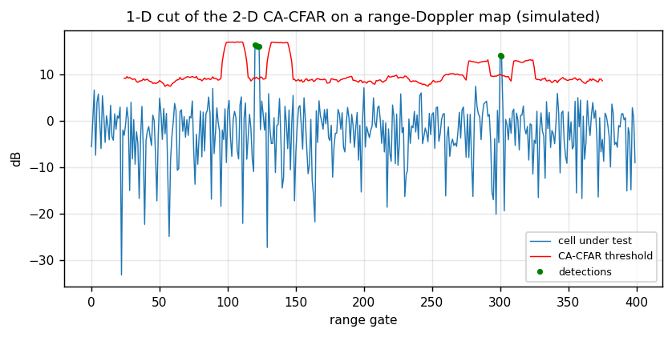
Figure 21. One-dimensional cut of the 2-D CA-CFAR statistic and threshold on a simulated range-Doppler map: planted cells detected, noise floor held [simulated].

Direction of arrival on the surveillance array
Per detected cell the four-element ULA provides an angle: beamscan by default (steered sums over the spatial spectrum, robust and cheap), with MUSIC available when two emitters or two targets share a range-Doppler cell and the snapshot covariance rank supports it. The CRLB-form accuracy relation below is carried in the track covariance from the first update:
sigma_theta ~= lambda / (2 pi d cos(theta) sqrt(2 SNR N_snap)) [derived]
Array calibration (mutual coupling, element gain/phase) is measured with a far-field source of opportunity at commissioning and stored per band; the DOA health monitor compares beamscan and MUSIC peaks where both run and alarms on disagreement beyond 2 sigma.
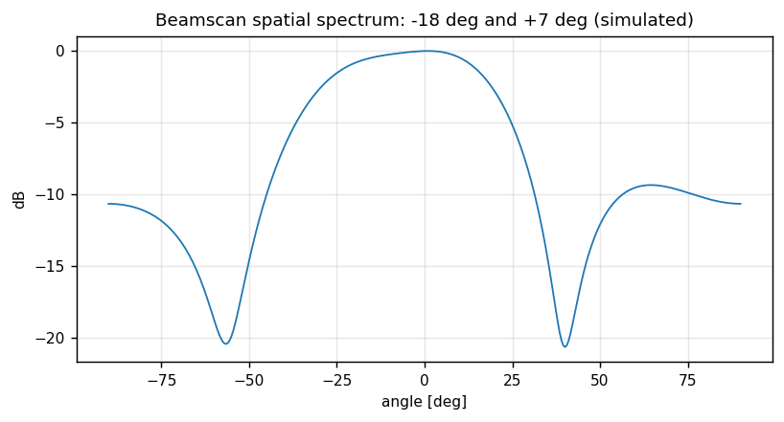
Figure 22. Beamscan spatial spectrum with two sources at -18 and +7 degrees on the 4-element ULA [simulated].
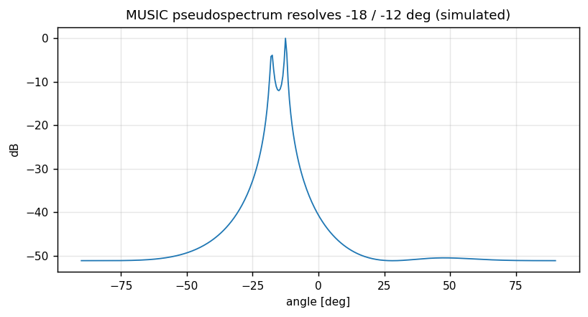
Figure 23. MUSIC pseudospectrum resolving a -18 / -12 degree pair that beamscan merges [simulated].

Bistatic tracking and micro-Doppler
Each lane runs a UKF in bistatic coordinates (bistatic range, range rate, DOA) with conversion to site Cartesian at fusion. Narrowband lanes add a micro-Doppler descriptor: the Doppler cut series around a track is inspected for rotor sideband combs, which is the primary rotary-wing cue on FM/DAB lanes where range is coarse.
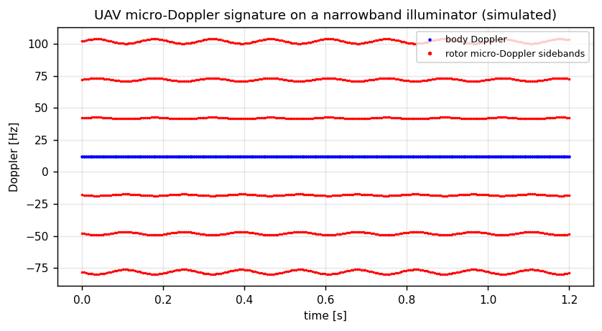
Figure 24. Simulated UAV micro-Doppler sideband comb around the body Doppler on a narrowband illuminator; the descriptor is the comb spacing and its modulation [simulated].

Emitter geolocation (passive-only observable)
Cooperative-free geolocation of emitters (covert transmitters, hostile radars) uses the emitter's own waveform: wideband correlator DOA on the surveillance array for angle, and - with a second node on the site grid - TDOA from the common-referenced timestamps for a hyperbolic line of position. Single-node fixes are AOA-only and are reported with an explicitly unbounded range covariance; the fusion and reporting layers must never present an AOA-only fix as a position.
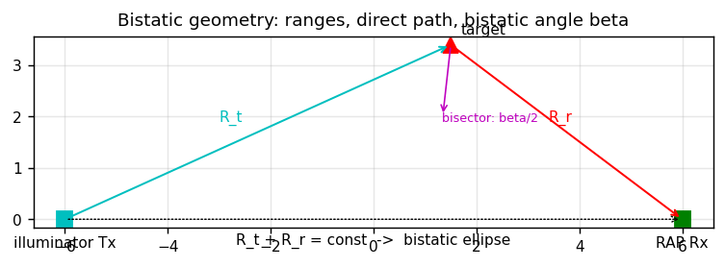
Figure 25. Bistatic geometry: illuminator, target and receiver; constant R_t + R_r defines the bistatic ellipse and the beta/2 bisector scaling of resolution.
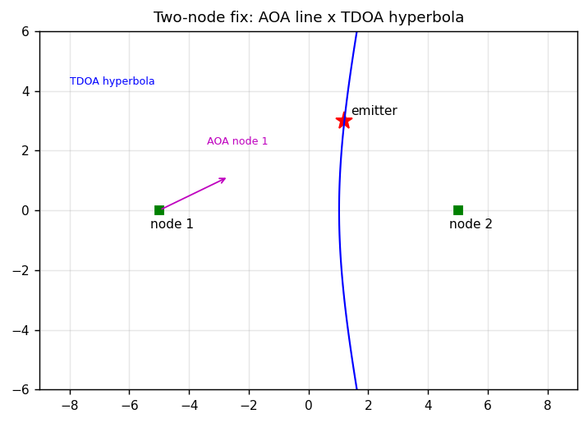
Figure 26. Two-node emitter fix: AOA line from node 1 intersecting the TDOA hyperbola between nodes.
Figure 27. Illustrative fix error ellipses: AOA-only, AOA+TDOA and three-node TDOA least squares.

Passive chain block-by-block explanation

P01 Channeliser and lane formatter
Purpose: take the 76.8 MS/s complex lane streams from the RFDC DDCs, apply channeliser filtering and per-lane digital gain, and format fixed-point frames for the cancellation stage. Inputs: six lane streams plus lane configuration (gain, filter set, mute map). Outputs: framed Q1.15-ish scaled complex samples with per-frame scale exponent so that DPI-dominated frames do not clip downstream. Determinism: FIR/CIC structure identical per lane; latency constant and reported in the lane status word. Failure signature: scale exponent saturation alarms; filter coefficient checksum mismatch halts the lane. Validation: tb_chan tone placement and group delay against golden ROM.

P02 Reference conditioning
Purpose: equalise the reference channel (pilot notch, CP-aware filter, LTE whitening coefficients) and produce the clean waveform copy that all projections use. Inputs: REF lane, lane parameter set decoded from the standard (TPS/FIC/CRS configuration). Outputs: conditioned reference stream plus a reference health word (power, spectral flatness, echo-monitor metric). Failure signature: flatness metric collapse indicates wrong lane tuning or transmitter fault. Validation: tb_refcond pilot replica suppression on golden DVB-T/DAB ROMs.

P03 ECA direct-path canceller
Purpose: batch least-squares subtraction of delayed reference copies from surveillance (M taps, batch 0.1-0.5 s). Inputs: SURV frame, conditioned REF frame, tap window centre from cable calibration. Outputs: DPI-clean frame, achieved residual power per batch (ECR monitor), tap weights for PS readback. Fixed point: 32-bit complex taps, 40-bit accumulation, normal-equation solve supervised by PS with PL residual application [budget]. Failure signature: residual power above budget => lane degraded flag. Validation: tb_eca bit-exact ECR on synthetic DPI ROM.

P04 Clutter canceller
Purpose: remove zero-Doppler and slow-clutter ridge by projecting out Doppler-shifted reference copies across the clutter Doppler span. Inputs: P03 output, clutter span configuration. Outputs: clutter-clean frame, per-f_d projection count. Failure signature: raised map floor near zero Doppler. Validation: tb_eca clutter case in the same ROM set.

P05 CAF range compression
Purpose: frequency-domain correlation of cleaned surveillance against conditioned reference per batch, producing delay profiles. Inputs: P04 output, REF. Outputs: delay profiles per Doppler step batch; CP gate mask applied per lane. Fixed point: 40-bit complex accumulation, block-floating-point per FFT stage. Failure signature: CP ridge leakage alarm on DVB-T lanes. Validation: tb_caf peak position and gain versus pcl_chain_ref ROM.

P06 Doppler formation
Purpose: Doppler FFT across batches per delay gate; window selectable (rectangular for maximum resolution, Blackman-Harris when sidelobe control dominates). Outputs: range-Doppler map page to DDR and to P07. Failure signature: batch count shortfall (blanking) flagged in page header. Validation: tb_caf Doppler axis checks.

P07 Two-dimensional CFAR
Purpose: CA-CFAR on log-magnitude map with lane-specific guard/train; deterministic multiplier. Outputs: detection list records. Failure signature: detection rate vs Pfa monitor divergence. Validation: tb_cfar2d noise-only Pfa and planted-target Pd.

P08 DOA estimator
Purpose: beamscan (default) or MUSIC (on demand) per detection cell using the four SURV element snapshots retained around the cell. Outputs: angle + spatial spectrum quality word. Failure signature: beamscan/MUSIC disagreement alarm. Validation: tb_doa angle error vs CRLB trend ROM.

P09 Emitter detector and classifier
Purpose: on the survey/AUX channel and on wideband slices, detect non-cooperative emitters, estimate features (bandwidth mask, modulation family, burst/PRI structure, micro-Doppler comb) and emit class likelihood vectors. Outputs: emitter event records. Failure signature: confidence below policy => record stays 'unresolved cluster', never forced. Validation: tb_survey + classification reference traces.

P10 Bistatic tracker
Purpose: per-lane UKF in bistatic coordinates with micro-Doppler descriptor attachment. Outputs: lane tracks with covariances. Validation: tb_track scenario traces vs fusion_ref.

P11 Geolocation engine
Purpose: AOA/TDOA combination per emitter event across nodes; covariance from CRLB forms; 2-D fixes with honest altitude-unbounded covariance. Outputs: emitter fixes. Validation: tb_tdoa two-node timestamp association and fix error.

P12 Evidence and health recorder
Purpose: attach SHA-256 hashes of IQ snippets and metadata to every detection/fix record; maintain lane health history (ECR monitor, REF echo monitor, scale exponents, calibration age). Outputs: evidence records and health pages. Validation: replay audit test (hash equality on reprocess).

Signal-domain views: how to read the passive figures

Per-illuminator ambiguity surfaces
The four CAF surfaces below are the single most important commissioning reference: a lane whose measured surface does not resemble its family template is mis-tuned, contaminated, or observing a different transmitter than the reference antenna believes. Compare shape first, peak second: the DVB-T lane must show the CP ridge at Tu and pilot replicas; the LTE lane must show traffic-weighted granularity that whitening flattens; the GSM lane must show the burst-train Doppler comb; the DAB lane must be the cleanest thumbtack of the set.
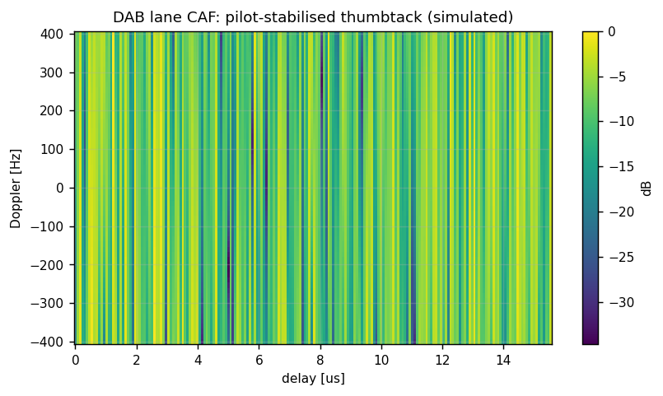
Figure 28. DAB lane CAF template: pilot-stabilised thumbtack, replicas at symbol periodicity [simulated].
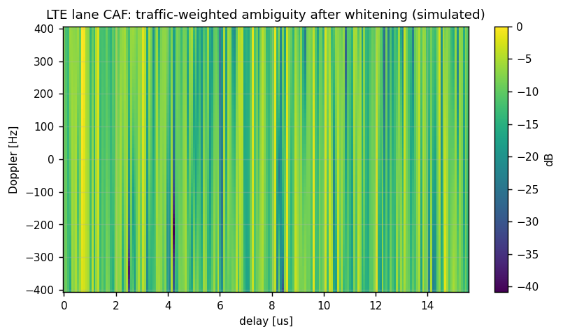
Figure 29. LTE lane CAF template after per-subframe whitening: fine delay cells, traffic granularity visible as mild ridge noise [simulated].
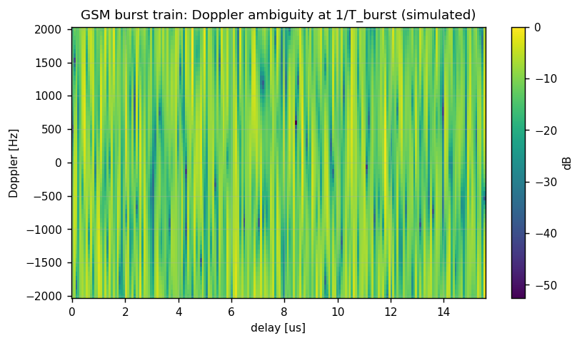
Figure 30. GSM burst train template: Doppler ambiguity combs at multiples of 1/T_burst; range axis nearly uninformative [simulated].

Range-Doppler map families
A range-Doppler map page is the detection surface and the operator's primary passive picture. The three families differ in axis meaning: DVB-T and LTE pages carry usable bistatic range; DAB pages carry usable range only as a gate; FM pages (previous section) are Doppler instruments. Planted-target templates below define what a healthy page looks like after cancellation: flat noise floor, point-like targets, no zero-Doppler skirt, no CP ridge leakage.
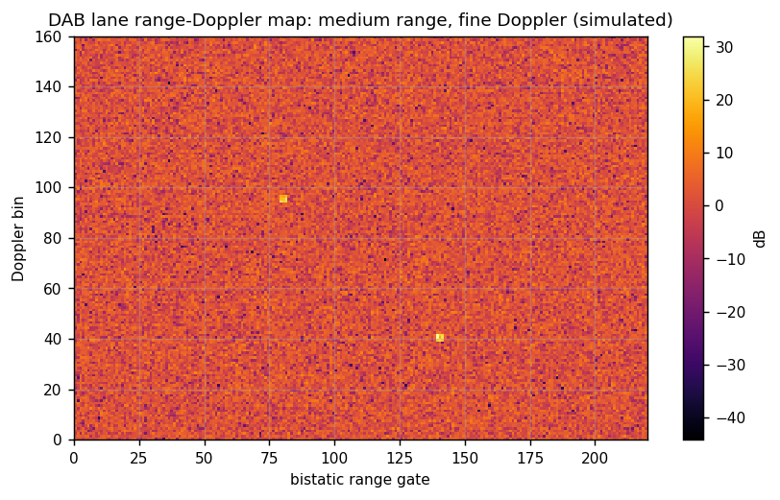
Figure 31. DAB page template: medium range cells, fine Doppler, two planted targets [simulated].
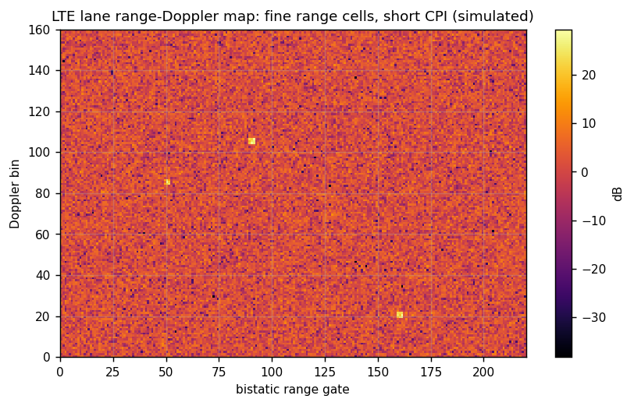
Figure 32. LTE page template: fine range cells at short CPI, three planted targets [simulated].
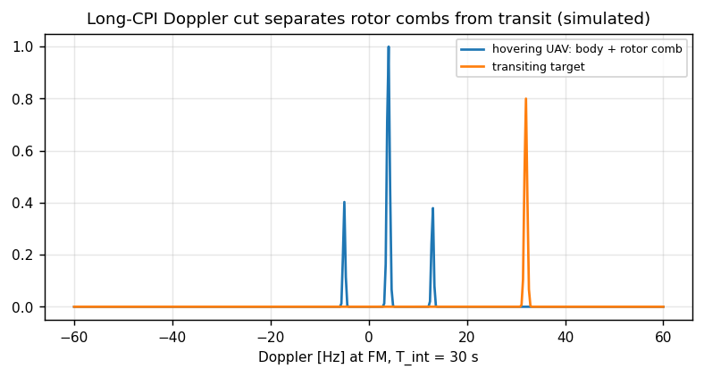
Figure 33. FM long-CPI Doppler cut: hovering rotary-wing target shows a rotor comb around the body line; transiting targets show a single narrow line [simulated].

Front-end behaviour views
Two views explain the front end to anyone who has never seen DPI: the AGC hold view shows why the converter is never allowed to see the interferer near full scale, and the reference pattern view shows the geometric guard against signal cancellation.
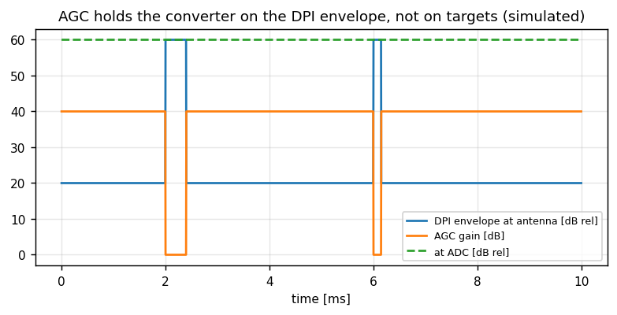
Figure 34. AGC envelope hold on DPI pulses: converter input held flat while antenna-level interference swings 40 dB [simulated].
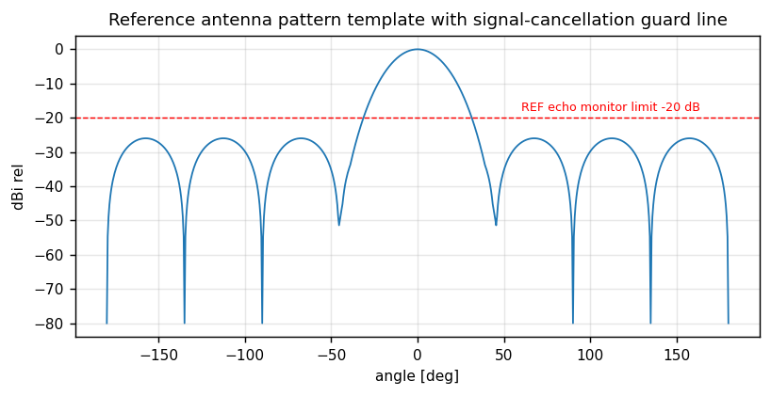
Figure 35. Reference antenna pattern template with the -20 dB echo-monitor guard line that protects against signal cancellation.
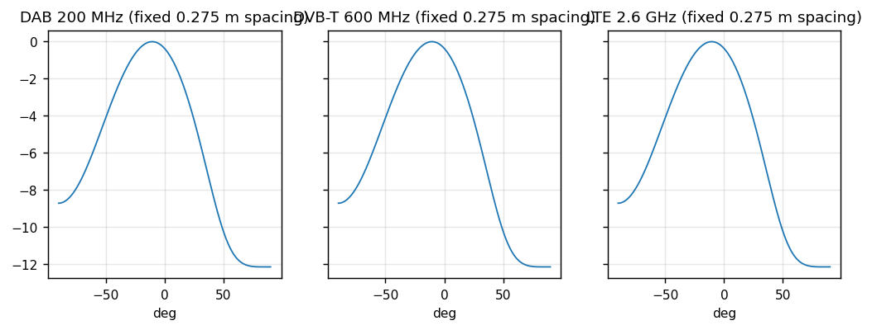
Figure 36. DOA beamwidth versus carrier for fixed 0.275 m element spacing: VHF broadens, LTE narrows; band-switched spacing policy follows from this chart [simulated].

Passive validation hooks and gates
Gate | Content | Pass criterion
G0 | golden ROM export from passive_channel_sim.m / pcl_chain_ref.m | plan and rounding cross-check PASS
G1 | tb_chan, tb_refcond, tb_eca | bit-exact vs ROM
G2 | tb_caf, tb_cfar2d, tb_doa | bit-exact or within stated LSB bounds
G-RES | out-of-context synthesis of passive lane | within DSP/BRAM budget table
G3 | integrated regression (active unchanged) | active 10/10 + passive TBs PASS
G4 | cable loopback: CAF peak at cable delay/Doppler | peak within 1 gate / 1 bin
G5 | field: ECR survey, illuminator ranking, cue timeline | budgets met, logs complete
Table 9.

Passive chain configuration and status tables (per block)

P01 Channeliser configuration
Field | Bits | Meaning
lane_gain[k] | 12 | digital gain per lane, dB code
filt_set[k] | 4 | channeliser filter bank index per band
mute_map | 6 | lane mute mask
scale_exp_mon | RO | block-floating-point exponent per frame
Table 10.

P02 Reference conditioning configuration
Field | Bits | Meaning
std_id | 4 | FM/DAB/DVB-T/LTE/GSM parameter set
pilot_notch_en | 1 | pilot replica notch in REF equaliser
cp_filter_en | 1 | CP-aware filter (DVB-T)
whiten_en | 1 | per-subframe whitening (LTE)
flatness_mon | RO | spectral flatness metric, alarm threshold in PS
Table 11.

P03 ECA canceller configuration and status
Field | Bits | Meaning
taps_M | 6 | tap count per lane
batch_code | 4 | batch length code (0.1-0.5 s)
tap_centre[k] | 10 | cable-calibrated delay centre per lane
ecr_mon[k] | RO 20 | residual power per batch, dB code
tap_weights_rd | DMA | PS readback of solved weights per batch
Table 12.

P04 Clutter canceller configuration
Field | Bits | Meaning
fd_span | 8 | clutter Doppler span code
fd_step | 8 | projection spacing code
proj_count | RO | projections applied per batch
Table 13.

P05/P06 CAF configuration
Field | Bits | Meaning
tint_code | 4 | integration time code per lane family
batch_count | 12 | batches per map page
dop_span | 12 | Doppler search span code
window_sel | 3 | rectangular / Blackman-Harris / Hamming
cp_gate_mask | 16 | excluded delay gates (DVB-T Tu ridge)
accum_wordlen | 6 | complex accumulator word length (40 default)
Table 14.

P07 CFAR configuration
Field | Bits | Meaning
guard_xy | 8 | guard ring cells per axis
train_xy | 8 | training ring cells per axis
pfa_code | 8 | threshold multiplier index (deterministic table)
det_rate_mon | RO | detections per page vs Pfa monitor
Table 15.

P08 DOA configuration
Field | Bits | Meaning
mode | 2 | beamscan / MUSIC / both
cal_table_idx | 4 | per-band array calibration table
disagree_mon | RO | beamscan vs MUSIC disagreement, sigma code
Table 16.

P09-P12 services (PS-side configuration)
Field | Register | Meaning
survey_mask_idx | SURVEY_PLAN | site radio plan occupancy mask version
class_policy_conf | EMCON_POLICY/evid | confidence floor below which class stays unresolved
ring_drop_flags | PASS_STATUS | long-CPI ring overrun history
hash_algo_id | EVID | SHA-256 identifier in evidence headers
Table 17.

Spectrum survey and evidence mode (P-HUNT)

Sweep architecture
The survey channel sweeps Nyquist zone 1 (0-1228.8 MHz) in fabric-rate slices, building spectrogram pages in PS. Detection runs log-mean CFAR across frequency against an occupancy mask of the site radio plan (known-friendly emitters); anything outside the mask, or any mask member whose mask shape has changed, becomes an emitter event.
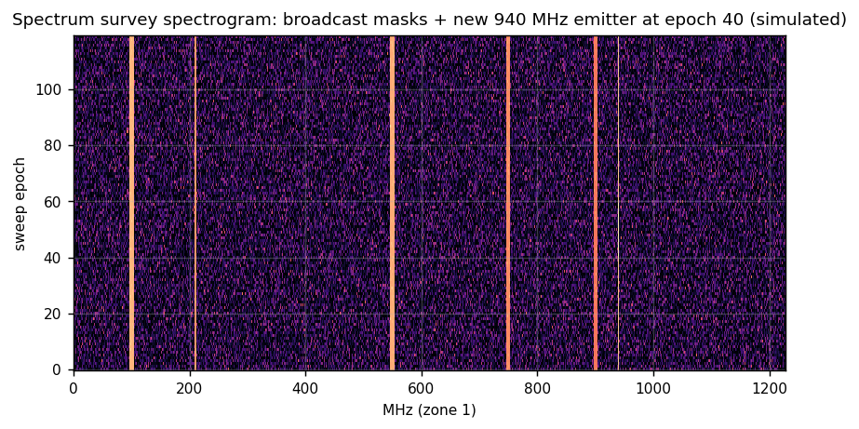
Figure 37. Simulated survey spectrogram: broadcast masks plus a new narrowband emitter appearing at 940 MHz at epoch 40 - the event the sweep exists to catch [simulated].
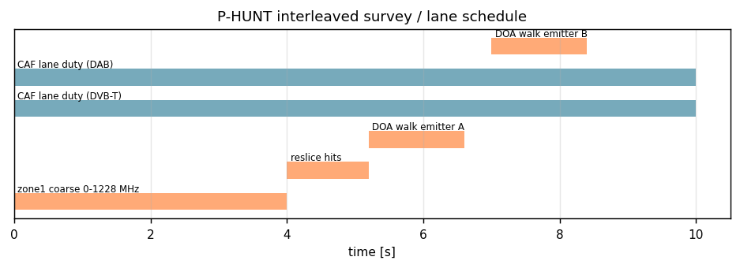
Figure 38. P-HUNT schedule: coarse sweep, hit reslices, DOA walks interleaved with CAF lane duty; lane integration loss from survey slices is priced, not ignored.

From event to evidence package
- Event: time, frequency mask, power history, sweep epoch.
2. Reslice: narrowband IQ record (pre- and post-event 50 ms) into the ring.
3. Features: occupied bandwidth, modulation family (OFDM CP length, FSK deviation, analogue deviation), burst/PRI structure, micro-Doppler comb presence.
4. Classification: likelihood vector over threat families; below policy confidence the record stays an unresolved cluster forever - forcing a class is forbidden.
5. Geolocation: DOA walk, TDOA with partner nodes if present.
6. Evidence record: all of the above plus SHA-256 of the IQ and of the metadata block.
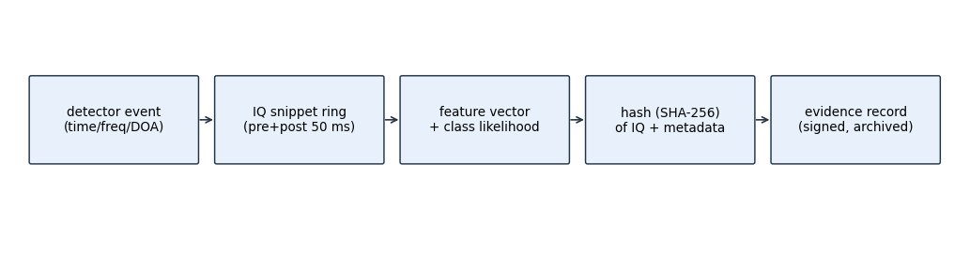
Figure 39. Evidence chain: event, IQ snippet, features, hash, signed archive record. Replay of any record through the golden model must reproduce its hash-derived features exactly.

Long-CPI memory design
Narrowband illuminators buy Doppler resolution with time: a 60 s FM CPI resolves about 0.15 m/s radial at 100 MHz [derived]. Sixty seconds of reference data at 76.8 MS/s complex is 18.4 GB for two REF lanes - this is a memory-system design, not a DSP design.
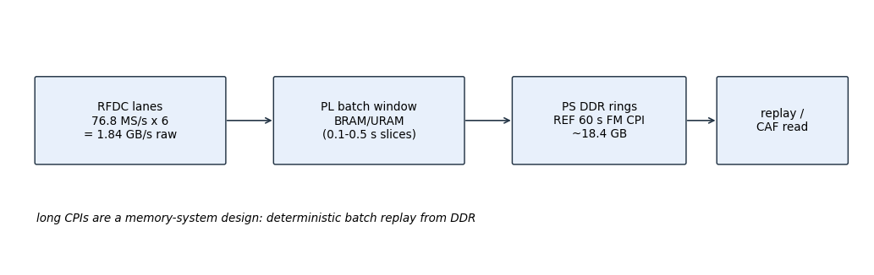
Figure 40. Memory hierarchy: RFDC lanes at 1.84 GB/s raw, PL batch windows in BRAM/URAM, long CPI rings in PS DDR, deterministic replay into the CAF.
Rules:
- PL never holds more than one batch window; rings live in DDR with a write pointer the PS owns.
- Replay is deterministic: the same ring window read twice must produce bit-identical CAF input (the offline replay test checks exactly this).
- Ring overrun policy: oldest-window drop with a header flag; a dropped window inside a track's CPI degrades that track's covariance, logged.
bytes_ring = 2 lanes * 8 B/sample * 76.8e6 * T_int ; T_int = 60 s -> 18.4 GB [derived]

Standalone software

Task set
The PS runtime is the same skeleton discipline as the integrated book's section 10 minus fusion-with-active and arbiter-with-active: IRQ service per batch, ranking, ECA supervision, trackers, geolocation coordinator client, survey planner, evidence recorder, and a node-coordinator client that exchanges cue/fix records over the site LAN with common-reference timestamps.

Register map (passive-only variant)
Offset | Register | Meaning
0x00-0x0C | ID/CTRL/STATUS/IRQ | same discipline as validated active map
0x100 | PASS_CTRL | lane mask, batch code, survey enable
0x104 | PASS_STATUS | lane health word
0x108 | ILLUM_RANK | ranked lane table
0x110+ | LANE_tune[k] | DDC NCO, gain, filter index per lane
0x140 | CAF_CFG | T_int code (long-CPI codes here), batches, windows
0x144 | ECR_MON | residual taps
0x150 | CUE/FIX FIFO | records out
0x160 | SURVEY_PLAN | sweep map, mask index, slice budget
0x170 | EVID | recorder control, hash readback
0x180 | NODE | node id, TDOA clock offset words, coordinator address
Table 18.

Data contract and replay
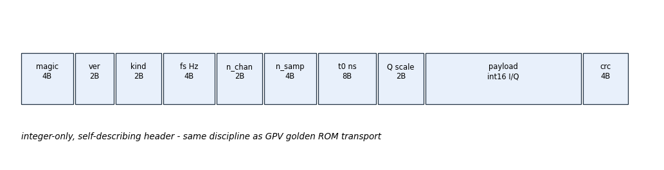
Figure 41. Integer-only self-describing record framing with CRC - identical contract to the integrated book, so one replay tool serves both configurations.
Every spectrogram page, map page, cue/fix record and evidence record travels in this framing; the offline tool reprocesses recorded rings through pcl_chain_ref.m and geolocation_ref.m and compares feature hashes. A deployed node's acceptance test is its own archive.

Operator workstation views

Lane wall
One tile per active lane: range-Doppler page with CFAR overlay, lane health strip (ECR monitor, REF echo monitor, scale saturation, calibration age), and the lane's current illuminator parameters. A degraded tile is visibly degraded; there is no mode in which a sick lane renders like a healthy one.

DOA rose and angle history
Per-lane spatial spectrum rose with beamscan solid and MUSIC dashed where both run; angle history waterfall per track so operator eyes can see a DOA bias developing before the health monitor declares it.

Emitter table
Every emitter event and track with class likelihood vector, covariance ellipse parameters, evidence hash, and persistence history. Unresolved clusters are rendered in a distinct style permanently.

Site map and baselines
Fixes with error ellipses, node positions, baseline health (TDOA residual trend per pair), and the fibred-reference status per node. Degraded-node fixes change style the moment the node flags itself.

Evidence browser and replay
Archive tree by day and node; one-click replay of any record through pcl_chain_ref/geolocation_ref with hash comparison displayed; export bundles archive plus tool versions for external examination.

Silence monitor
During acceptance and periodically in service, an external spectrum monitor's verdict is ingested and displayed: the system's claim of silence is verified by an instrument that is not the system.

Baseline geometry design
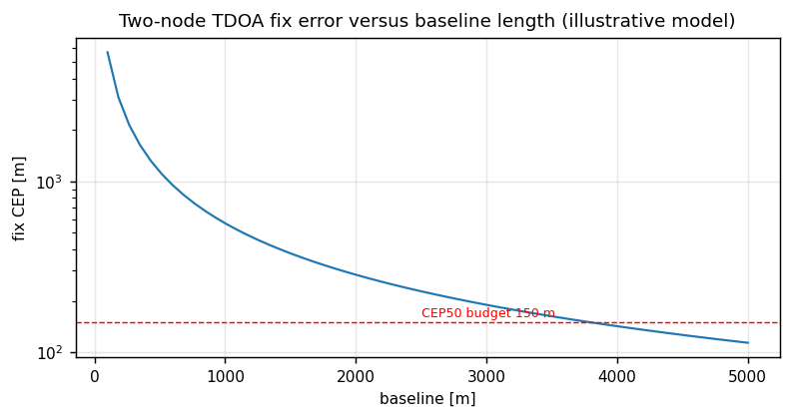
Figure 42. Two-node TDOA fix error versus baseline length for a DVB-T-class lane: the 150 m CEP50 budget sets the minimum site-grid spacing [illustrative model].
Baseline placement is a design variable of the site grid: too short and the hyperbola curvature vanishes into AOA error; too long and the common-reference distribution cost dominates. The chart above is recomputed per site with the site's actual illuminator set at commissioning and stored with the configuration version.

Validation and acceptance

Golden models and testbenches
- Shared: passive_channel_sim.m, pcl_chain_ref.m with tb_chan, tb_refcond, tb_eca, tb_caf, tb_cfar2d, tb_doa (bit-exact or stated-LSB versus ROM).
- Standalone additions: geolocation_ref.m (AOA/TDOA CRLB-consistent fixes), survey_ref.m (mask CFAR on synthetic spectra), tb_tdoa (two-node timestamp association), tb_survey (event and feature extraction), tb_ring (deterministic replay and overrun flags).

Gates
Gate | Content | Pass
G0-G2 | shared bit-exact gates | as RAP-EDB-001
G-RES | passive lane OOC synthesis | within budget
G4' | cable TDOA/DOA loopback | fix within stated covariance
G5' | field: ECR survey, fix accuracy vs surveyed truth, evidence audit | metrics below
Table 19.

Acceptance metrics [budget]
Metric | Target
ECR strongest DPI | >= 80 dB
CAF gain vs theory | within 1 dB
DOA rms at SNR >= 20 dB | <= 3 deg
two-node fix CEP50 urban DVB-T lane | <= 150 m
emitter sensitivity | -100 dBm in-band, Pd 0.9 at 1e-6 FA/h
FM 60 s CPI Doppler resolution | <= 0.02 Hz (about 0.15 m/s at 100 MHz) [derived]
replay hash equality | 100 percent of sampled records
own radiation | zero, external monitor verified
Table 20.

Failure modes and diagnostics (standalone)
Failure | Observable | Response
illuminator maintenance outage | REF power drop | re-rank; profile degrades gracefully, operator notified
reference distribution fault | TDOA residual jump | single-node AOA fallback with flagged covariances
ULA element fault | DOA bias, sidelobe rise | element health injection, array re-cal
dense co-channel emitters | classification confidence collapse | unresolved cluster record, never forced class
survey self-blindness during long CPI | missed new emitters | interleaved slices priced into schedule
ring overrun | header drop flags | covariance degradation logged per track
evidence ring half-full unserviced | IRQ latency monitor | recorder stalls lanes per policy (integrity over continuity)
Table 21.

Requirements traceability (standalone)
Req | Statement | Validation
REQ-P-001 | zero own radiation | external monitor, acceptance
REQ-P-002 | T1 detection sensitivity -100 dBm class | G5' survey exercise
REQ-P-003 | two-node fix CEP50 <= 150 m urban | G5' surveyed truth
REQ-P-004 | long-CPI replay determinism | tb_ring + archive audit
REQ-P-005 | lane outage continuity without operator | re-rank exercise
REQ-P-006 | evidence integrity (hashes) | replay audit 100 percent
REQ-P-007 | degraded modes flagged, never silent | fault injection table
Table 22.

References
- RAP-EDB-001 rev 1.0 - integrated book; shared passive core sections.
2. GPV ps-runtime / GPM v1.8 - software discipline, RFDC practice, gate philosophy.
3. AMD UG1410, PG269 - board and converter facts.
4. Griffiths & Long 1986; Howland 1999; Colone et al.; Bournaka et al. 2008; Malanowski et al.; Skolnik Radar Handbook.
5. Site radio plan template and occupancy mask format - operator document, referenced not reproduced.

Appendix A - Operational procedures

Commissioning sequence
- Clock plant acceptance (phase_drift chart per lane family). 2. Cable/path calibration per band. 3. Array calibration per band. 4. 24 h ECR baseline survey. 5. Illuminator survey vs site radio plan; ranking table signed off. 6. Cooperative emitter exercise for TDOA covariance validation. 7. Evidence replay audit on the commissioning archive.

Daily health review
Lane health words (ECR monitor, REF echo monitor, scale saturation, calibration age), ranking changes since last review, ring drop flags, and the silence monitor log. Any lane whose ECR monitor trends toward budget is re-calibrated before it becomes an alarm.

Evidence handling rules
Records are append-only; hashes are computed at creation in PS and re-verified at archive; no record is editable, only annotated by separate annotation records that reference the original hash. Court-facing export is the archive plus the replay tool plus the golden model versions, so that any examiner can reproduce every feature.

Appendix B - Glossary
Term | Meaning
PCL | passive coherent location
CAF | cross-ambiguity function
ECA / ECR | extensive cancellation algorithm / ratio
DPI | direct-path interference
CPI | coherent processing interval
TDOA / AOA / FDOA | time / angle / frequency difference of arrival
ULA | uniform linear array
CEP50 | 50 percent circular error probable
site radio plan | operator list of known-friendly emitters and masks
Table 23.

