## User Guide

**1.1. Preparing for the running the application**

All the additional materials needed for the running the system is provided in “extra” folder.

* **Xampp** – needed for Database and Server
* **Adobe Reader** – needed to open help files.

**1.2. Importing database**

Open the web browser and type [http://localhost/phpmyadmin](http://localhost/phpmyadmin%20) to login to control panel of MySQL database.

* Create a database- click the databases tab, give name to new database “shanty_store” and click on create button.

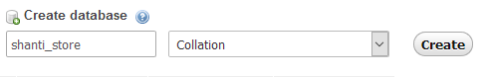

* Click the import tab. Browse the .sql file, then Choose File shanty_store.sql from the “extra” folder and open then click GO at the end of the page.

Once the database has been imported we can run the webpage.

Step 1: 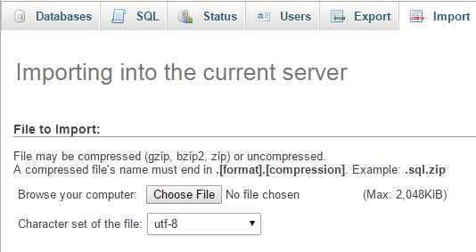

Step 2: 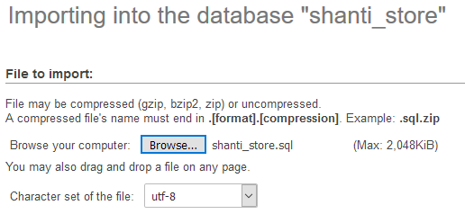

Step 3: 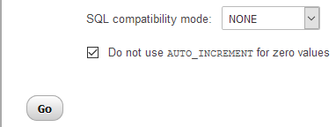

**2. Installation and Running**

Once XAMPP application is installed, copy the “application” folder to C:\XAMPP\htdocs\

Step 1: 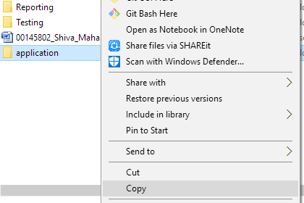

Step 2: 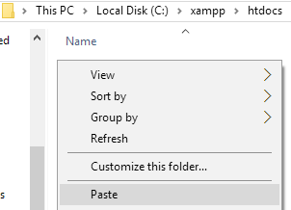

Now open web browser and browse “localhost/application/index.php” and will open the index page.

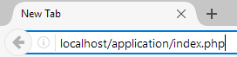

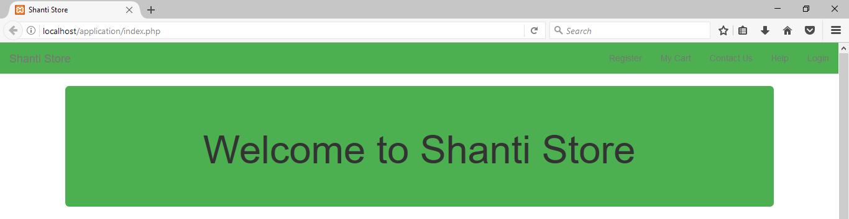

**3. Login**

Click login in the navigation bar inside webpage. Then enter username and password where

**Username**: [shivamaharjan1234567890@gmail.com](mailto:shivamaharjan1234567890@gmail.com)

**Password**: shiva

The password can be changed later if required.

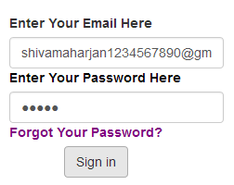

**4. Understanding the interface**

Opens User Guide

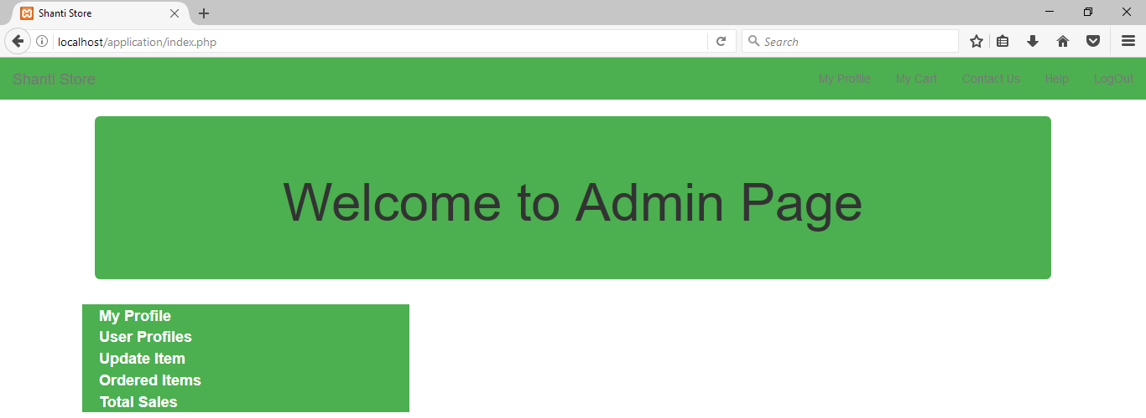

Logs one Out of the system

Control Panel

Navigation Panel

**5. Getting Help**

Click the help button on the navigation bar of the webpage(near “Contact Us”). This will open as you to download the user guide file. Once download completes, you can read through it.

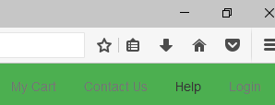

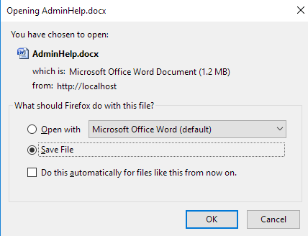

**6. Veiwing admin profile and editing**

In the index page, click My Profile then it shows information about the user/ admin. Then to update click “Update”.

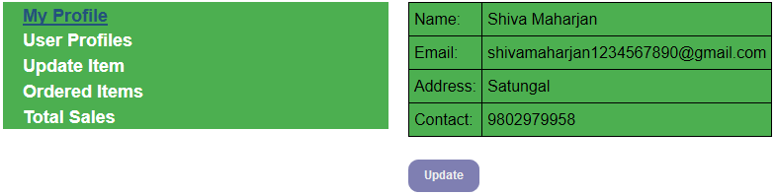

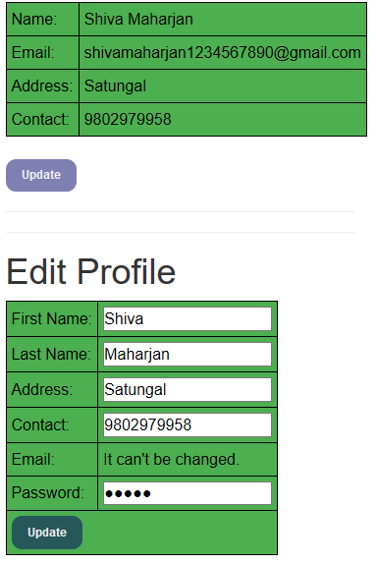

**7. Viewing User Profiles**

Click User Profile in the panel. It shows all details about users. You can edit their profile if necessary as well as delete them.

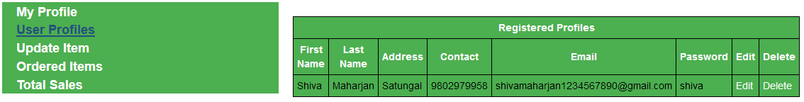

**8. Adding new items**

Click Update item. If no items are available then it prompts to add new item first. If there are items already available, you can edit and delete them as well. For this task there are edit and delete link.

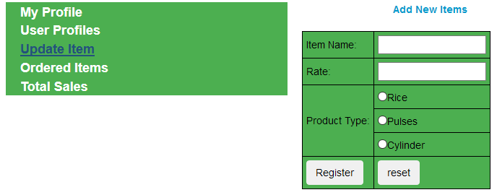

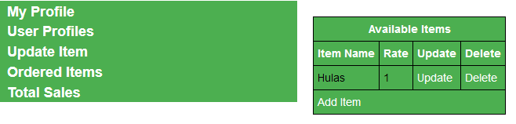

**9. Viewing Ordered Items**

Click Ordered Items. It shows all the items that are being ordered by users. You can update their status to “Delivered”, “Pending” and “Out Of Stock”.

**10. Viewing Report**

Click Total Sales, it shows all the registered users. You can click “View” in each of the user to see what they have purchased till date.

