## User Guide

**1.1. Preparing for the running the application**

All the additional materials needed for the running the system is provided in “extra” folder.

* **Xampp** – needed for Database and Server
* **Microsoft word/ WordPad** – needed to open help files.

**1.2. Importing database**

Open the web browser and type [http://localhost/phpmyadmin](http://localhost/phpmyadmin%20) to login to control panel of MySQL database.

* Create a database- click the databases tab, give name to new database “shanty_store” and click on create button.

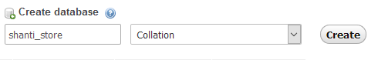

* Click the import tab. Browse the .sql file, then Choose File shanty_store.sql from the “extra” folder and open then click GO at the end of the page.

Once the database has been imported we can run the webpage.

Step 1: 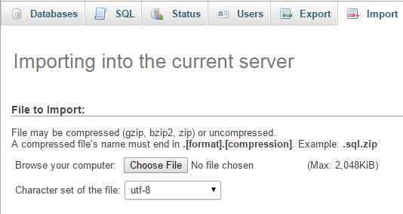

Step 2: 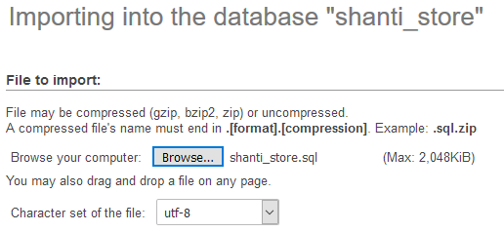

Step 3: 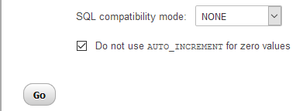

**2. Installation and Running**

Once XAMPP application is installed, copy the “application” folder to C:\XAMPP\htdocs\

Step 1: 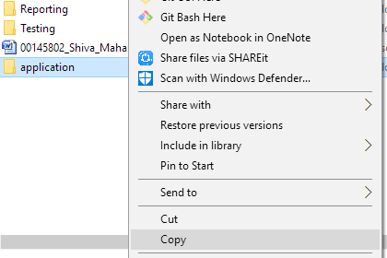

Step 2: 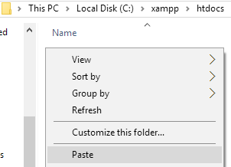

Now open web browser and browse “localhost/application/index.php” and will open the index page.

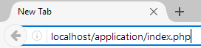

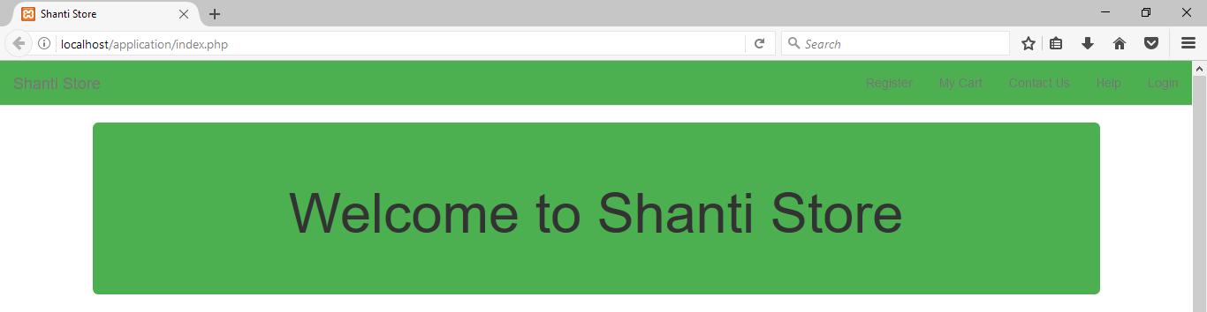

**3. Registration**

Click “Register” in the navigation bar. Then input required details then click register.

UserRegis.png

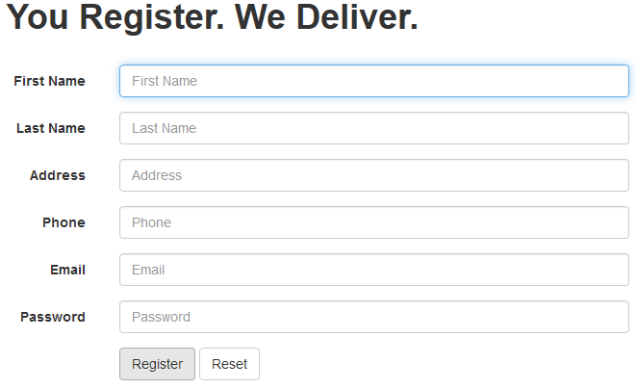

**4. Login**

Click login in the navigation bar inside webpage. Then enter username and password where necessary

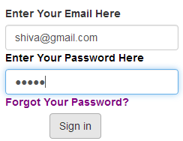

**5. Understanding the interface**

Opens User Guide

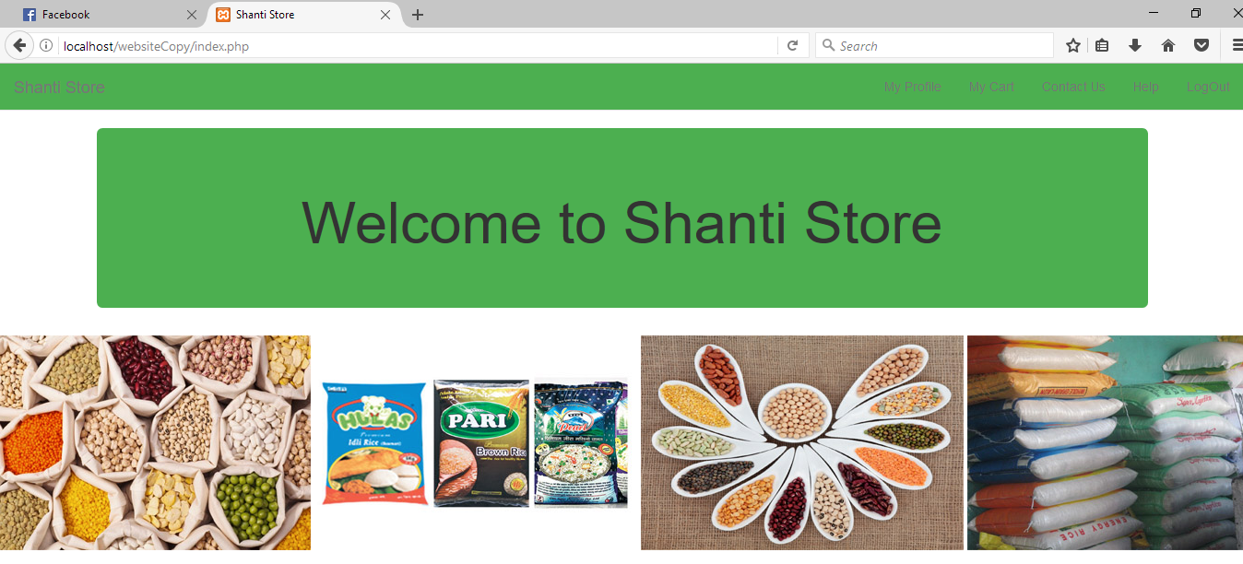

Scrolling Panel

Logs one Out of the system

Navigation Panel

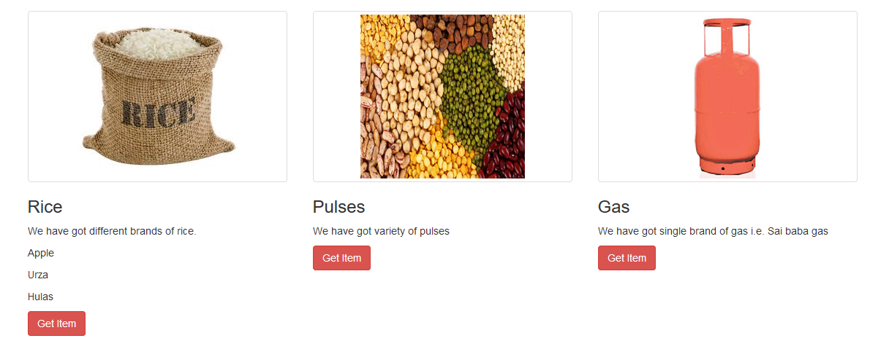

**6. Getting Help**

Click the help button on the navigation bar of the webpage(near “Contact Us”). This will open as you to download the user guide file. Once download completes, you can read through it.

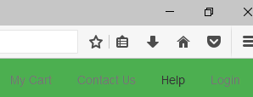

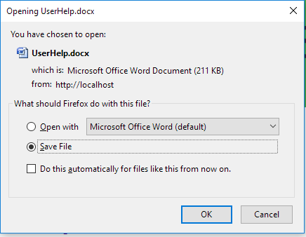

**7. Veiwing profile and editing**

In the index page, click My Profile on the navigation bar then it shows information about the user. Then to update click “Update”.

userUp.png

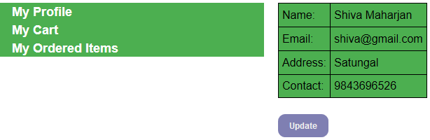

**8. Adding items to cart**

Go to index page. Click “Get Item” on desired item. Then insert desired number. Then click add item.

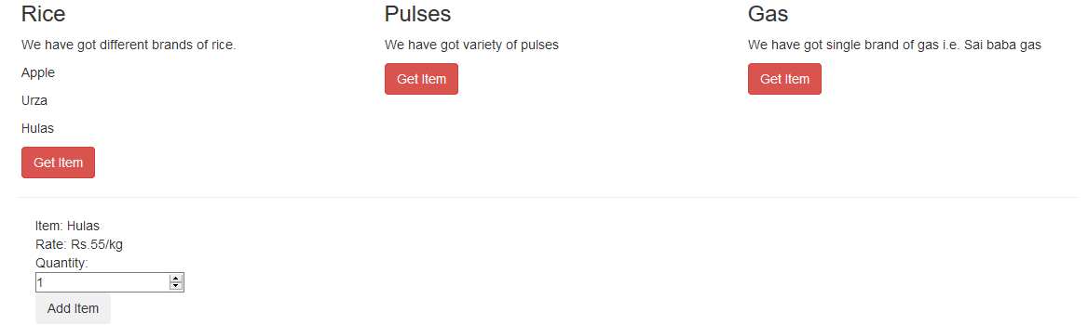

**9. Viewing Ordered Items**

Click My Cart on the navigation bar. It shows all the items that are being add by user. You can update the Quantity, delete if not required and confirm the items for the item to be delivered.

cart.png

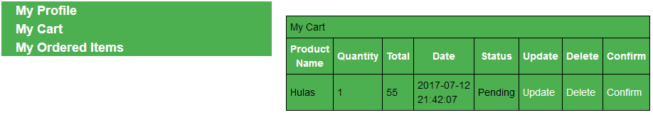

**10. Viewing Ordered Items**

Click “Ordered items” after going to profile. Sometimes when there are no items left in the cart it direct you to index page to add new order. It shows all the ordered items. 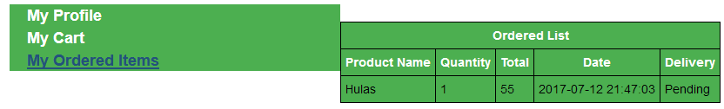

**11. If You forgot your password**

Click “Forgot Your Password?” in the login page. Then it prompts your email and contact number. If correct information is given it shows your password.

