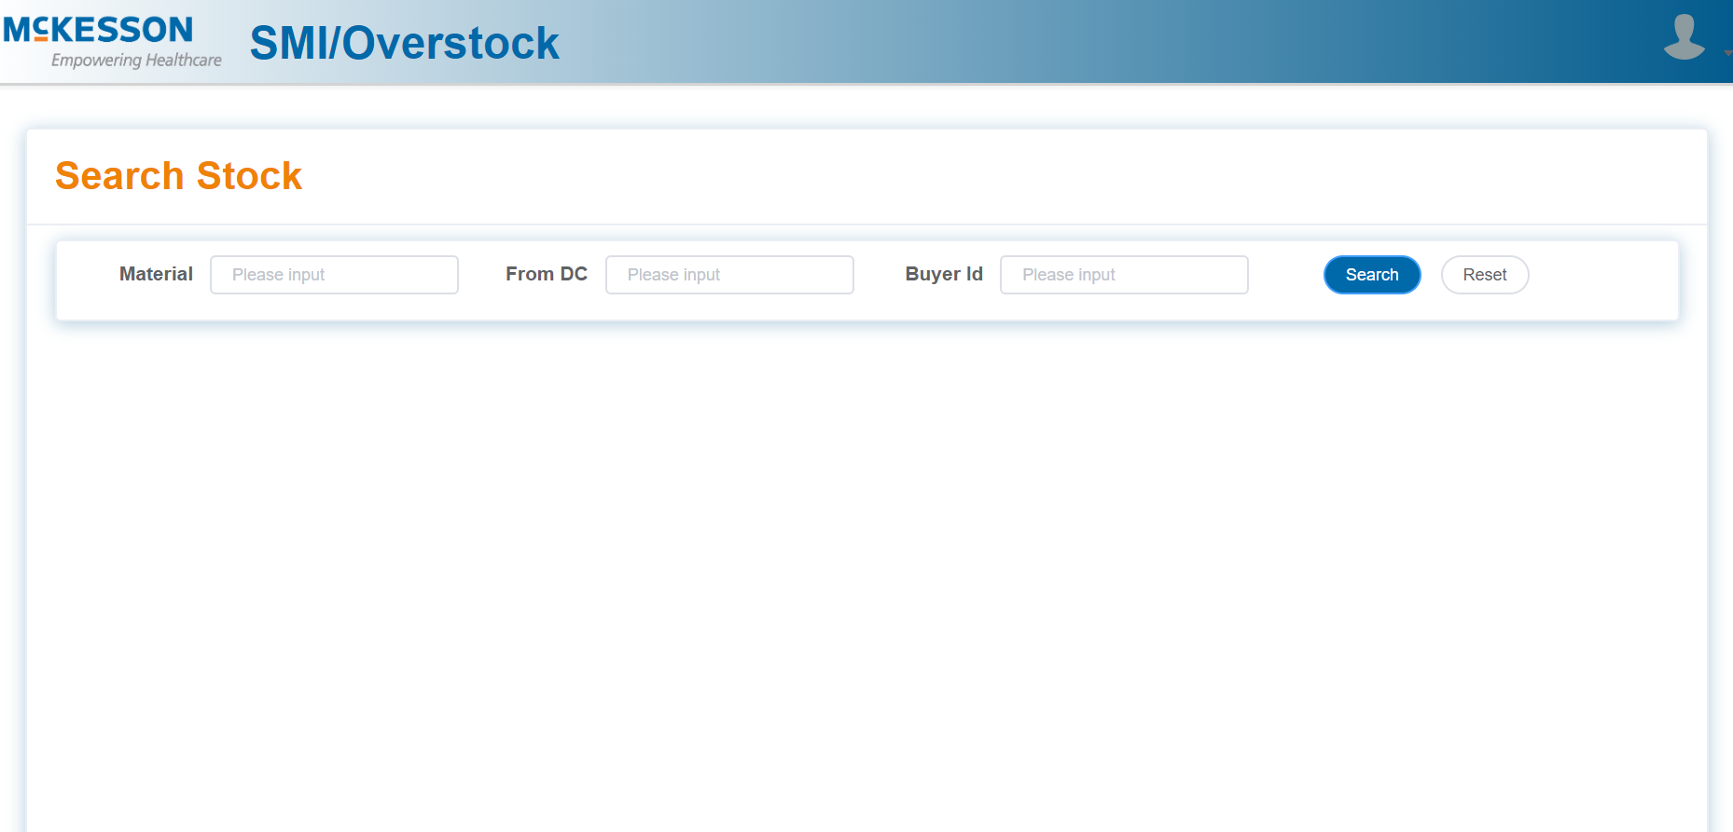

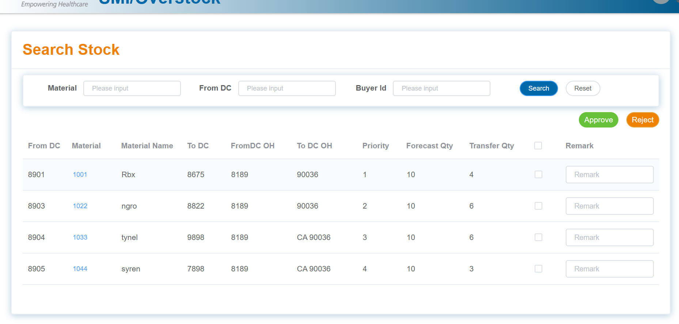

tableData1: [

{

date: '8901',

name: '1001',

state: 'Rbx',

city: '8675',

address: '8189',

zip: '90036',

tag: 'Home',

Priority: '1',

ForecastQty: '10',

TransferQty: '4'

},

{

date: '8903',

name: '1022',

state: 'ngro',

city: '8822',

address: '8189',

zip: '90036',

tag: 'Office',

Priority: '2',

ForecastQty: '10',

TransferQty: '6'

},

{

date: '8904',

name: '1033',

state: 'tynel',

city: '9898',

address: '8189',

zip: 'CA 90036',

tag: 'Home',

Priority: '3',

ForecastQty: '10',

TransferQty: '6'

},

{

date: '8905',

name: '1044',

state: 'syren',

city: '7898',

address: '8189',

zip: 'CA 90036',

tag: 'Office',

Priority: '4',

ForecastQty: '10',

TransferQty: '3'

}

],

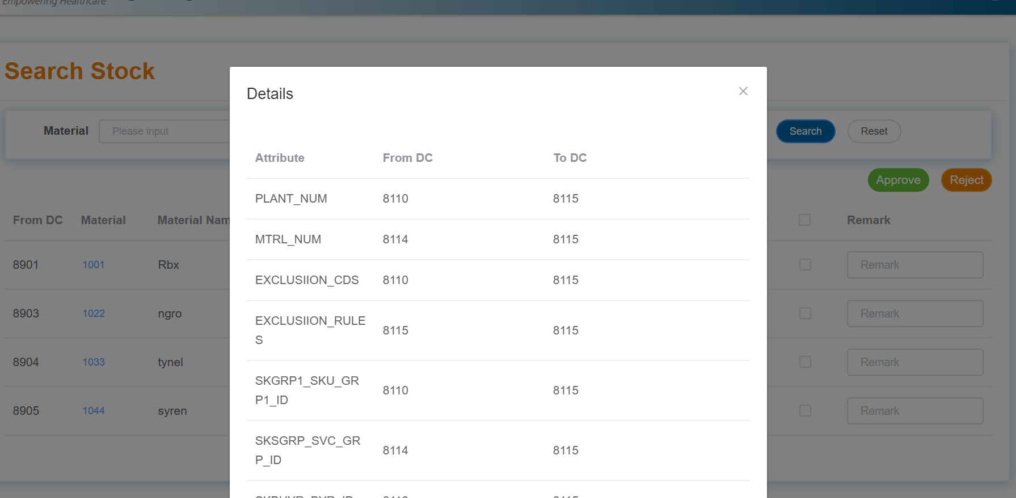

// var baseURI='http://bw-dev-hana.mckesson.com:8000/PK_MCKESSON/PH/MM/IM/OS/smi.xsjs?action=GET_DETAILS&'

// var searchParams ='from_dc='+this.searchForm.fromDC

// +'&to_dc='+this.searchForm.ToDC

// +'&material='+this.searchForm.materialId

// +'btch_proc_dt=2019-07-22'

1. {FROMDC_BTCH_PROC_DT: "2019-07-30T07:00:00.000Z", FROMDC_TRANSFER_DOH: "NA",…}
   1. FROMDC_BTCH_PROC_DT: "2019-07-30T07:00:00.000Z"
   2. FROMDC_CATEGORY: "GX"
   3. FROMDC_DC_REGION: "AK"
   4. FROMDC_DLY_FCST_QTY: "0.016"
   5. FROMDC_DOH_THRESHOLD: "NA"
   6. FROMDC_DRPSHP_IND: "N"
   7. FROMDC_EXCLUSIION_CDS: "4"
   8. FROMDC_EXCLUSIION_RULES: "SMI_FROMDC_EXCL_MICA"
   9. FROMDC_GXIND_CAL: "Y"
   10. FROMDC_HZDMTRL_CD: ""
   11. FROMDC_ITEM_ACTVY_CD: "A"
   12. FROMDC_ITEM_DEAL_IND: " "
   13. FROMDC_ITEM_HHC_IND: "N"
   14. FROMDC_LAST_RECPT_DATE_AGE: 201
   15. FROMDC_LICENSE_TYPE_CAL: "WD"
   16. FROMDC_LOAD_DATE_AGE: 11738
   17. FROMDC_MAX_XFER_AMT: "103.798"
   18. FROMDC_MAX_XFER_DYS
   19. : "150.640"
   20. FROMDC_MAX_XFER_QTY: "2.410"
   21. FROMDC_MCK_PD_MEM_NTWK_CD: ""
   22. FROMDC_MICA_DEPT_ID: "IB"
   23. FROMDC_MS_IND: "N"
   24. FROMDC_MTRL_NUM: "000000000001250307"
   25. FROMDC_OH_BALANCE_DYS: "250.000"
   26. FROMDC_ON_ORDER_DYS: "0.000"
   27. FROMDC_PLANT_NUM: "8130"
   28. FROMDC_PLNOGRM_IND: "N"
   29. FROMDC_PREF_FLG: "N"
   30. FROMDC_RXDA_CD_CAL: "R"
   31. FROMDC_RX_PAK_FLG: "N"
   32. FROMDC_SALE_DATE_AGE: 192
   33. FROMDC_SKACCL_DFLT_ACTVY_CLS_CD: "A"
   34. FROMDC_SKADTE_LST_LOAD_DT: "2015-12-02T08:00:00.000Z"
   35. FROMDC_SKAPPC_AVG_PURCH_PRC_AMT: "43.070"
   36. FROMDC_SKBALD_BAL_QTY_DYS: "254.78"
   37. FROMDC_SKBAL_BAL_QTY: 4
   38. FROMDC_SKBUYR_BYR_ID: "031 "
   39. FROMDC_SKDOLS_MECHLN_LAST_SLS_DT: "2019-01-19T08:00:00.000Z"
   40. FROMDC_SKDPRF_SEASN_PRFL_ID: " "
   41. FROMDC_SKFCST_DMND_FCST_QTY: "0.110"
   42. FROMDC_SKGRP1_SKU_GRP1_ID: "R "
   43. FROMDC_SKGRP2_SKU_GRP2_ID: "REFRG"
   44. FROMDC_SKGRP3_SKU_GRP3_ID: "IB "
   45. FROMDC_SKHDBD_HOLD_BEG_DT: null
   46. FROMDC_SKHDED_HOLD_END_DT: null
   47. FROMDC_SKLSXD_LST_TXN_DT: "2019-07-30T07:00:00.000Z"
   48. FROMDC_SKLT_LT_DYS: "7.720"
   49. FROMDC_SKOHDD_HLDOUT_DYS: 0
   50. FROMDC_SKOHDQ_HLDOUT_QTY: 0
   51. FROMDC_SKOHDY_OH_DYS: "254.770"
   52. FROMDC_SKOHND_OH_QTY: 4
   53. FROMDC_SKOODY_ONORD_DYS: "0.000"
   54. FROMDC_SKOORD_ONORD_QTY: 0
   55. FROMDC_SKORSV_ON_RSRV_QTY: 0
   56. FROMDC_SKOUPD_ORD_TO_LVL_DYS: "92.360"
   57. FROMDC_SKOUPU_ORD_TO_LVL_QTY: "1.440"
   58. FROMDC_SKRCLC_NEED_RECALC_CD: "5"
   59. FROMDC_SKSFST_SEASNL_FCST: "0.110"
   60. FROMDC_SKSGRP_SVC_GRP_ID: " "
   61. FROMDC_SKTCMD_TOT_COMMT_DYS: "0.000"
   62. FROMDC_SKTCMU_TOT_COMMT_QTY: "0.000"
   63. FROMDC_SKXFRX_XFER_XCLD_CD: "1"
   64. FROMDC_SMI_OS_ID: "SMIF"
   65. FROMDC_STATE: "AK"
   66. FROMDC_SUSKLRCTDT_LAST_RCPT_DATE: "2019-01-10T08:00:00.000Z"
   67. FROMDC_TRANSFER_DOH: "NA"
   68. FROMDC_VNDR_NUM: "0000001657"
   69. TODC_BTCH_PROC_DT: "2019-07-30T07:00:00.000Z"
   70. TODC_CATEGORY: "GX"
   71. TODC_DC_REGION: "NY"
   72. TODC_DLY_FCST_QTY: "2.256"
   73. TODC_DOH_THRESHOLD: 30
   74. TODC_DRPSHP_IND: "N"
   75. TODC_EXCLUSIION_CDS: null
   76. TODC_EXCLUSIION_RULES: null
   77. TODC_GXIND_CAL: "Y"
   78. TODC_HZDMTRL_CD: ""
   79. TODC_ITEM_ACTVY_CD: "A"
   80. TODC_ITEM_DEAL_IND: " "
   81. TODC_ITEM_HHC_IND: "N"
   82. TODC_LAST_RECPT_DATE_AGE: 62
   83. TODC_LICENSE_TYPE_CAL: "WD"
   84. TODC_LOAD_DATE_AGE: 11738
   85. TODC_MAX_XFER_AMT: "0.000"
   86. TODC_MAX_XFER_DYS: "0.000"
   87. TODC_MAX_XFER_QTY: "0.000"
   88. TODC_MCK_PD_MEM_NTWK_CD: ""
   89. TODC_MICA_DEPT_ID: "IB"
   90. TODC_MS_IND: "N"
   91. TODC_MTRL_NUM: "000000000001250307"
   92. TODC_OH_BALANCE_DYS: "0.000"
   93. TODC_ON_ORDER_DYS: "25.709"
   94. TODC_PLANT_NUM: "8113"
   95. TODC_PLNOGRM_IND: "N"
   96. TODC_POST_TRANSFER_DOH: "30.000"
   97. TODC_PREF_FLG: "N"
   98. TODC_RXDA_CD_CAL: "R"
   99. TODC_RX_PAK_FLG: "N"
   100. TODC_SALE_DATE_AGE: 31
   101. TODC_SKACCL_DFLT_ACTVY_CLS_CD: "A"
   102. TODC_SKADTE_LST_LOAD_DT: "2002-12-08T08:00:00.000Z"
   103. TODC_SKAPPC_AVG_PURCH_PRC_AMT: "43.070"
   104. TODC_SKBALD_BAL_QTY_DYS: "22.170"
   105. TODC_SKBAL_BAL_QTY: 50
   106. TODC_SKBUYR_BYR_ID: "031 "
   107. TODC_SKDOLS_MECHLN_LAST_SLS_DT: "2019-06-29T07:00:00.000Z"
   108. TODC_SKDPRF_SEASN_PRFL_ID: " "
   109. TODC_SKFCST_DMND_FCST_QTY: "15.790"
   110. TODC_SKGRP1_SKU_GRP1_ID: "R "
   111. TODC_SKGRP2_SKU_GRP2_ID: "REFRG"
   112. TODC_SKGRP3_SKU_GRP3_ID: "IB "
   113. TODC_SKHDBD_HOLD_BEG_DT: null
   114. TODC_SKHDED_HOLD_END_DT: null
   115. TODC_SKLSXD_LST_TXN_DT: "2019-07-30T07:00:00.000Z"
   116. TODC_SKLT_LT_DYS: "6.760"
   117. TODC_SKOHDD_HLDOUT_DYS: 0
   118. TODC_SKOHDQ_HLDOUT_QTY: 0
   119. TODC_SKOHDY_OH_DYS: "0.000"
   120. TODC_SKOHND_OH_QTY: 0
   121. TODC_SKOODY_ONORD_DYS: "22.160"
   122. TODC_SKOORD_ONORD_QTY: 50
   123. TODC_SKORSV_ON_RSRV_QTY: 0
   124. TODC_SKOUPD_ORD_TO_LVL_DYS: "21.710"
   125. TODC_SKOUPU_ORD_TO_LVL_QTY: "48.970"
   126. TODC_SKRCLC_NEED_RECALC_CD: "5"
   127. TODC_SKSFST_SEASNL_FCST: "15.790"
   128. TODC_SKSGRP_SVC_GRP_ID: " "
   129. TODC_SKTCMD_TOT_COMMT_DYS: "0.000"
   130. TODC_SKTCMU_TOT_COMMT_QTY: "0.000"
   131. TODC_SKXFRX_XFER_XCLD_CD: "1"
   132. TODC_SMI_OS_ID: "PROP"
   133. TODC_STATE: "NY"
   134. TODC_SUSKLRCTDT_LAST_RCPT_DATE: "2019-05-29T07:00:00.000Z"
   135. TODC_VNDR_NUM: "0000001657"