**Description**

This application is intended to connect people in need of assistance with people wishing to do good deeds. After creating an account and logging into the site, users can submit needs, look for people in need of a good deed, or both. Through the “Get Help” view, a user needing help with something can submit a Need, see a list of pending Needs, and keep track of Needs that have been resolved. Through the “Give Help” view, a user can search for a Need that matches their skills, capacity, and willingness to provide a Good Deed. This application, while similar to other social networking (NextDoor) or crowdsourcing platforms (Go Fund Me), is unique by bringing people together based solely on the compatibility of one person’s need and another’s willingness to do a good deed.

**Development Team**

|  |  |  |  |
| --- | --- | --- | --- |
| Erik Woodworth  Project Manager  React Frontend | AJ Jordan  Frontend  Utilities & Routing | Mike Bagheri  Authentication  User Database | Mike Bagheri  Deeds Database  Express Routing |

**Frontend UI Layout (Draft)**

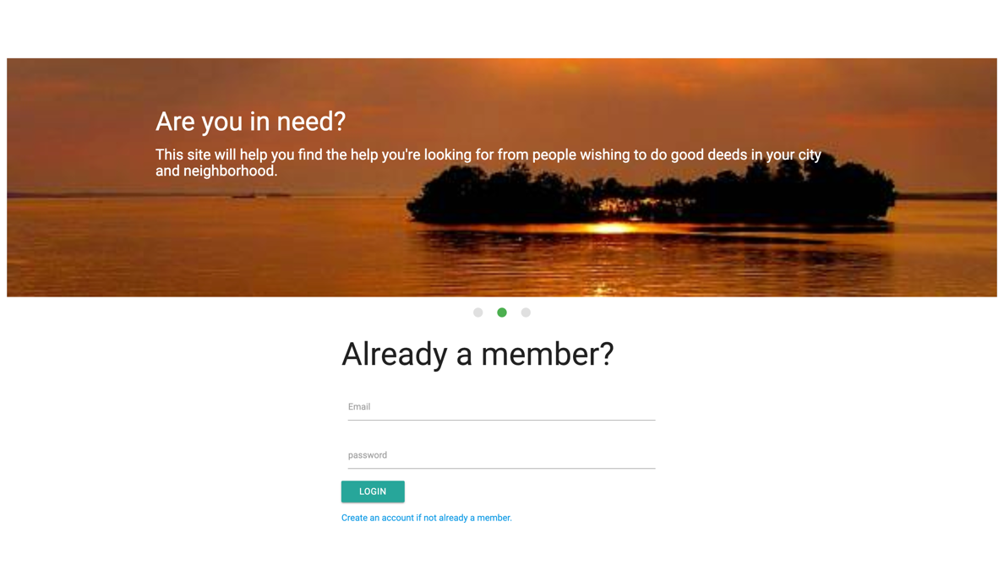**Landing & Login Page**

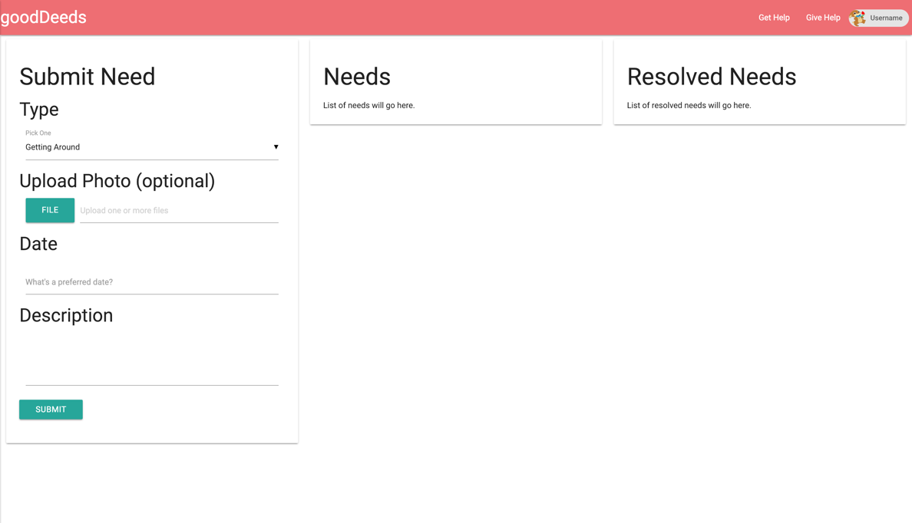**Get Help**

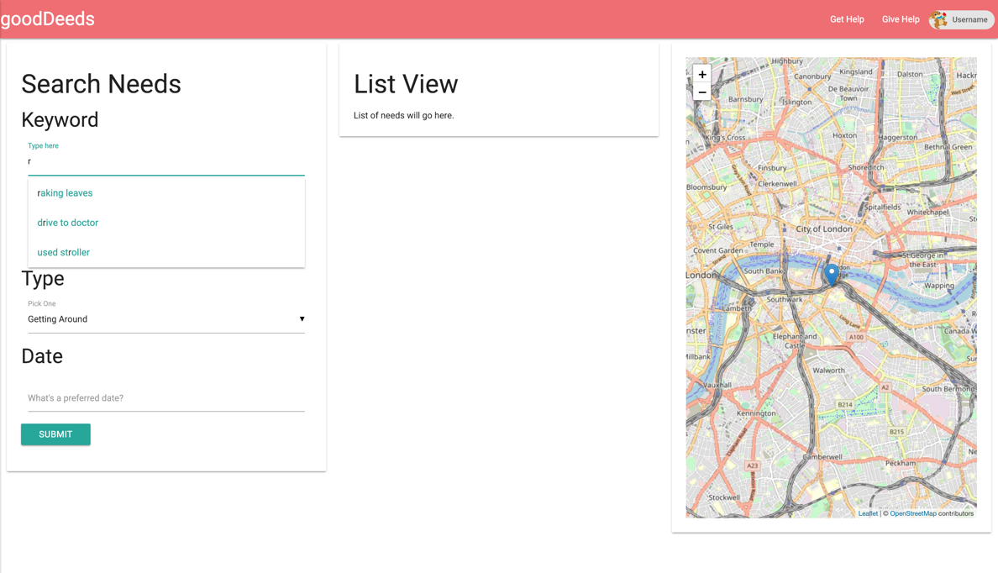**Give Help**

**Timeline**

|  |  |
| --- | --- |
| **Week 1** | Plan, Research, Design, and Wireframe |
| **Week 2** | Authentication, Database, Routes, and Connecting Front and Backend |
| **Week 3** | Creating and Finetuning Utilities and Stateful Component Rendering |
| **Week 4** | Final Styling and Issue Resolution |

**Project Board**

