Change Hardware compatibility of a VM (Either by clone/create new one) which is already created and configured, using virtual box.
Aim: To change the hardware compatibility of an existing Virtual Machine in VirtualBox by modifying its configuration or cloning it with updated settings.
Procedure;
- Open Oracle VM VirtualBox on your system.
- Select the Virtual Machine whose hardware compatibility you want to change (ensure it is powered off).
- Right-click the VM and select Settings.
- In the System tab, you can change hardware parameters:
- Base Memory (RAM)
- Processor(s)
- Boot Order
- In the Display tab, adjust:
- Video memory
- Graphics controller
- In the Storage tab, you can attach or remove virtual hard disks.
- In the Network tab, adjust adapter type and mode.
- Optionally, you can clone the VM (Full Clone) to create a new VM with updated hardware while keeping the original unchanged.
- Apply the changes by clicking OK.
- Power on the VM and verify its functionality with the updated hardware settings.
Output:
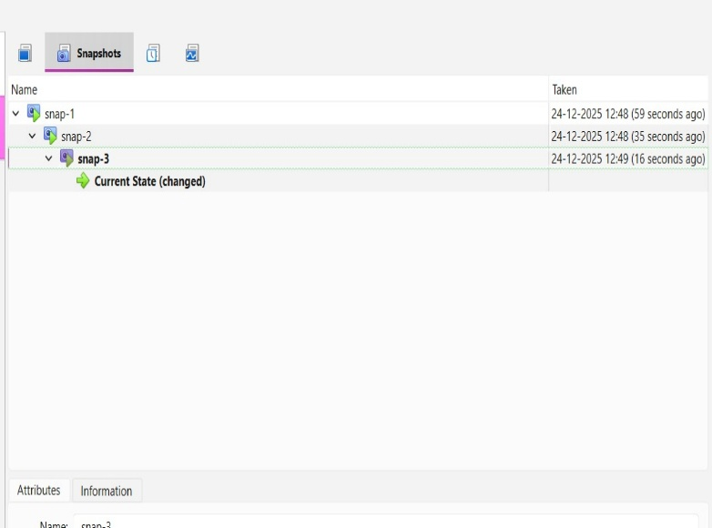
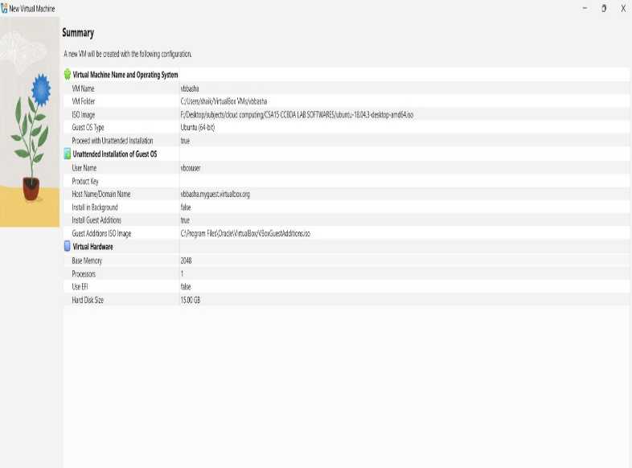

Result:
The hardware compatibility of the Virtual Machine was successfully updated.
The VM operated correctly with the modified configuration, demonstrating VirtualBox’s flexibility in adapting VM hardware to host capabilities.

