Create a Virtual Hard Disk and allocate the storage using virtual box.
Aim: To create a Virtual Hard Disk for a Virtual Machine and allocate the required storage space using Oracle VirtualBox.
Procedure:
- Open Oracle VM VirtualBox on your computer.
- Select the Virtual Machine for which you want to create a new virtual hard disk (ensure the VM is powered off).
- Click on Settings from the top menu.
- Go to Storage from the left panel.
- Under Storage Devices, click the Controller (SATA/IDE).
- Click on the Add Hard Disk (+ icon) button.
- Choose Create New Disk and click Next.
- Select the disk type — VDI (VirtualBox Disk Image) and click Next.
- Choose storage type:
  - Dynamically Allocated (expands as needed)
  - Fixed Size (better performance, takes full space immediately)
Then click Next.
- Set the disk size (e.g., 10GB / 15GB) and choose the location to save the virtual disk → Click Create.
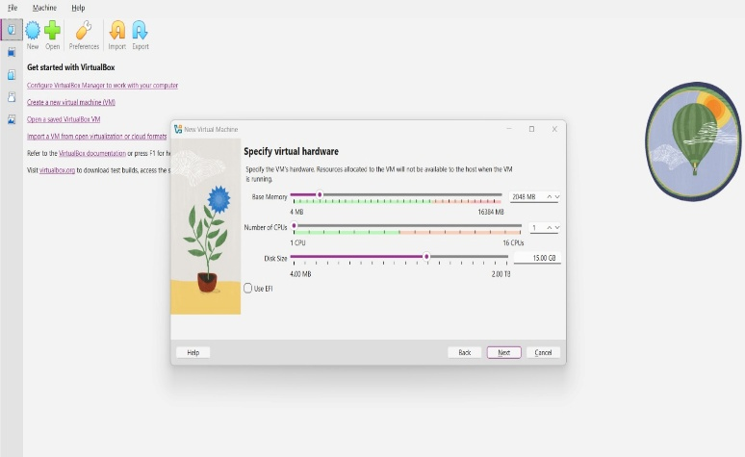
Output:
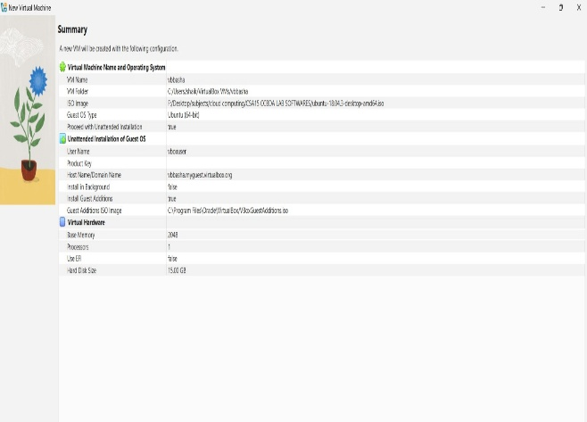

Result:
A Virtual Hard Disk was successfully created and storage space was allocated using Oracle VirtualBox, enabling the Virtual Machine to store operating system files and user data.

