9. Create a Snapshot of a VM and Test it by loading the Previous Version/Cloned VM using virtual box.
Aim: To create a snapshot of a Virtual Machine in VirtualBox and verify it by restoring the VM back to the previous saved state.
Procedure:
- Open Oracle VM VirtualBox on your system.
- Select the Virtual Machine for which you want to create a snapshot (ensure it is powered on and stable).
- Click the Snapshots icon (camera symbol) on the top-right of the VM window.
- Click Take to create a new snapshot.
- Enter a Snapshot Name and optional Description (e.g., “OS Installed – Clean State”).
- Click OK to save the snapshot successfully.
- Now make some changes to the VM (e.g., install software or modify settings).
- To restore, again go to the Snapshots tab.
- Select the previously taken snapshot and click Restore.
- Power on the VM and verify that it has returned to the original saved state, with recent changes removed.
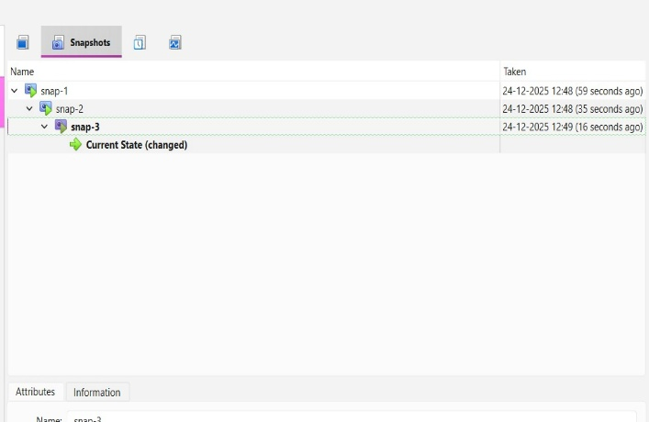
Output:
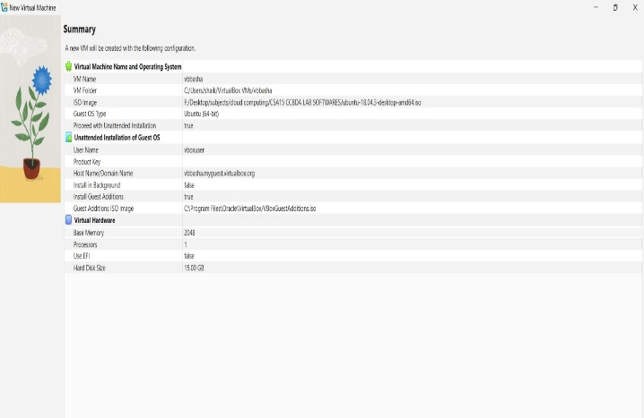
Result:
A snapshot of the VM was successfully created and restored using VirtualBox.
The VM reverted to its earlier state, proving that snapshots help in version control and quick recovery during testing.

