Demonstrate virtualization by Installing Type-2 Hypervisor in your device,
create and configure VM image with a Host Operating system (Either
Windows/Linux) using virtual box.
Aim: To demonstrate virtualization by installing a Type-2 Hypervisor (VirtualBox) and creating and configuring a Virtual Machine with a Host Operating System (Windows/Linux).
Procedure:
- Download Oracle VM VirtualBox from the official website and install it on your device.
- Launch the VirtualBox application after installation.
- Click New to create a Virtual Machine.
- Enter the VM Name, select Type: Linux/Windows, and choose the corresponding Version.
- Allocate Memory (RAM) — for example 2048 MB (2GB).
- Configure CPU as required (e.g., 1 CPU core).
- Create a Virtual Hard Disk:
- Select Create a virtual hard disk now
- Choose disk type: VDI – VirtualBox Disk Image
- Select Dynamically allocated
- Set size: e.g., 15GB
- After VM creation, open Settings ➜ Storage and attach the OS ISO file to the virtual CD/DVD drive.
- Start the VM and follow on-screen instructions to install the selected OS inside the virtual machine.
- Once installation completes, verify the working virtual environment by exploring the OS desktop and system settings.

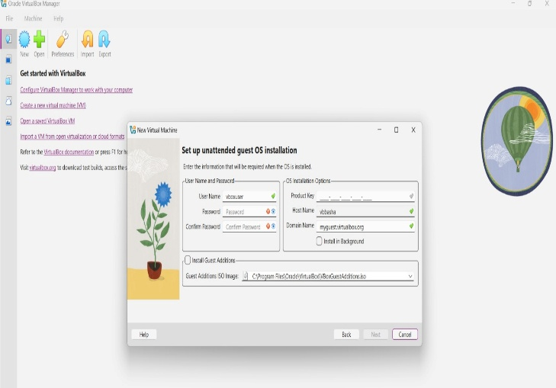
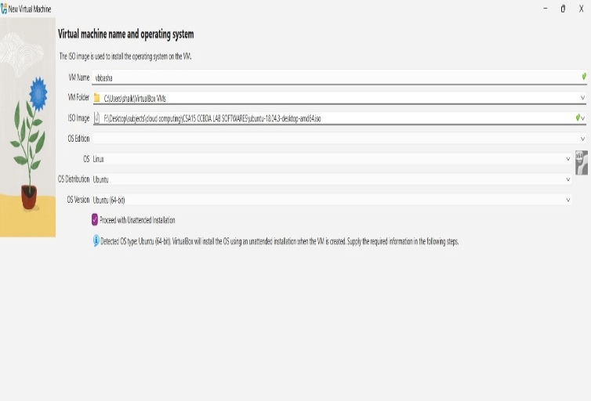
Output:
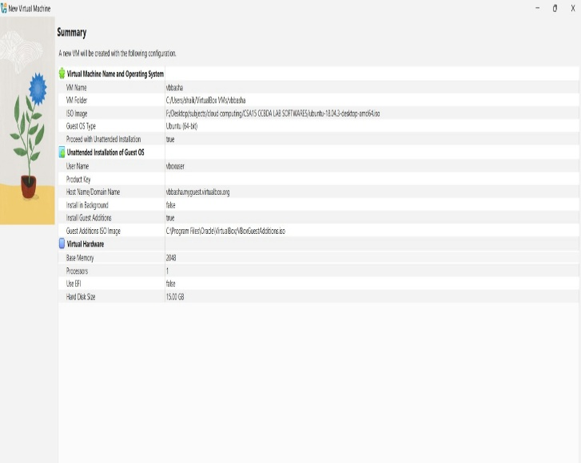
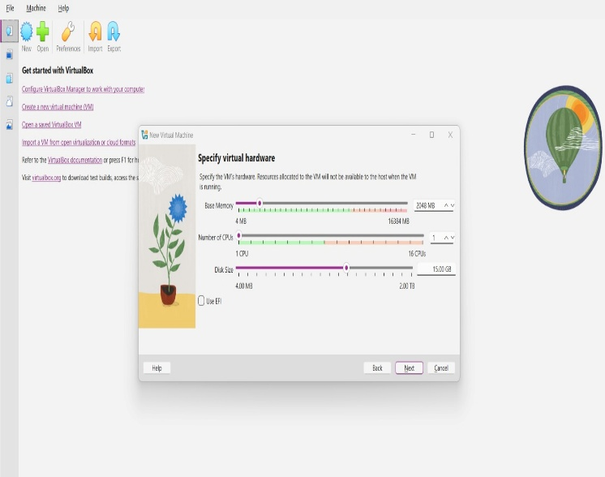

Result:
Virtualization was successfully demonstrated by installing a Type-2 Hypervisor (Oracle VirtualBox) and creating a fully functional Virtual Machine with a host Operating System, proving that multiple OS environments can run on a single physical computer.

