**JAVA作业2**

**学号1517440121姓名 黄春翔**

1. 在自己的计算机上完成下列代码的调试,该程序能输出变量r的值，但是程序有错误请修改正确后运行。将修改后的程序，做为本题结果。

[代码]

package test3;

public abstract class test3 {

public static void main(String[] args) {

float r=98678.18;

r=r+0.000001;

System.out.println("r="+r);

}

}

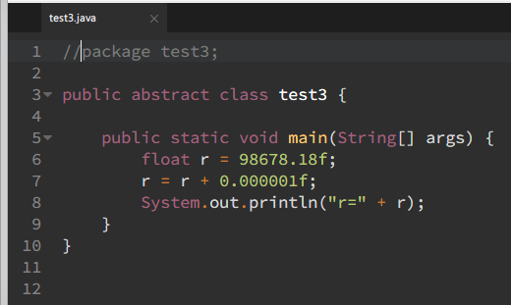

//package test3;

public abstract class test3 {

public static void main(String[] args) {

float r = 98678.18f;

r = r + 0.000001f;

System.out.println("r=" + r);

}

}

1. 编程计算长方体的体积。

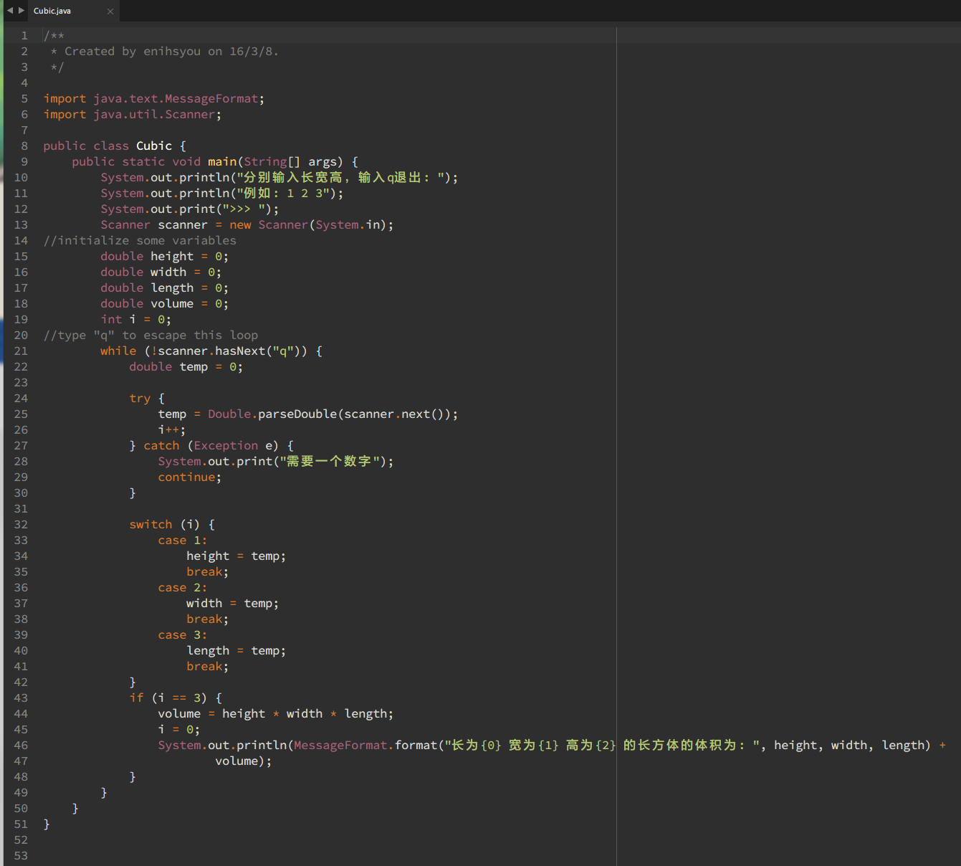

import java.text.MessageFormat;

import java.util.Scanner;

public class Cubic {

public static void main(String[] args) {

System.out.println("分别输入长宽高，输入q退出: ");

System.out.println("例如: 1 2 3");

System.out.print(">>> ");

Scanner scanner = new Scanner(System.in);

//initialize some variables

double height = 0;

double width = 0;

double length = 0;

double volume = 0;

int i = 0;

//type "q" to escape this loop

while (!scanner.hasNext("q")) {

double temp = 0;

try {

temp = Double.parseDouble(scanner.next());

i++;

} catch (Exception e) {

System.out.print("需要一个数字");

continue;

}

switch (i) {

case 1:

height = temp;

break;

case 2:

width = temp;

break;

case 3:

length = temp;

break;

}

if (i == 3) {

volume = height * width * length;

i = 0;

System.out.println(MessageFormat.format("长为{0} 宽为{1} 高为{2} 的长方体的体积为: ", height, width, length) +

volume);

}

}

}

}

阅读P40-42编写如下程序

1. 编程实现封装红包，输入红包的总金额，输入分派的红包个数，输入发红包的缘由，例如：新春红包，开学红包等等，程序打印红包封装清单，例如：输出清单见图1。

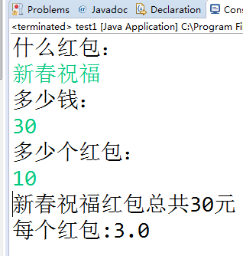

图1

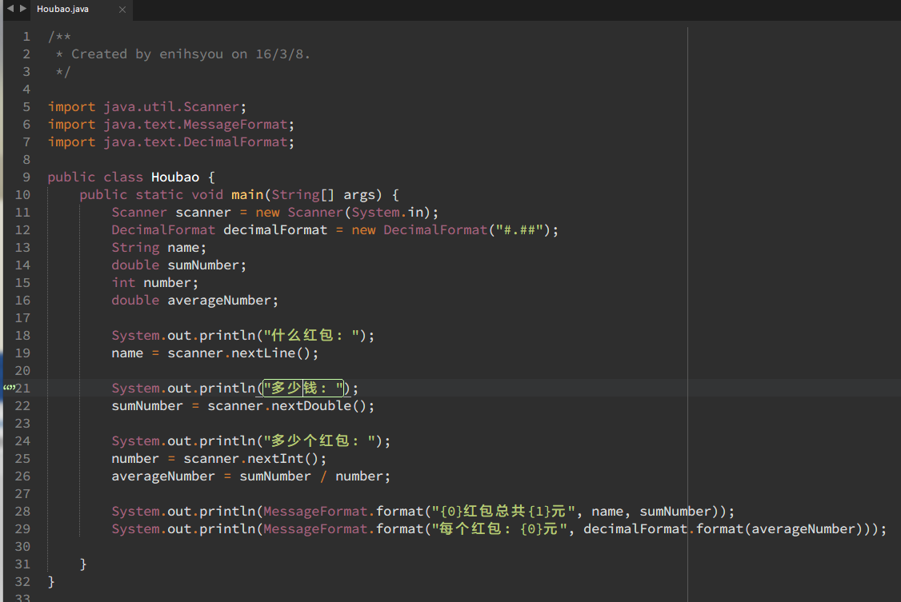

/**

* Created by enihsyou on 16/3/8.

*/

import java.util.Scanner;

import java.text.MessageFormat;

import java.text.DecimalFormat;

public class Houbao {

public static void main(String[] args) {

Scanner scanner = new Scanner(System.in);

DecimalFormat decimalFormat = new DecimalFormat("#.##");

String name;

double sumNumber;

int number;

double averageNumber;

System.out.println("什么红包: ");

name = scanner.nextLine();

System.out.println("多少钱: ");

sumNumber = scanner.nextDouble();

System.out.println("多少个红包: ");

number = scanner.nextInt();

averageNumber = sumNumber / number;

System.out.println(MessageFormat.format("{0}红包总共{1}元", name, sumNumber));

System.out.println(MessageFormat.format("每个红包: {0}元", decimalFormat.format(averageNumber)));

}

}

1. 编程输出“上海理工大学”但输出的样式自行设计，至少3种输出样式。

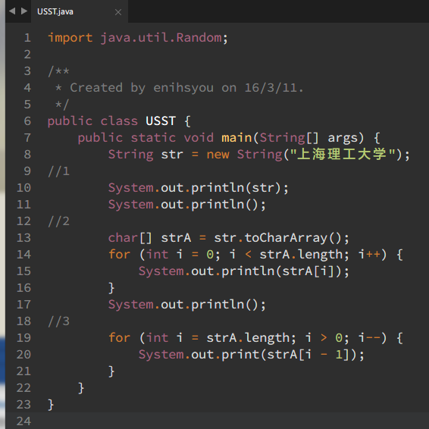

import java.util.Random;

/**

* Created by enihsyou on 16/3/11.

*/

public class USST {

public static void main(String[] args) {

String str = new String("上海理工大学");

//1

System.out.println(str);

System.out.println();

//2

char[] strA = str.toCharArray();

for (int i = 0; i < strA.length; i++) {

System.out.println(strA[i]);

}

System.out.println();

//3

for (int i = strA.length; i > 0; i--) {

System.out.print(strA[i - 1]);

}

}

}

1. 用Raptor设计口令红包的封装与领取（口令正确可领红包）。

