JAVA作业3

学号1517440121姓名黄春翔

编写程序实现如下功能。

1. 输出1-10的平方表。  
   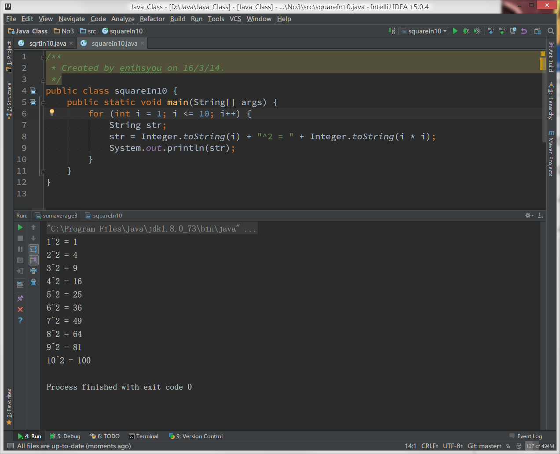

/**

* Created by enihsyou on 16/3/14.

*/

public class squareIn10 {

public static void main(String[] args) {

for (int i = 1; i <= 10; i++) {

String str;

str = Integer.toString(i) + "^2 = " + Integer.toString(i * i);

System.out.println(str);

}

}

}

1. 输出1-10的平方根表。

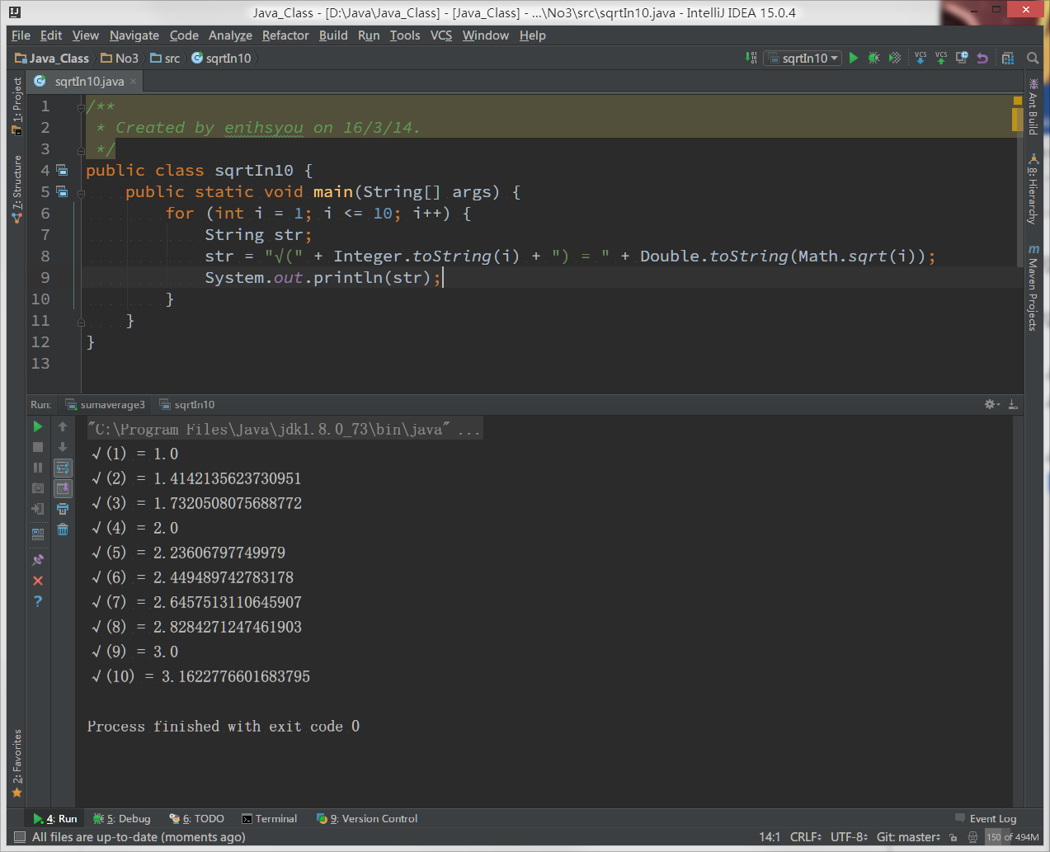

/**

* Created by enihsyou on 16/3/14.

*/

public class sqrtIn10 {

public static void main(String[] args) {

for (int i = 1; i <= 10; i++) {

String str;

str = "√(" + Integer.toString(i) + ") = " + Double.toString(Math.sqrt(i));

System.out.println(str);

}

}

}

1. 输出a-z的代码和字符的对应表。

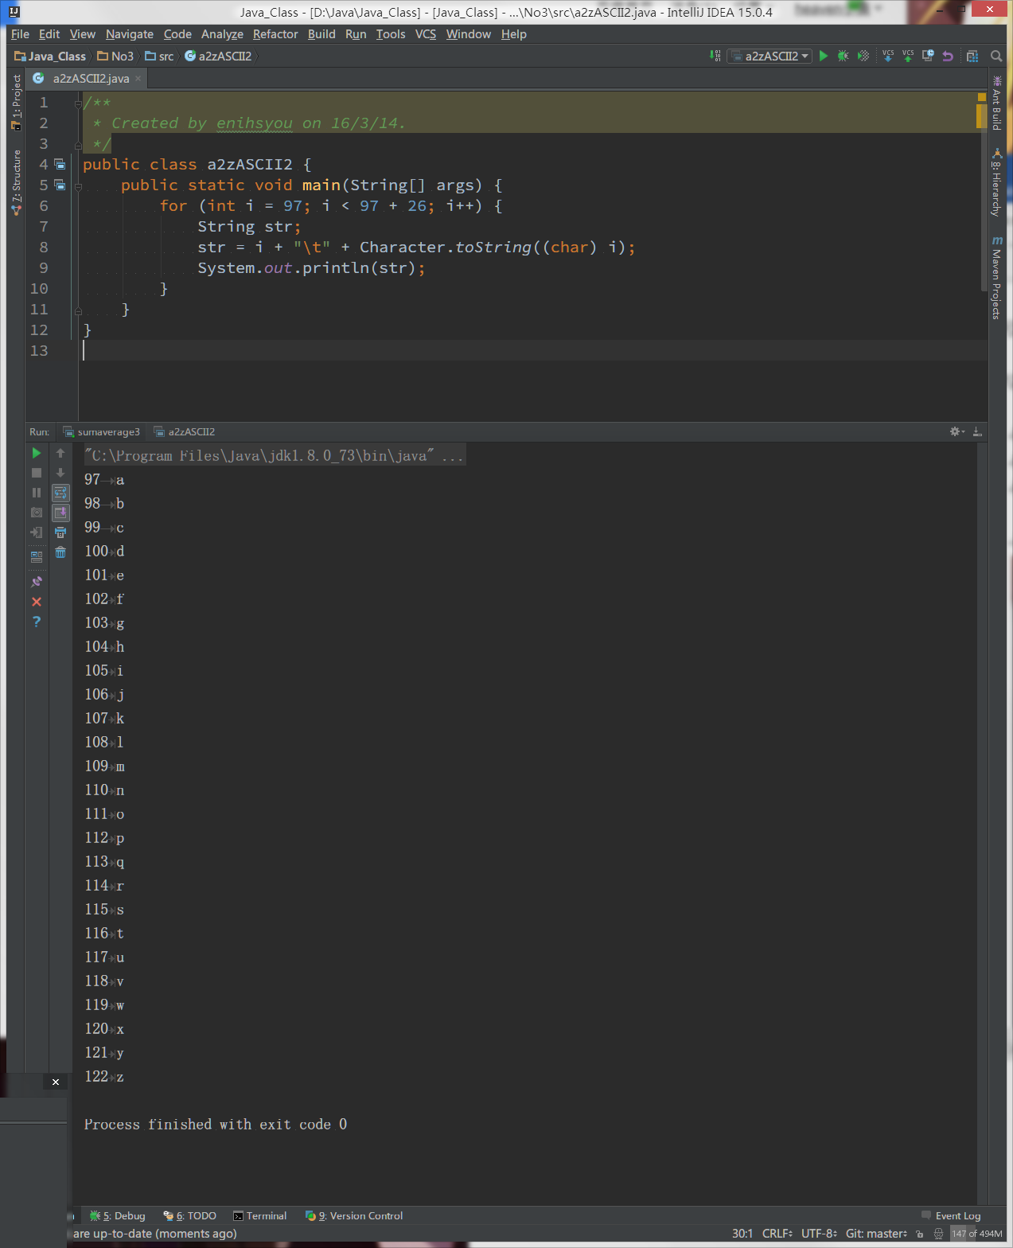

/**

* Created by enihsyou on 16/3/14.

*/

public class a2zASCII2 {

public static void main(String[] args) {

for (int i = 97; i < 97 + 26; i++) {

String str;

str = i + "\t" + Character.toString((char) i);

System.out.println(str);

}

}

}

1. 计算任意3个数的平均值，（3个任意数从键盘输入）。

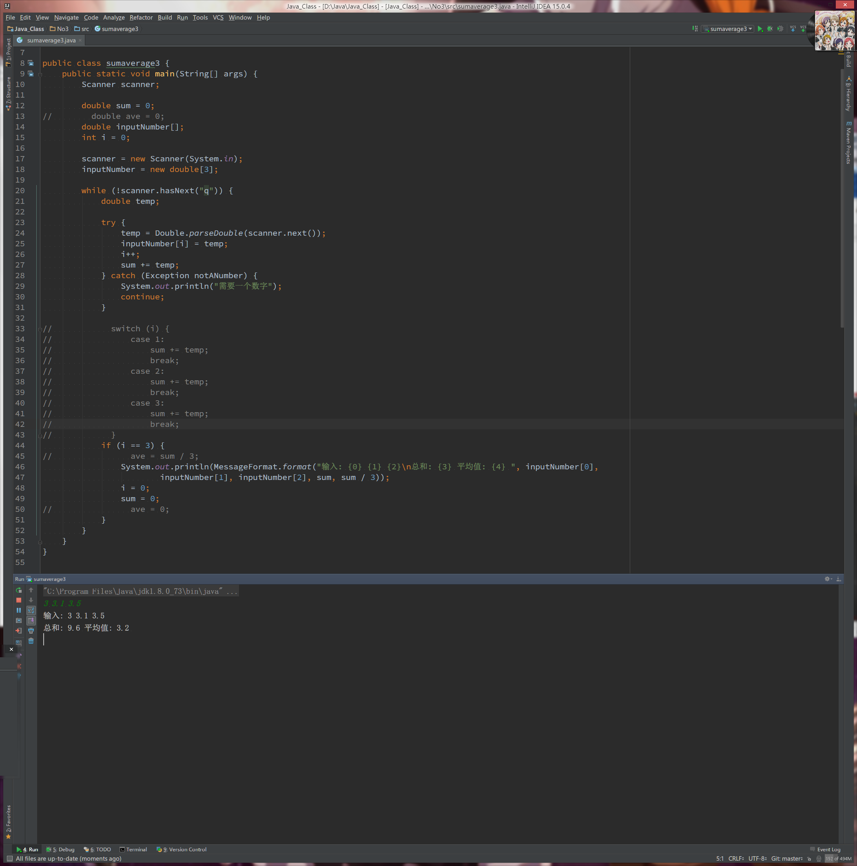

/**

* Created by enihsyou on 16/3/14.

*/

import java.text.MessageFormat;

import java.util.Scanner;

public class sumaverage3 {

public static void main(String[] args) {

Scanner scanner;

double sum = 0;

double inputNumber[];

int i = 0;

scanner = new Scanner(System.in);

inputNumber = new double[3];

while (!scanner.hasNext("q")) {

double temp;

try {

temp = Double.parseDouble(scanner.next());

inputNumber[i] = temp;

i++;

sum += temp;

} catch (Exception notANumber) {

System.out.println("需要一个数字");

continue;

}

if (i == 3) {

System.out.println(MessageFormat.format("输入: {0} {1} {2}\n总和: {3} 平均值: {4} ", inputNumber[0],

inputNumber[1], inputNumber[2], sum, sum / 3));

i = 0;

sum = 0;

}

}

}

}

1. 计算任意3个数的总和（3个任意数从键盘输入）。



/**

* Created by enihsyou on 16/3/14.

*/

import java.text.MessageFormat;

import java.util.Scanner;

public class sumaverage3 {

public static void main(String[] args) {

Scanner scanner;

double sum = 0;

double inputNumber[];

int i = 0;

scanner = new Scanner(System.in);

inputNumber = new double[3];

while (!scanner.hasNext("q")) {

double temp;

try {

temp = Double.parseDouble(scanner.next());

inputNumber[i] = temp;

i++;

sum += temp;

} catch (Exception notANumber) {

System.out.println("需要一个数字");

continue;

}

if (i == 3) {

System.out.println(MessageFormat.format("输入: {0} {1} {2}\n总和: {3} 平均值: {4} ", inputNumber[0],

inputNumber[1], inputNumber[2], sum, sum / 3));

i = 0;

sum = 0;

}

}

}

}

1. 编程实现模拟超市收银功能。一次购买多个物品，最后计算总价。

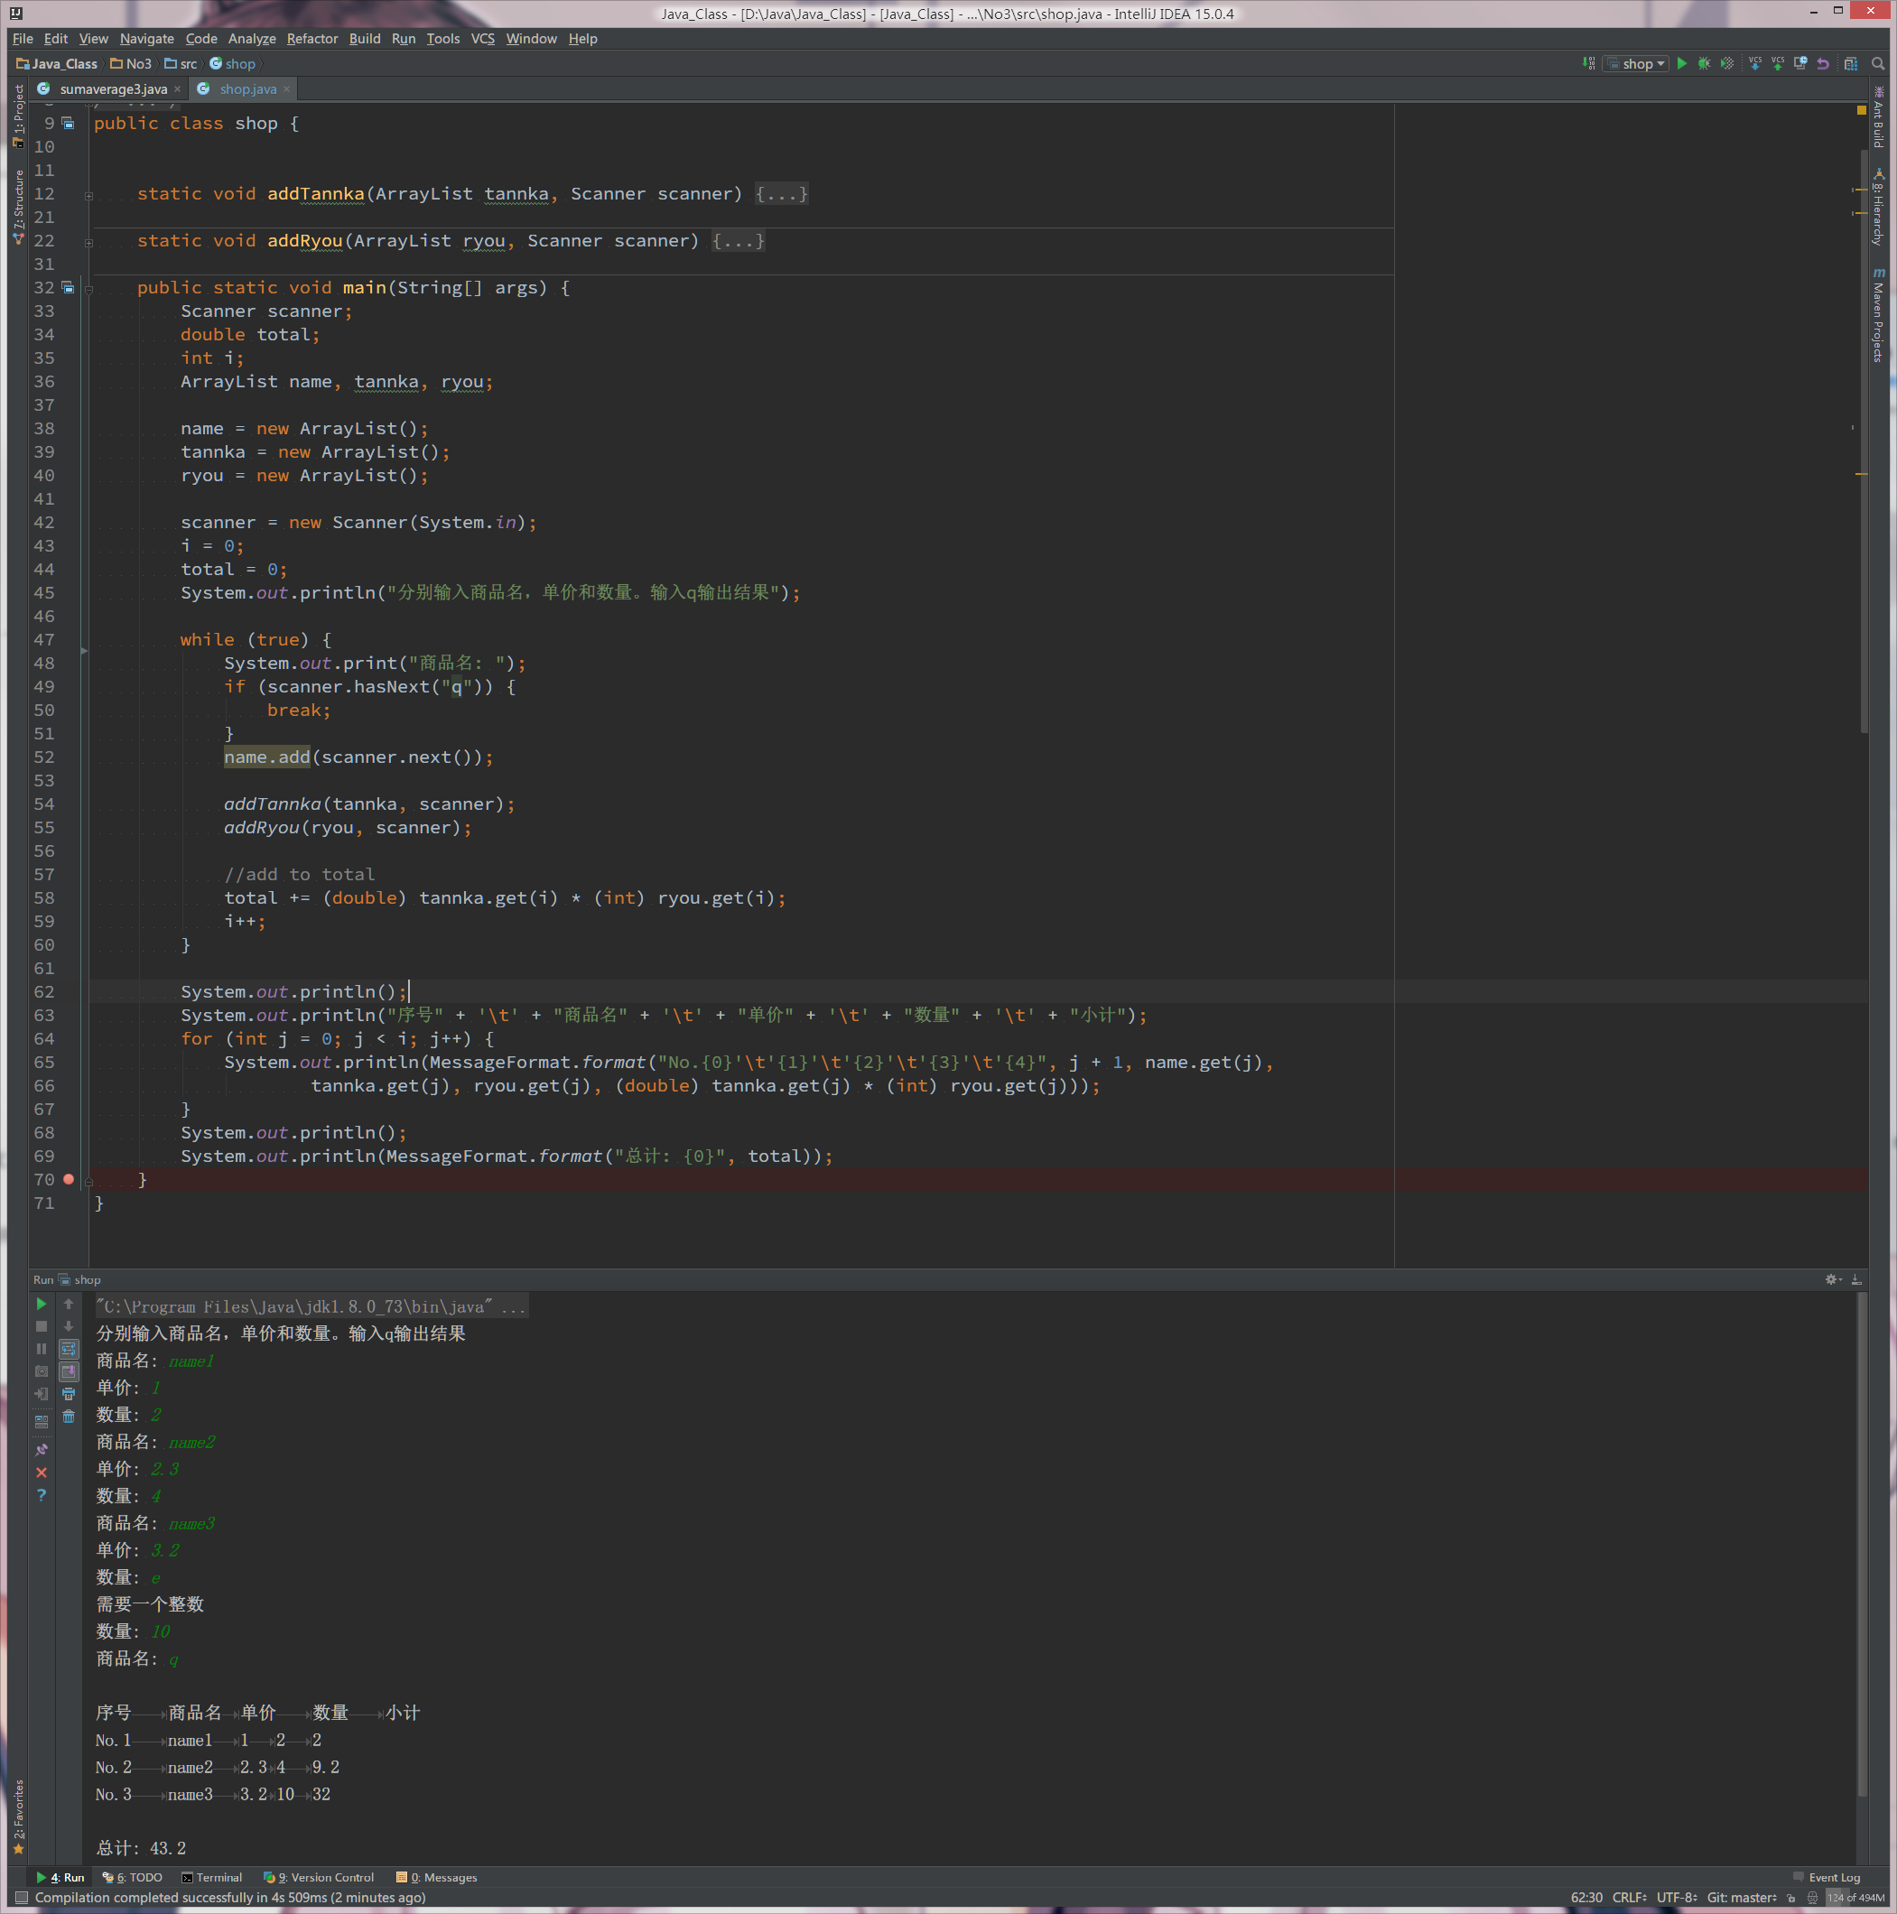

import java.text.MessageFormat;

import java.util.ArrayList;

import java.util.Scanner;

/**

* Created by enihsyou on 16/3/14.

* 依据输入商品名 单价 数量 打印输出单

*/

public class shop {

static void addTannka(ArrayList tannka, Scanner scanner) {

try {

System.out.print("单价: ");

tannka.add(Double.parseDouble(scanner.next()));

} catch (Exception notANumber) {

System.out.println("需要一个数字");

addTannka(tannka, scanner);

}

}

static void addRyou(ArrayList ryou, Scanner scanner) {

try {

System.out.print("数量: ");

ryou.add(Integer.parseInt(scanner.next()));

} catch (Exception notANumber) {

System.out.println("需要一个整数");

addRyou(ryou, scanner);

}

}

public static void main(String[] args) {

Scanner scanner;

double total;

int i;

ArrayList name, tannka, ryou;

name = new ArrayList();

tannka = new ArrayList();

ryou = new ArrayList();

scanner = new Scanner(System.in);

i = 0;

total = 0;

System.out.println("分别输入商品名，单价和数量。输入q输出结果");

while (true) {

System.out.print("商品名: ");

if (scanner.hasNext("q")) {

break;

}

name.add(scanner.next());

addTannka(tannka, scanner);

addRyou(ryou, scanner);

//add to total

total += (double) tannka.get(i) * (int) ryou.get(i);

i++;

}

System.out.println();

System.out.println("序号" + '\t' + "商品名" + '\t' + "单价" + '\t' + "数量" + '\t' + "小计");

for (int j = 0; j < i; j++) {

System.out.println(MessageFormat.format("No.{0}'\t'{1}'\t'{2}'\t'{3}'\t'{4}", j + 1, name.get(j),

tannka.get(j), ryou.get(j), (double) tannka.get(j) * (int) ryou.get(j)));

}

System.out.println();

System.out.println(MessageFormat.format("总计: {0}", total));

}

}

1. 输入2个数，输出时这2个数的次序与输入时相反。

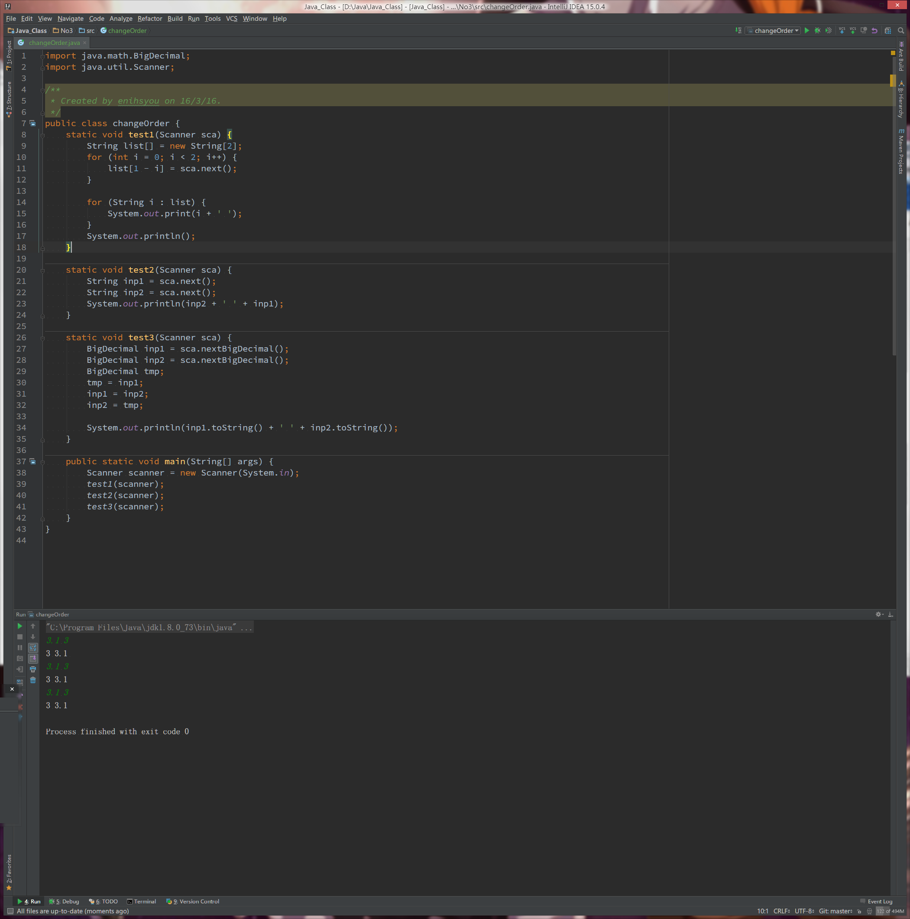

import java.math.BigDecimal;

import java.util.Scanner;

/**

* Created by enihsyou on 16/3/16.

*/

public class changeOrder {

static void test1(Scanner sca) {

String list[] = new String[2];

for (int i = 0; i < 2; i++) {

list[1 - i] = sca.next();

}

for (String i : list) {

System.out.print(i + ' ');

}

System.out.println();

}

static void test2(Scanner sca) {

String inp1 = sca.next();

String inp2 = sca.next();

System.out.println(inp2 + ' ' + inp1);

}

static void test3(Scanner sca) {

BigDecimal inp1 = sca.nextBigDecimal();

BigDecimal inp2 = sca.nextBigDecimal();

BigDecimal tmp;

tmp = inp1;

inp1 = inp2;

inp2 = tmp;

System.out.println(inp1.toString() + ' ' + inp2.toString());

}

public static void main(String[] args) {

Scanner scanner = new Scanner(System.in);

test1(scanner);

test2(scanner);

test3(scanner);

}

}

参考if语句编写如下程序

1. 编程差旅费报销计算器，住宿费不得高于500元，每天的补助为200元，下面是报销的凭证，根据凭证计算报销费用。

|  |  |  |  |
| --- | --- | --- | --- |
| 序号 | 凭证 | 数量 | 金额 |
| 1 | 出租车票 | 4 | 123.5 |
| 2 | 住宿费 | 2天 | 1215 |
| 3 | 资料费 | 2 | 1300 |

???????????理解不能