FINAL PROJECT REPORT
SmartPlate AI
AI-Powered Food Demand Prediction and Waste Reduction System
Domain: Environment & Sustainability
Submitted by
Team Member Name | Register Number
ENIKA RS | 7376251CS178
HASHINI OS | 7376251CS212
ROHINI S | 7376252IT311
DEVAMITHRA RG | 7376252AD143

TABLE OF CONTENTS
1. Problem 3
2. Problem Description 4
2.1 Background and Context 4
2.2 Current Limitations 4
2.3 Scope of the Project 4
3. Objectives 6
4. Literature Survey 7
4.1 Review of Existing Work 7
4.2 Gap Addressed by This Project 8
4.3 References 8
5. Requirements 9
5.1 Functional Requirements 9
5.2 Non-Functional Requirements 10
6. Obtained Solution 11
6.1 Overall Approach 11
6.2 Technologies, Tools, Algorithms and Dataset 12
6.3 Machine Learning Method 12
6.4 Key Modules 12
6.5 Results Achieved 13
6.6 Limitations and Future Work 13
7. Output Screenshots 14
8. GitHub Link 17

1. Problem
College canteens and hostels usually decide how much food to cook from an approximate student strength or manual guess, so they often prepare more than students actually eat. This overproduction affects canteen management through avoidable cost, and it affects society and the environment through wasted food, water, energy and emissions. An AI-based solution that learns from past consumption patterns is needed to estimate future food requirements and reduce this waste.

2. Problem Description

2.1 Background and Context
Food in a college canteen or hostel mess is prepared in bulk, in advance, for a fixed number of students per meal. Actual demand changes from day to day because of attendance, the menu served, weekdays and weekends, holidays, examinations, college events and many other factors. Food that is prepared but not eaten is food waste, and it represents wasted raw material, labour, fuel and money.
Research on catering and university dining shows that poor demand forecasting is a main cause of food waste, and that machine learning forecasts can reduce the number of wasted meals considerably [1]. Hostels and canteens that serve the same students every day also generate a rich history of consumption data, which is rarely used for planning.

2.2 Current Limitations
- Preparation quantity is decided from approximate student strength or the cook's experience, not from data.
- Factors such as menu popularity, attendance, exams and holidays are not considered systematically.
- Prepared, consumed and remaining quantities are often not recorded, so waste is never measured and cannot be reduced.
- Existing AI approaches either only forecast demand [1]-[5] or require hardware such as cameras and smart scales to measure waste after it has occurred [6].
- Many forecasting studies are not packaged as a simple tool that canteen staff can use, and they rarely close the loop by learning from each new day of data.

2.3 Scope of the Project
Covered in this project:
- A web-based system for college canteens and hostel messes.
- Entry and validation of historical and daily consumption data.
- Machine-learning-based prediction of meals required for a selected date and meal, and a recommended preparation quantity with a safety margin.
- Recording of actual consumption, calculation of waste and waste percentage, dashboards, alerts and basic sustainability indicators.
- Feedback of newly recorded data to improve later predictions.
Not covered in this version:
- IoT-based automatic weighing of leftovers and camera-based waste recognition.
- Weather integration, ingredient-level prediction and inventory management.
- Mobile application and integration with external canteen billing systems.

3. Objectives
Main objective
To develop an AI-based system that predicts future food requirements from historical consumption data and helps reduce food waste in college canteens and hostels.
Specific objectives
- Design a database and data-entry module that records date, meal, attendance, menu, quantity prepared and quantity consumed, and rejects invalid entries (for example, consumed quantity greater than prepared quantity).
- Develop a Random Forest regression model that predicts meal demand using features such as day of week, meal type, attendance, menu, holiday and exam period.
- Implement a recommendation module that converts predicted demand into a preparation quantity using a configurable safety margin (for example, 5%).
- Implement waste tracking that calculates waste and waste percentage for every meal, and an alert when waste exceeds a set threshold (for example, 15%).
- Evaluate the model using MAE and RMSE against a simple baseline (such as the average of the same weekday), and analyse waste trends through dashboards.

4. Literature Survey

4.1 Review of Existing Work
Several researchers have applied machine learning to food demand forecasting in catering, university dining halls and canteens. Commercial systems also exist for measuring kitchen waste. Table 1 compares six relevant works and systems.
No. | Title | Author / Year | Method Used | Limitation
1 | ML models for short-term demand forecasting in food catering services [1] | Rodrigues et al., 2024 | Four ML models (including random forest and LSTM) compared with two baselines on catering data; reported 14% to 52% fewer wasted meals. | Forecasting only; no tool for quantity recommendation, waste tracking or alerts.
2 | Reducing Food Waste in Campus Dining [2] | Türker, 2025 | Six regression models (e.g., linear regression, extra trees, XGBoost, gradient boosting) on daily campus data; reported waste reduced to 28%. | Model comparison on one campus; no end-user decision-support interface reported.
3 | Demand Forecasting for Food Production Using ML: University Refectory [3] | Aci and Yergök, 2023 | Eighteen models in five technique groups using calendar effect and meal ingredients, without pre-booking. | Single refectory; prediction only, no waste monitoring or feedback loop.
4 | Preventing food waste in subsidy-based university dining systems [4] | Faezirad et al., 2021 | Artificial neural network with a two-step approach under uncertainty, using meal reservation data; reported up to 79% less waste. | Depends on meal booking data; not suitable where students do not pre-book.
5 | Intelligent computational techniques of ML models for demand analysis and prediction [5] | Sundar et al., 2023 | Twelve ML models with feature engineering compared using RMSE for food demand. | General food demand data, not canteen-specific; no waste tracking or recommendation.
6 | Winnow Vision [6] | Winnow Solutions, 2019 | Camera and smart scales with machine learning identify and weigh discarded food in commercial kitchens. | Needs installed hardware; measures waste after it happens and does not predict demand.
Table 1: Comparison of existing work

4.2 Gap Addressed by This Project
The reviewed studies show that machine learning can forecast food demand well, and that random forest style models are effective for this task [1], [7]. However, most of them stop at the forecasting model, while commercial tools measure waste after it has been produced and need extra hardware. Few of the reviewed works combine, in one low-cost web application, (i) demand prediction, (ii) a preparation quantity recommendation with a safety margin, (iii) recording of prepared versus consumed food, (iv) waste alerts and (v) a feedback loop that learns from every new record, and work without a meal pre-booking system. SmartPlate AI fills this gap for college canteens and hostels.

4.3 References
[1] M. Rodrigues, V. Miguéis, S. Freitas, and T. Machado, "Machine learning models for short-term demand forecasting in food catering services: A solution to reduce food waste," J. Clean. Prod., vol. 435, Art. no. 140265, 2024, doi: 10.1016/j.jclepro.2023.140265.
[2] G. F. Türker, "Reducing food waste in campus dining: A data-driven approach to demand prediction and sustainability," Sustainability, vol. 17, no. 2, p. 379, 2025, doi: 10.3390/su17020379.
[3] M. Aci and D. Yergök, "Demand forecasting for food production using machine learning algorithms: A case study of university refectory," Teh. Vjesn. (Tech. Gaz.), pp. 1683-1691, 2023, doi: 10.17559/TV-20230117000232.
[4] M. Faezirad, A. Pooya, Z. Naji-Azimi, and M. Amir Haeri, "Preventing food waste in subsidy-based university dining systems: An artificial neural network-aided model under uncertainty," Waste Manag. Res., 2021, doi: 10.1177/0734242X211017974.
[5] G. N. Sundar et al., "Intelligent computational techniques of machine learning models for demand analysis and prediction," Int. J. Intell. Inf. Database Syst., vol. 16, no. 1, 2023.
[6] Winnow Solutions, "Winnow brings AI into the commercial kitchen to tackle food waste," Hospitality Net, 2019. [Online]. Available: https://www.hospitalitynet.org/news/4092645.html
[7] L. Breiman, "Random forests," Mach. Learn., vol. 45, no. 1, pp. 5-32, 2001.
[8] F. Pedregosa et al., "Scikit-learn: Machine learning in Python," J. Mach. Learn. Res., vol. 12, pp. 2825-2830, 2011.

5. Requirements

5.1 Functional Requirements
Table 2 lists what the system must do, with the inputs, processing and expected outputs.
ID | Requirement | Input / Processing / Output
FR-01 | User login: authorized users log in with valid credentials. | In: username, password.  Proc: verify against stored hash.  Out: dashboard access or error.
FR-02 | Historical data entry: users enter past consumption records. | In: date, meal, students, attendance, menu, prepared, consumed, remaining.  Proc: store record.  Out: saved record.
FR-03 | Data validation: invalid entries are rejected before storing. | In: entered record.  Proc: check non-negative values and consumed <= prepared.  Out: accepted or error message.
FR-04 | Demand prediction: system estimates future demand. | In: prediction parameters.  Proc: Random Forest model.  Out: predicted number of meals.
FR-05 | Prediction inputs: system accepts date, meal type, expected attendance and menu. | In: the four parameters.  Proc: validate and encode.  Out: model-ready input.
FR-06 | Preparation recommendation: system recommends quantity using a safety margin. | In: predicted demand, margin %.  Proc: demand x (1 + margin).  Out: recommended quantity (e.g., 420 gives about 441 at 5%).
FR-07 | Actual consumption: users record actual consumption after each meal. | In: prepared, consumed, remaining.  Proc: validate and store.  Out: saved actual record.
FR-08 | Waste calculation: waste = prepared - consumed. | In: prepared, consumed.  Proc: subtract.  Out: waste quantity.
FR-09 | Waste percentage = (prepared - consumed) / prepared x 100. | In: prepared, consumed.  Proc: formula.  Out: waste %.
FR-10 | Analytics: system shows consumption and waste trends as charts. | In: stored records.  Proc: aggregate by date and meal.  Out: graphs.
FR-11 | Alerts: system raises an alert when waste exceeds a threshold. | In: waste %, threshold.  Proc: compare over recent meals.  Out: alert message.
FR-12 | Recommendations: system suggests actions from patterns. | In: trends, expected attendance.  Proc: rule-based checks.  Out: advice text.
FR-13 | Prediction accuracy: system shows MAE, RMSE and accuracy trend. | In: predicted vs actual.  Proc: error metrics.  Out: metric display.
FR-14 | Feedback: new actual records are used as input for later predictions. | In: new records.  Proc: add to dataset, retrain.  Out: updated model version.
FR-15 | Sustainability: system shows cumulative food waste avoided against a baseline. | In: waste history.  Proc: compare with baseline.  Out: sustainability indicator.
FR-16 | Configuration: administrator sets the safety margin and alert threshold. | In: margin %, threshold %.  Proc: validate and save.  Out: updated settings.
Table 2: Functional requirements

5.2 Non-Functional Requirements
ID | Category | Measurable Requirement
NFR-01 | Performance | A prediction shall be returned within 5 seconds, and any dashboard page shall load within 3 seconds under normal prototype usage.
NFR-02 | Usability | A canteen manager shall be able to generate a prediction in at most 4 steps from the dashboard.
NFR-03 | Reliability | Saved consumption records shall not be lost; the database shall be backed up at least once a day.
NFR-04 | Security | Passwords shall be stored only as hashes; administrative functions shall be available only to the Administrator role.
NFR-05 | Scalability | The design shall allow at least 3 canteens and 10,000 consumption records without redesign.
NFR-06 | Compatibility | The interface shall work on the latest versions of Chrome and Edge.
NFR-07 | Maintainability | Prediction model, dashboard and database shall be separate modules that can be updated independently.
NFR-08 | Availability | The system shall be available at least 95% of the time during canteen operating hours.
Table 3: Non-functional requirements

6. Obtained Solution

6.1 Overall Approach
SmartPlate AI is a web-based decision-support system. Historical consumption records are cleaned and converted into features, a Random Forest regression model [7] is trained to predict meal demand, and the prediction is converted into a recommended preparation quantity. After every meal the actual prepared and consumed quantities are recorded, waste is calculated, and the new record is added to the dataset so that the model improves over time. Figure 1 shows the architecture and Figure 2 the workflow.
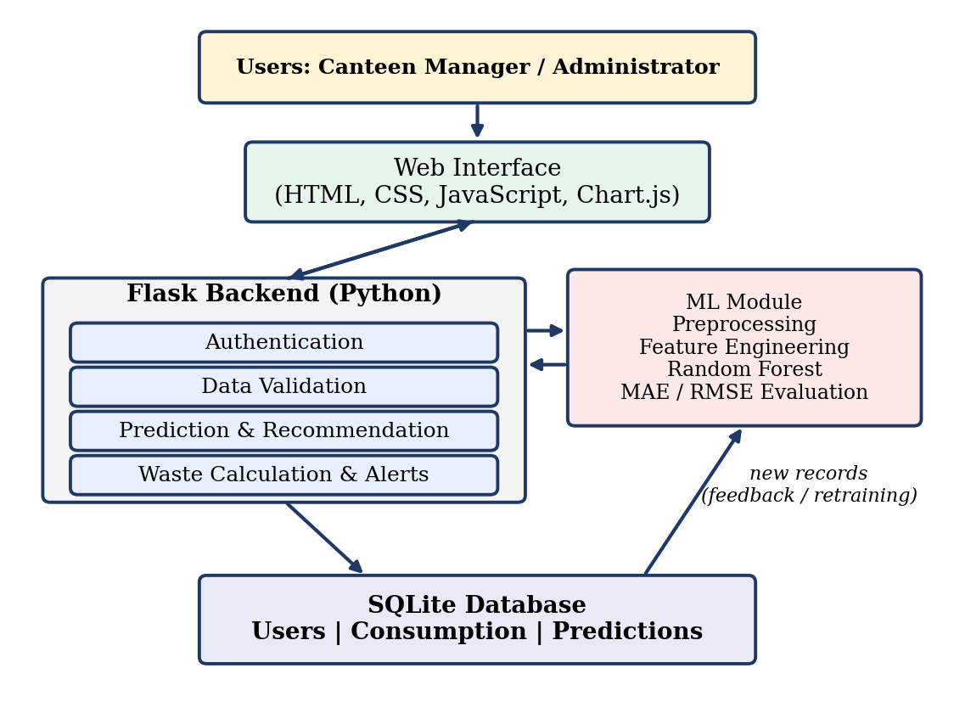
Figure 1: System architecture of SmartPlate AI
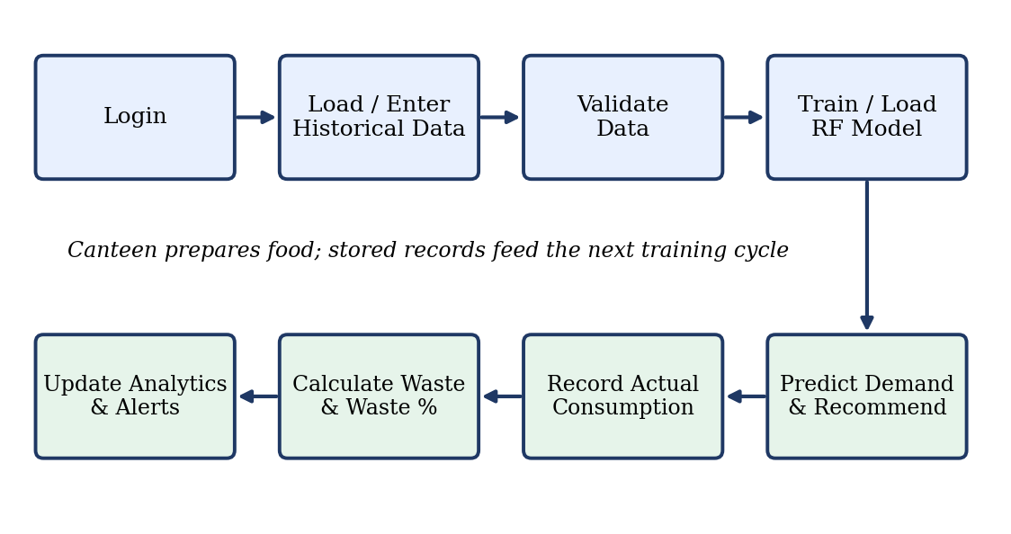
Figure 2: Prediction and feedback workflow

6.2 Technologies, Tools, Algorithms and Dataset
Item | Details
Frontend | HTML, CSS, JavaScript, Chart.js
Backend | Python, Flask
Machine learning | Python, Scikit-learn [8], Pandas, NumPy
Algorithm | Random Forest Regression [7]
Database | SQLite (tables: Users, Consumption, Predictions)
Tools | VS Code, Git and GitHub, Chrome / Edge
Dataset | Historical canteen / hostel records (date, meal, students, attendance, menu, prepared, consumed). [Fill in: source, number of records and period; state clearly if simulated data was used.]
Table 4: Technologies and dataset

6.3 Machine Learning Method
- Data cleaning: remove missing and invalid records.
- Features: day of week, meal type, student strength, attendance, menu, holiday flag, exam-period flag, previous consumption and rolling average consumption.
- Split: earlier records for training and the most recent records for testing, so that the model is tested on future data.
- Model: Random Forest Regressor, chosen because it handles mixed tabular data and non-linear patterns well.
- Evaluation: MAE and RMSE, compared with a baseline that predicts the average of the same weekday.
- Recommendation: recommended quantity = predicted demand x (1 + safety margin), rounded up.

6.4 Key Modules
Module | Function and Interaction
User Management | Handles login and roles; protects admin functions (FR-01, FR-16).
Data Management | Takes entries from the interface, validates and stores them in SQLite (FR-02, FR-03, FR-07).
Prediction Engine | Loads the trained model, predicts demand and computes the recommended quantity (FR-04 to FR-06).
Waste Monitoring | Calculates waste and waste %, raises alerts (FR-08, FR-09, FR-11).
Analytics Dashboard | Reads stored data and shows trends, model accuracy and sustainability indicators (FR-10, FR-13, FR-15).
Feedback / Retraining | Adds new actual records to the dataset and retrains the model, saving a new version (FR-14).
Table 5: Key modules

6.5 Results Achieved
Fill the values below after running the final model on your dataset. Do not leave placeholders in the submitted report.
Metric | Baseline (weekday average) | SmartPlate AI (Random Forest)
MAE (meals) | [value] | [value]
RMSE (meals) | [value] | [value]
Average waste % | [value] | [value]
Table 6: Model performance
Objective | How it was met | Evidence
1. Data entry and validation | Entry forms with validation reject invalid records. | Figures 4 and 5
2. Demand prediction model | Random Forest model trained on historical data. | Figure 6, Table 6
3. Recommendation | Predicted demand plus safety margin displayed. | Figure 6
4. Waste tracking and alerts | Waste and waste % calculated; alert shown above threshold. | Figures 7 and 9
5. Evaluation and dashboards | MAE/RMSE compared with baseline; trend charts shown. | Figures 8 and 10, Table 6
Table 7: Objectives versus results

6.6 Limitations and Future Work
Prediction quality depends on the quantity and quality of recorded data, and predictions are estimates that should support the canteen manager, not replace human judgement. The prototype does not measure leftovers automatically. Future work includes IoT weighing sensors, weather integration, a mobile application, multi-canteen support, comparison with other forecasting models, ingredient-level prediction, inventory integration and, where legally and operationally feasible, coordination for safe handling of suitable surplus food.

7. Output Screenshots

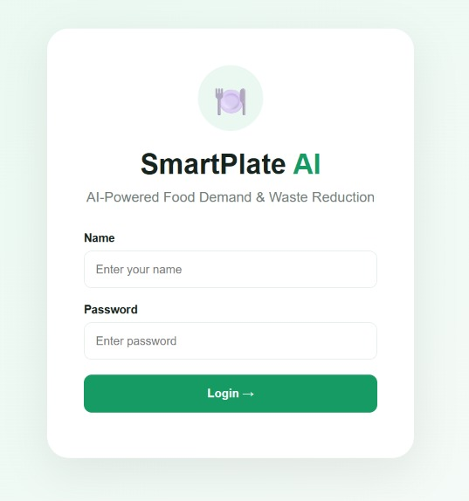
Figure 1: SmartPlate Login Page
Authorized users enter their credentials to securely access the SmartPlate food management system.
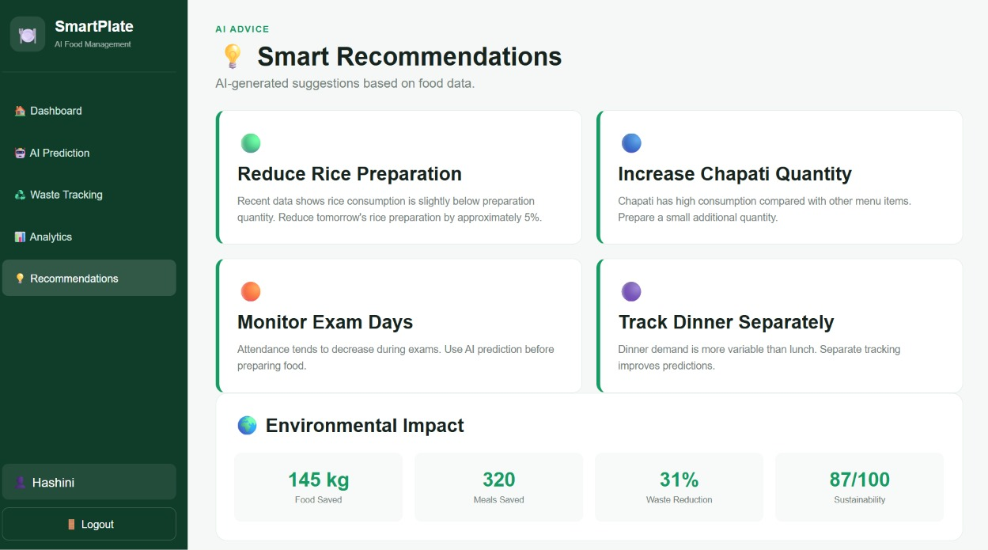
Figure 4: AI-Powered Smart Recommendations
AI-generated recommendations help users optimize food preparation, monitor consumption patterns, and reduce food waste.
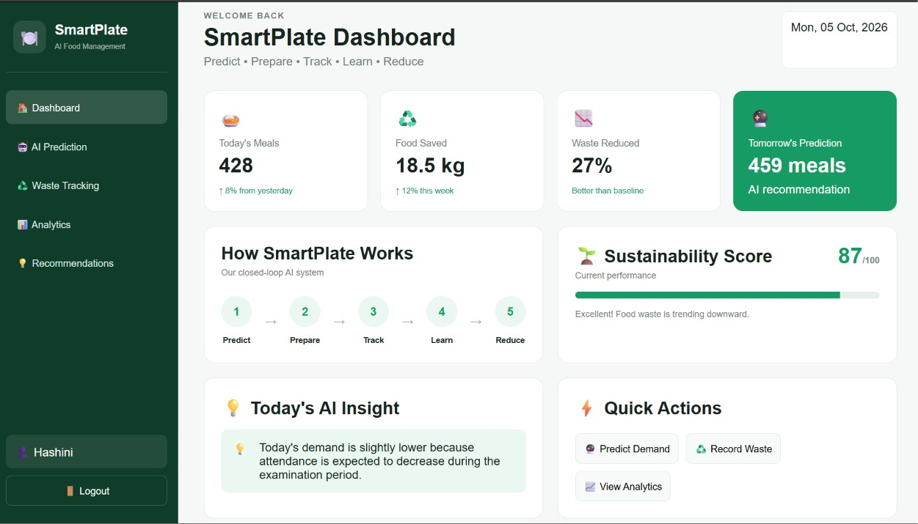
Figure 5: SmartPlate Dashboard Overview
The dashboard provides an overview of daily meals, food saved, waste reduction, tomorrow's prediction, sustainability score, and AI insights.
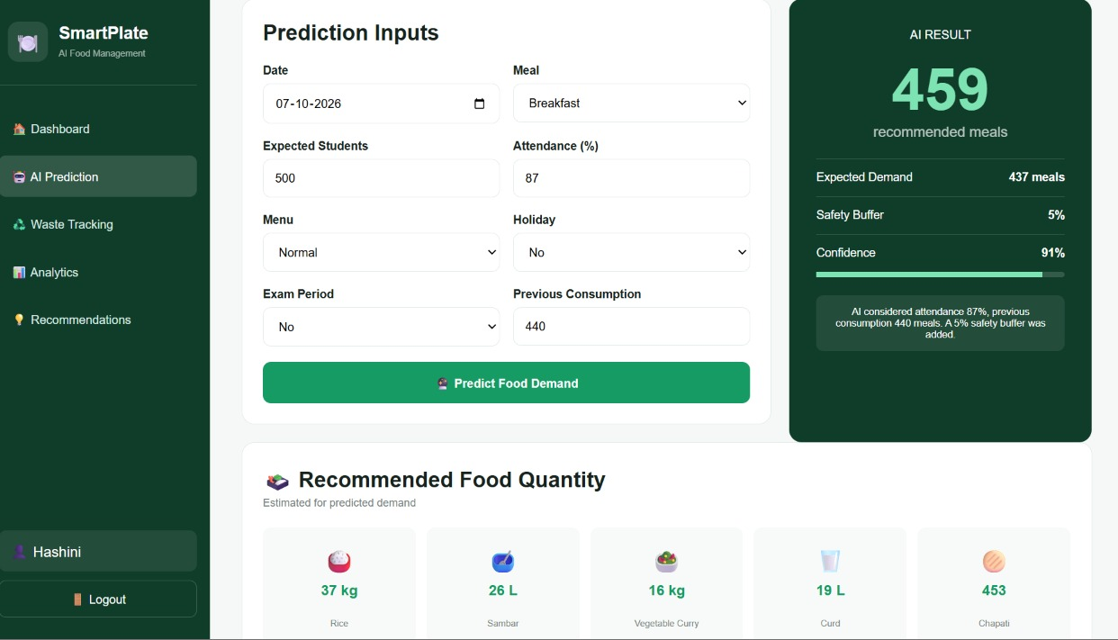
Figure 6: AI Food Demand Prediction and Recommended Food Quantity
Users provide prediction inputs such as attendance, meal type, menu, holiday status, exam period, and previous consumption to estimate food demand and preparation quantities.
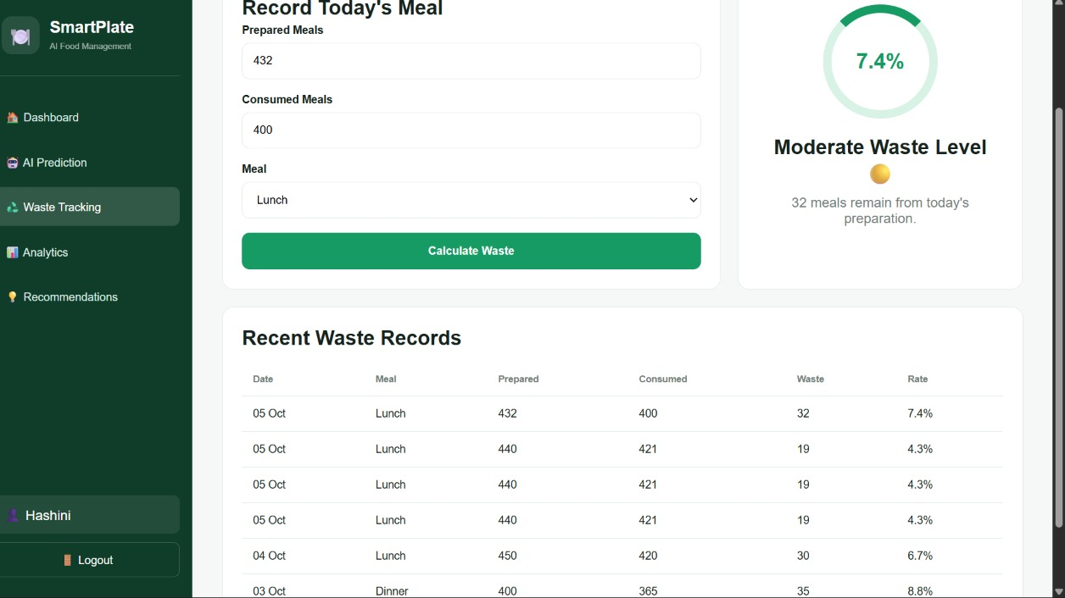
Figure 7: Actual Consumption and Food Waste Tracking
Prepared and consumed meal quantities are recorded to calculate food waste and monitor recent waste records.
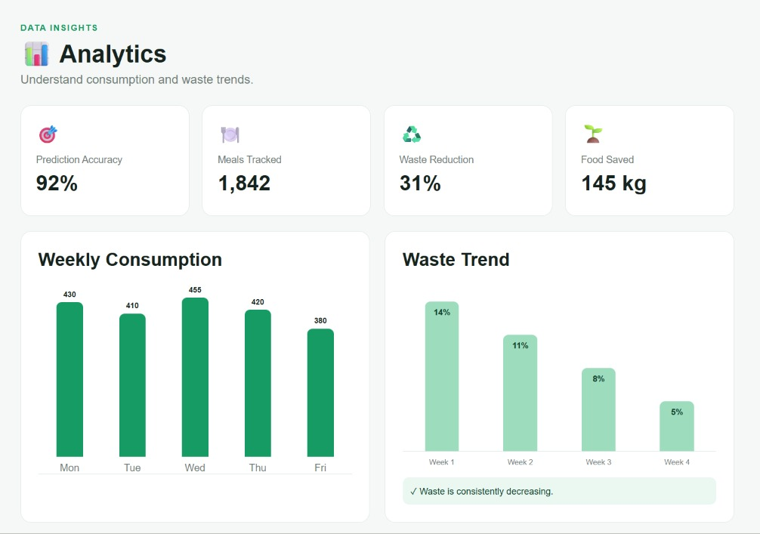
Figure 8: Analytics Dashboard
The analytics dashboard visualizes weekly food consumption and waste trends to help identify patterns and measure improvement.
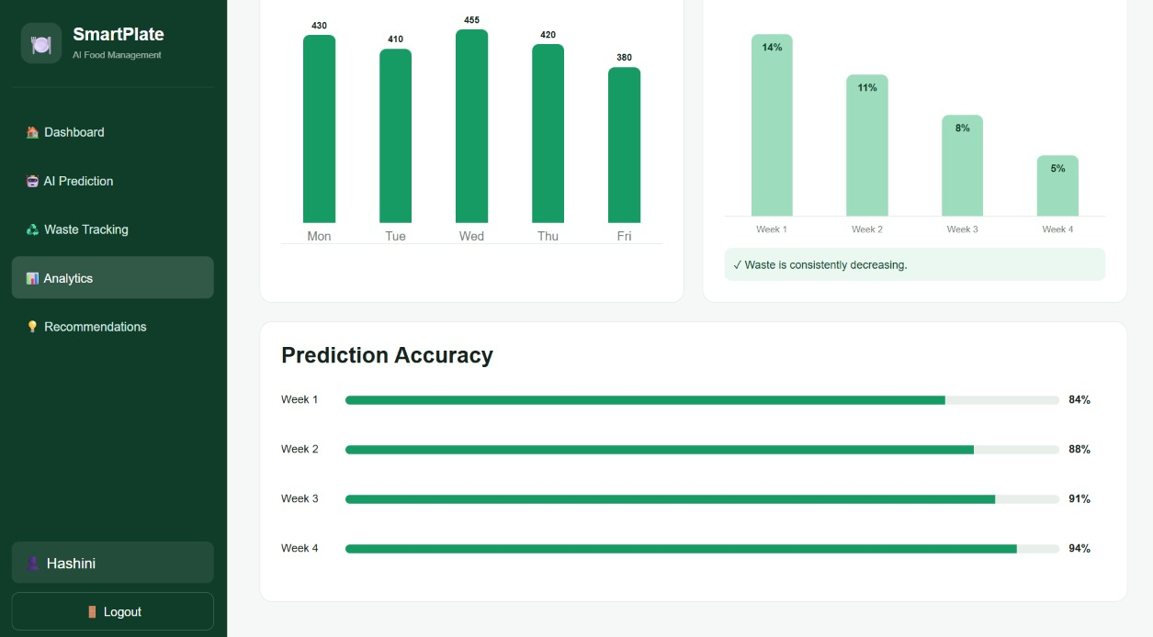
Figure 9: Model Performance and Prediction Accuracy
Prediction accuracy is monitored across different weeks to evaluate the performance of the AI-based demand prediction system.

8. GitHub Link
Repository URL:
https://github.com/[username]/smartplate-ai
The repository is public and contains the complete source code, the dataset or data generator, the trained-model script and a README with:
- project title and description;
- setup steps (install Python, create a virtual environment, install requirements, run the Flask app);
- usage instructions for each screen;
- regular commits that show the development history.

