

CECS 460 Project 1 – Counter to Seven-Segment Display using TramelBlaze

Marc Dominic Cabote

014938597

8 February 2018

Introduction

This project is the 16-bit counter from CECS 360 last semester. Instead of using a counter to step through and count, the Tramel Blaze is used to replace it. This project has the option to count down or count up depending on the “up-high, down-low” switch. The 16-bit counter is displayed as 4-hex in the seven-segment display. It is able to count from 0x0000 to 0xFFFF.

The TramelBlaze

The TramelBlaze is a 16-bit embedded microcontroller designed by Mr. John Tramel. The TramelBlaze is designed to emulate the 8-bit Pico Blaze. The TramelBlaze has three memories inside—stack RAM, scratch RAM and instruction ROM. The instruction set architecture is the same with the PicoBlaze. The assembler for the TramelBlaze is written in python and will generate the memory models required for building a Xilinx code ROM along with other files that is used for debugging the project—one example is the sim.sim file to verify the the design before creating the ROM. For this project, the TramelBlaze replaced the counter from the previous semester.

Operation

The operation is pretty straightforward. You use sw[0] on board to toggle the uphdnl switch—if the switch is low, it counts down and if its high, it counts up. The reset button is located in button up while the debounce button—which is used to count—will be located in button down. As you press button up or down (depending on the uphdnl switch), it will either count up or down. If you are counting up and it reaches 0xFFFF, the next count would then be reset to 0x0000.

Verification

This project has been verified through simulation. The simulation is as straightforward as the project. The verification starts with the reset being high to verify it the reset works. During the simulation, you will be able to see the address and the instruction. When you look at the .lst file you should be able to compare the waveform and see that the addresses and instructions match each other.

Schematic

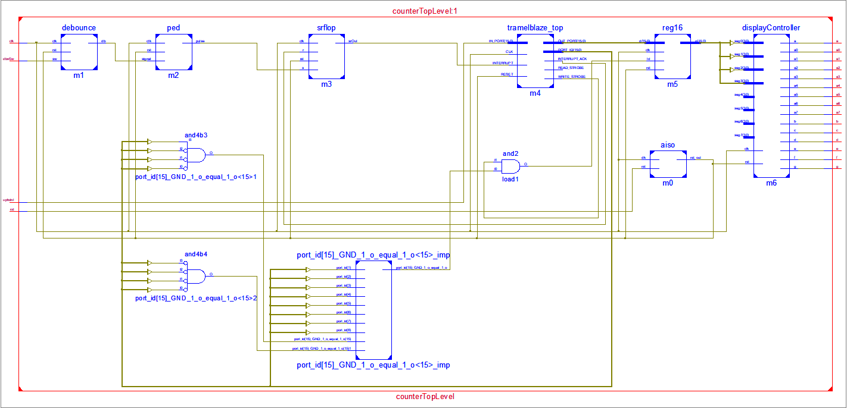

Simulated Waveform

