Patrolling New York State

Emma Ning and Kristy Shi

12/19/2018

Table of Contents

New York State, the Empire State, the home of Lady Liberty and Lazarus’ inscription “*Give me your tired, your poor, Your huddled masses yearning to breathe free*.” It is the home to the most populous city, one that has seen 9/11 and the fall of its twin towers. Much has occurred after the terrorist attacks of 2001: America entered the currently ongoing Afghanistan War, passed the Patriot Act that makes it possible for government surveillance, and has digitized. Amidst these events, how has crime changed? We looked into Index, Violent, Property, and Firearm Rates By County: Beginning 1990 data to visualize the change of crime rates in New York State.

crime_types <- violence %>%   
 group_by(Year) %>%   
 drop_na() %>%   
 mutate(violent_crime=sum(Violent.Count),  
 nonviolent_crime=sum(Property.Count)) %>%   
 distinct(violent_crime, nonviolent_crime) %>%   
 gather(key="crime_type", value="count", violent_crime:nonviolent_crime)  
  
ggplot(crime_types, aes(x=Year, y=count)) +   
 geom_line(aes(color=crime_type), size=1)+  
 labs(x="Year", y="Violence Count",   
 title="Crime Violence in New York State from 1990 to 2017", color="Crime Type")+  
 scale_x_continuous(breaks=(crime_types$Year))+  
 theme(plot.title = element_text(size = 20, hjust = 0.5),   
 axis.title.x = element_text(size = 15),  
 axis.text.x = element_text(angle = 90, size=6),  
 axis.title.y = element_text(size = 15))+  
 scale_color_manual(values = c("royalblue1", "#dd1c77"))

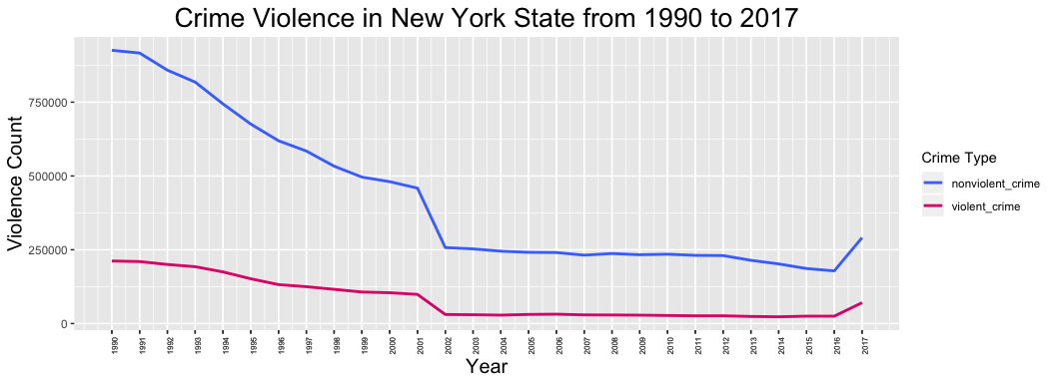 This graph shows that from 1990 to 2001, in the macro level, crime counts in New York State seemed to decrease at a similar rate, dropped drastically from 2001 to 2002, and continued to decrease at a slower rate until 2016, where it increased sharply.

It seems that the stark decrease of crime rates between 2001 and 2002 has a correlation with the increase of security in surveillance, defense, immigration, among other sectors in the subsequent period after event (PBS). Nonetheless, crime count rates in New York State increased between 2016 and 2017. We want to examine the 2016 to 2017 crime rate increase to determine the factors that influence crime rate and areas with the most crime.