How CRIS gets its numbers
The logic behind the CRIS ratings assistant, from the nightly refresh of the tables to each of the 22 questions it can answer. No SQL; where a rule is a knob someone can turn, its parameter name is given in the margin. Version 77, 30 September 2026.

1. The journey of a number
Everything CRIS says starts with Nielsen measuring who watched what, minute by minute. A&E loads those measurements into Snowflake. Every night CRIS reshapes them into six ready-made tables where the awkward parts (duplicates, codes, clock arithmetic) have already been dealt with. When someone asks a question, a planner (CRISpy) decides which of the 22 questions it is, fills in the blanks (which network, which programme, which window), runs the query and hands the rows to CRIS, which writes the sentence.
Figure 1. From Nielsen to the sentence on the screen.
Three things make the numbers trustworthy along the way. The tables are rebuilt whole every night, so restated Nielsen data and late Cable Tracks cataloguing are always picked up. Every query returns the window it used and the demo it measured, so any figure can be traced. And every rule that A&E has confirmed carries the name and date of the confirmation in the code, so a later reader knows what is a decision and what is an assumption.
The rest of this document follows that path: the refresh (2), the tables (3), the rules that apply to every question (4), the norms (5), the 22 questions one by one (6), the planner (7), and a glossary (8).

2. The nightly refresh
The six tables are rebuilt every night by six scheduled tasks in Snowflake, one per table, chained so each starts when the previous one has finished. Only the first has a clock; the others follow it.
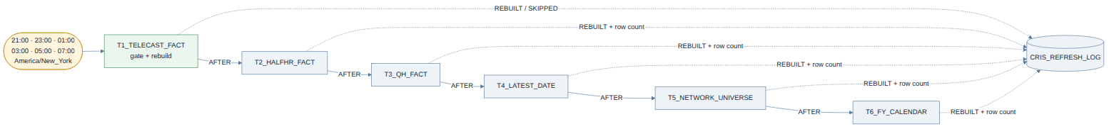
Figure 2. The chain. Every task also writes a line to the refresh log.
The first task fires every two hours from 9pm to 7am (New York). Each time, it asks one question: does the Nielsen view have a newer broadcast date than our table? If not, it writes SKIPPED to the log and goes back to sleep; nothing else runs. If yes, it rebuilds, and the other five follow. So whichever firing comes after A&E's load does the work, before anyone sits down at 9am, and the others cost nothing. Once we know at what time the load lands, this drops to one firing.
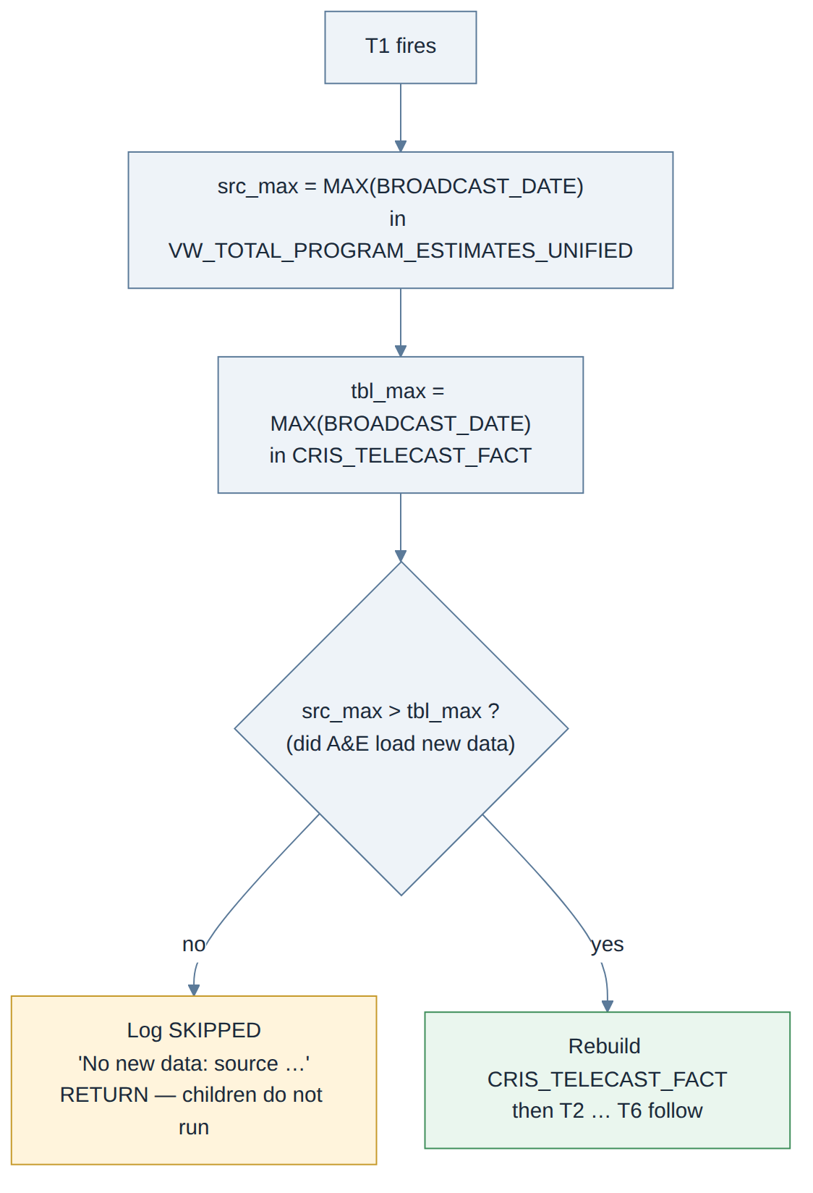
Figure 3. The check at the top of every firing.
A table is never empty while it rebuilds. Each task builds a copy next to the live table, swaps the two in one instant, and drops the old copy. A question asked during the rebuild is answered from yesterday's data; a question asked after it, from today's.
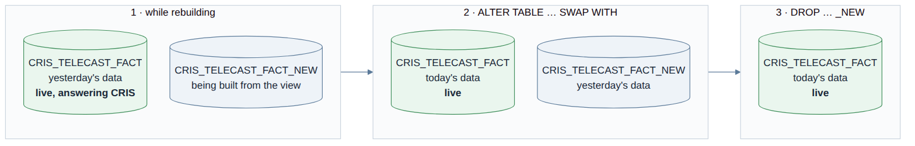
Figure 4. Build and swap.
The chain runs in sequence rather than in parallel because the helper tables read the fact tables (the latest-date table is computed from the telecast and quarter-hour facts; the network universe from the half-hour fact), and because the warehouse is a small one. A full rebuild takes several minutes; a skipped firing takes seconds.
Every run leaves a trace in CRIS_REFRESH_LOG: one SKIPPED line when there was nothing new, or one REBUILT line per table with its row count and its latest broadcast date. CRIS_LATEST_DATE.REFRESHED_AT moves with every rebuild and is what the screen can show as "data loaded".
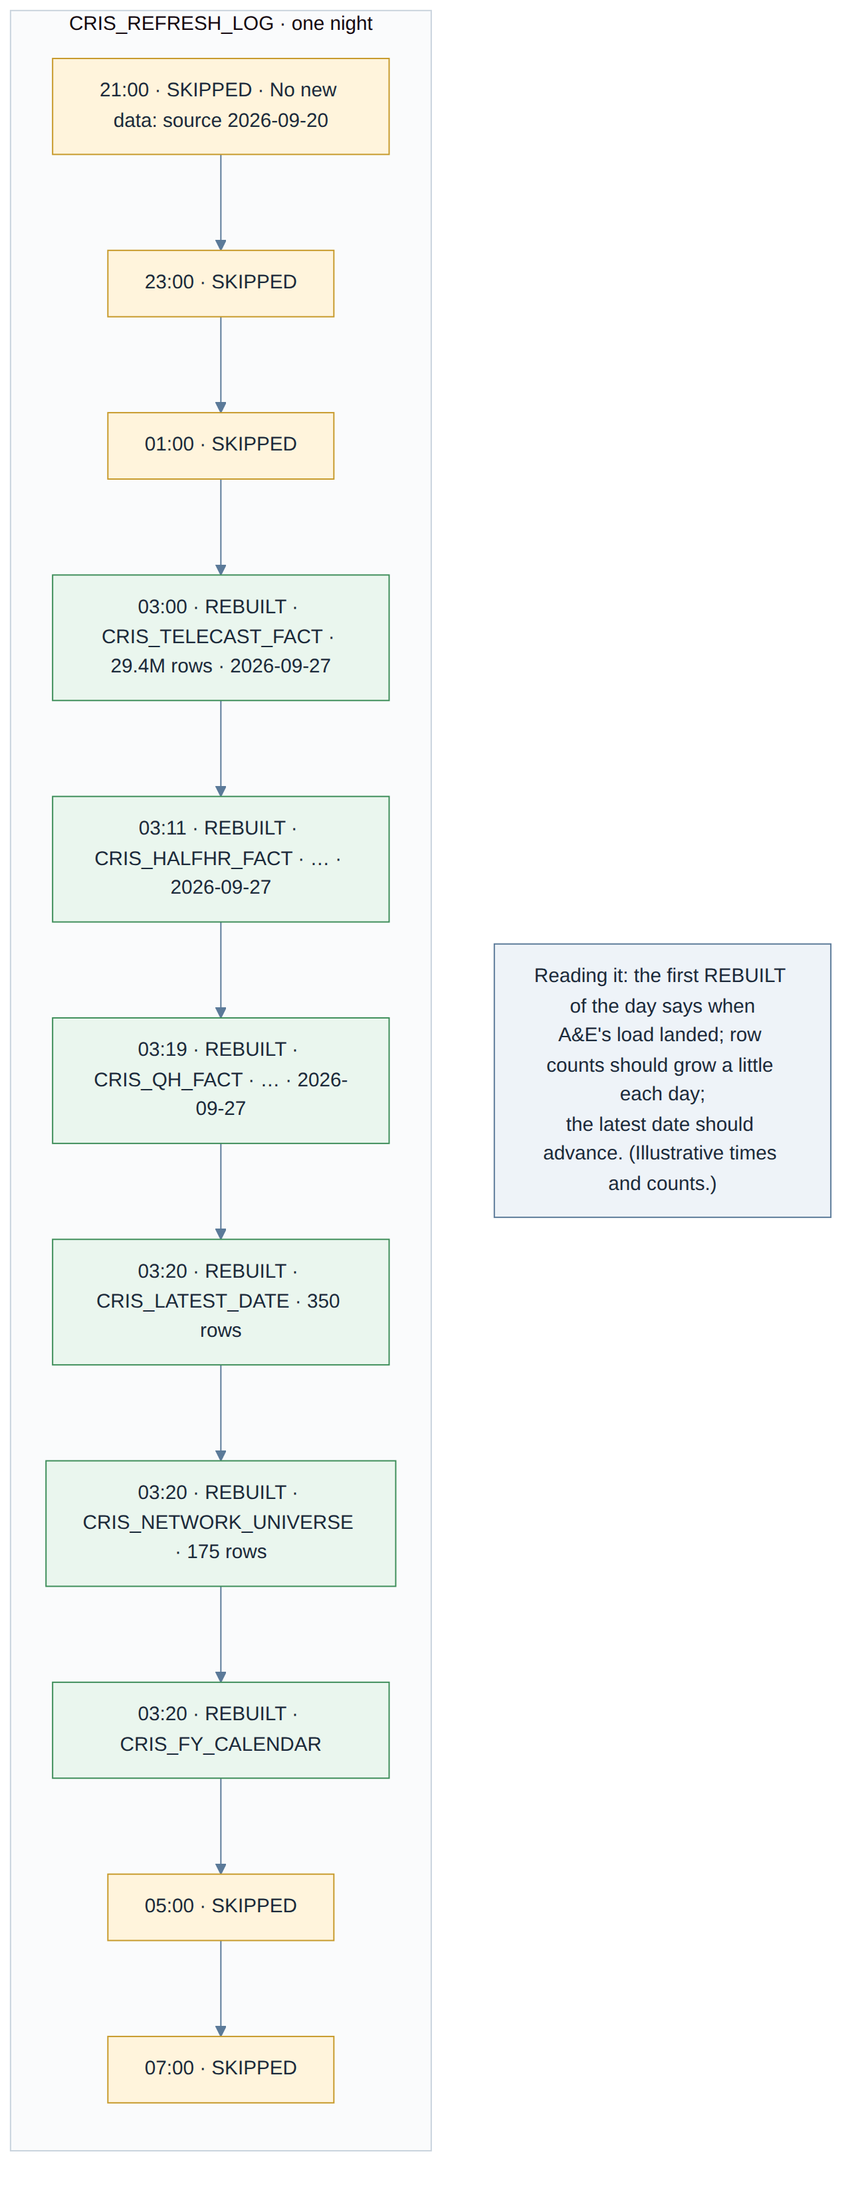
Figure 4b. What a healthy night looks like in the log.
To pause the refresh, suspend the first task; the chain stops. To change the schedule, change the first task's clock. To change a table, the tables notebook is edited and the tasks notebook regenerated from it and re-run; the tasks are replaced in place. All of this is in the scheduled-refresh document in the v76 folder.

3. The six tables
Three of the tables are the Nielsen data itself, at three grains: the whole telecast, its half hours, and its quarter hours. The other three are small helpers derived from them.
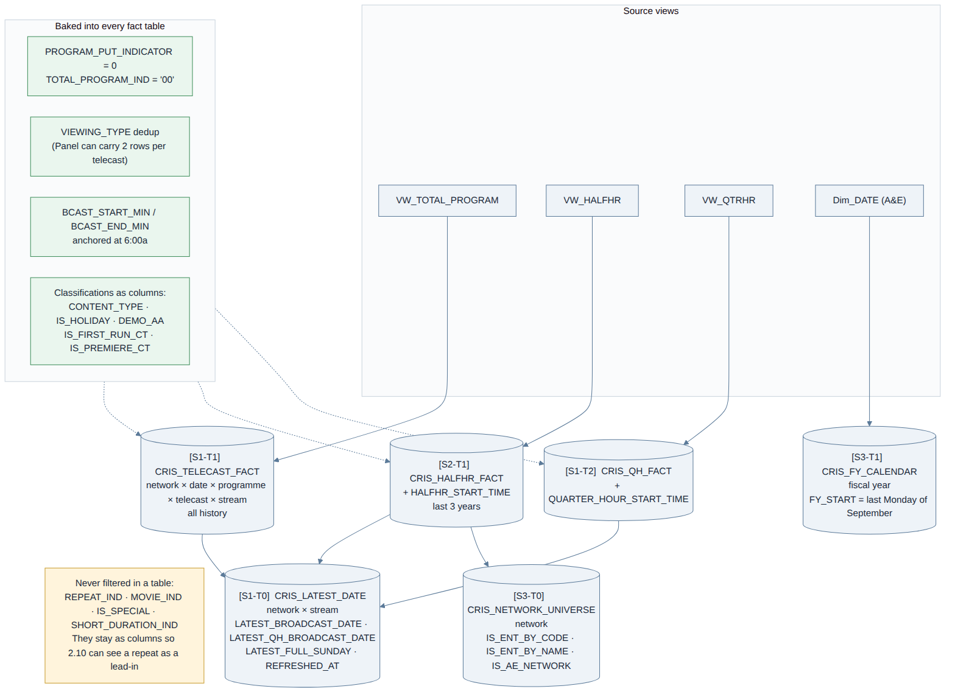
Figure 5. What each table is built from and what is baked in.
Table | One row is | Used for
CRIS_TELECAST_FACT | one telecast on one network in one stream | season averages, premiere and prime norms, ranks among premieres, lead-ins, telecast detail
CRIS_HALFHR_FACT | one half hour of a telecast (last 3 years) | time-period ranks, daypart analyses, network and genre rankers
CRIS_QH_FACT | one quarter hour of a telecast | quarter-hour movement, overnight and by series
CRIS_LATEST_DATE | one network and stream | the latest night with data and the latest full Sunday; every window ends there
CRIS_NETWORK_UNIVERSE | one network (all 175) | which networks count as entertainment cable, by A&E's code list or the PRD name list
CRIS_FY_CALENDAR | one fiscal year | fiscal-year-to-date windows (A&E's year starts on the last Monday of September)

One design rule governs all of them: a classification becomes a column, a filter stays in the question. The tables record that a telecast is a repeat, a movie, a special, a first run, a holiday film, the season it belongs to; they never throw one away. Whether a particular question includes movies or repeats is decided when the question is asked, not when the table is built. That is why a default can change without rebuilding anything, and why the lead-in question can still see a repeat as the programme that came before a premiere.
Figure 5b. What happens to a Nielsen row on its way into the telecast table.
What is done once, at build time, because every question would otherwise redo it: the duplicate rows Nielsen's panel files carry for the same telecast are removed; the reporting date is the broadcast date, never the calendar date; start and end are also stored as minutes into the broadcast day; and the flags below are computed.
Two of the flags deserve a word. CONTENT_TYPE says whether a telecast is a series, a special or a movie, taken from Cable Tracks' first genre with Nielsen's special indicator as a fallback; it is what lets a question say "no specials". DEMO_AA is the network's own key demo already resolved (P25-64 on A&E, History and FYI; F25-64 on Lifetime and LMN), so a question that does not name a demo measures the right one, and the answer says which.
At the end of every build three uniqueness checks run: one row per telecast in the telecast table, one per telecast and half hour, one per telecast and quarter hour. If any of them fails, the filtering or the de-duplication is wrong, and the build is not trusted.

4. Rules that apply to every question

4.1 The broadcast day
Television's day runs from 6:00am to 5:59am. A show at 12:30am belongs to the evening before it, on the same broadcast date, and the clock keeps counting past 24:00 (a 1am start reads as 25:00). Every window, every daypart and every "same night" in CRIS uses this clock.
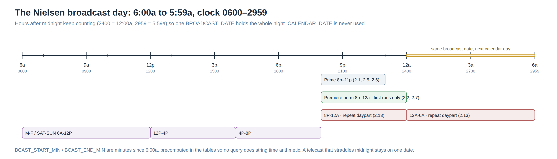
Figure 6. The broadcast day and the dayparts CRIS uses.

4.2 Every average is weighted by minutes
A 60-minute telecast counts twice as much as a 30-minute one in any average; a 3-minute tail counts a fifth of a 15-minute quarter hour. Nothing in CRIS is a plain average of numbers. This is A&E's own method (Adarsh, 11 Sep 2026).
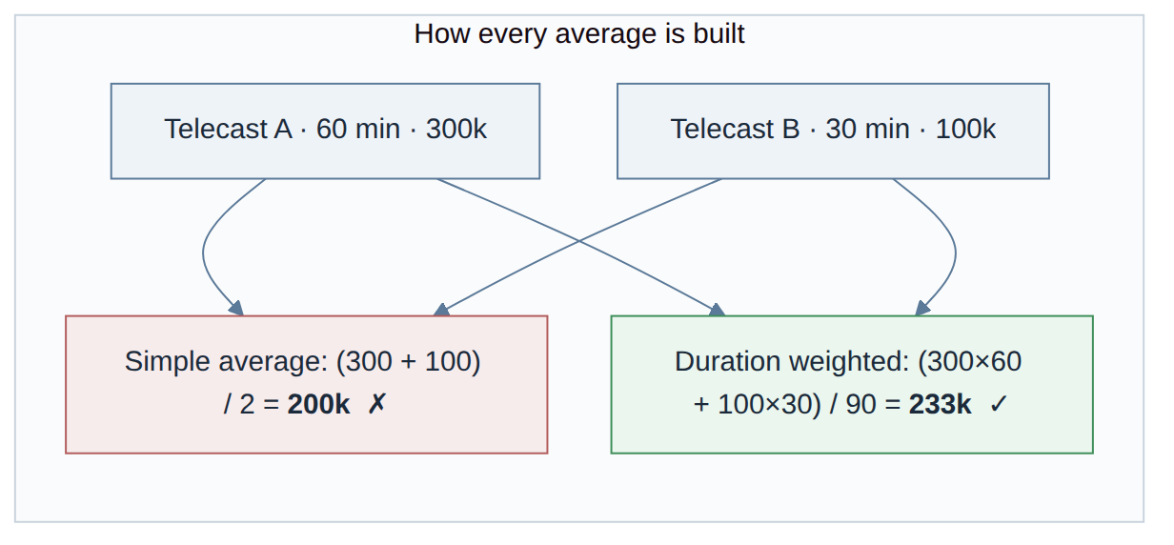
Figure 7. Why the weighting matters.

4.3 What counts as a premiere
Two different questions hide behind the word "premiere". A first run (an episode airing for the first time) is what Nielsen marks as not-a-repeat; every question that says "premieres" means these. A season premiere is one telecast, the first first-run of a season, and it is only used when the question actually asks for it ("how did the season premiere do").
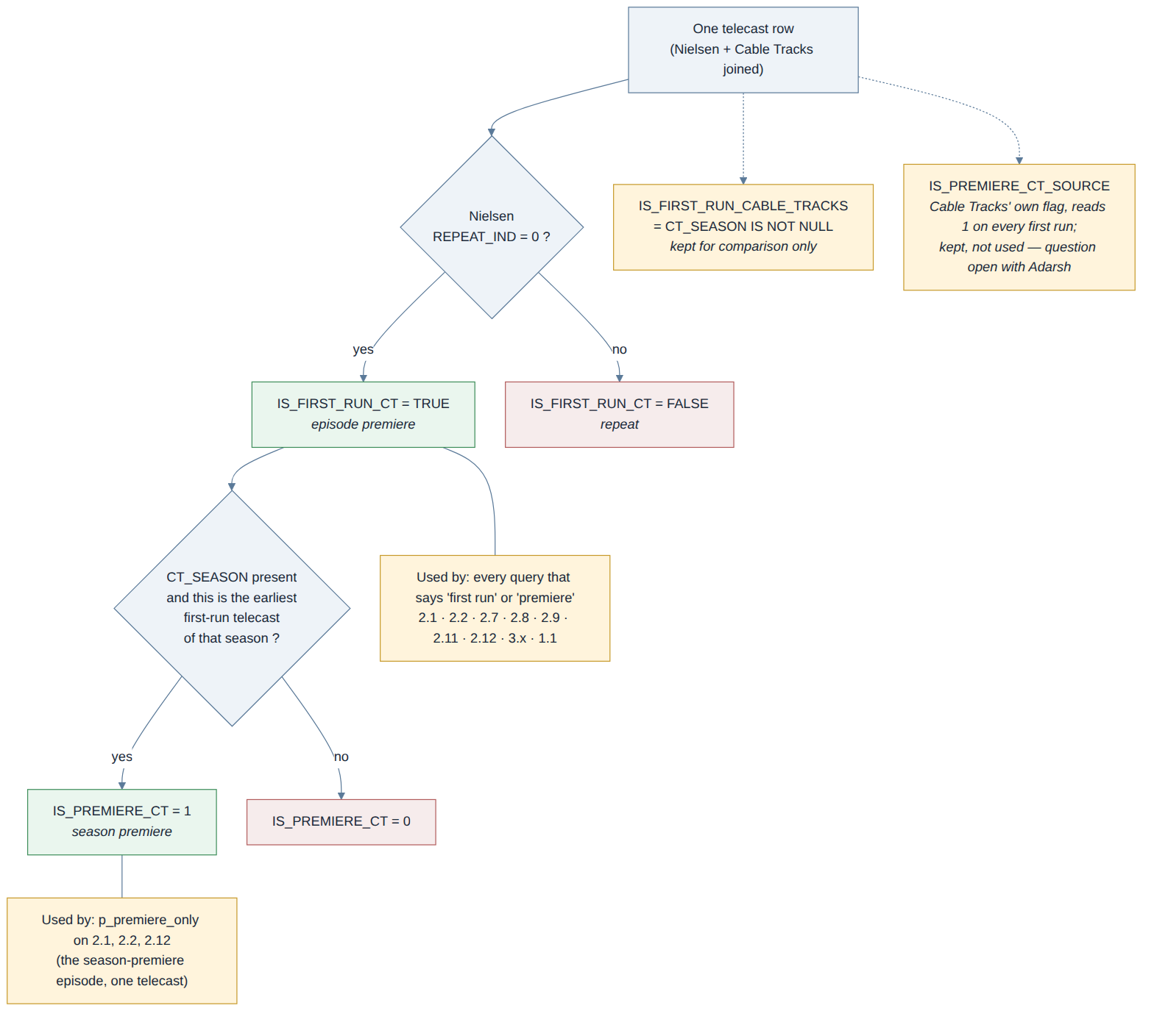
Figure 8. The two premiere flags.
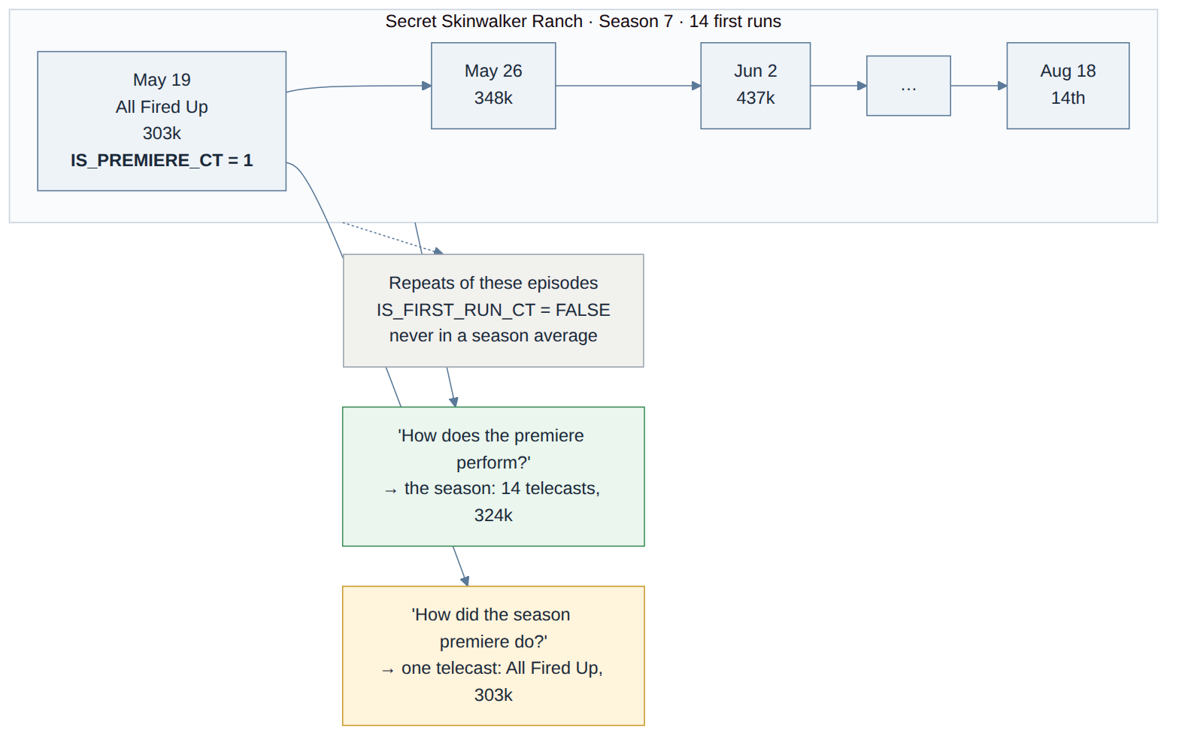
Figure 8b. Skinwalker, season 7: fourteen first runs, one season premiere, and the repeats that never enter a season average.
The season-premiere reading is switched on by p_premiere_only on the three questions that support it (2.1, 2.2, 2.12). The planner sets it only when the wording says season premiere, premiere episode, first episode, opener, or names the episode; "how does X's premiere perform vs the premiere norm" means the season and leaves it off. Getting that wrong is what produced 303k (the opener) instead of 324k (the season) for Skinwalker on 29 September.

4.4 Windows and dates
No date is ever written into a question. The window end is the latest full Sunday with data, read from the helper table, and it is a ceiling: if a later date is asked for (the planner once passed the end of the fiscal year), the window still stops at the data. Network norms run the latest twelve months back from that Sunday. A season is bounded by its own identity, not by dates: a season that runs fourteen months comes out whole. The dates a figure covers are always returned next to it.
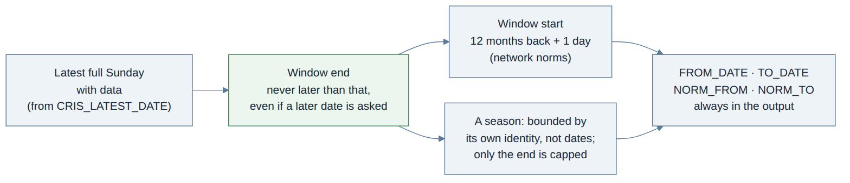
Figure 9. How a window is resolved.
An example. On 30 September the latest full Sunday with data is 27 September 2026, so a twelve-month norm runs from 28 September 2025 to 27 September 2026. Jill's pull a week earlier ran from 21 September 2025 to 20 September 2026, which is why a figure compared across the two has to be compared on the same window: the query takes p_win_to = '2026-09-20' to reproduce hers exactly. Overnight questions use the latest night loaded rather than the latest Sunday, because last night is what they are about.

4.5 Seasons and Cable Tracks
The season a telecast belongs to comes from A&E's own catalogue, Cable Tracks. Anything that compares seasons, norms a season, or ranks within a season uses only telecasts that Cable Tracks has catalogued; a telecast with no season does not appear in those answers rather than appearing against a guess. Sub-seasons (13B, 2026C) are kept apart from their parent.

5. The norms
A norm is the "normal" a figure is compared with. CRIS builds four kinds, and the choice of population is what makes each one.
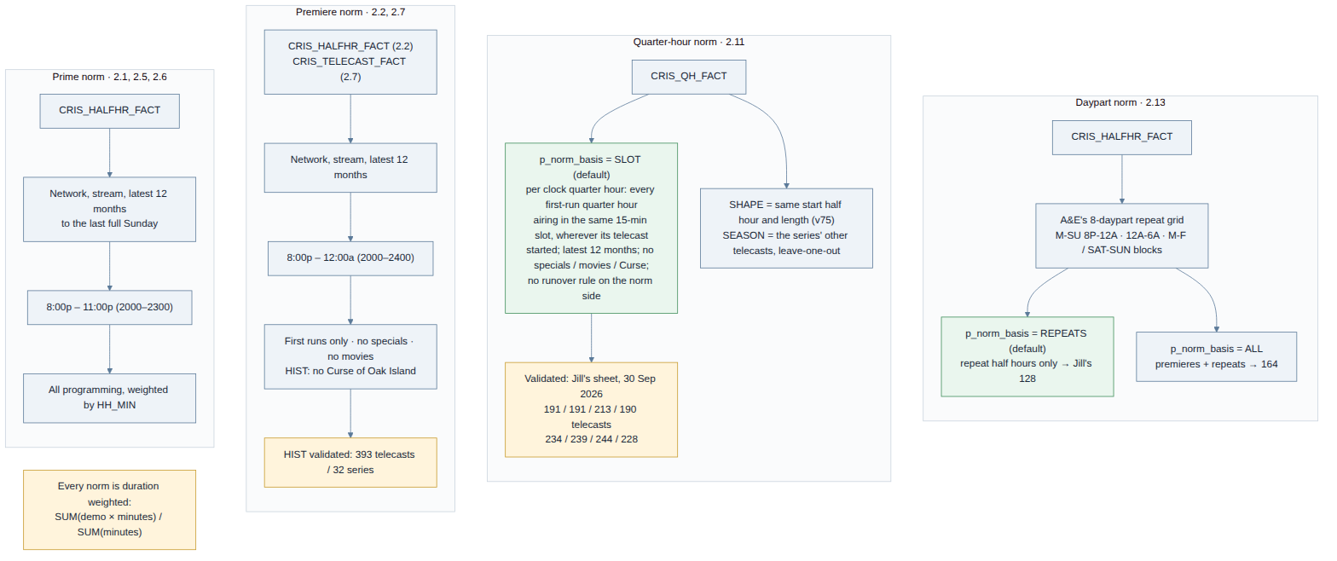
Figure 10. The four norms and what feeds them.

Prime norm (2.1, 2.5, 2.6)
Everything the network aired between 8pm and 11pm over the latest twelve months, weighted by minutes. The plain "what does this network do in prime" figure.

Premiere norm (2.2, 2.7)
First runs only, 8pm to midnight, latest twelve months, with three exclusions A&E asked for: no specials, no movies, and on History no Curse of Oak Island (p_include_specials, p_movies, p_exclude_curse). On History that is 393 telecasts from 32 series, the figure Jill validated.
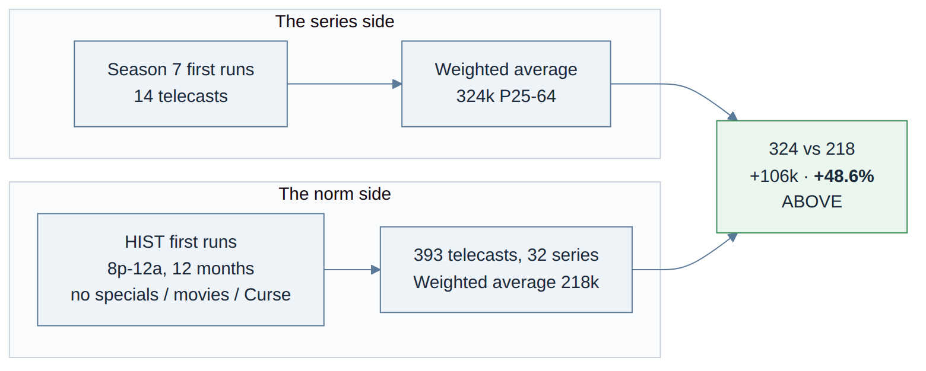
Figure 10b. A series against the premiere norm: Skinwalker's season 7.

Quarter-hour norm (2.11)
Built per clock quarter hour: for the 9:00-9:15 slot, every first-run quarter hour History aired in that slot over the latest twelve months, wherever the telecast started, with the premiere-norm exclusions, and with no runover rule on this side (a show that ends at 9:33 counts its last three minutes in the 9:30 slot). This is the reading in Jill's sheet, and CRIS reproduces it exactly: 191 / 191 / 213 / 190 telecasts, 234 / 239 / 244 / 228 thousand. Two other readings remain available: SHAPE (only telecasts that start in the same half hour and run the same length, followed through their own quarters) and SEASON (the series' own other telecasts). The knob is p_norm_basis.
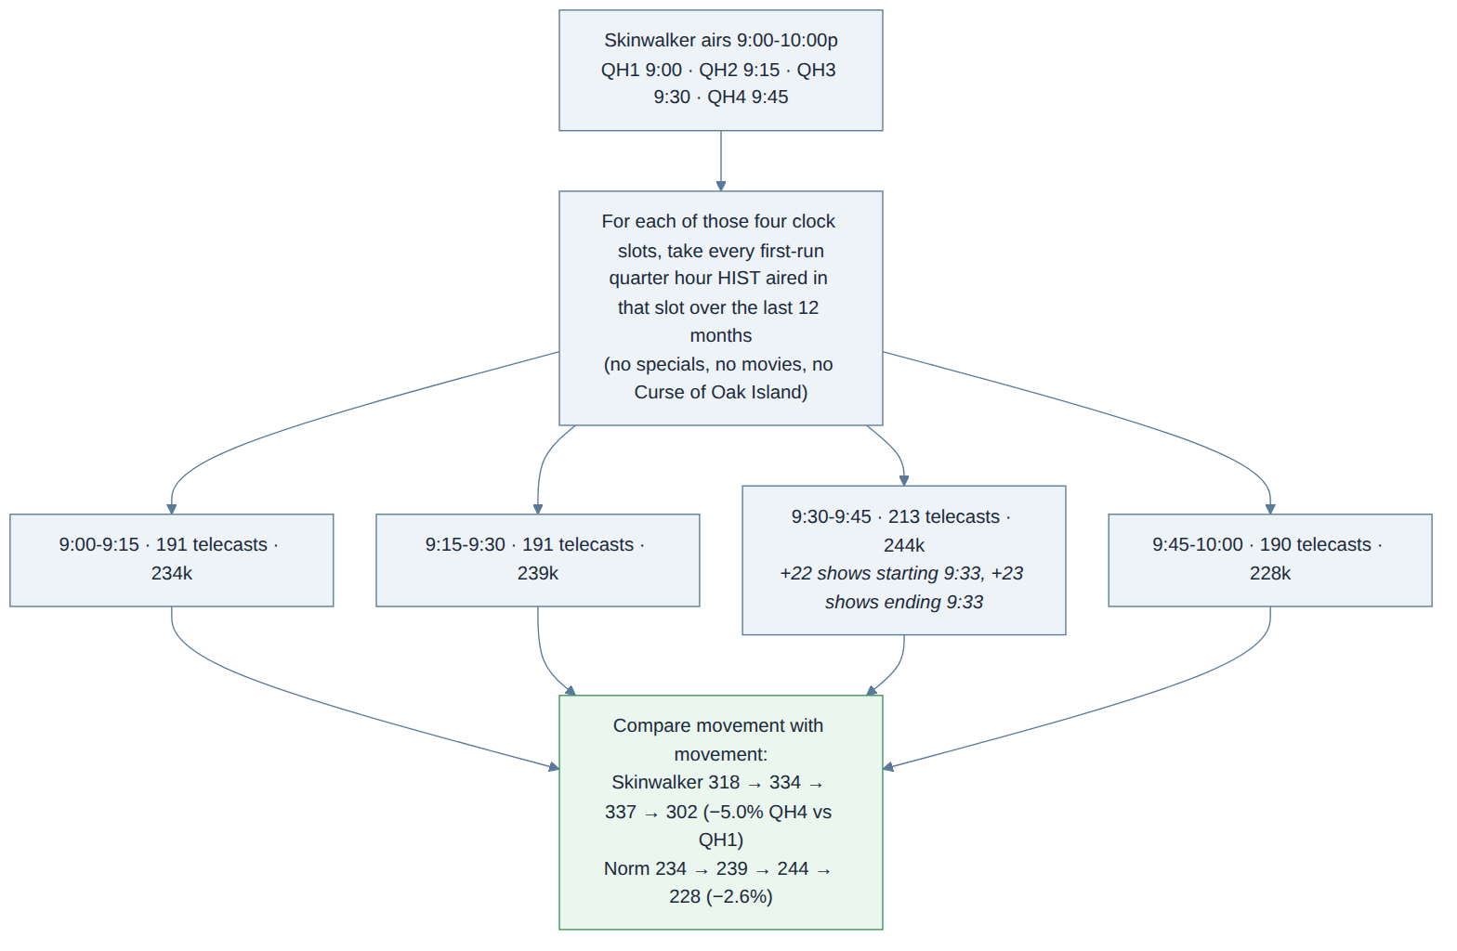
Figure 11. The quarter-hour norm, slot by slot.
Why the 9:30 slot has more telecasts than the others: it picks up the first quarter of shows that start at 9:33 (Ice Road Truckers, Pawn Stars, 11 or 12 minutes each) and the last quarter of 8pm shows that end at 9:33 (Mountain Men, Swamp People, 3 or 4 minutes each). Those short quarters are weighted by their minutes, so they count as telecasts without moving the average much. On the series side the runover rule still applies: Skinwalker's 2-minute fifth quarter is not a QH5. In the working session of 28 July 2026 the 15-minute rule was agreed for the series being measured; Jill's sheet showed it does not apply to the norm, and the query follows the sheet.

Daypart norm (2.13)
For the repeat question, the daypart average is built on repeat half hours only, which is how A&E compute it (128k for History 8pm-midnight; all programming would give 164k). p_norm_basis = REPEATS or ALL.

6. The 22 questions
Each question is one query with a fixed set of knobs. The planner fills the knobs from the wording; anything it does not fill takes the default described here. Every answer returns which demo was measured, the dates it covers, and, where there is a norm, the dates of the norm.
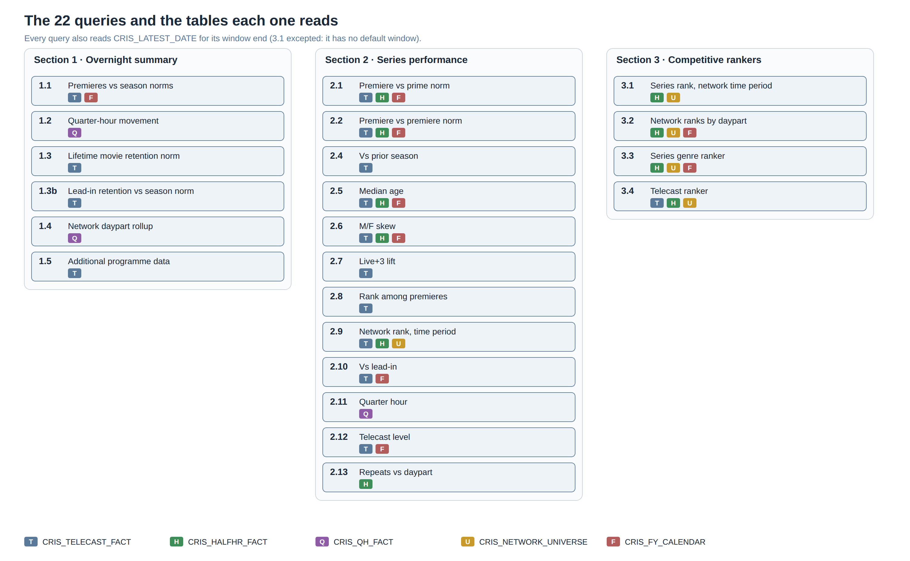
Figure 12. The 22 questions and the tables each one reads.

Section 1 · The overnight summary
"What happened last night." All six use the most recent night with data unless a date is given (p_target_date), and prime 8pm to midnight. Specials are included here (a special that aired last night is part of last night), which is the opposite of the rankers.
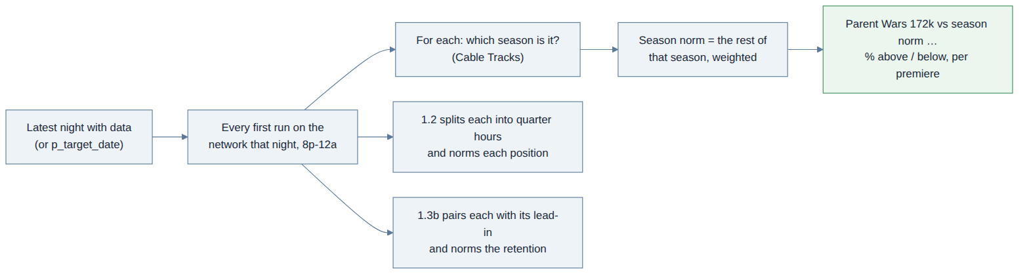
Figure 12b. The overnight questions share one starting point: last night's first runs.

1.1 Premieres vs season norms
Answers: How each of last night's premieres did against the average of its own season so far.
How it thinks: Finds every first run on the network that night, works out which season each belongs to, averages the rest of that season (weighted by minutes), and reports the difference. A first episode has no norm yet and says so.
Knobs: p_network, p_target_date, p_include_specials
What comes out: one row per premiere: audience, season norm, % vs norm, telecasts in the norm.

1.2 Quarter-hour movement
Answers: How each premiere built or lost audience through its quarter hours, against the season norm for the same position.
How it thinks: Splits each telecast into quarter hours (QH1, QH2, …), keeps a short first quarter (a 10:03 start is real) and drops a short trailing one (a runover), and norms each position against the same position in the rest of the season, leaving the episode itself out. Also reports the last quarter against the first, for the telecast and for the norm.
Knobs: p_runover_max_min = 15, p_include_leadin_qh
What comes out: one row per quarter hour with % vs prior, % vs norm, and final vs first.

1.3 Lifetime movie retention norm
Answers: How last night's Lifetime movie held its lead-in, against the norm for that kind of movie.
How it thinks: Pairs each movie with its lead-in, classifies both as original or acquired (and holiday or not), and compares the retention with the average retention of the same pairing over the latest twelve months.
Knobs: p_network (LIF / LMN), p_holiday
What comes out: retention, norm retention, and the pairing used.

1.3b Lead-in retention vs season norm
Answers: How each premiere held its lead-in, against its own season's average retention.
How it thinks: Same lead-in logic as 2.10 for one night; the norm is the season's average retention rather than a twelve-month one.
What comes out: one row per premiere with lead-in, retention and season norm retention.

1.4 Network daypart rollup
Answers: How the network did last night by daypart.
How it thinks: Sums the quarter hours of the night into dayparts (prime, total day, and the rest) and reports each with its minutes; every figure weighted.
Knobs: p_network, p_target_date
What comes out: one row per daypart.

1.5 Additional programme data
Answers: Everything else about last night's programmes: length, genre, season, repeat or first run, ratings on several demos.
How it thinks: A straight listing of the night from the telecast table, no norm.
What comes out: one row per telecast.

Section 2 · Series performance
"How is this series doing." The series is its latest season unless one is named (p_season); the demo is the network's key demo unless one is named (p_demo); the stream is Live+SD unless one is named (p_stream).

2.1 Series vs prime norm
Answers: The season average against what the network normally does in prime.
How it thinks: Averages the season's first runs (weighted by minutes) and compares with the prime norm (§5). With p_premiere_only the season premiere alone is measured instead.
Knobs: p_premiere_only, p_include_specials, p_movies
What comes out: season average, prime norm, difference and %, telecasts in each.

2.2 Series vs premiere norm
Answers: The season average against what the network's premieres normally do.
How it thinks: As 2.1, against the premiere norm (first runs, 8pm-midnight, exclusions). This is the 324k vs 218k (+48.6%) Skinwalker case.
Knobs: p_premiere_only, p_exclude_curse, p_norm_from / p_norm_to to pin the norm's own window
What comes out: as 2.1, plus the norm's telecasts and series counts.
Figure 12c. 2.1 and 2.2 are the same shape: the season on one side, a norm on the other.

2.4 This season vs the prior season
Answers: Whether the series grew or fell from its previous season.
How it thinks: Finds the season in scope and the one before it (by Cable Tracks season, not by dates), averages each, and reports the change. Neighborhood Wars: 266 vs 188, +41.5%.
Knobs: p_season
What comes out: both seasons' averages, telecasts, dates and % change.
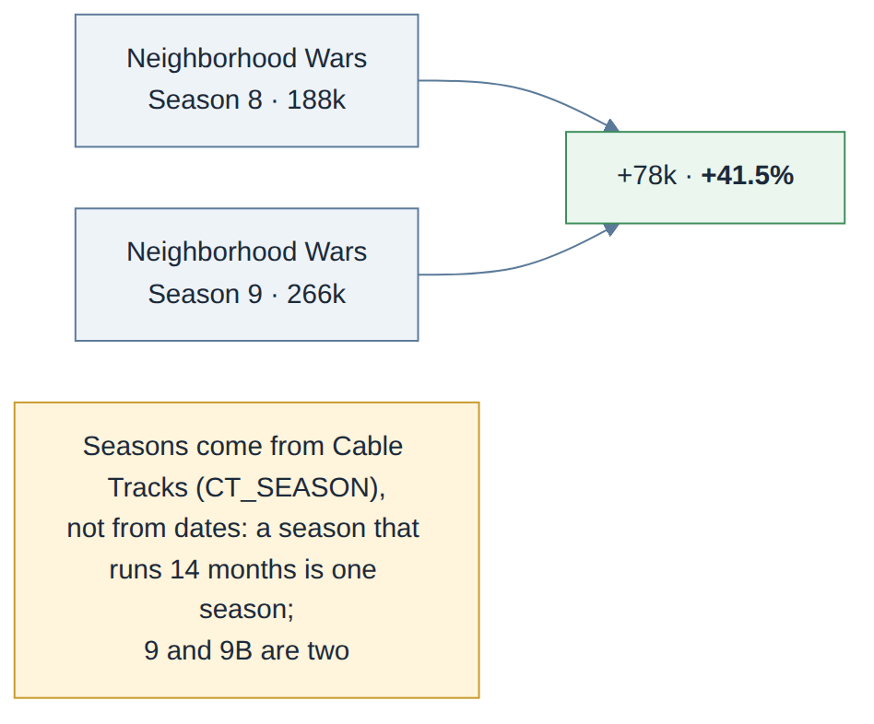
Figure 12d. Season against season, by identity.

2.5 Median age vs prime norm
Answers: Whether the series skews older or younger than the network's prime.
How it thinks: Median age of the season's viewers, weighted by minutes, against the prime norm's median age. Measured on everyone (P2+), which the answer states.
What comes out: series median age, norm median age, difference in years.

2.6 Male / female skew vs prime norm
Answers: Whether the series draws more men or women than the network's prime.
How it thinks: Share of men and women in the season's audience against the prime norm's share. Measured on P2+.
What comes out: series % male / female, norm % male / female, difference in points.

2.7 Live+3 lift
Answers: How much the series gains from three days of delayed viewing, against what the network's premieres normally gain.
How it thinks: Season average on Live+SD and on Live+3 (same telecasts), the lift between them, and the same lift for the premiere norm.
Knobs: p_holiday, p_grain (series or telecast)
What comes out: both averages, lift %, norm lift %.

2.8 Rank among the network's premieres
Answers: Where the series (or movie) sits among everything the network premiered in the window.
How it thinks: Ranks every first-run series or film on the network over the window by weighted average, all of them in order, the asked one marked. Ties share a rank ("7 (tied)").
Knobs: p_grain (series or telecast: a Lifetime movie is a telecast), p_movies, p_min_tcasts
What comes out: the whole ranking with the target flagged.
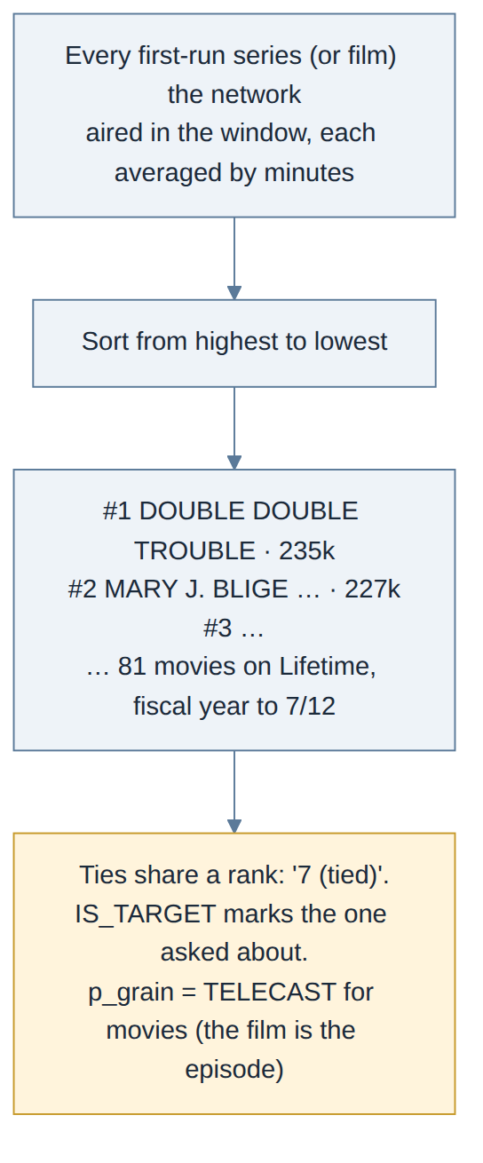
Figure 12e. The rank among premieres, Lifetime's movies as the example.

2.9 The network's rank in the series' time period
Answers: Where the network ranks against other networks during the exact slots the series occupied.
How it thinks: Takes the dates and half hours the season actually aired (a half hour counts only if the series filled at least 15 minutes of it, so a 10:01 finish does not drag in the 10:00 half hour), measures every network on those same slots, and ranks them. Measured over the season's own dates.
Knobs: p_slot_min_min = 15, p_excl_by (A&E code list or PRD names)
What comes out: one row per network in rank order, the series' network marked.
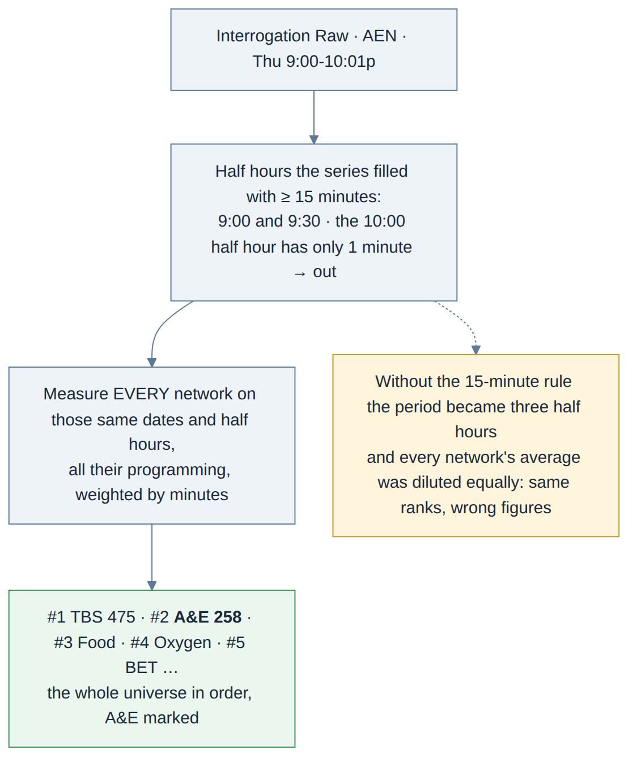
Figure 12f. The time-period rank (2.9 and 3.1): the slots come from the series, the measurement is of every network.

2.10 Series vs its lead-in
Answers: How each premiere did against whatever aired right before it, and the season rollup.
How it thinks: Each premiere telecast is one unit. Its lead-in is the one telecast that ends within five minutes before it starts, whatever programme it is and whether it is a premiere or a repeat, including a premiere of the same series when two air back to back; shorts under 15 minutes are stepped over. The rollup gives the season against all its lead-ins, then a breakdown by lead-in programme and airing. Modern Marvels: WWII returns its three lead-ins exactly as Jill listed them.
Knobs: p_leadin_grain = TELECAST (BLOCK keeps the older night-block rule), p_adjacent_min = 5, p_min_leadin_min = 15, p_rollup
What comes out: per night: lead-in, its airing, both audiences, retention and %; rolled up: ALL LEAD-INS then one row per lead-in programme and airing.
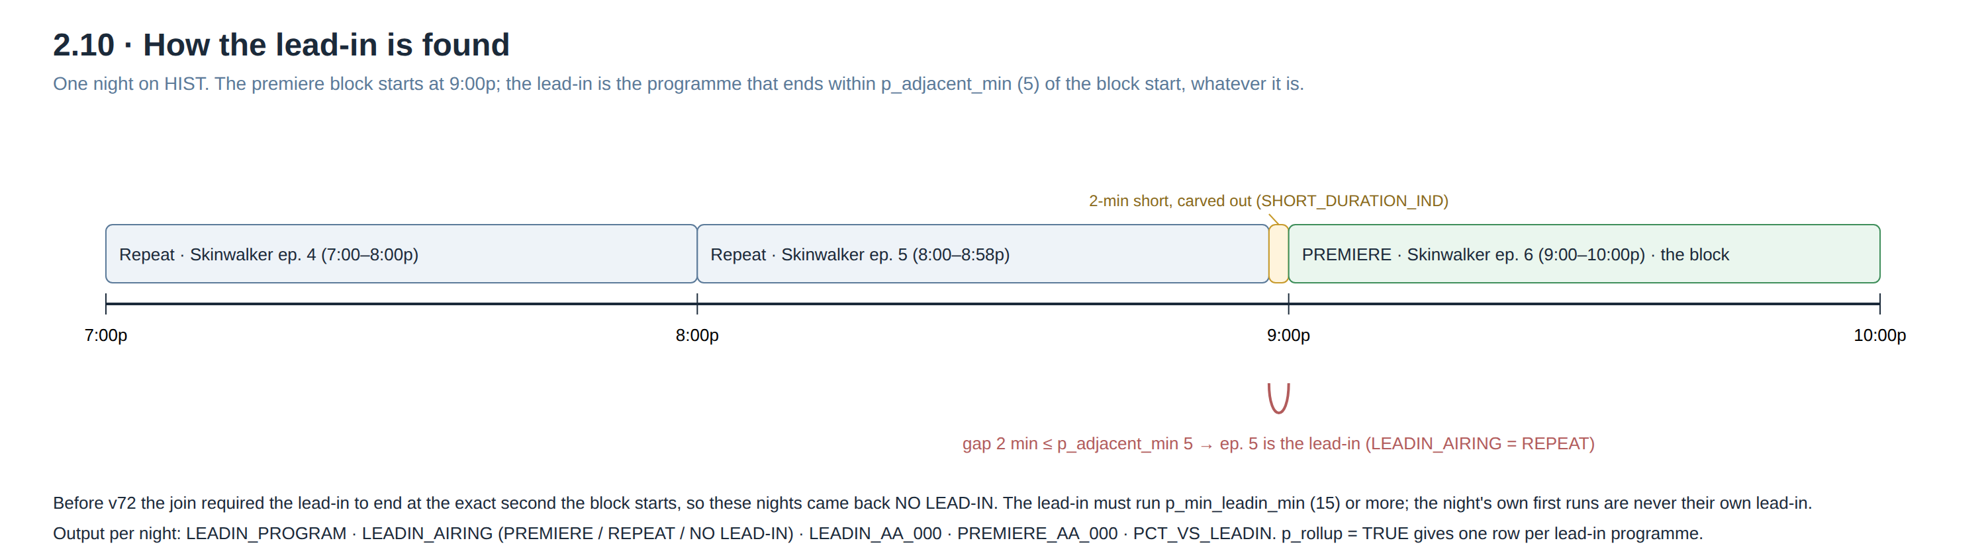
Figure 12g. One night of the lead-in rule.

2.11 Quarter hours vs norm
Answers: How the audience moves through the series' telecasts, against how the time period normally moves.
How it thinks: Splits each telecast into quarter hours, drops a short trailing runover, and puts the series' quarter-hour curve next to the norm's curve (§5). Per telecast or rolled up by season; the rollup is what the series question wants.
Knobs: p_norm_basis = SLOT, p_rollup, p_runover_max_min, the premiere-norm exclusions
What comes out: one row per quarter hour: series audience and % vs prior, norm audience and % vs prior, final vs first for both, telecasts in the norm.

2.12 Telecast level
Answers: The season episode by episode.
How it thinks: Every first run of the season with its audience, ranked, the season premiere marked.
Knobs: p_premiere_only
What comes out: one row per telecast, ordered by rank.

2.13 Repeats vs the daypart
Answers: Whether the series' repeats help or hurt the daypart they air in.
How it thinks: Finds the series' repeat half hours, groups them by A&E's eight-daypart grid according to where they actually aired, and compares each group with the daypart's own repeat average (§5).
Knobs: p_norm_basis = REPEATS
What comes out: one row per daypart: repeat telecasts, their audience, the daypart average, difference and verdict.
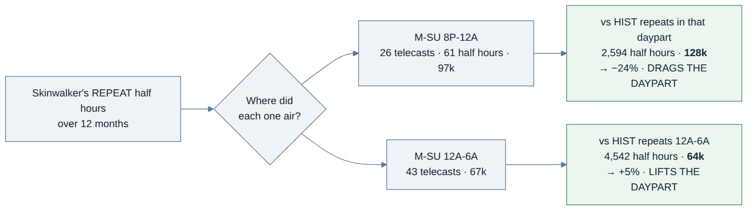
Figure 12h. Repeats against the daypart they aired in.

Section 3 · Competitive rankers
"Where do we stand." Every ranker returns the whole universe in rank order with the asked network or series marked, ties shown as "(tied)". Entertainment cable is defined by A&E's station-code list (p_excl_by = CODE) or, as a fallback, the PRD's name list.

3.1 Series rank in the network's time period
Answers: Where the network ranks among entertainment cable during a series' slots.
How it thinks: As 2.9, restricted to entertainment cable and phrased from the series' side. R_3: TBS #1, A&E #2, Food #3 on Interrogation Raw.
Knobs: p_slot_min_min = 15, p_demo
What comes out: one row per network.

3.2 Network ranks by daypart
Answers: Where the network ranks in prime and in total day, fiscal year to date, against all cable and against entertainment cable.
How it thinks: Averages every network over the fiscal year so far in each daypart, ranks twice (all cable, entertainment cable), and reports both ranks with tie labels. Also the same period a year earlier for context.
Knobs: p_fiscal_year, p_fy_to
What comes out: one row per network and daypart with both ranks.
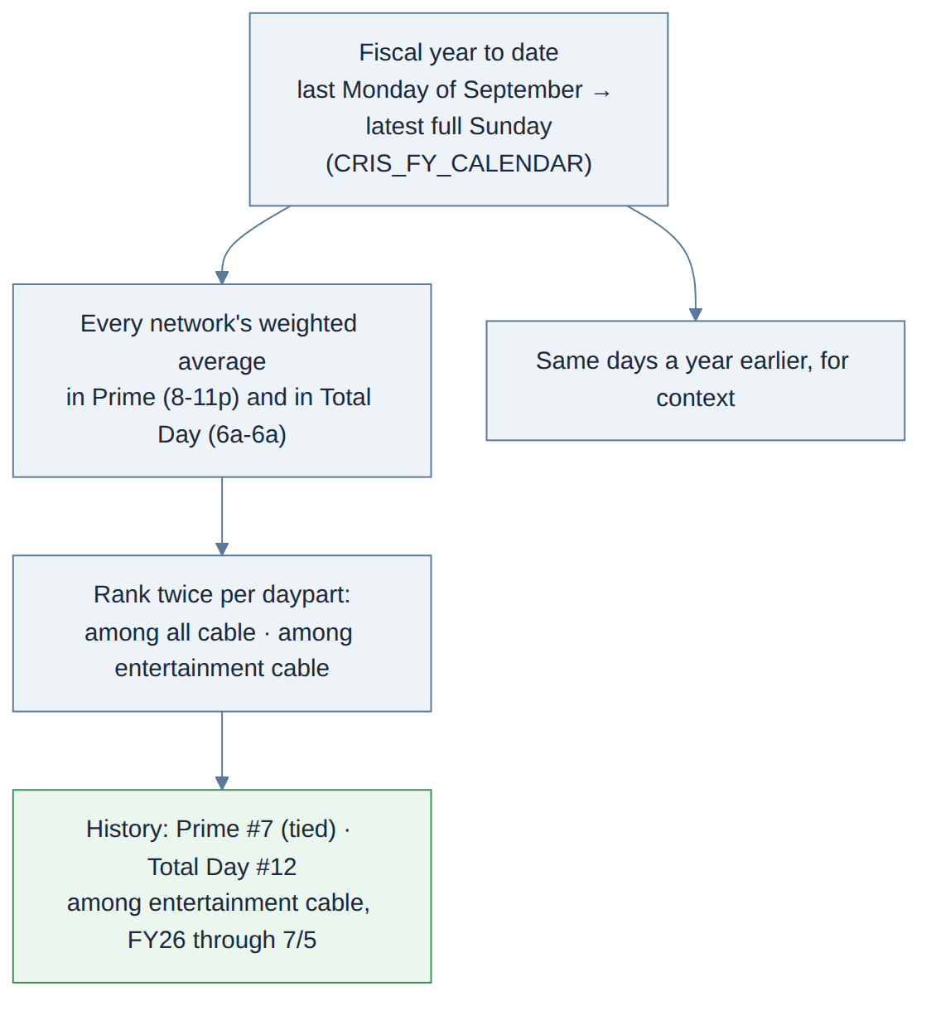
Figure 12i. Fiscal-year-to-date network ranks, two universes, two dayparts.

3.3 Series genre ranker
Answers: The top series within a genre across the competitive set, and where ours sit.
How it thinks: Every first-run series in the genre over the fiscal year, ranked by weighted average; genre from Cable Tracks (CT_GENRE_1, with the second genre to separate, say, wrestling from a cooking competition).
Knobs: p_genre, p_genre_col, p_top_n, p_min_tcasts
What comes out: the ranking, with the target network's series marked.
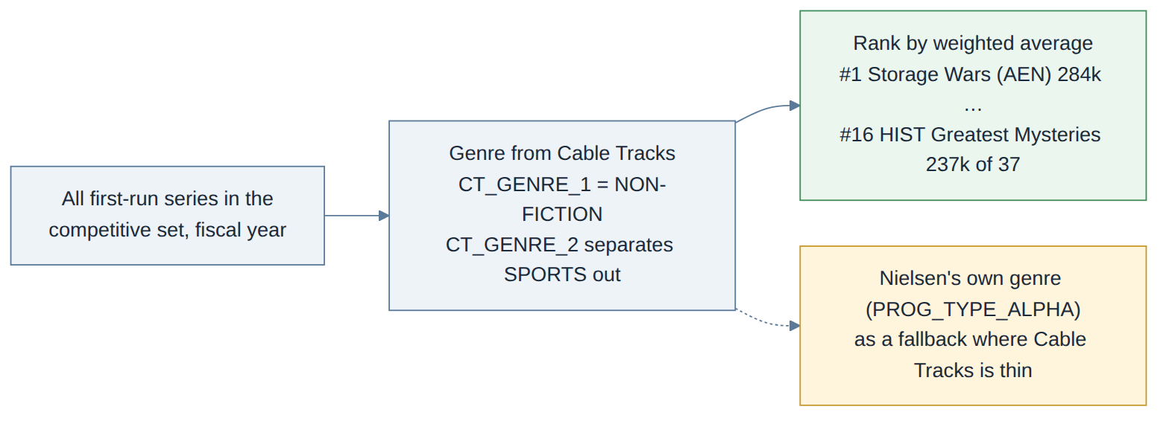
Figure 12j. The genre ranker.

3.4 Telecast ranker
Answers: The top telecasts across television in the latest full week.
How it thinks: Every telecast in the week ranked by weighted average across the whole universe (broadcast, cable, news and sports included), with its daypart.
Knobs: p_universe, p_top_n
What comes out: the ranking with the target marked.

7. The planner
CRISpy never writes a query. It reads the question, decides whether it is a ratings question at all, works out which of the 22 it is (rules first, a language model second), extracts what the question names (network, programme, season, demo, dates, stream), turns wording into knobs ("season premiere" switches p_premiere_only on; "how do the repeats do" goes to 2.13), fills the blanks of the query file and runs it. A question that needs more than one query (a full series snapshot) fans out to several. The answer always carries every knob that was used, so any figure can be traced to its query and its window.
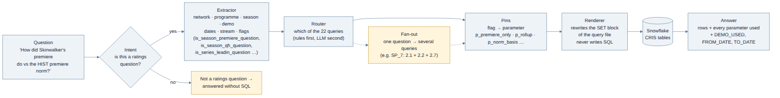
Figure 13. From the question to the rows.
Some wording rules the planner applies, because they decide which query and which knobs: "season premiere", "premiere episode", "opener" switch the season-premiere reading on; "among entertainment cable" sends a time-period question to 3.1 rather than 2.9; "which movie" ranks at telecast grain; "vs its lead-in" for a series asks for the rollup; "quarter hours" for a series (no date) is 2.11, for a night is 1.2; "how do the repeats do" is 2.13. A question with a date is not an overnight unless it is about one night.
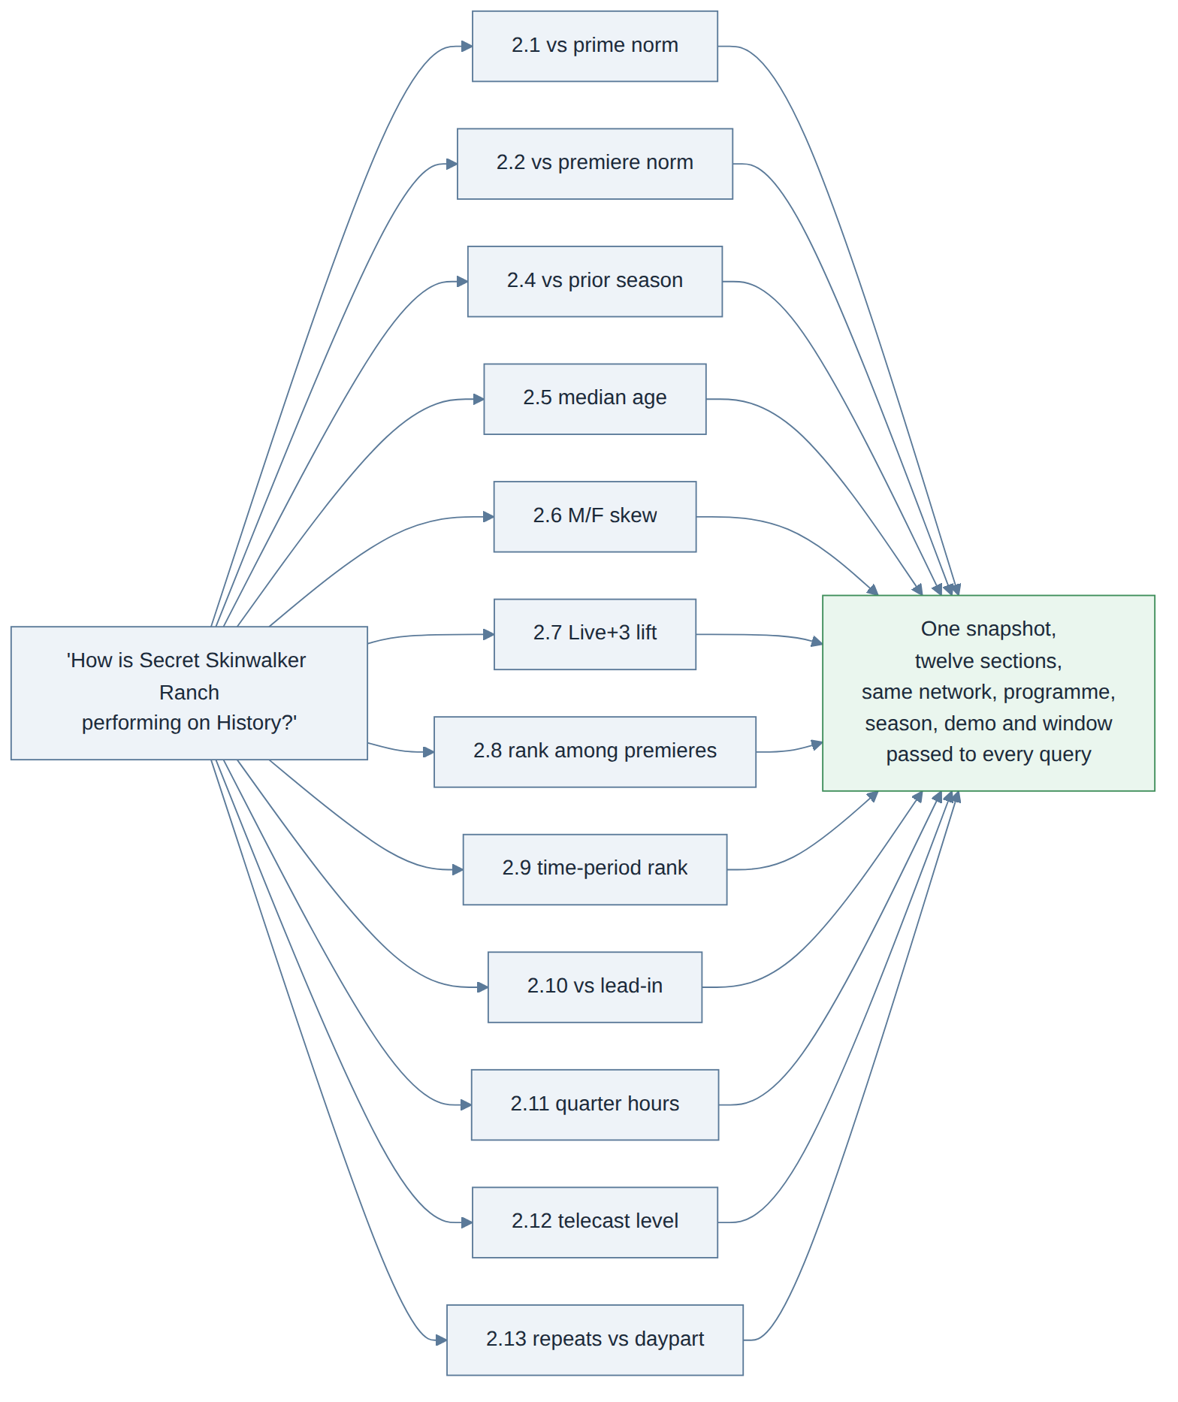
Figure 14. A series snapshot fans out to twelve queries with the same inputs.
Two things the planner never does: it never invents a figure (every number comes from a query), and it never changes a default silently (a knob is either set from the wording or left at the documented default, and the answer lists which).

8. Glossary
Term | Meaning
AA (000) | Average audience in thousands. All CRIS figures are AA on one demo.
Demo | The audience group measured: P25-64 on A&E, History and FYI; F25-64 on Lifetime and LMN; P2+ for median age and skew. DEMO_USED in every answer says which.
Stream | Live+SD (same day), Live+3, Live+7: how many days of delayed viewing are counted.
Broadcast date / day | Nielsen's day, 6:00am to 5:59am; a 1am show belongs to the evening before.
First run | An episode airing for the first time (Nielsen: not a repeat). "Premieres" in a question means these.
Season premiere | The first first-run telecast of a season. Only measured when asked for.
Norm | The average a figure is compared with: prime, premiere, quarter-hour or daypart (§5).
Latest full Sunday | The last Sunday with a complete week of data; every window ends there at the latest.
Lead-in | The telecast that ended right before a premiere started.
Runover | A short trailing quarter hour (under 15 minutes) when a show runs past the hour; dropped on the series side, counted on the norm side.
Mirror | The same-night re-airing of a premiere (9pm and again at 1am). Not flagged in the data; a rule from A&E is pending.
Cable Tracks | A&E's programme catalogue: seasons, genres, specials. The authority on what a season is.
Entertainment cable | The competitive set of networks, by A&E's code list (or the PRD name list).
Fiscal year | A&E's year, starting on the last Monday of September.
Knob / parameter | A named setting on a query (p_…). The planner fills it from the question; otherwise the default applies.

