Nama : Enisa Hutagalung
Nim : 251011700344
Matkul : PWEB

A.Script Html
<!DOCTYPE html>
<html lang="id">
<head>
<meta charset="UTF-8">
<meta name="viewport" content="width=device-width, initial-scale=1.0">
<title>Profil Mahasiswa - Enisa Hutagalung</title>

<!-- Bootstrap CSS -->
<link href="https://cdn.jsdelivr.net/npm/bootstrap@5.3.2/dist/css/bootstrap.min.css" rel="stylesheet">

<style>
.menu-content {
display: none;
}
.menu-content.active {
display: block;
}

.project-img {
width: 100%;
height: 200px;
object-fit: cover;
}

/* 🔥 INI YANG MEMBUAT FOTO MEDIA SAMA UKURAN */
.media-img {
width: 100%;
height: 200px;
object-fit: cover;
}

.media-video {
width: 100%;
max-height: 300px;
}
</style>
</head>

<body class="bg-light">

<div class="container mt-4">

<!-- Header -->
<h1 class="text-center">WEBSITE PROFIL MAHASISWA</h1>
<h5 class="text-center text-secondary">Enisa Hutagalung</h5>
<hr>

<!-- Navigasi -->
<div class="text-center mb-4">
<button class="btn btn-primary btn-sm" onclick="showMenu('home')">Home</button>
<button class="btn btn-success btn-sm" onclick="showMenu('profil')">Profil</button>
<button class="btn btn-warning btn-sm" onclick="showMenu('karya')">Karya & Project</button>
<button class="btn btn-info btn-sm" onclick="showMenu('media')">Media</button>
<button class="btn btn-secondary btn-sm" onclick="showMenu('informasi')">Informasi</button>
<button class="btn btn-danger btn-sm" onclick="showMenu('kontak')">Kontak</button>
</div>

<!-- HOME -->
<div id="home" class="menu-content active">
<div class="text-center mb-4">
<h2>Selamat Datang di Website Saya 👋</h2>
<p class="mt-3">
Website Enisa Hutagalung <b>Sistem Informasi</b><br>
Universitas Pamulang
</p>
<button class="btn btn-light mt-3" onclick="showMenu('profil')">
Lihat Profil Saya
</button>
</div>

<div class="row text-center">
<div class="col-md-4 mb-3">
<div class="card shadow">
<div class="card-body">
<h5>👩‍🎓 Profil</h5>
<p>Informasi pribadi dan akademik mahasiswa.</p>
<button class="btn btn-success btn-sm" onclick="showMenu('profil')">Buka</button>
</div>
</div>
</div>

<div class="col-md-4 mb-3">
<div class="card shadow">
<div class="card-body">
<h5>💼 Karya & Project</h5>
<p>Hasil tugas dan project perkuliahan.</p>
<button class="btn btn-warning btn-sm" onclick="showMenu('karya')">Buka</button>
</div>
</div>
</div>

<div class="col-md-4 mb-3">
<div class="card shadow">
<div class="card-body">
<h5>🎬 Media</h5>
<p>Galeri foto dan video.</p>
<button class="btn btn-info btn-sm" onclick="showMenu('media')">Buka</button>
</div>
</div>
</div>
</div>
</div>

<!-- PROFIL -->
<div id="profil" class="menu-content card">
<div class="card-body">
<h4 class="text-center mb-3">Profil Pribadi</h4>
<table class="table table-bordered">
<tr><th width="35%">Nama Lengkap</th><td>Enisa Hutagalung</td></tr>
<tr><th>Tanggal Lahir</th><td>30 Maret 2006</td></tr>
<tr><th>Alamat</th><td>Tarutung, Sumatera Utara</td></tr>
<tr><th>No. Telepon</th><td>0838-3477-8934</td></tr>
<tr><th>Email</th><td>enisa@email.com</td></tr>
<tr><th>Program Studi</th><td>Sistem Informasi</td></tr>
<tr><th>Universitas</th><td>Universitas Pamulang</td></tr>
<tr><th>Hobi</th><td>Bernyanyi,menari,menonton</td></tr>
</table>
</div>
</div>

<!-- KARYA -->
<div id="karya" class="menu-content card">
<div class="card-body">
<h4 class="text-center mb-3">Karya & Project</h4>

<div class="row">

<!-- PROJECT 1 -->
<div class="col-md-4 mb-3">
<div class="card shadow h-100">
<img src="gambar/mockup-html.jpg" class="project-img">
<div class="card-body">
<h6>Project 1: Mockup HTML</h6>
<p>Desain mockup website.</p>
<a href="gambar/mockup-html.jpg" target="_blank"
class="btn btn-secondary btn-sm">Lihat</a>
</div>
</div>
</div>

<!-- PROJECT 2 -->
<div class="col-md-4 mb-3">
<div class="card shadow h-100">
<video controls class="project-img">
<source src="video/ecommerce.mp4" type="video/mp4">
</video>
<div class="card-body">
<h6>Project 2: Video E-Commerce</h6>
<p>Video penjelasan.</p>
</div>
</div>
</div>

<!-- PROJECT 3 -->
<div class="col-md-4 mb-3">
<div class="card shadow h-100">
<img src="gambar/python.jpg" class="project-img">
<div class="card-body">
<h6>Project 3: Program Python</h6>
<p>Program sederhana Python.</p>
<a href="gambar/python.jpg" target="_blank"
class="btn btn-success btn-sm">Lihat</a>
</div>
</div>
</div>

<!-- PROJECT 4 : DESAIN ERD -->
<div class="col-md-4 mb-3">
<div class="card shadow h-100">
<img src="gambar/erd.jpg" class="project-img">
<div class="card-body">
<h6>Project 4: Desain ERD</h6>
<p>Entity Relationship Diagram sistem.</p>
<a href="gambar/erd.jpg" target="_blank"
class="btn btn-primary btn-sm">Lihat ERD</a>
</div>
</div>
</div>

</div>
</div>
</div>

<!-- MEDIA -->
<div id="media" class="menu-content card">
<div class="card-body">
<h5 class="text-center mb-4">Media</h5>

<!-- GALLERY GAMBAR -->
<h6>📷 Galeri Foto</h6>
<div class="row mb-4">
<div class="col-md-4 mb-3">
<img src="gambar/foto1.jpg" class="media-img rounded img-fluid">
</div>
<div class="col-md-4 mb-3">
<img src="gambar/foto2.jpg" class="media-img rounded img-fluid">
</div>
<div class="col-md-4 mb-3">
<img src="gambar/foto3.jpg" class="media-img rounded img-fluid">
</div>
<div class="col-md-4 mb-3">
<img src="gambar/foto4.jpg" class="media-img rounded img-fluid">
</div>
<div class="col-md-4 mb-3">
<img src="gambar/foto5.jpg" class="media-img rounded img-fluid">
</div>
</div>

<!-- VIDEO -->
<h6>🎬 Video</h6>
<video controls class="media-video rounded w-100 mb-4">
<source src="video/profil.mp4" type="video/mp4">
Browser Anda tidak mendukung video.
</video>

<!-- AUDIO -->
<h6>🎧 Audio</h6>
<audio controls class="w-100 mb-4">
<source src="audio/audio-profil.mp3" type="audio/mpeg">
Browser Anda tidak mendukung audio.
</audio>

<!-- DOKUMEN -->
<h6>📄 Dokumen</h6>
<ul>
<li>
<a href="dokumen/laporan-project.docx" target="_blank">
Laporan Project (Word)
</a>
</li>
</ul>

</div>
</div>

<!-- INFORMASI -->
<div id="informasi" class="menu-content card">
<div class="card-body">
<h5>Informasi</h5>
<p>
Halooo!! Saya adalah mahasiswa aktif Universitas Pamulang.
Saat ini saya sedang menempuh semester 2 dan memiliki minat
di bidang web development.
</p>
</div>
</div>

<!-- KONTAK -->
<div id="kontak" class="menu-content card">
<div class="card-body">
<h5>Kontak</h5>
<p>No HP: 0838-3477-8934</p>
<p>Email: enisa@email.com</p>
<p>Instagram: @vynnisaa</p>
</div>
</div>

<footer class="text-center mt-4">
<b>© 2025 - Enisa Hutagalung | Universitas Pamulang</b>
</footer>

</div>

<script>
function showMenu(menuId) {
document.querySelectorAll('.menu-content').forEach(m => m.classList.remove('active'));
document.getElementById(menuId).classList.add('active');
}
</script>

</body>
</html>
B.Gambar Tampilan Website
1.HOME
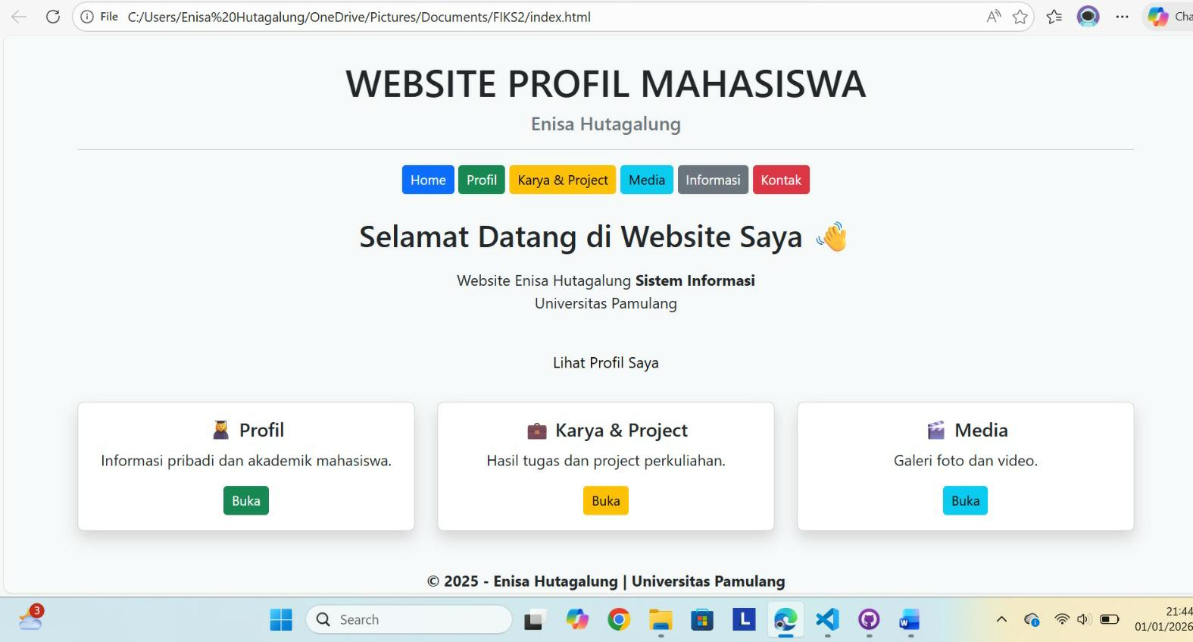

2.PROFIL
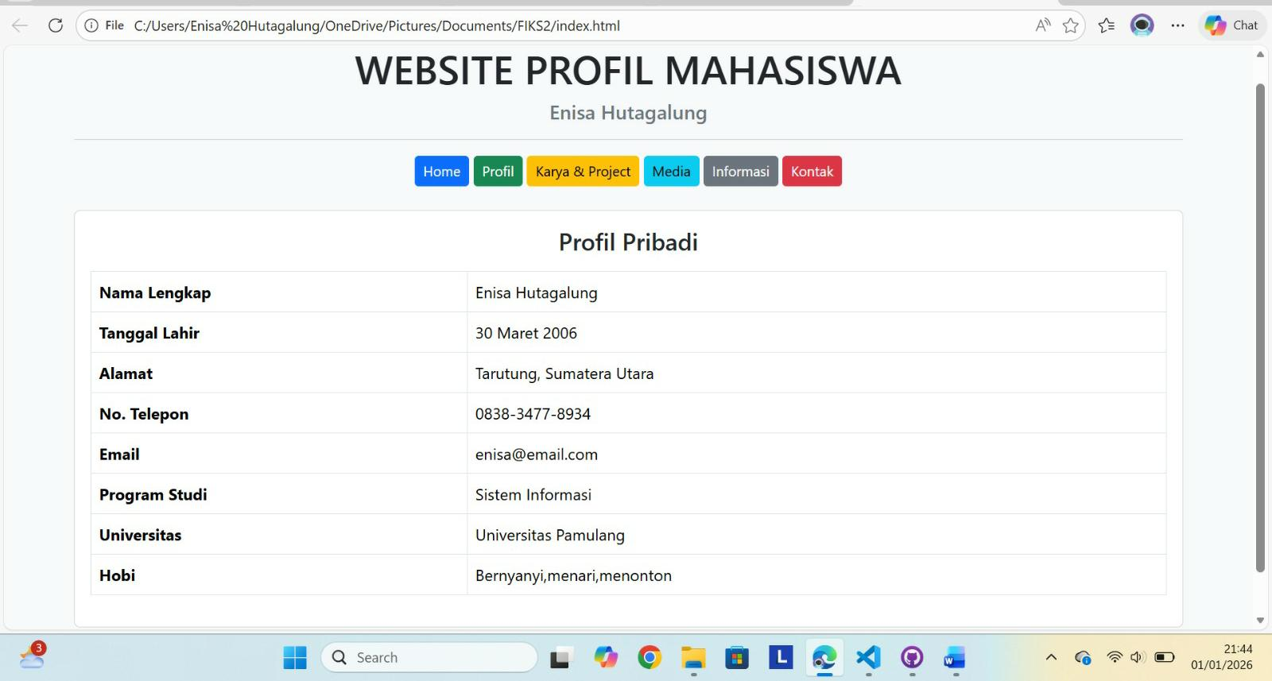

3.KARYA & PROJECT
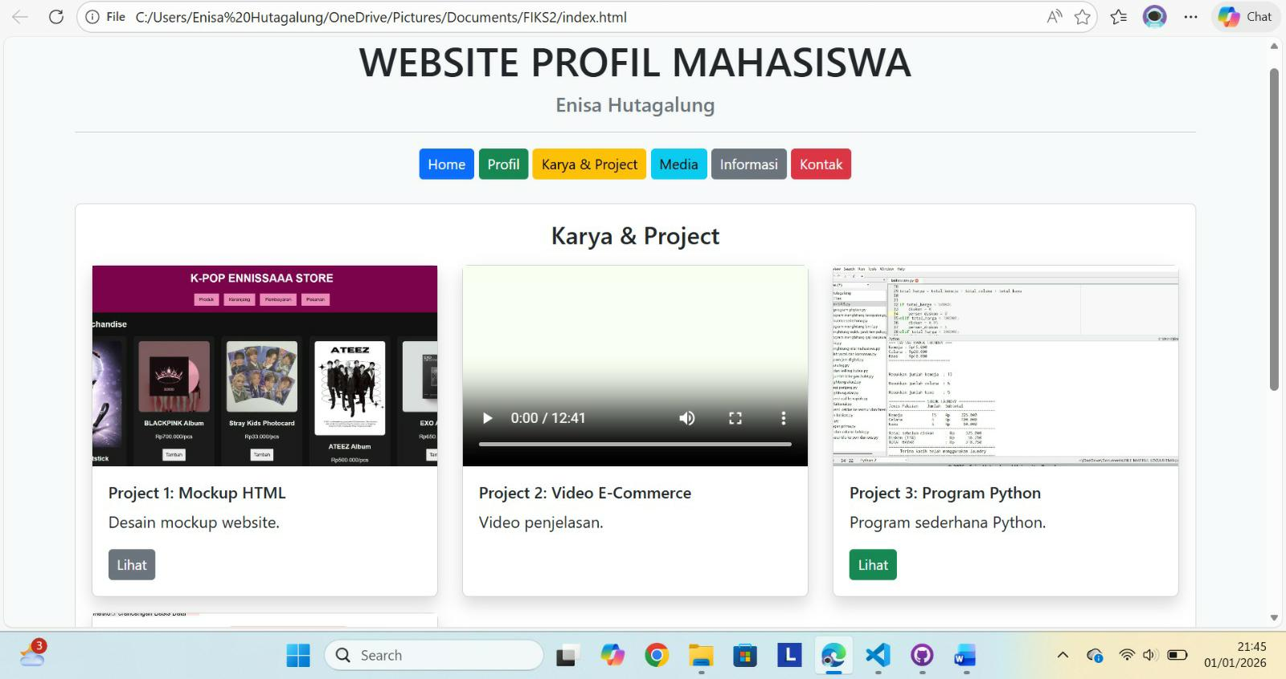

4.MEDIA
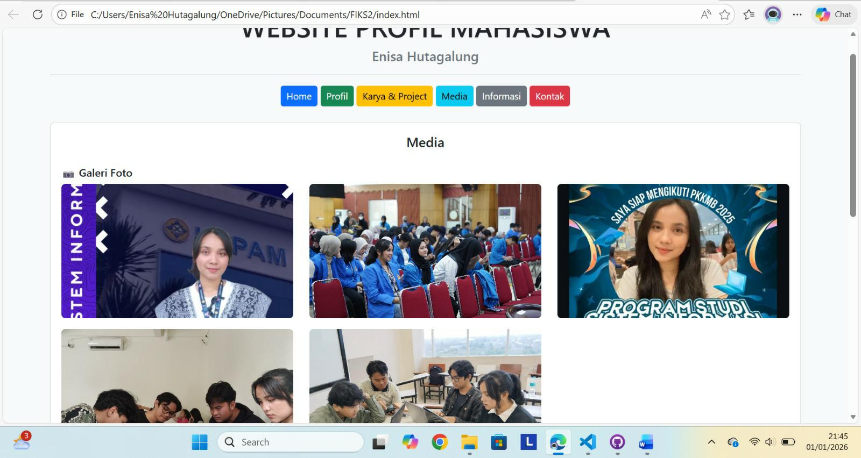

5.INFORMASI
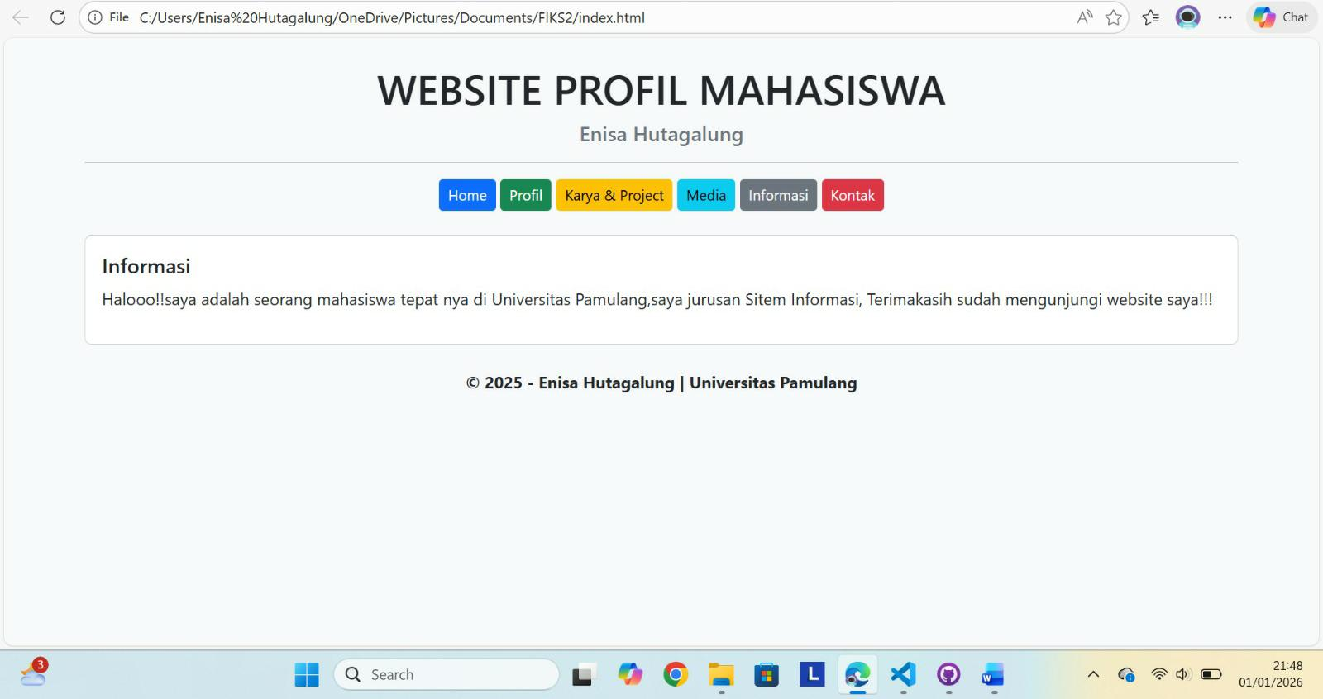

6.KONTAK
