Research on the dataset of Adult for
Understanding Race and Gender Inequality in the Individuals Income

Enise İrem Çolak
1507935
May, 2020

Table of Contents

Table of Contents

Introduction
Problem/Question (Purpose) & Hypothesis

Research

Materials and Procedure

Data/Observations
Conclusions

Acknowledgments

Bibliography
Appendix

INTRODUCTION

The adult dataset is from the 1994 Census database⁽¹⁾. This dataset can be found at the UCI Machine Learning Repository. It has records about people, and their some information. The modified dataset consists of approximately 32,561 data points, with each data point having 4 features. I am interested to learn which group of society is most likely to have less income than the others. For that, I only work with related columns for my purpose. I mainly use two machine learning techniques for examine data; the k-nearest neighbor and logistic regression.

PROBLEM (PURPOSE) & HYPOTHESIS

PROBLEM: The purpose of my experiment is to find out which group of the society has a lack of opportunity and as a result that has a lower income.

HYPOTHESIS: I believe that most discriminated groups of the society are who has ethnic roots to non-white race and who identified themselves as women.

RESEARCH

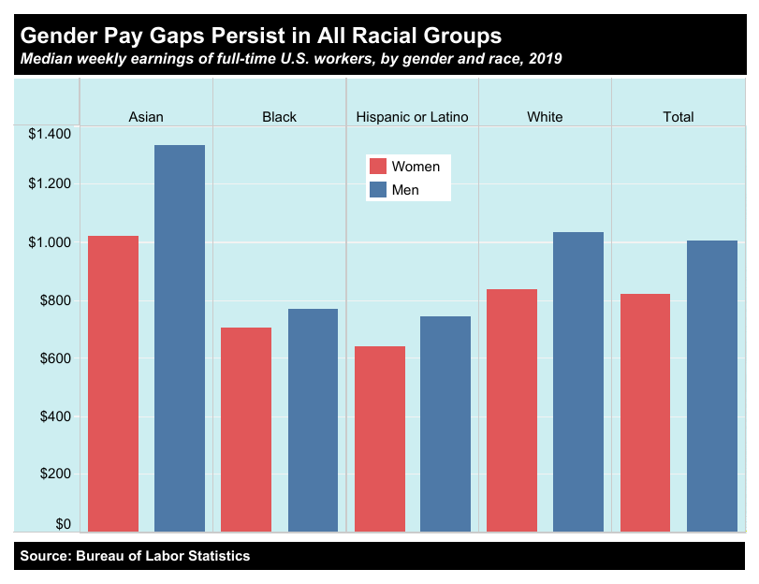
During the years economic inequality by gender and race sported by many articles. In this dataset, focused on the US, income divided two as higher than $50k or lower from the same amount.

However, according to National Partnership’s, March 2020 report⁽²⁾
“Quantifying America’s Gender Wage Gap by Race/Ethnicity” Women of color in the United States experience inequality for decades. The gaps as a result of sexism and white supremacy. The report also explains, even white women in the United States are typically paid 79 cents for every dollar paid to men, for a year this difference becomes (median annual pay) $13,186 per year. Statics are worse with women in color. Overall, this means it is more than a full additional year of tuition and fees for a four-year public university or more than 13 additional months of child care. These examples can be interpreted as inequalities that return to society as more inequality.

From table 1^{(3),} inequality is seen.

MATERIALS AND PROCEDURES

For the research to understand the data itself, two machine learning algorithms used. The methods are chosen according to data.
While working on data with preprocessing labels included, data itself does not have labels but from UCI it was included as a separate file. Two methods were chosen as K- nearest neighbors and logistic regression. At the conclusion, you will see the report as the findings depend on those two.

DATA/OBSERVATIONS
Data information is divided into 4 columns with 32561 entries. Columns are “education-num”, “race”, “sex”, “income”. Income is the target of algorithms. Sex contains “Male” and “Female”. The race also divided into two for a better understanding of data, “white” and “non-white”. Education-num is given a number according to individuals' education level. Third place was the original numbers from the data source, but decreased for this research;

# 5 Group ; No-education background : 0 -> will be number 1 on table
# Primary level : 1 -> 2,3,4,5...,8
# Highschool level : 2 -> 9
# Bachelor or college : 3 -> 10,11,12,13
# Higher than Bachelor : 4 -> 13+

# Sex 0; Female 1; Male
# Race 0; Non-white 1:White
#Income 0; -$50K 1; +$50K

According to research from the Federal Reserve Bank of St.Louis by Wolla and Sullivan (2017), they explain a strong relationship between education and income, the paper called Education, Income, and Wealth⁽⁴⁾. As they clarified, education alone is can not be the expectation of higher income and wealth. But of course, two of them related.
But I will also examine the education level since it is, in fact, as one of the affecting values.

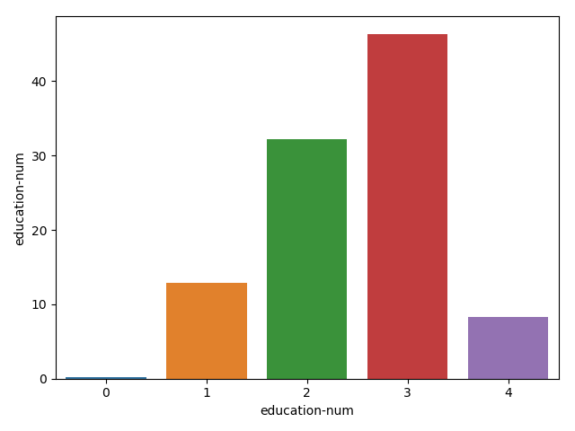

As seen from the table, over 40 percent of the table has a 3rd level of education, Bachelor or College. There is 0.15 percent who have no educational background, which means most of them to have access to the primary level education, and even more.

After that table, we should also look into the relationship between education and income.

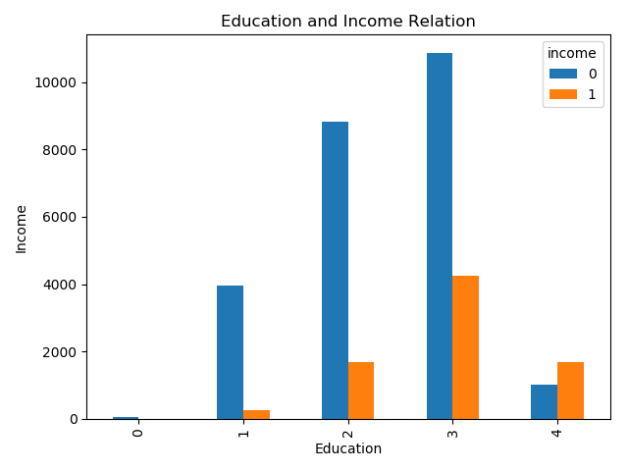
Income seen in table 3 shows us that, the percentage of lower-income most likely expected, even with the Bachelor level income. The number of people with higher income only slightly more from lower-income when the education level is higher than the Bachelor. But for other levels of education lower-income comes with an undeniable difference.

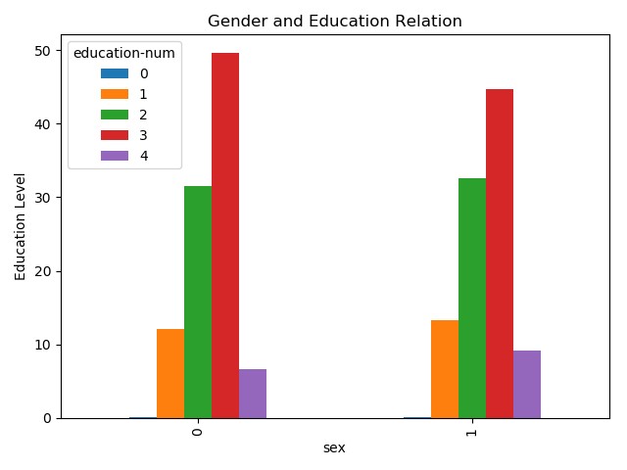

The main idea was to see the difference between gender and race with income but I want to also see this table. The results are close numbers but one of them has much difference, it seems women have more educated at the level of 3, bachelor, or college. But further education leading gender is male. Also for all other education levels male individuals slightly more.

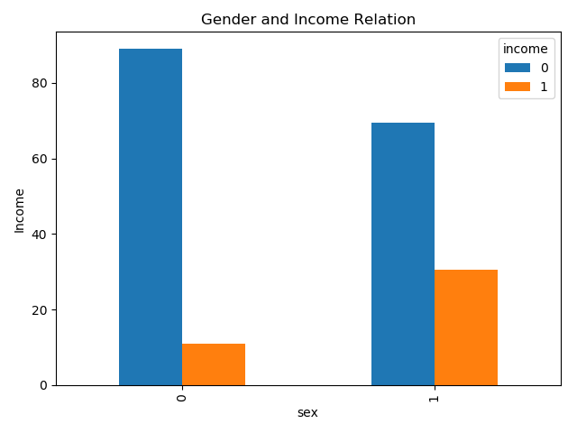

But when we get into the gender income relation, over 90 percent of women have lower income. The numbers show inequality clearly.
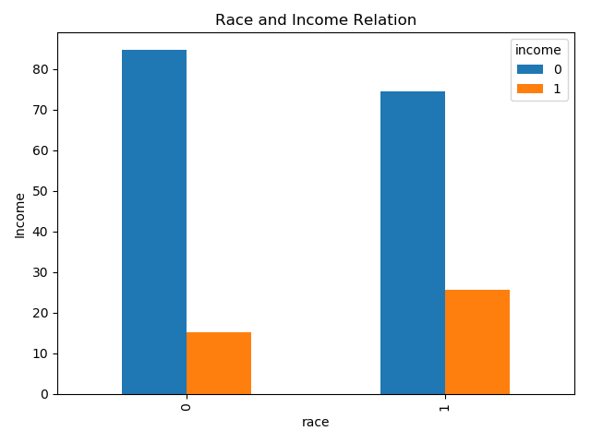

For the last examination of data, race also seems a huge impact on income. The result has similarities with the gender table. More than 90 percent of non*white community has a lower income. Even all dataset has a lower income issue, the most problematic communities seem like women and non-white individuals.

After preprocessing of the data and understanding what we have. I mostly focus on preprocess than use the algorithms I mentioned before. Algorithms have 3 stages. First, they will be trained with ordinary data but I choose to separate a test sample. After that, I’ll check the accuracy and made it to use adults.test data which will bring us to the conclusion.

CONCLUSION

After training the algorithms with the current dataset, we can examine the results of prediction to see that if the algorithm itself, confirms that, bias against race and gender is high.
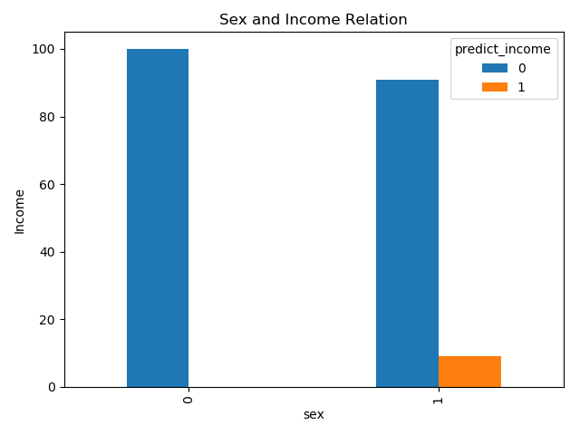

For the first examination, we can focus on the Logistic Regression results. Even though our model was not good enough, I first saw the 0.7 as accuracy. After model improvements, it gave us 0.78 accuracies. At that time our results show us what seems like a big impact for a bias.

Almost all of the women predicted as lower income.

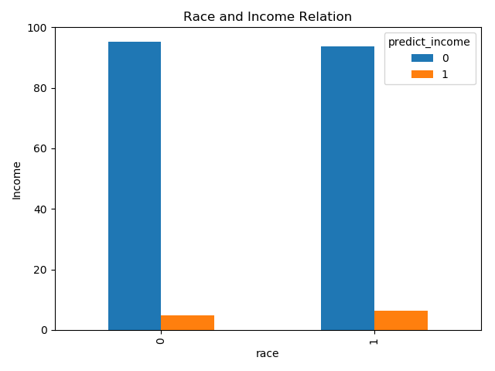
But with race, it doesn’t seem an issue. The numbers are pretty close.

These two actually can say that, with the Logistic Regression, gender is a bigger bias than race.

K-Nearest Neighbor algorithm gave me 1.0 accuracy with arraged test data. So later I did test it with again.

BIBLIOGRAPHY

- Dua, D., and Graff, C. (2019). UCI Machine Learning Repository [http://archive.ics.uci.edu/ml]. Irvine, CA: the University of California, School of Information and Computer Science.
- NATIONAL PARTNERSHIP FOR WOMEN & FAMILIES, (2020), Quantifying America’s Gender Wage Gap by Race/Ethnicity from https://www.nationalpartnership.org/ourwork/resources/economic-justice/fair-pay/quantifying-americas-gender-wage-gap.pdf
- INSTITUTE OF POLICY STUDIES, (2020), Racial Economic Inequality from https://inequality.org/facts/racial-inequality/
- Scott A. Wolla and Jessica Sullivan, (January 2017), Education, Income and Wealth from https://research.stlouisfed.org/publications/page1-econ/2017/01/03/education-income-and-wealth/

APPENDIX
You can reach all the codes from https://github.com/eniseirem/DS_Adult

