PART A
(PART A: TO BE REFFERED BY STUDENTS) Experiment No.01

A.1—Aim:
To study different types of connecting devices in Computer network and importance of Standards in Computer Networking

A.2--- Prerequisite:
Basic familiarity of Computer Network and internetworking devices

A.3--- Outcome:
After successful completion of this experiment students will be able to:
- Understand the various connecting devices
- Importance of Standards

A.4--- Tasks:
- Study various network connecting devices: Hub, Switches, Router, Bridge, Gateway and Repeater
- Document the details studied in point 1, it should include following sub points:
Description
Figure
Applicability
- Answer the following questions:
What is Standard?
Importance of IEEE computer standards
List with brief explanation of standards for Computer Networks (Wired as well as Wireless)
- Save the file and name it as CN_EXP1_your Roll no_Batch No.

(PART - B)

(TO BE COMPLETED BY STUDENTS)

(Students must submit the soft copy as per following segments within two hours of the practical.
The soft copy must be uploaded on the Blackboard or emailed to the concerned lab in charge faculties at the end of the practical in case there is no Black board access available)

Roll.No. : B032 | Name: Naman Garg
Sem/Year : 5/3 | Batch: B2
Date of Experiment : 6-7-2020 | Date of Submission:
Grade

B.1: Procedure of performed experiment
(students are expected to write the reason of the choice of topology and device)
- HUB:
Description: Hubs and switches serve as a central connection for all your network equipment and handles a data type known as frames. Frames carry your data. When a frame is received, it is amplified and then transmitted on to the port of the destination PC.
Basically, a hub is a box with lots of connections (sockets) for Ethernet cables. The hub repeats all messages it receives to all connected nodes, and these nodes filter out only the messages that are intended for them. This filtering takes place at the Ethernet level: incoming messages carry the Ethernet network address of the intended recipient.

Figure:
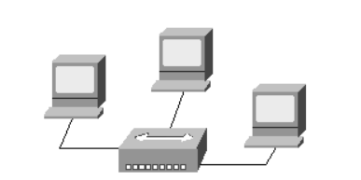
Applicibility: A problem with this approach is that hubs generate a lot of traffic, especially on larger networks. Most of this traffic is wasted, since it is intended for only one node but it is sent to all nodes on the network.

- SWITCHES:
Description: A switch still connects all nodes to each other, like a hub, but is more intelligent in which messages are passed on to which node. A switch examines incoming Ethernet messages to see which node is the intended recipient, and then directly (and only) passes the messages to that node. This way other nodes do not unnecessarily receive all traffic.
Figure:
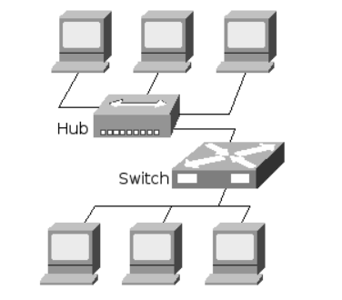
Applicability: Since switches are more expensive than hubs, a low-traffic part of the network could be set up using a hub, with the more high-traffic nodes being interconnected to the switch. The hub segment is then connected to the switch as well

- BRIDGE:
Description: A large network can be divided into multiple parts which are called segments. Each segment can use its own network protocol, security rules, firewalls and so on. Nodes on different segments cannot directly communicate with each other. To make this possible, a bridge is added between the segments
Figure:
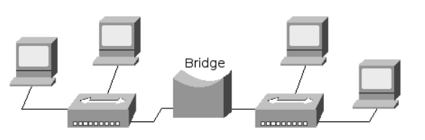
Applicability: The bridge lets packet pass that are destined for a host on the other side. This seems to turn the two segments into one big network again, but there is an important difference. Data packets generated on one segment and intended for that same segment are not passed to the other segment. This saves on data transmission on the network.

- GATEWAY/ROUTER:
Description: a router or gateway is used to connect different networks
A router is connected to two different networks and passes packets between them. In a typical home network, the router provides the connection between the network and the Internet.
A gateway is the same as a router, except in that it also translates between one network system or protocol and another. The NAT protocol for example uses a NAT gateway to connect a private network to the Internet.
Figure:
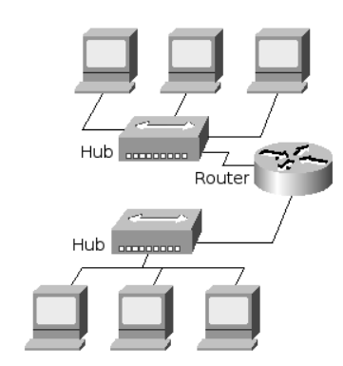
Gateway/Router
Applicability: The above examples all presented a single network at the Internet Protocol level. Even when the network is segmented, all nodes are still able to communicate with each other. To connect networks, a router or gateway is used.

- REPEATER
Description: A network device used to regenerate or replicate a signal. Repeaters are used in transmission systems to regenerate analog or digital signals distorted by transmission loss. Analog repeaters frequently can only amplify the signal while digital repeaters can reconstruct a signal to near its original quality.
Figure:
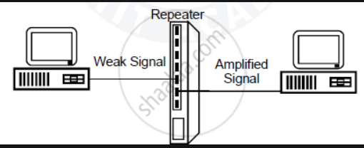
Applicability: In a data network, a repeater can relay messages between subnetworks that use different protocols or cable types. Hubs can operate as repeaters by relaying messages to all connected computers. A repeater cannot do the intelligent routing performed by bridges and routers.

// answer the following:
- What is Standard?
Networking standards ensure the interoperability of networking technologies by defining the rules of communication among networked devices. Networking standards exist to help ensure products of different vendors can work together in a network without risk of incompatibility.
- Importance of IEEE computer standards
Standards form the fundamental building blocks for product development by establishing consistent protocols that can be universally understood and adopted. This helps fuel compatibility and interoperability and simplifies product development, and speeds time-to-market. Standards also make it easier to understand and compare competing products. As standards are globally adopted and applied in many markets, they also fuel international trade.

- List with brief explanation of standards for Computer Networks (Wired as well as Wireless)
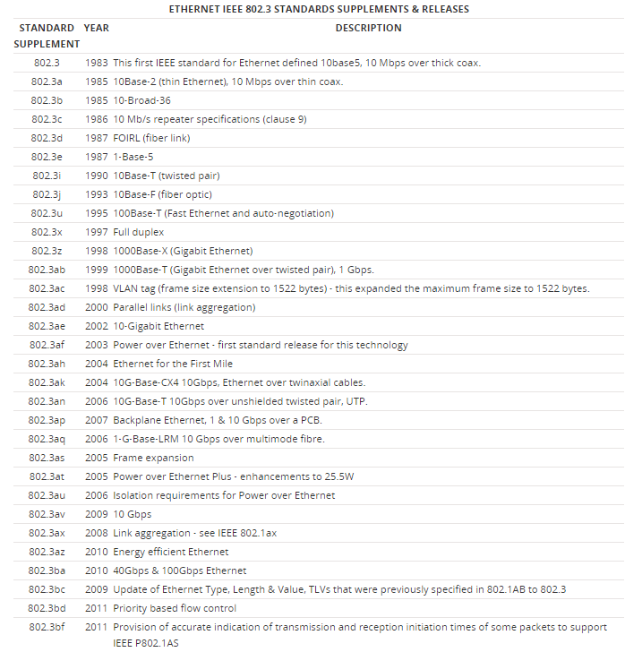

B.2: Observations and Learning’s:
Standards are very important for networking as it is all about working with different people from different parts of the world so if there are no standards, we would need to combat many compatibility issues in world trade/ work.
I also observed that both routers and gateways are functionally the same a gateway is like a feature to the router in the sense that it can be used to communicate between 2 different internet protocol types

B.3: Conclusion:
- Understood the various connecting devices
- Understood Importance of Standards

B.4: Questions of Curiosity:

- Difference between a Hub and a Switch
A hub works on the physical layer (Layer 1) of OSI model while Switch works on the data link layer (Layer2). Switch is more efficient than the hub. A switch can join multiple computers within one LAN, and a hub just connects multiple Ethernet devices together as a single segment. Switch is smarter than hub to determine the target of the forwarding data. Since switch has a higher performance, its cost will also become more expensive.
- Give the need for internetworking devices
Internetworking has evolved as an answer to a few key problems: isolated LANs, duplication of resources, and an absence of network management. Isolated LANs created transmission problem between totally different offices or departments. Duplication of resources meant that constant hardware and code had to be provided to every workplace or department, as did a separate support employee. This lack of network management meant that no centralized methodology of managing and troubleshooting networks existed.

