PART A
(PART A: TO BE REFFERED BY STUDENTS) Experiment No.02

A.1—Aim:
Study of different types of network cable and explore some network related commands

A.2--- Prerequisite:
basic idea of running commands on window’s command line interface.

A.3--- Outcome:
After successful completion of this experiment students will be able to:
- Learn and execute basic commands to examine a network & execute them on windows command line interface.
- Identify various types of media

A.4--- Tasks:
- Study various network media in computer networks
- Document the details studied in point 1, it should include following sub points:
Description
Figure
Applicability
- Explore the following networking commands on command prompt
- hostname: finding host/domain name and IP address
- ping: Ping is a computer network administration utility used to test whether a particular host is reachable across an Internet Protocol (IP) network and to measure the round-trip time for packets sent from the local host to a destination computer, including the local host's own interfaces.
- ipconfig getting network configuration
- netstat : Network connections, routing tables, interface statistics
- nbtstat:- It displays protocol statistics and current TCP/IP connections using NBT.
- nslookup: query DNS lookup name
- telnet: communicate with other hostname
- tracert : It is use to trace the root
- finger : Displays information about a user on a specified system running the Finger service. Output varies based on the remote system.

- Save the file and name it as CN_EXP2_your Roll no_Batch No.

(PART - B)

Roll.No. : B032 | Name: Naman Garg
Sem/Year : 5 | Batch: B2
Date of Experiment : 13-7-2020 | Date of Submission:
Grade --

B.1: Procedure of performed experiment
Network Media
Network media refers to the communication channels used to interconnect nodes on a computer network. Network media are of two broad types, guided media and unguided media.
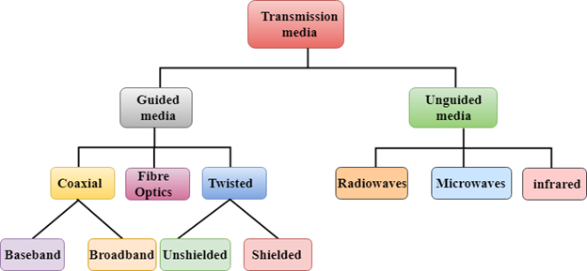

Guided Media

Fiber Optics

Fiber offers enormous bandwidth, immunity to many types of interference and noise, and improved security. Therefore, fiber provides very clear communications and a relatively noise-free environment. The downside of fiber is that it is costly to purchase and deploy because it requires specialized equipment and techniques.

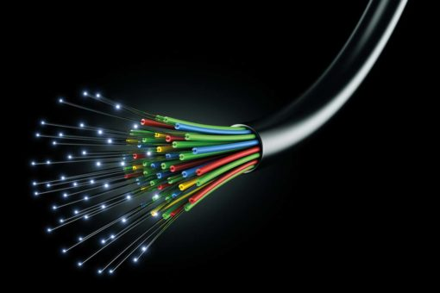

Fiber optic cables provide high speed network connectivity, therefore they are best used at places where high speed connections are a must.

Twisted Pair Cable

Copper wires are the most common wires used for transmitting signals because of good performance at low costs. They are most commonly used in telephone lines. However, if two or more wires are lying together, they can interfere with each other’s signals. To reduce this electromagnetic interference, pair of copper wires are twisted together in helical shape like a DNA molecule. Such twisted copper wires are called twisted pair.

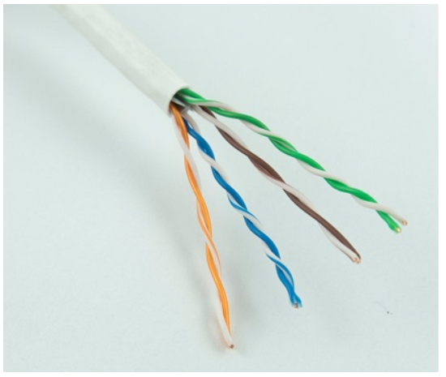

Twisted pair cables are cheap, therefore they are used pretty muchc everywhere, for almost all connections.

Coaxial Cable

Coaxial cables are copper cables with better shielding than twisted pair cables, so that transmitted signals may travel longer distances at higher speeds. Coaxial consists of three layers, a core copper component, an insulating material on top of it and Closely woven braided mesh of conducting material surrounding the insulator. Sometimes there is a fourth layer also, that is a plastic cover used to protect the wire.

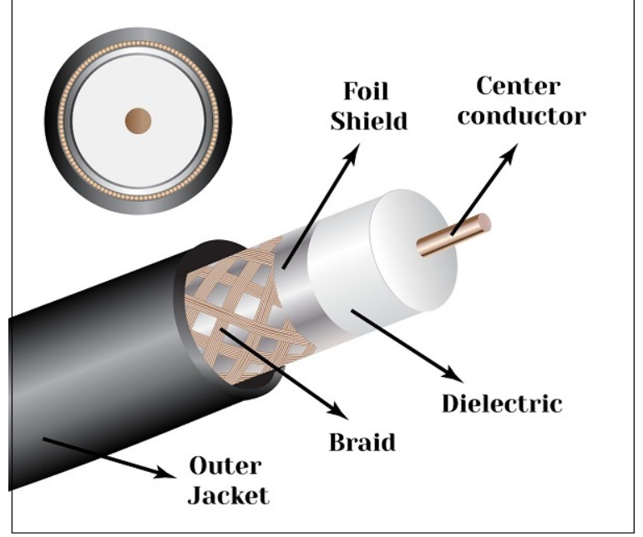

Coaxial cables are used to transmit data over a long distances.

Guided Media

Infrared media

Low frequency infrared waves are used for very short distance communication like TV remote, wireless speakers, automatic doors, hand held devices etc. Infrared signals can propagate within a room but cannot penetrate walls. However, due to such short range, it is considered to be one of the most secure transmission modes.

Infrared media

Transmission of data using radio frequencies is called radio-wave transmission. We all are familiar with radio channels that broadcast entertainment programs. Radio stations transmit radio waves using transmitters, which are received by the receiver installed in our devices.

HOSTNAME:
The hostname command is used to get the domain name system,

The option -a (for alias if any), -b(to set alias), don’t work as the windows OS uses the control panel for these purposes
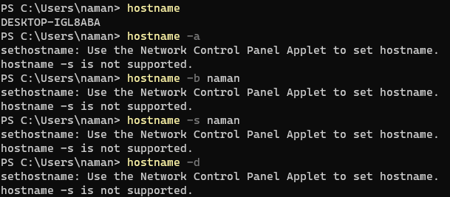
PING:
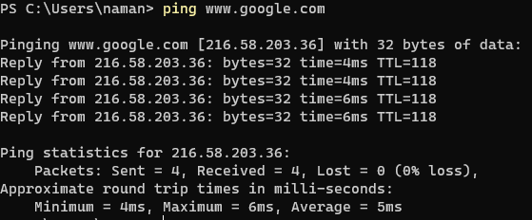
The ping command is a Command Prompt command used to test the ability of the source computer to reach a specified destination computer. The ping command is usually used as a simple way to verify that a computer can communicate over the network with another computer or network device.

IPCONFIG:
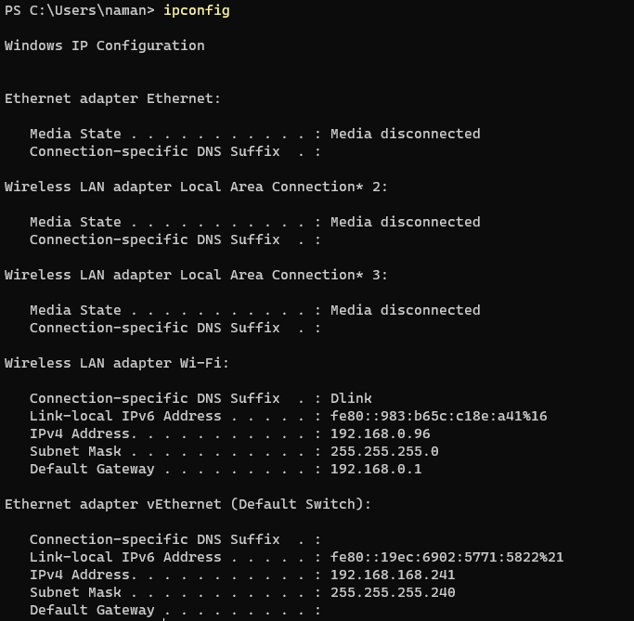
NETSTAT:
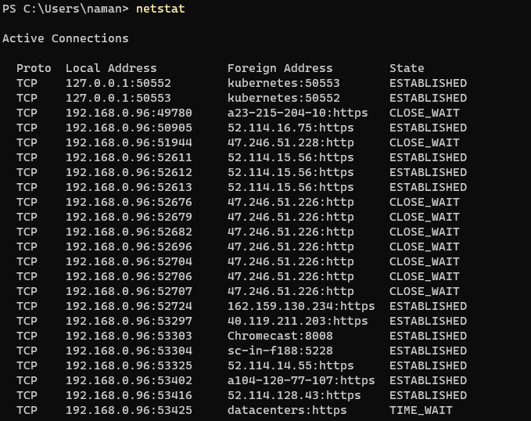
NBTSTAT:
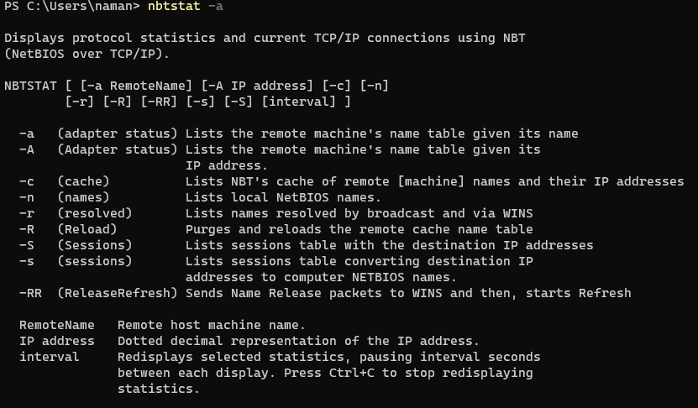
NS LOOKUP:

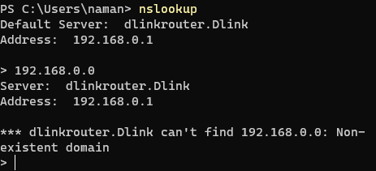
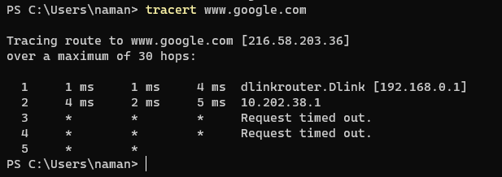
FINGER:
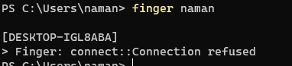

B.2: Observations and Learning’s:
I learnt how to run basic commands on the command prompt and their uses too.

B.3: Conclusion:

After performing this lab, I understood the use of the above commands and the various types of media

B.4: Questions of Curiosity:

Differentiate between twisted pair cable and co-axial cable.
- Coaxial cables are generally used for cable television and internet connections.
- Twisted pair cables are usually used for telephone connections.
- Coaxial cables support greater cable lengths.
- Twisted pair cables are thinner and less expensive.
- Coaxial cables are better shielded from crosstalk.
- Twisted pair cables provide high transmission rates.

