PART A
(PART A: TO BE REFFERED BY STUDENTS) Experiment No.10

A.1 Aim:
To configure a network using OSPF in cisco packet tracer.
A.2 Prerequisite:
Knowledge about Link state Routing Algorithm

A.3 Outcome:
After successful completion of this experiment students will be able to:
- Understand the concept of routing algorithms

A.4 Theory:

Open Shortest Path First, an interior gateway routing protocol developed for IP networks based on the shortest path first or link-state algorithm.

Routers use link-state algorithms to send routing information to all nodes in an internetwork by calculating the shortest path to each node based on a topography of the Internet constructed by each node. Each router sends that portion of the routing table (keeps track of routes to particular network destinations) that describes the state of its own links, and it also sends the complete routing structure (topography).

The advantage of shortest path first algorithms is that they results in smaller more frequent updates everywhere. They converge quickly, thus preventing such problems as routing loops and Count-to-Infinity (when routers continuously increment the hop count to a particular network). This makes for a stable network.

The disadvantage of shortest path first algorithms is that they require a lot of CPU power and memory. In the end, the advantages outweigh the disadvantages.
OSPF Version 2 is defined in RFC1583. It is rapidly replacing RIP on the Internet.

A.5 Procedure/Algorithm:

A.5.1 TASK:

1. Develop a Topology shown in figure given below

2. Configure all Routers.

3. Implement OSPF protocols in Router to configure network.
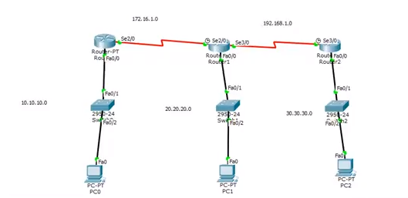

PART B
(PART B : TO BE COMPLETED BY STUDENTS)
(Students must submit the soft copy as per following segments within two hours of the practical. The soft copy must be uploaded on the Blackboard or emailed to the concerned lab in charge faculties at the end of the practical in case there is no Black board access available)

Roll No: B032 | Name: Naman Garg
Class: B Tech CS B | Batch: B2
Date of Experiment: 19/10/20 | Date of Submission:
Grade:

B.1 Answers of Task to be written by student:
(Paste your answers completed during the 2 hours of practical in the lab here)

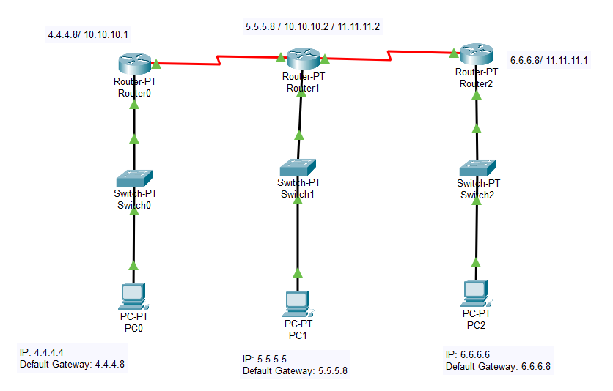

Configuring the Routers using CLI:

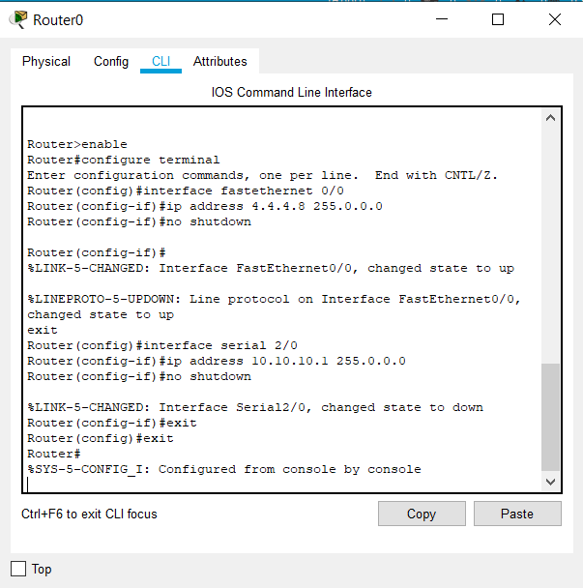

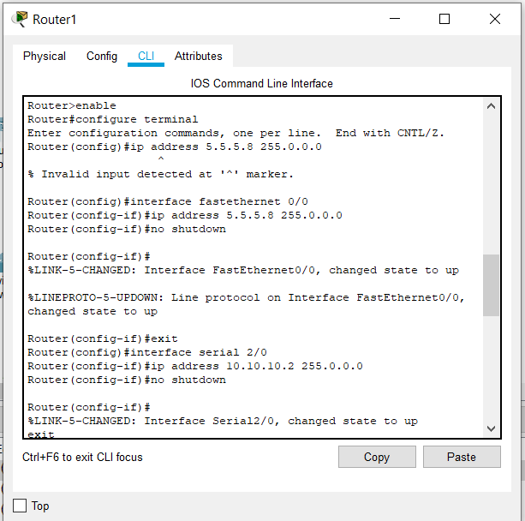

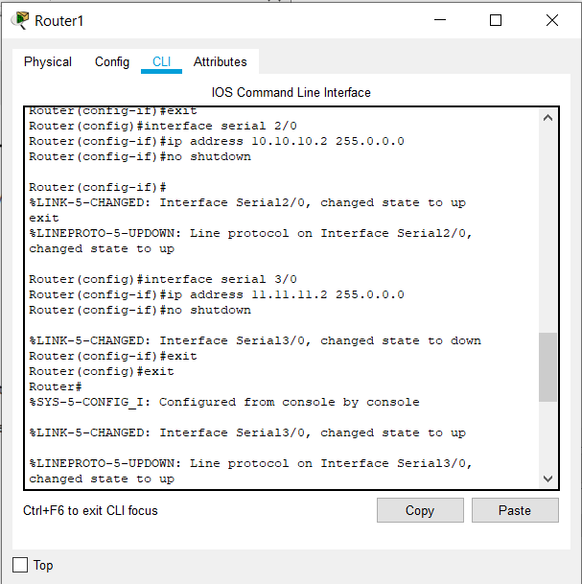

Implementing OSPF protocols in Router to configure network:

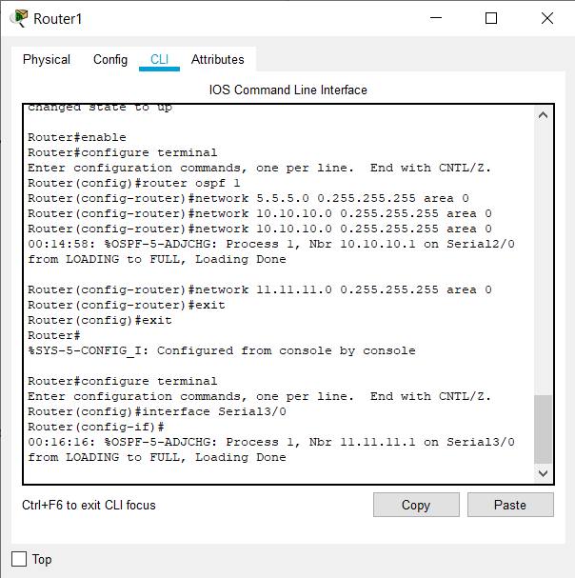

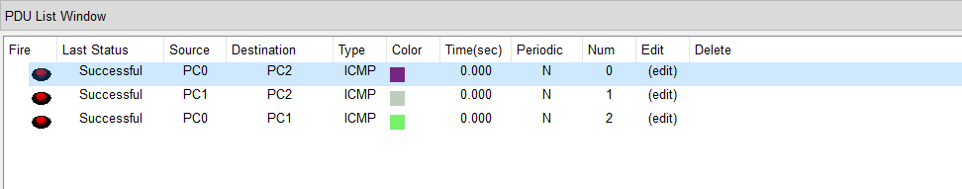

B.2 Observations and learning:
(Students are expected to comment on the output obtained with clear observations and learning for each task/ sub part assigned)

I have learnt to:
- Configure router using CLI commands.
- Implement OSPF protocols in Router to configure network
- Observe the path taken by packet in the configurations.

B.3 Conclusion:

configured a network using OSPF in cisco packet tracer. I also learned to configure router using cli commands.

B.4 Question of Curiosity

Q1. Solve the following using shortest path algorithm:

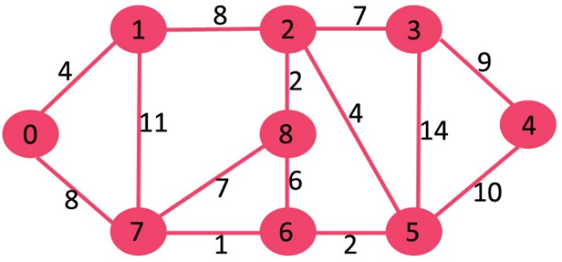

Source is considered as 0,
Vertex Distance Path
0 -> 1 4 0 1
0 -> 2 12 0 1 2
0 -> 3 19 0 1 2 3
0 -> 4 21 0 7 6 5 4
0 -> 5 11 0 7 6 5
0 -> 6 9 0 7 6
0 -> 7 8 0 7
0 -> 8 14 0 1 2 8

