PART A
(PART A: TO BE REFFERED BY STUDENTS) Experiment No.08

A.1—Aim:
To implement Classful addressing.

A.2--- Prerequisite:
Concepts of Classful Addressing

A.3--- Outcome:
After successful completion of this experiment, students will be able to:
Determine the class given an IP address

A.4--- Theory:

When the first precursor of the Internet was developed, some of the requirements of the internetwork, both present and future, were quickly realized. The Internet would start small but eventually grow. It would be shared by many organizations. Since it is necessary for all IP addresses on the internetwork to be unique, a system had to be created for dividing up the available addresses and share them amongst those organizations. A central authority had to be established for this purpose, and a scheme developed for it to effectively allocate addresses.
The developers of IP recognized that organizations come in different sizes and would therefore need varying numbers of IP addresses on the Internet. They devised a system whereby the IP address space would be divided into classes, each of which contained a portion of the total addresses and were dedicated to specific uses. Some would be devoted to large networks on the Internet, while others would be for smaller organizations, and still others reserved for special purposes.
Since this was the original system, it had no name; it was just “the” IP addressing system. Today, in reference to its use of classes, it is called the “classful” addressing scheme, to differentiate it from the newer classless scheme.
IP Address Classes
IP Address Class | Fraction of Total IP Address Space | Number Of Network ID Bits | Number Of Host ID Bits | Intended Use
Class A | 1/2 | 8 | 24 | Unicast addressing for very large organizations with hundreds of thousands or millions of hosts to connect to the Internet.
Class B | 1/4 | 16 | 16 | Unicast addressing for medium-to-large organizations with many hundreds to thousands of hosts to connect to the Internet.
Class C | 1/8 | 24 | 8 | Unicast addressing for smaller organizations with no more than about 250 hosts to connect to the Internet.
Class D | 1/16 | n/a | n/a | IP multicasting.
Class E | 1/16 | n/a | n/a | Reserved for “experimental use”.

Class | 1st Octet Decimal Range | 1st Octet High Order Bits | Network/Host ID (N=Network, H=Host) | Default Subnet Mask | Number of Networks | Hosts per Network (Usable Addresses)
A | 1 – 126* | 0 | N.H.H.H | 255.0.0.0 | 126 (2⁷ – 2) | 16,777,214 (2²⁴ – 2)
B | 128 – 191 | 10 | N.N.H.H | 255.255.0.0 | 16,382 (2¹⁴ – 2) | 65,534 (2¹⁶ – 2)
C | 192 – 223 | 110 | N.N.N.H | 255.255.255.0 | 2,097,150 (2²¹ – 2) | 254 (2⁸ – 2)
D | 224 – 239 | 1110 | Reserved for Multicasting
E | 240 – 254 | 1111 | Experimental; used for research

A.5 Task:

Write a program to-
- Convert the binary representation (IP address) provided by user to decimal equivalent
- Display the decimal equivalent
- Determine and display the class of the IP Address
- Determine and display the N/w portion of the IP Address
- Determine and display the host portion of the IP Address

Save the file and name it as CN_EXP8_your Roll no_Batch No.

(PART - B)

(TO BE COMPLETED BY STUDENTS)

(Students must submit the soft copy as per following segments within two hours of the practical.
The soft copy must be uploaded on the Blackboard or emailed to the concerned lab in charge faculties at the end of the practical in case there is no Black board access available)

Roll.No.: B0332 | Name: Naman Garg
Sem/Year: V/3rd | Batch: B2
Date of Experiment: 21/9/2020 | Date of Submission:
Grade --

B.1: Procedure of performed experiment
(students are expected to paste the code and the output screenshots)

Code

ip=input('Enter IP address in binary: ')
if len(ip)!=32:
print('Invalid. Length of the address should be 32.')
else:
ip_lst=[]
ip_dec_lst=[]
for i in range(0,32,8):
ip_lst.append(ip[i:i+8])
for i in ip_lst:
ip_dec_lst.append(int(i,2))
print(f'\nDecimal: {ip_dec_lst[0]}.{ip_dec_lst[1]}.{ip_dec_lst[2]}.{ip_dec_lst[3]}')
if ip_lst[0][0]=='0':
print('Class: A')
print(f'Network ID: {ip_dec_lst[0]}')
print(f'Host ID: {ip_dec_lst[1]}.{ip_dec_lst[2]}.{ip_dec_lst[3]}')
elif ip_lst[0][0:2]=='10':
print('Class: B')
print(f'Network ID: {ip_dec_lst[0]}.{ip_dec_lst[1]}')
print(f'Host ID: {ip_dec_lst[2]}.{ip_dec_lst[3]}')
elif ip_lst[0][0:3]=='110':
print('Class: C')
print(f'Network ID: {ip_dec_lst[0]}.{ip_dec_lst[1]}.{ip_dec_lst[2]}')
print(f'Host ID: {ip_dec_lst[3]}')
elif ip_lst[0][0:4]=='1110':
print('Class: D')
print('Network ID: N/A')
print('Host ID: N/A')
elif ip_lst[0][0:4]=='1111':
print('Class: E')
print('Network ID: N/A')
print('Host ID: N/A')

Output
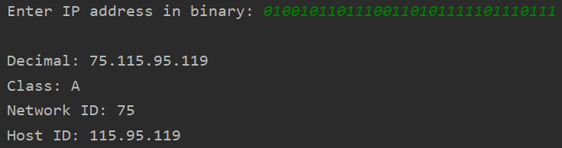

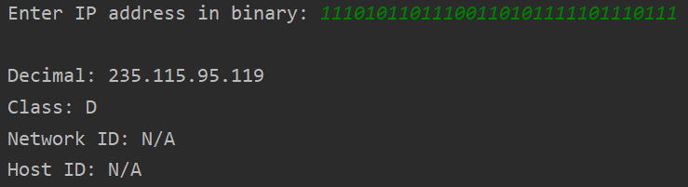

B.2: Observations and Learning’s:
(Students are expected to comment on the output obtained with clear observations and learning for each task/ sub part assigned)
I learnt about the different IP address classes and its intended uses. I implemented python code to perform the following tasks:
- Check validity of IP address
- Convert binary IP address to decimal and display it
- Determine and display the class of the IP Address
- Determine and display the Network ID
- Determine and display the Host ID

B.3: Conclusion:
(Students must write the conclusion as per the attainment of individual outcome listed above and learning/observation noted in section B.2)
Determined the class, network id and host id for given IP address.

B.4: Questions of Curiosity:
Compare classful and classless addressing.

Classful Routing:
Classful Routing does not import subnet mask. And in this also subnet mask is provided after the route update. In classful routing, subnet mask is same throughout, does not vary for all devices, we can see it in the given picture. In classful routing, VLMS (Variable Length Subnet Mask) is not supported and also CIDR (Classless Inter-Domain Routing).

Classless Routing:
Classless Routing imports subnet mask and in this, triggered updates are used. In classless routing, VLMS (Variable Length Subnet Mask) is supported and also CIDR (Classless Inter-Domain Routing). In classless routing, hello messages are used for checking status. In classless routing, subnet mask is not same throughout, it may vary for all devices, we can see it in the given picture.

