PART A
(PART A: TO BE REFFERED BY STUDENTS) Experiment No.09

A.1 Aim:
To configure a network using routing information protocol in cisco packet tracer.
A.2 Prerequisite:
Knowledge about Distance Vector Routing Algorithm

A.3 Outcome:
After successful completion of this experiment students will be able to:
- Understand the concept of routing algorithms.

A.4 Theory:
A router transmits its distance vector to each of its neighbors in a routing packet.
Each router receives and saves the most recently received distance vector from each of its neighbors.
- A router recalculates its distance vector when:
- It receives a distance vector from a neighbor containing different information than before.
- It discovers that a link to a neighbor has gone down.

The DV calculation is based on minimizing the cost to each destination

Dx(y) = Estimate of least cost from x to y

C(x, v) = Node x knows cost to each neighbor v

Dx = [Dx(y): y ∈ N] = Node x maintains distance vector

Node x also maintains its neighbors' distance vectors

– For each neighbor v, x maintains Dv = [Dv(y): y ∈ N]

From time-to-time, each node sends its own distance vector estimate to neighbors.
When a node x receives new DV estimate from any neighbor v, it saves v’s distance vector and it updates its own DV using B-F equation:

Dx(y) = min {C(x, v) + Dv(y)} for each node y ∈ N

A.5 Procedure/Algorithm:

A.5.1 TASK:

1. Develop a Topology shown in figure given below

2. Configure all Routers.

3. Implement RIP protocols in Router to configure network.
.
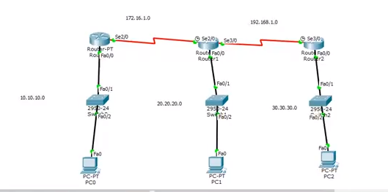

PART B
Roll No.: B032 | Name: Naman Garg
Class: B Tech CS (B div) | Batch: B2
Date of Experiment: 5/10/2020 | Date of Submission: 6/10/2020
Grade:

B.1 Answers of Task to be written by student:
(Paste your answers completed during the 2 hours of practical in the lab here)

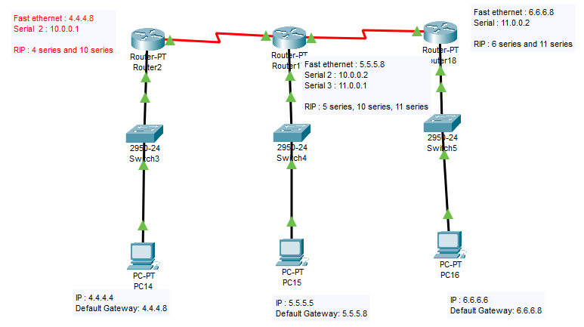

Router 1

Fast Ethernet

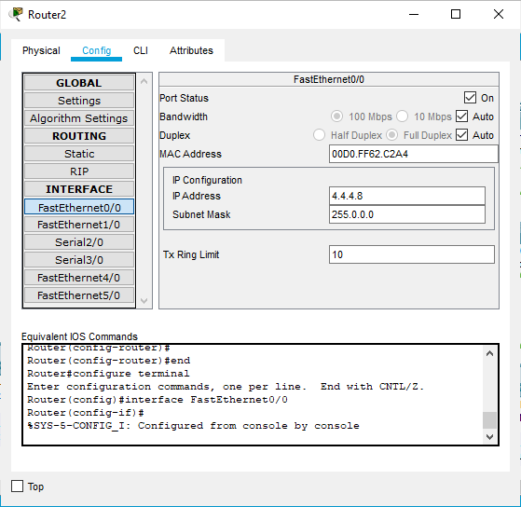

Serial 2

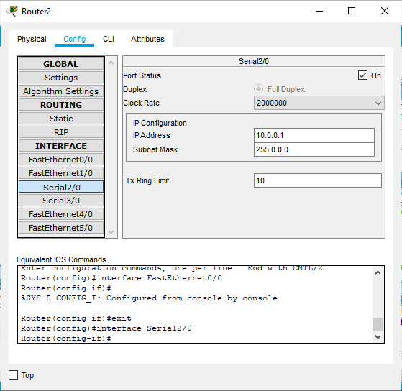

RIP

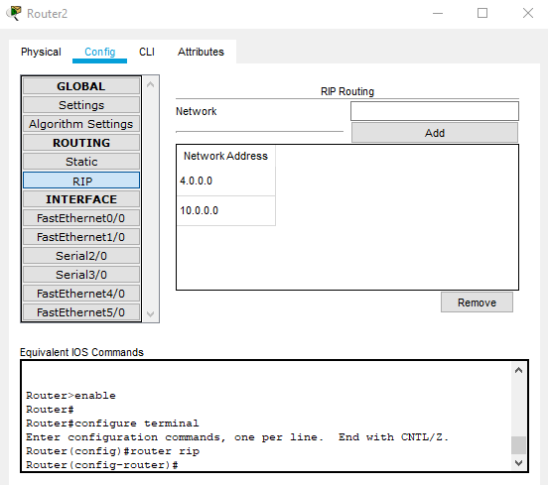

Router 2

Fast Ethernet

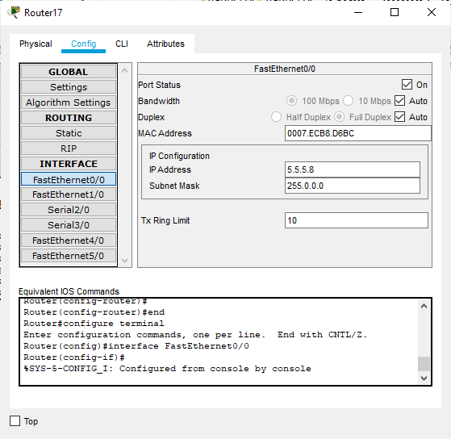

Serial 2

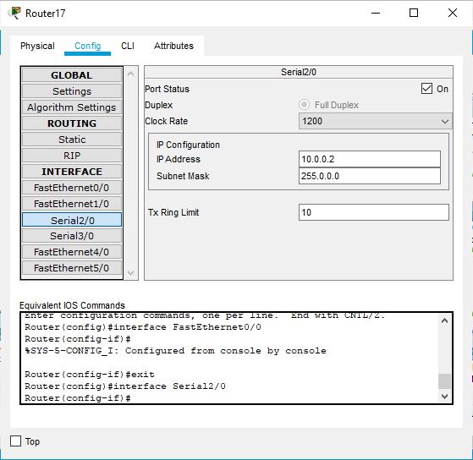

Serial 3

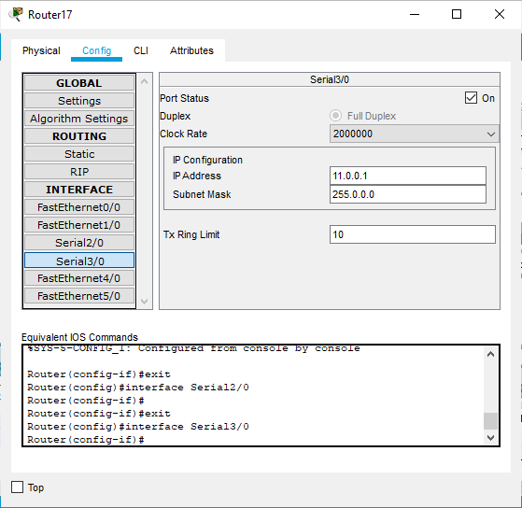

RIP

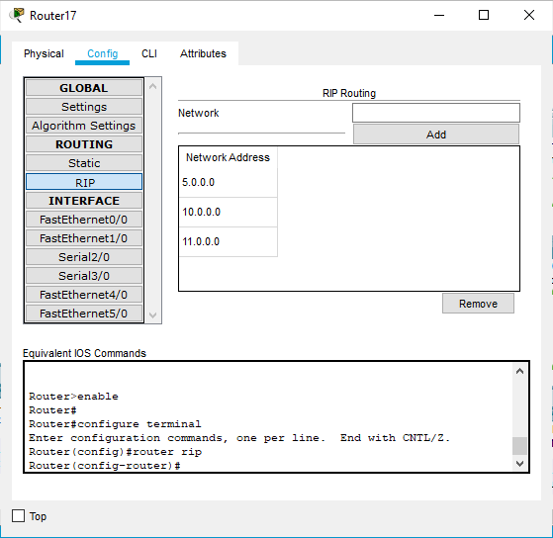

Router 3: Similar to Router 1 except the Serial Port 2 is of 11 series

Ping from PC 1 to PC 3

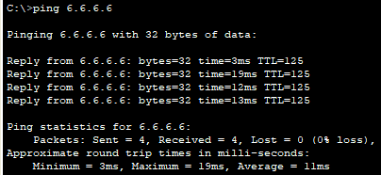

B.2 Observations and learning:
(Students are expected to comment on the output obtained with clear observations and learning for each task/ sub part assigned)
I successfully learnt and implemented distance vector routing in cisco packet tracer. Since in distance vector routing, the routers share their information only with their neighbours and with each pass the routing table gets updated as more and more information comes in, here in the RIP, the first router has only the serial port series belonging to the 10 series i.e. the one connecting it to its neighbour 2nd router. The second router has 2 neighbours so it has 2 serial port series i.e. 10 and 11 series both connecting to its neighbours. While the third router has only 1 serial port series i.e. the 11 series connecting to the 2nd router. I successfully implemented the RIP tables for all 3 routers and later verified the connectivity.

B.3 Conclusion:
(Students must write the conclusion as per the attainment of individual outcome listed above and learning/observation noted in section B.2)
Understood the concept of routing algorithms.

B.4 Question of Curiosity
(To be answered by student based on the practical performed and learning/observations)
Q1. Explain Count to infinity problem.
Counting to infinity problem:

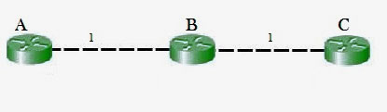

So, in this example, the Bellman-Ford algorithm will converge for each router, they will have entries for each other. B will know that it can get to C at a cost of 1, and A will know that it can get to C via B at a cost of 2.

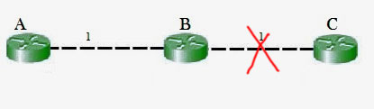

If the link between B and C is disconnected, then B will know that it can no longer get to C via that link and will remove it from its table. Before it can send any updates it’s possible that it will receive an update from A which will be advertising that it can get to C at a cost of 2. B can get to A at a cost of 1, so it will update a route to C via A at a cost of 3. A will then receive updates from B later and update its cost to 4. They will then go on feeding each other bad information toward infinity which is called as Count to Infinity problem.

Solution for Count to Infinity problem:
Route Poisoning:
When a route fails, distance vector protocols spread the bad news about a route failure by poisoning the route. Route poisoning refers to the practice of advertising a route, but with a special metric value called Infinity. Routers consider routes advertised with an infinite metric to have failed. Each distance vector routing protocol uses the concept of an actual metric value that represents infinity. RIP defines infinity as 16. The main disadvantage of poison reverse is that it can significantly increase the size of routing announcements in certain fairly common network topologies.
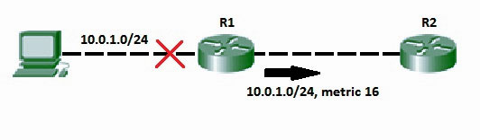

Q2. Give the advantages and disadvantages of RIP.
RIP is a vector routing protocol that uses the hop count as the routing unit for finding the most suitable path between the source and the destination. Now, let us understand the meaning of the terms used in the definition of RIP.

Advantages of RIP:
- It is easy to configure.
- That it does not require an update every time the topology of network changes.
- Guaranteed to support almost all routers.

Disadvantages of RIP:
- It is only based on hop count. So, if there is a better route available with better bandwidth then it will not select that route.

