PART A
(PART A: TO BE REFFERED BY STUDENTS) Experiment No.05

A.1—Aim:
To simulate following scenarios using Packet tracer software:
- LAN connection with two router configurations
- Configure WEP security between wireless end devices like smartphone, printer, laptop, tablet etc and a wireless access point

A.2--- Prerequisite:
Basic understanding of internetworking devices

A.3--- Outcome:
After successful completion of this experiment, students will be able to:
- Familiarity of the packet tracer software
- Identify the right devices and cables for building networks
- Know the difference in wired and wireless configurations

A.4--- Tasks:

Perform the following simulation activities:
- Simulate a simple LAN connection with two router configurations
- create two LANs
- connect one router to each LAN
- connect the two routers
- make logical connections among the devices
- verify the connectivity of the network
- See the simulation of sent and received packet using simple and complex PDU
- Simulate a simple wireless network

- Configure a network having one end device, one switch and one router
- Configure a wireless access point and connect few wireless end devices to it
- Connect wireless access point to the router
- make logical connections among the devices
- verify the connectivity of the network
- See the simulation of sent and received packet using simple and complex PDU

Save the file and name it as CN_EXP5_your Roll no_Batch No.

(PART - B)

(TO BE COMPLETED BY STUDENTS)

Roll.No. : | Name:
Sem/Year : | Batch:
Date of Experiment : | Date of Submission:
Grade --

B.1: Procedure of performed experiment
TASK 1:
Network topology and PDU tracing successful therefore we know that the network works
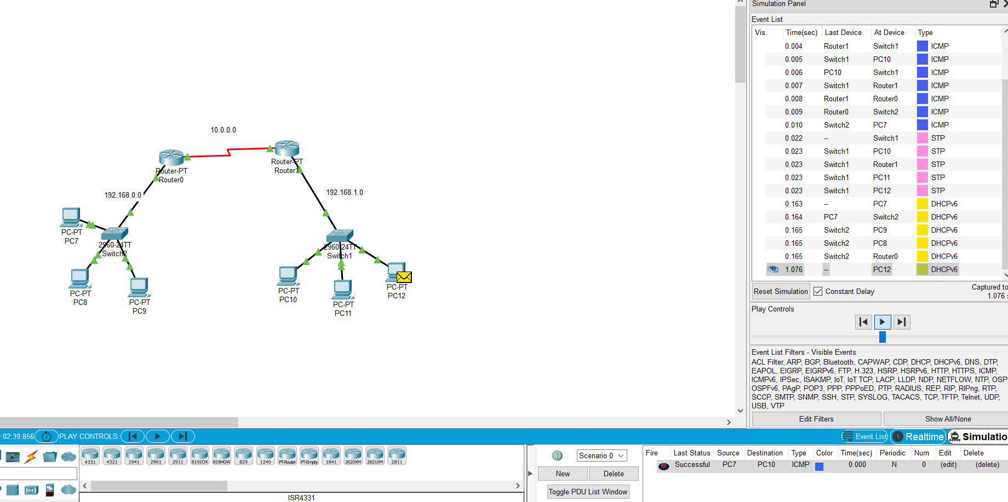

Steps taken to conncet 2 routers::
Give the 2 routers a new serial address and conncet them::
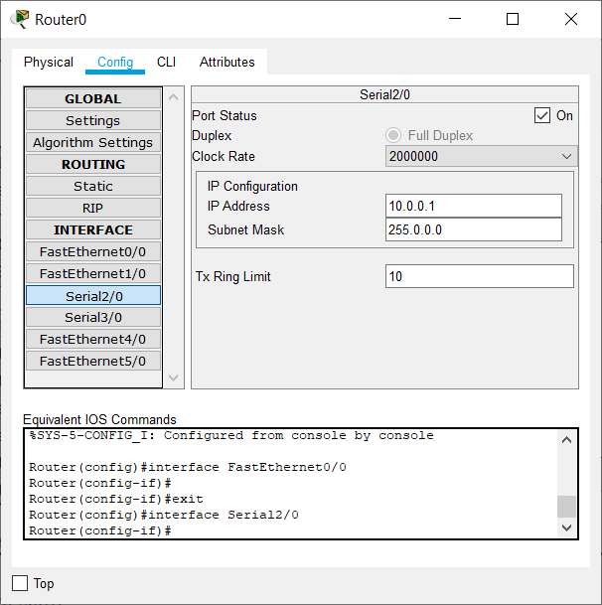
To the RIP routing, add 2 network addresses i.e. the serial for the 2 routers and the lan connected to the router
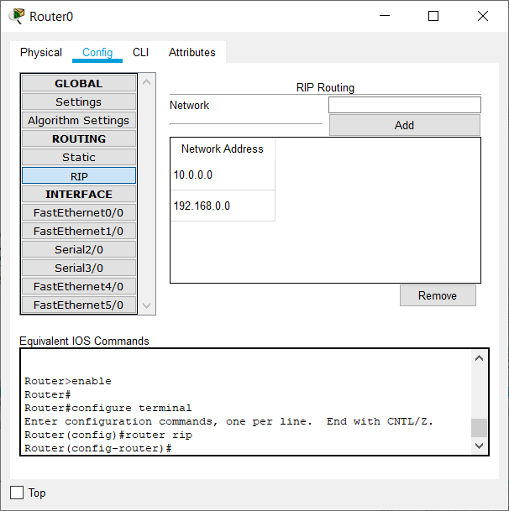

Task2 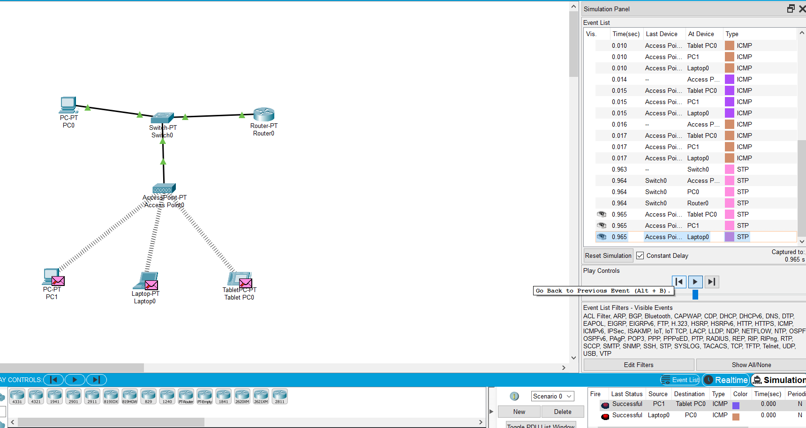
As we can see the 2 pdu tesed are successful therefore the network is working

First we must add a wireless module to the devices that don’t have it by default Like
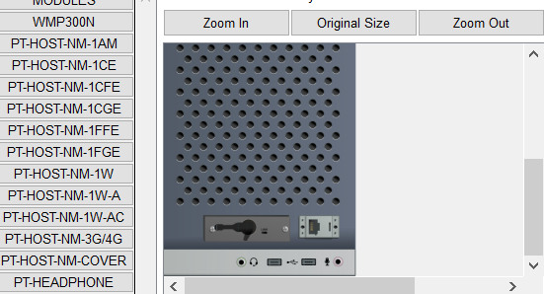

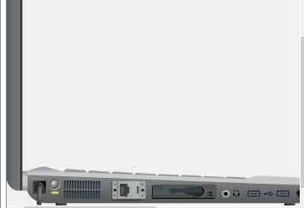
Then, we must add wep key and ssid to our access point

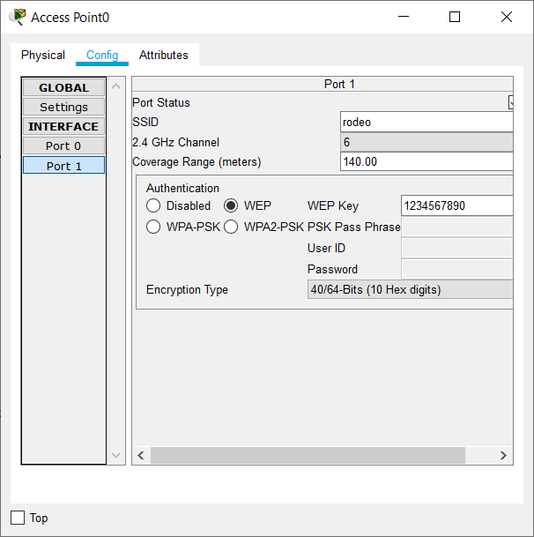
Connect eveything shown as in the topology and set gateway to the ip address of the router and set their ip addesses according to the series
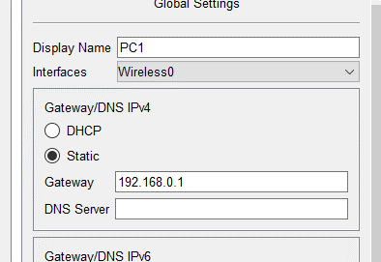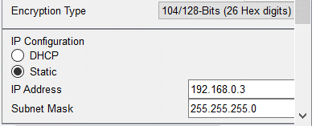
Connect to the accesspoint using the wireless section of the desktop for pc and laptop
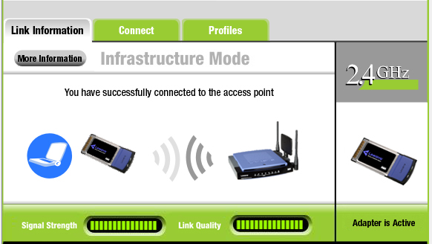

For tablet use the config tab
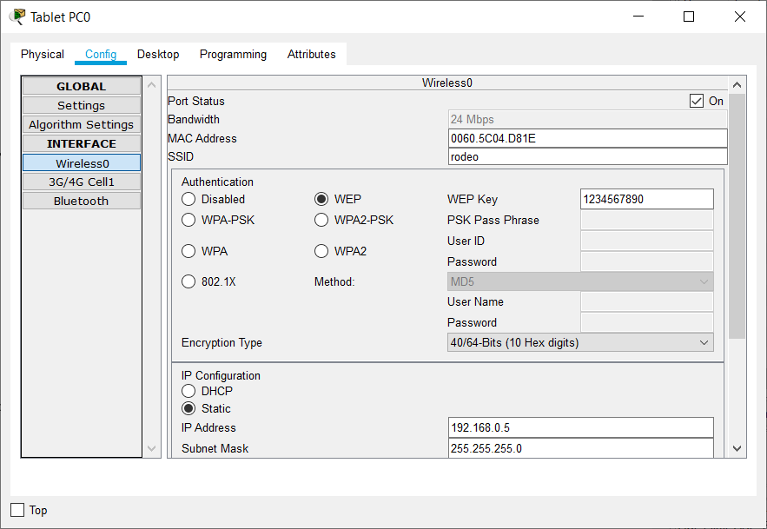

B.2: Observations and Learning’s:
I observed that its very important to have gateways configured if we do not have dynamic allocation
Serial port is used to connect 2 lans

B.3: Conclusion:
learnt to do
- LAN connection with two router configurations
- Configure WEP security between wireless end devices like smartphone, printer, laptop, tablet etc and a wireless access point

B.4: Questions of Curiosity:

- For the simple and complex PDU added in the simulation mode, view the contents of the PDU and analyse the information (add screenshots)
- Use event list to see PDU information
- View the information of the first ICMP PDU packet from the PC.
- Observe the information in the OSI Model tab
- click the Outbound PDU Details tab. Notice that this tab shows details of the protocol headers
- Explore the contents of other PDUs listed in the Simulation Panel and review the information that is available in each.
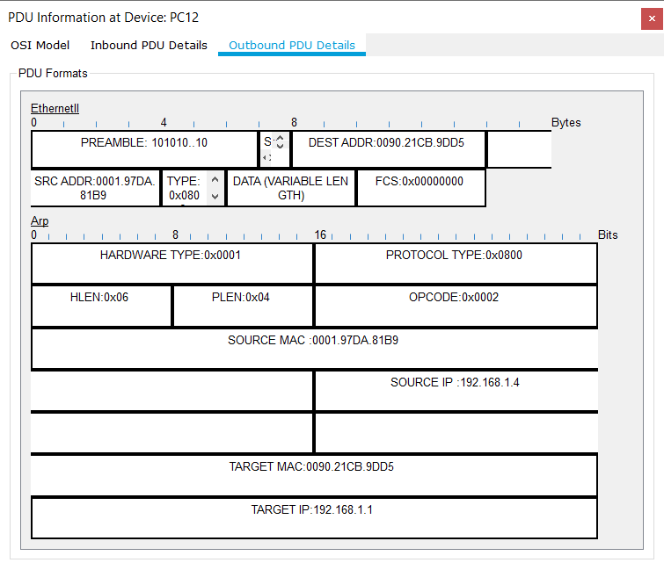
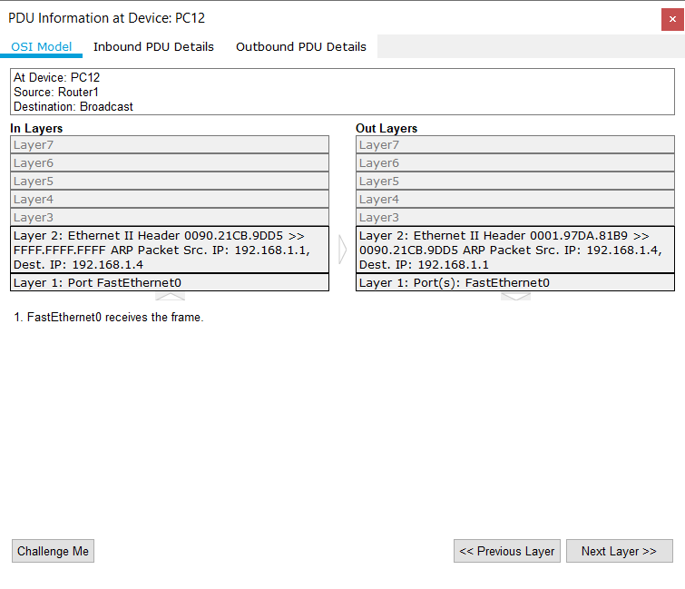
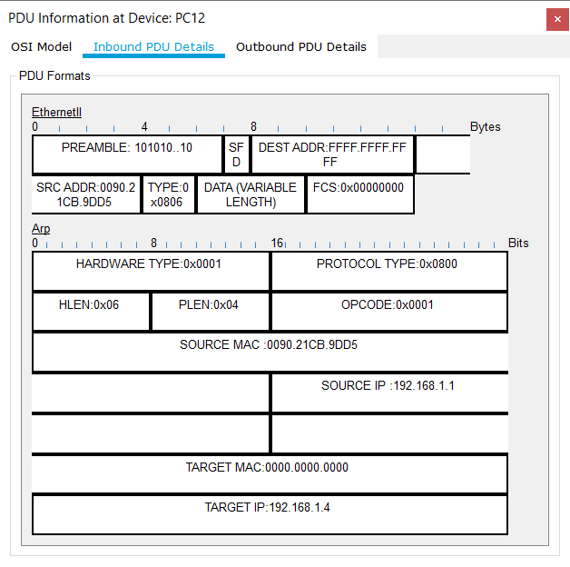
Complex pdu::
1sticmp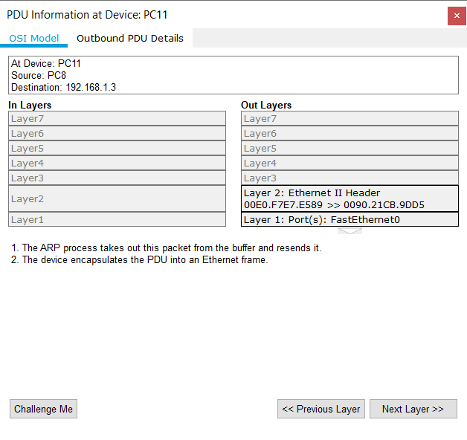
2nd icmp
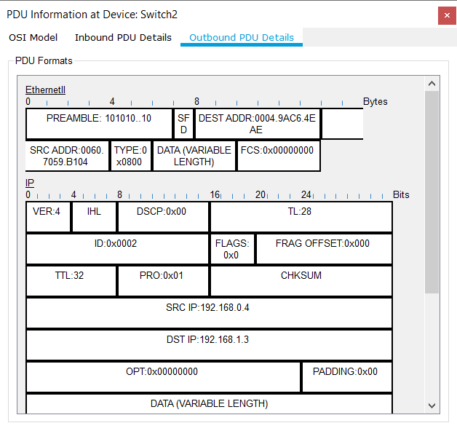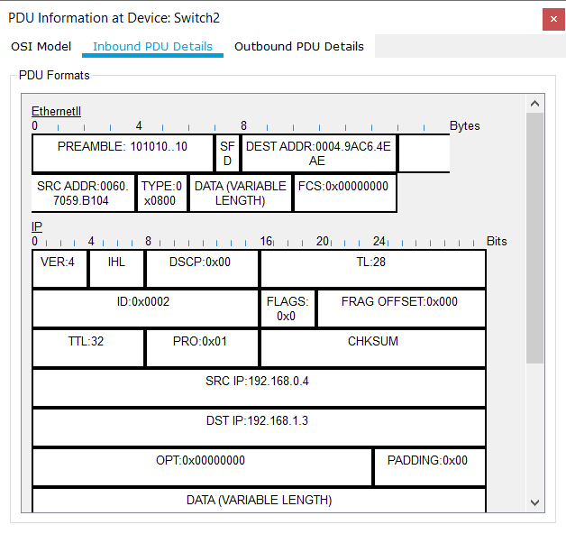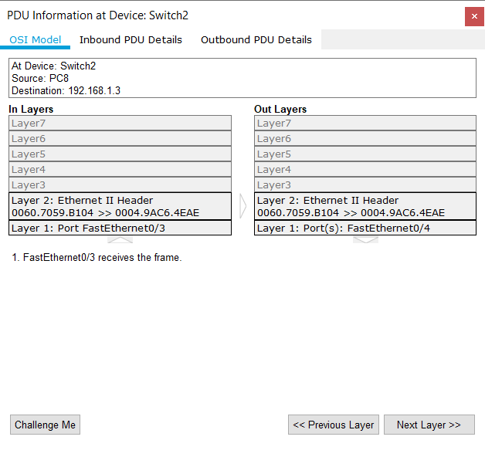
This just shows us were the packet has travelled to before current and where it is travelling to next::
The outbound pdu gives us the format of ethernet 2 and ip of the pdu.
Ip is decribed in 32 bits
Ethernet 2 in 16 bits

