PART A
(PART A: TO BE REFFERED BY STUDENTS) Experiment No.07

A.1—Aim:
To implement a program to generate Hamming code

A.2--- Prerequisite:
Fundamentals of error detection and correction

A.3--- Outcome:
After successful completion of this experiment, students will be able to:
Demonstrate Hamming code for error detection and correction

A.4--- Theory:

Hamming code is a set of error-correction codes that can be used to detect and correct the errors that can occur when the data is moved or stored from the sender to the receiver. It is technique developed by R.W. Hamming for error correction.
Redundant bits are extra binary bits that are generated and added to the information-carrying bits of data transfer to ensure that no bits were lost during the data transfer.
The number of redundant bits can be calculated using the following formula:
2^r ≥ m + r + 1
where, r = redundant bit, m = data bit
Suppose the number of data bits is 7, then the number of redundant bits can be calculated using:
= 2^4 ≥ 7 + 4 + 1
Thus, the number of redundant bits= 4

Parity bits –
A parity bit is a bit appended to a data of binary bits to ensure that the total number of 1’s in the data is even or odd. Parity bits are used for error detection. There are two types of parity bits:

- Even parity bit:
In the case of even parity, for a given set of bits, the number of 1’s are counted. If that count is odd, the parity bit value is set to 1, making the total count of occurrences of 1’s an even number. If the total number of 1’s in a given set of bits is already even, the parity bit’s value is 0.
- Odd Parity bit –
In the case of odd parity, for a given set of bits, the number of 1’s are counted. If that count is even, the parity bit value is set to 1, making the total count of occurrences of 1’s an odd number. If the total number of 1’s in a given set of bits is already odd, the parity bit’s value is 0.

General Algorithm of Hamming code –
The Hamming Code is simply the use of extra parity bits to allow the identification of an error.

- Write the bit positions starting from 1 in binary form (1, 10, 11, 100, etc).
- All the bit positions that are a power of 2 are marked as parity bits (1, 2, 4, 8, etc).
- All the other bit positions are marked as data bits.
- Each data bit is included in a unique set of parity bits, as determined its bit position in binary form.
a. Parity bit 1 covers all the bits positions whose binary representation includes a 1 in the least significant position (1, 3, 5, 7, 9, 11, etc).
b. Parity bit 2 covers all the bits positions whose binary representation includes a 1 in the second position from the least significant bit (2, 3, 6, 7, 10, 11, etc).
c. Parity bit 4 covers all the bits positions whose binary representation includes a 1 in the third position from the least significant bit (4–7, 12–15, 20–23, etc).
d. Parity bit 8 covers all the bits positions whose binary representation includes a 1 in the fourth position from the least significant bit bits (8–15, 24–31, 40–47, etc).
e. In general, each parity bit covers all bits where the bitwise AND of the parity position and the bit position is non-zero.
- Since we check for even parity set a parity bit to 1 if the total number of ones in the positions it checks is odd.
- Set a parity bit to 0 if the total number of ones in the positions it checks is even.

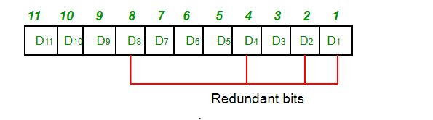
Suppose the data to be transmitted is 1011001, the bits will be placed as follows:
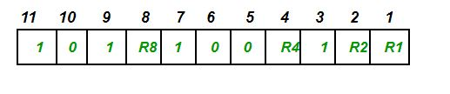

Determining the parity bits:

- R1 bit is calculated using parity check at all the bits positions whose binary representation includes a 1 in the least significant position.
R1: bits 1, 3, 5, 7, 9, 11
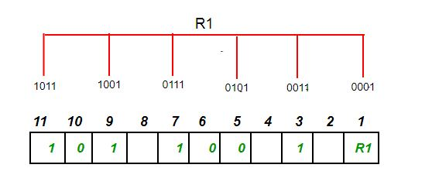
To find the redundant bit R1, we check for even parity. Since the total number of 1’s in all the bit positions corresponding to R1 is an even number the value of R1 (parity bit’s value) = 0
R2 bit is calculated using parity check at all the bits positions whose binary representation includes a 1 in the second position from the least significant bit.
R2: bits 2,3,6,7,10,11
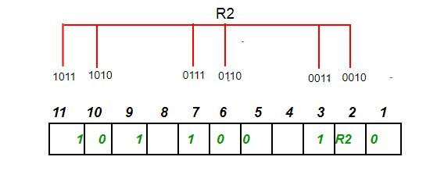
To find the redundant bit R2, we check for even parity. Since the total number of 1’s in all the bit positions corresponding to R2 is odd the value of R2(parity bit’s value)=1

R4 bit is calculated using parity check at all the bits positions whose binary representation includes a 1 in the third position from the least significant bit.
R4: bits 4, 5, 6, 7
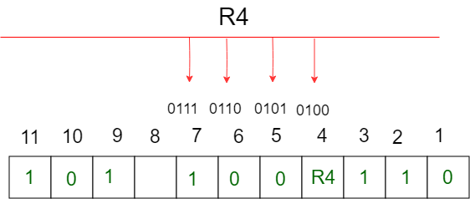

To find the redundant bit R4, we check for even parity. Since the total number of 1’s in all the bit positions corresponding to R4 is odd the value of R4(parity bit’s value) = 1

R8 bit is calculated using parity check at all the bits positions whose binary representation includes a 1 in the fourth position from the least significant bit.
R8: bit 8,9,10,11
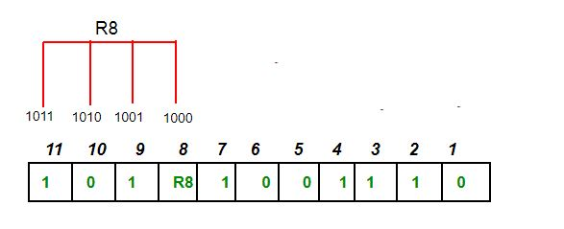

To find the redundant bit R8, we check for even parity. Since the total number of 1’s in all the bit positions corresponding to R8 is an even number the value of R8(parity bit’s value)=0.
Thus, the data transferred is:
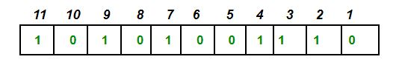

Save the file and name it as CN_EXP7_your Roll no_Batch No.

(PART - B)

(TO BE COMPLETED BY STUDENTS)

(Students must submit the soft copy as per following segments within two hours of the practical.
The soft copy must be uploaded on the Blackboard or emailed to the concerned lab in charge faculties at the end of the practical in case there is no Black board access available)

Roll.No. : B032 | Name: Naman Garg
Sem/Year : 5 | Batch: B2
Date of Experiment : 7-9-2020 | Date of Submission: 7-9-2020
Grade --

B.1: Procedure of performed experiment
# NAMAN GARG
# B032
# HAMMING CODE PYTHON IMPLEMENTATION

def calculate_RedundantBits(m):

for i in range(m):
if(2**i >= m + i + 1):
print("there are ", i, " redundant bits required in ",
m, " bit long binary number")
return i

def add_RedundantBits(data, r):

j = 0
k = 1
m = len(data)
resultis = ''

for i in range(1, m + r+1):
if(i == 2**j):
resultis += '0'
j += 1
else:
resultis = resultis + data[-1 * k]
k += 1
print("after adding redundant bits, we have ", resultis[::-1])
return resultis[::-1]

def calculate_ParityBits(arr, r):
n = len(arr)

for i in range(r):
val = 0
for j in range(1, n + 1):

if(j & (2**i) == (2**i)):
val = val ^ int(arr[-1 * j])
arr = arr[:n-(2**i)] + str(val) + arr[n-(2**i)+1:]
print("after adding parity bits, we have ", arr)
return arr

data = input("enter data\n")

r = calculate_RedundantBits(len(data))

arr = add_RedundantBits(data, r)

arr = calculate_ParityBits(arr, r)

print("Data to be transferred is " + arr)

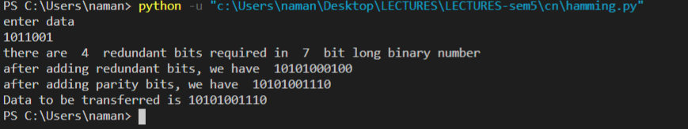

B.2: Observations and Learning’s:
We rote functions for the different steps in calculating hamming code.
counting the number of redundant bits
getting the position of the redundant bits
Calculating the parity bits
Error detection

B.3: Conclusion:
Demonstrated Hamming code for error detection and correction.

B.4: Questions of Curiosity:
1. Give the general frame work of error detection and correction technique

Error codes are Implemented either at Data link layer or Transport Layer of OSI Model

Due to data loss in physical transmission of messages, we use these codes

Some popular techniques for error detection are:
1. Simple Parity check
2. Two-dimensional Parity check
3. Checksum
4. Cyclic redundancy check

1. Simple Parity check
Blocks of data from the source are subjected to a check bit or parity bit generator form, where a parity of:
- 1 is added to the block if it contains odd number of 1’s, and
- 0 is added if it contains even number of 1’s
This scheme makes the total number of 1’s even, that is why it is called even parity checking.
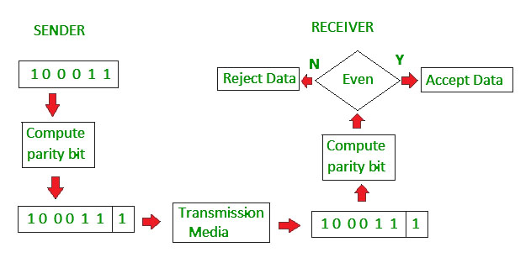
2. Two-dimensional Parity check
Parity check bits are calculated for each row, which is equivalent to a simple parity check bit. Parity check bits are also calculated for all columns, then both are sent along with the data. At the receiving end these are compared with the parity bits calculated on the received data.
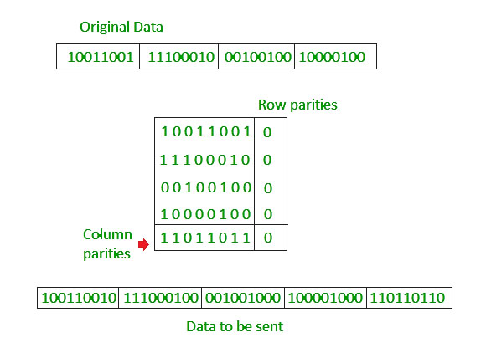

3. Checksum
- In checksum error detection scheme, the data is divided into k segments each of m bits.
- In the sender’s end the segments are added using 1’s complement arithmetic to get the sum. The sum is complemented to get the checksum.
- The checksum segment is sent along with the data segments.
- At the receiver’s end, all received segments are added using 1’s complement arithmetic to get the sum. The sum is complemented.
- If the result is zero, the received data is accepted; otherwise discarded.
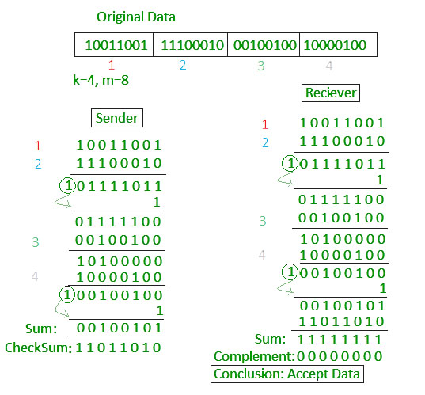

4. Cyclic redundancy check (CRC)
- Unlike checksum scheme, which is based on addition, CRC is based on binary division.
- In CRC, a sequence of redundant bits, called cyclic redundancy check bits, are appended to the end of data unit so that the resulting data unit becomes exactly divisible by a second, predetermined binary number.
- At the destination, the incoming data unit is divided by the same number. If at this step there is no remainder, the data unit is assumed to be correct and is therefore accepted.
- A remainder indicates that the data unit has been damaged in transit and therefore must be rejected.
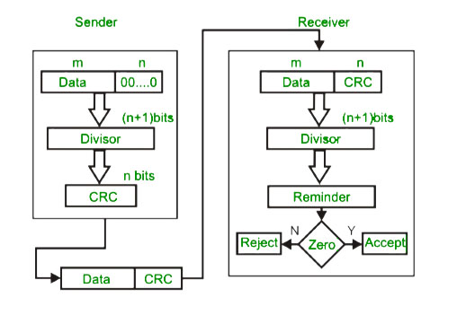

Example:
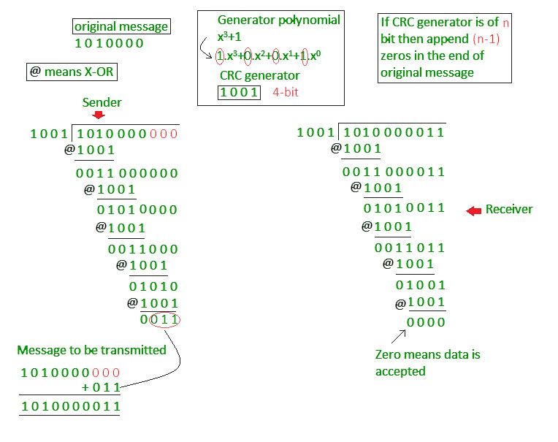

Error Correction
In the digital world, error correction can be done in two ways:

Backward Error Correction - When the receiver detects an error in the data received, it requests back the sender to retransmit the data unit.

Forward Error Correction - When the receiver detects some error in the data received, it executes error-correcting code, which helps it to auto-recover and to correct some kinds of errors.

The first one, Backward Error Correction, is simple and can only be efficiently used where retransmitting is not expensive. For example, fiber optics. But in case of wireless transmission retransmitting may cost too much. In the latter case, Forward Error Correction is used.

To correct the error in data frame, the receiver must know exactly which bit in the frame is corrupted. To locate the bit in error, redundant bits are used as parity bits for error detection.For example, we take ASCII words (7 bits data), then there could be 8 kind of information we need: first seven bits to tell us which bit is error and one more bit to tell that there is no error.

For m data bits, r redundant bits are used. r bits can provide 2r combinations of information. In m+r bit codeword, there is possibility that the r bits themselves may get corrupted. So the number of r bits used must inform about m+r bit locations plus no-error information, i.e. m+r+1.

- Write the steps involved in error detection and correction using hamming code
Step 1 − Calculation of the number of redundant bits.
If the message contains m𝑚number of data bits, r𝑟number of redundant bits are added to it so that m𝑟 is able to indicate at least (m + r+ 1) different states. Here, (m + r) indicates location of an error in each of (𝑚 + 𝑟) bit positions and one additional state indicates no error. Since, r𝑟 bits can indicate 2r𝑟 states, 2r𝑟 must be at least equal to (m + r + 1). Thus the following equation should hold 2r ≥ m+r+1

Step 2 − Positioning the redundant bits.
The r redundant bits placed at bit positions of powers of 2, i.e. 1, 2, 4, 8, 16 etc. They are referred in the rest of this text as r1 (at position 1), r2 (at position 2), r3 (at position 4), r4 (at position 8) and so on.

Step 3 − Calculating the values of each redundant bit.
The redundant bits are parity bits. A parity bit is an extra bit that makes the number of 1s either even or odd. The two types of parity are −
- Even Parity − Here the total number of bits in the message is made even.
- Odd Parity − Here the total number of bits in the message is made odd.

Each redundant bit, ri, is calculated as the parity, generally even parity, based upon its bit position. It covers all bit positions whose binary representation includes a 1 in the ith position except the position of ri. Thus −
- r1 is the parity bit for all data bits in positions whose binary representation includes a 1 in the least significant position excluding 1 (3, 5, 7, 9, 11 and so on)
- r2 is the parity bit for all data bits in positions whose binary representation includes a 1 in the position 2 from right except 2 (3, 6, 7, 10, 11 and so on)
- r3 is the parity bit for all data bits in positions whose binary representation includes a 1 in the position 3 from right except 4 (5-7, 12-15, 20-23 and so on)

Decoding a message in Hamming Code
Once the receiver gets an incoming message, it performs recalculations to detect errors and correct them. The steps for recalculation are −
- Step 1 − Calculation of the number of redundant bits.
- Step 2 − Positioning the redundant bits.
- Step 3 − Parity checking.
- Step 4 − Error detection and correction

Step 1 − Calculation of the number of redundant bits
Using the same formula as in encoding, the number of redundant bits are ascertained.
2r ≥ m + r + 1 where m is the number of data bits and r is the number of redundant bits.

Step 2 − Positioning the redundant bits
The r redundant bits placed at bit positions of powers of 2, i.e. 1, 2, 4, 8, 16 etc.

Step 3 − Parity checking
Parity bits are calculated based upon the data bits and the redundant bits using the same rule as during generation of c1, c2, c3, c4 etc. Thus
c1 = parity (1, 3, 5, 7, 9, 11 and so on)
c2 = parity (2, 3, 6, 7, 10, 11 and so on)
c3 = parity (4-7, 12-15, 20-23 and so on)

Step 4 − Error detection and correction
The decimal equivalent of the parity bits binary values is calculated. If it is 0, there is no error. Otherwise, the decimal value gives the bit position which has error. For example, if c1c2c3c4 = 1001, it implies that the data bit at position 9, decimal equivalent of 1001, has error. The bit is flipped to get the correct message.

