PART A
(PART A: TO BE REFFERED BY STUDENTS) Experiment No.03

A.1—Aim:
To simulate simple peer-to-peer network, LAN and inter- LAN connections using Packet Tracer software

A.2--- Prerequisite:
Basic understanding of internetworking devices

A.3--- Outcome:
After successful completion of this experiment, students will be able to:
- Familiarity of the packet tracer software
- Identify the right devices and cables for building networks

A.4--- Tasks:

- Download and Install CISCO Packet Tracer Software: visit - netacad.com
- List down important components of the software
- List down the various features of the software
- Perform the following simulation activities:
- Simulate a peer-to-peer network
- Simulate a simple LAN connection
- Simulate a simple inter-LAN connection

Save the file and name it as CN_EXP4_your Roll no_Batch No.

(PART - B)

(TO BE COMPLETED BY STUDENTS)

(Students must submit the soft copy as per following segments within two hours of the practical.
The soft copy must be uploaded on the Blackboard or emailed to the concerned lab in charge faculties at the end of the practical in case there is no Black board access available)

Roll.No. : B032 | Name: Naman Garg
Sem/Year : 5 | Batch: B2
Date of Experiment : | Date of Submission:
Grade --

B.1: Procedure of performed experiment
A1.)

The components of the Packet Tracer interface are as follows:

Area 1: Menu bar – This is a common menu found in all software applications; it is used to open, save, print, change preferences, and so on.

Area 2: Main toolbar – This bar provides shortcut icons to menu options that are commonly accessed, such as open, save, zoom, undo, and redo, and on the right-hand side is an icon for entering network information for the current network.

Area 3: Logical/Physical workspace tabs – These tabs allow you to toggle between the Logical and Physical work areas.

Area 4: Workspace – This is the area where topologies are created and simulations are displayed.

Area 5: Common tools bar – This toolbar provides controls for manipulating topologies, such as select, move layout, place note, delete, inspect, resize shape, and add simple/complex PDU.

Area 6: Realtime/Simulation tabs – These tabs are used to toggle between the real and simulation modes. Buttons are also provided to control the time, and to capture the packets.

Area 7: Network component box – This component contains all of the network and end devices available with Packet Tracer, and is further divided into two areas:

Area 7a: Device-type selection box – This area contains device categories

Area 7b: Device-specific selection box – When a device category is selected, this selection box displays the different device models within that category

Area 8: User-created packet box – Users can create highly-customized packets to test their topology from this area, and the results are displayed as a list.

A2.)

- Packet Tracer Workspaces: Cisco Packet Tracer has two workspaces—logical and physical. The logical workspace allows users to build logical network topologies by placing, connecting, and clustering virtual network devices. The physical workspace provides a graphical physical dimension of the logical network, giving a sense of scale and placement in how network devices such as routers, switches, and hosts would look in a real environment.

- Packet Tracer Modes: Cisco Packet Tracer provides two operating modes to visualize the behaviour of a network—real-time mode and simulation mode. In real-time mode the network behaves as real devices do, with immediate real-time response for all network activities. In simulation mode the user can see and control time intervals, the inner workings of data transfer, and the propagation of data across a network.

- Modular Devices: Graphical representations visually simulate hardware and offer the ability to insert interface cards into modular routers and switches, which then become part of the simulation.

- Multiuser Functionality: Cisco Packet Tracer is a network-capable application, with a multiuser peer-to-peer mode that allows collaborative construction of virtual networks over a real network.

- Tutorials: Packet Tracer includes several basic step-by-step tutorials that familiarize users with the product features and explain how to engage in simulations.
- Help: A help feature is available to familiarize users with the Cisco Packet Tracer interface, functions, and features. The help area includes important notes and tips and provides annotated screenshots to aid understanding.

- Activity Wizard: The Activity Wizard allows users to author their own learning activities by setting up scenarios using instructional text, and creating initial and final network topologies and predefined packets. The Activity Wizard also includes grading and feedback capabilities.

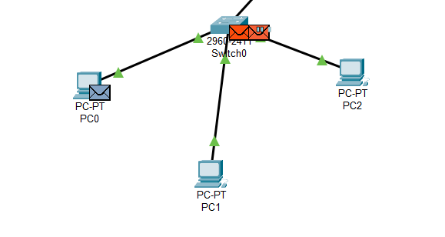

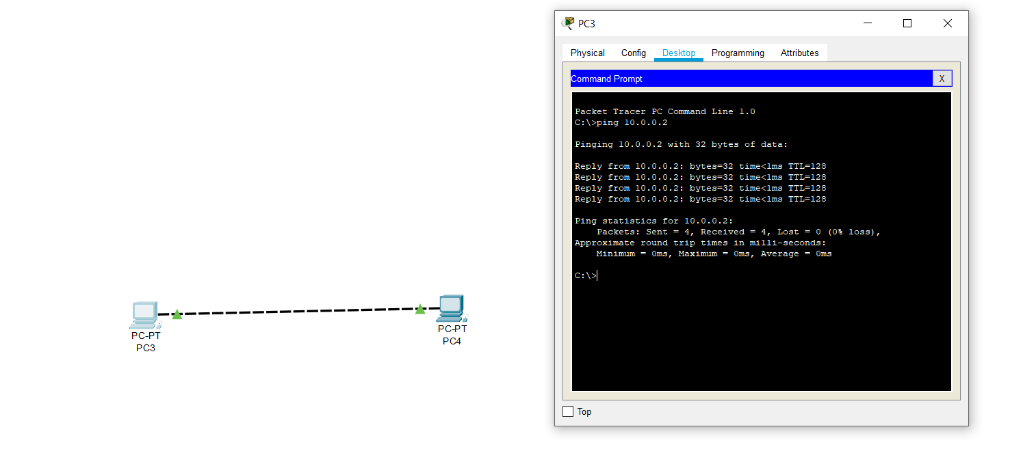
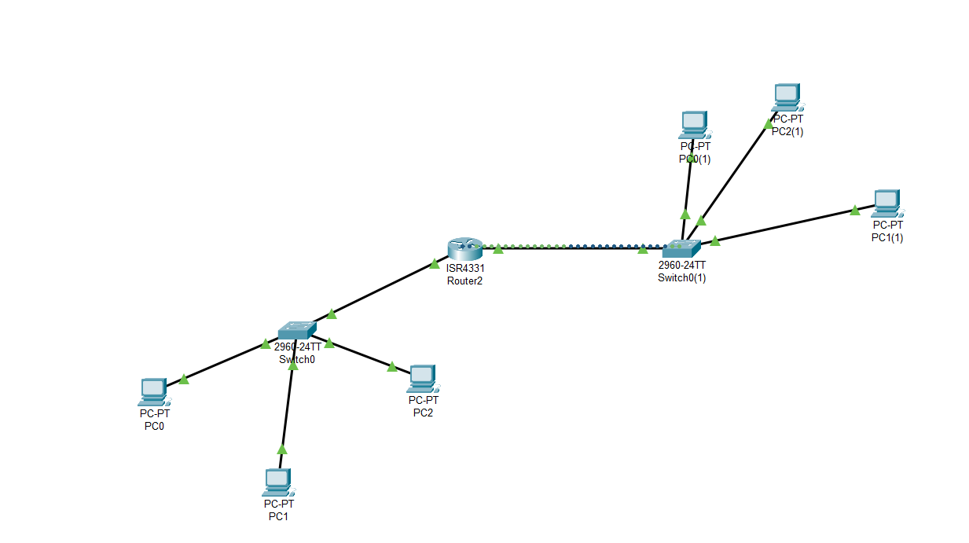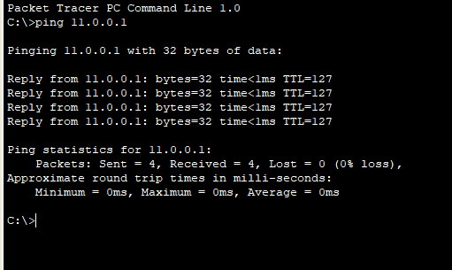

B.2: Observations and Learning’s:
Cisco packet tracer is a useful simulation tool.
Its useful for planning networks for internal lan networks and maybe even small scale port forwarded server farms.

B.3: Conclusion:
(Students must write the conclusion as per the attainment of individual outcome listed above and learning/observation noted in section B.2)

B.4: Questions of Curiosity:

Q1. Difference between physical address and logical address? How to find physical address?
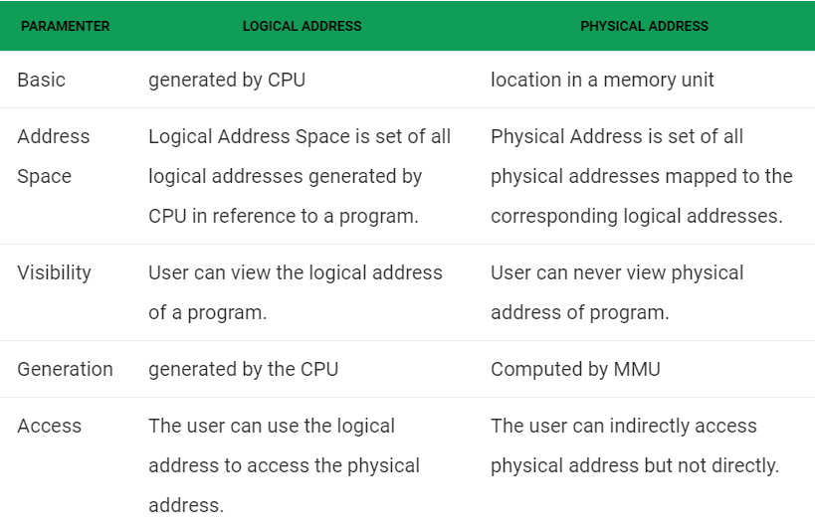
- Click Windows Start or press the Windows key.
- In the search box, type cmd.
- Press the Enter key.
A command window displays.
- Type ipconfig /all.
- Press Enter.
A physical address displays for each adapter. The physical address is your device’s MAC address.

Q2. What is meant by interface on devices? List down the steps involved in configuring a router.
In computing, an interface is a shared boundary across which two or more separate components of a computer system exchange information. The exchange can be between software, computer hardware, peripheral devices, humans, and combinations of these.
A device interface is a symbolic link to a Plug and Play (PnP) device that an application can use to access the device.

Steps to configure a router:
Step 1: Decide where to place the router
The best place for a wireless business router is in an open area of the workplace, as you'll benefit from even coverage. However, sometimes it's not easy to find a space out in the open because you must connect the router to a broadband gateway from your ISP (Internet service provider), which is usually attached to a cable near an outside wall.

Step 2: Connect to the Internet
Attach the router to a cable - or choose a mesh router
To solve the "long-distance" problem when connecting a router, you can use a CAT5e or CAT6 cable to connect the router to the ISP gateway's Ethernet port. Another option is to run Ethernet cables through the walls of your office to the chosen central location for the router.

Yet another option is to install a mesh network with a router. A mesh network allows you to place multiple Wi-Fi transmitters across your home or office, all on one network. Unlike extenders, which can be used with any wireless router, mesh networks require a router with this capability built-in.

No matter which option you choose, you'll use a basic Ethernet cable, plugged into the router's wide-area network (WAN) or Internet port. The Internet port is typically set apart from other ports by a different color.

Check the router's LED lights
Your router's LED lights tell you if you've successfully made an active Internet connection. If you don't see lights confirming such a connection, make sure you've plugged the cable into the correct port.

Test the connection with a device
Confirm that your router has a working connection by plugging a laptop computer into one of the device ports on the back of the router. If all goes well, you should be able to begin a wired connection, just as you did when confirming an active Internet connection.

Step 3: Configure the wireless router gateway
In some cases, ISPs offer customers gateways with built-in routers. In most cases, these combined devices are not built for business environments, nor do they have extra ports, security, and other options that allow you to add services and expand networks as the business grows.

If you have a gateway with an integrated router, you'll have to configure the gateway to disable the router and pass the WAN IP address—the unique Internet protocol address that the Internet provider assigns to your account—and all network traﬃc through to your new router.

If you don’t take this step, you may run into conflicts that prevent devices from working properly. You may need to contact your ISP for help with this step.

Step 4: Connect gateway to router
First, turn off the gateway. If there is already an Ethernet cable plugged into the gateway's local-area network (LAN) port, unplug the cable and plug it into your router's WAN port. Turn the gateway back on and wait a few minutes for it to boot up. Plug in the router's power supply and turn it on, again waiting a few minutes.

