PART A
(PART A: TO BE REFFERED BY STUDENTS) Experiment No.06

A.1—Aim:
To simulate Siding window protocol using socket programming in Java

A.2--- Prerequisite:
Basic understanding of socket and sliding window protocol

A.3--- Outcome:
After successful completion of this experiment, students will be able to:
- Write network-based programs using socket programming
- Demonstrate the functioning of sliding window protocol

A.4--- Theory:
What is socket programming?
Socket programming is a way of connecting two nodes on a network to communicate with each other. One socket (node) listens on a particular port at an IP, while other socket reaches out to the other to form a connection. Server forms the listener socket while client reaches out to the server.
State diagram for server and client model
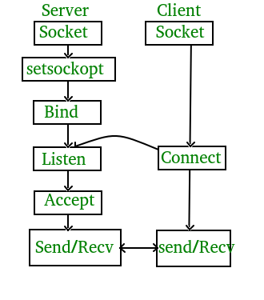
Sliding Window Protocol:
- Sliding window protocol is a flow control protocol.
- It allows the sender to send multiple frames before needing the acknowledgements.
- Sender slides its window on receiving the acknowledgements for the sent frames,
window that slides from left to right over time.
- At a given moment, only those frames in the window can be transmitted.
- This allows the sender to send more frames.
- It is called so because it involves sliding of sender’s window.
- Maximum number of frames that sender can send without acknowledgement = Sender
window size
They are thus called Sliding Window Protocols

When window size is large relative to the round-trip time, we can take full advantages of the bandwidth.

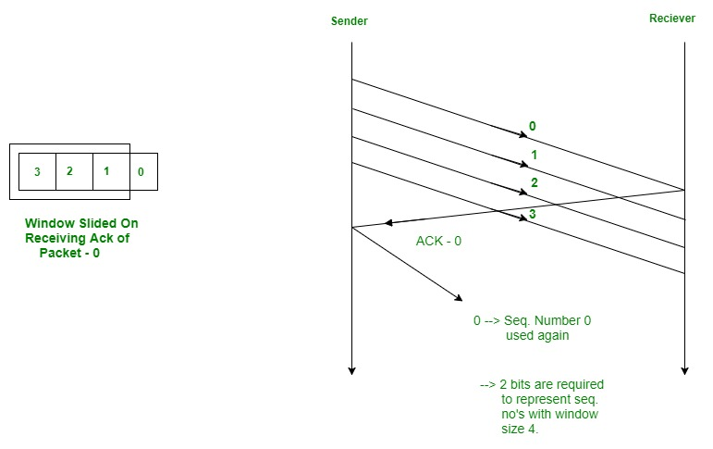

A.5--- Task/Procedure:

- Write two programs one acting as Sender and the other as Receiver
- Use socket programming to enable sender process communicate with the receiver process
- Simulate the sliding window protocol (sender side)
- Take input from the user, the window size
- Display the data frames in the current window
- Send the data frames having sequence nos., to the receiver
- At the receiver side, display the received data frames
- Let the receiver send acknowledgement of received data frame
- Display the data frames in the slided window
- Continue this process

Save the file and name it as CN_EXP6_your Roll no_Batch No.
(PART - B)

(TO BE COMPLETED BY STUDENTS)

(Students must submit the soft copy as per following segments within two hours of the practical.
The soft copy must be uploaded on the Blackboard or emailed to the concerned lab in charge faculties at the end of the practical in case there is no Black board access available)

Roll No.: B032 | Name: Naman Garg
Sem/Year:5 | Batch: B2
Date of Experiment: 24/8/2020 | Date of Submission: 31/8/2020
Grade --

B.1: Procedure of performed experiment
(students are expected to write the reason of the choice of topology and device)

Server
import java.net.*;
import java.io.*;

public class sender
{
private Socket socket = null;
private ServerSocket server = null;
private DataInputStream in = null;
private DataOutputStream out = null;

public sender(int port)
{
try
{
server = new ServerSocket(port);
System.out.println("Server started");

System.out.println("Waiting for a client ...");

socket = server.accept();
System.out.println("Client accepted");

in = new DataInputStream(new BufferedInputStream(socket.getInputStream()));

out = new DataOutputStream(socket.getOutputStream());

String line = "";
String size = "";
String ack = "Ack";
String window = "";
int n, w, w2, k, j;

while (true)
{
try
{
size = in.readUTF();
if(size.equals("Over"))
break;
n=Integer.parseInt(size);
window = in.readUTF();
w=Integer.parseInt(window);
w2=w;
n=n-w;
k=1;
j=1;
while(w>0)
{
try
{
line = in.readUTF();
System.out.println("Received data item "+k+": "+line);
}
catch(IOException i)
{
System.out.println(i);
}
w--;
k++;
}
while(n>0)
{
try
{
out.writeUTF(ack);
System.out.println(ack+" "+j+" sent");
line = in.readUTF();
System.out.println("Received data item "+k+": "+line);
}
catch(IOException i)
{
System.out.println(i);
}
n--;
k++;
j++;
}
while(w2>0)
{
out.writeUTF(ack);
System.out.println(ack+" "+j+" sent");
w2--;
j++;
}
}
catch(IOException i)
{
System.out.println(i);
}
}
System.out.println("Closing connection");
socket.close();
in.close();
out.close();
}
catch(IOException i)
{
System.out.println(i);
}
}

public static void main(String args[])
{
sender sender = new sender(4000);
}
}

Client
import java.net.*;
import java.io.*;

public class receiver
{
private Socket socket = null;
private BufferedReader input = null;
private DataOutputStream out = null;
private DataInputStream in = null;

public receiver(String address, int port)
{
try
{
socket = new Socket(address, port);
System.out.println("Connection established");

input = new BufferedReader(new InputStreamReader(System.in));

out = new DataOutputStream(socket.getOutputStream());

in = new DataInputStream(new BufferedInputStream(socket.getInputStream()));
}
catch(UnknownHostException u)
{
System.out.println(u);
}
catch(IOException i)
{
System.out.println(i);
}

String line = "";
String size = "";
String ack = "";
String win = "";
int n, w, w2, k, j;

while (true)
{
try
{
System.out.println("Enter the No. of data items. Enter 't' to terminate.");
size = input.readLine();
out.writeUTF(size);
if(size.equals("t"))
break;
n=Integer.parseInt(size);
System.out.println("window size:");
win = input.readLine();
out.writeUTF(win);
w=Integer.parseInt(win);
System.out.println("Enter "+n+" data elements:");
w2=w;
n=n-w;
k=1;
j=1;
while(w>0)
{
try
{
System.out.print("no."+k+"-> ");
line = input.readLine();
out.writeUTF(line);
}
catch(IOException i)
{
System.out.println(i);
}
w--;
k++;
}
while(n>0)
{
try
{
ack = in.readUTF();
System.out.println(ack+" "+j+" received");
System.out.print("item "+k+": ");
line = input.readLine();
out.writeUTF(line);
}
catch(IOException i)
{
System.out.println(i);
}
n--;
k++;
j++;
}
while(w2>0)
{
ack = in.readUTF();
System.out.println(ack+" "+j+" received");
w2--;
j++;
}
}
catch(IOException i)
{
System.out.println(i);
}
}

try
{
input.close();
out.close();
socket.close();
in.close();
}
catch(IOException i)
{
System.out.println(i);
}
}

public static void main(String args[])
{
receiver receiver = new receiver("localhost", 4000);
}
}

Output
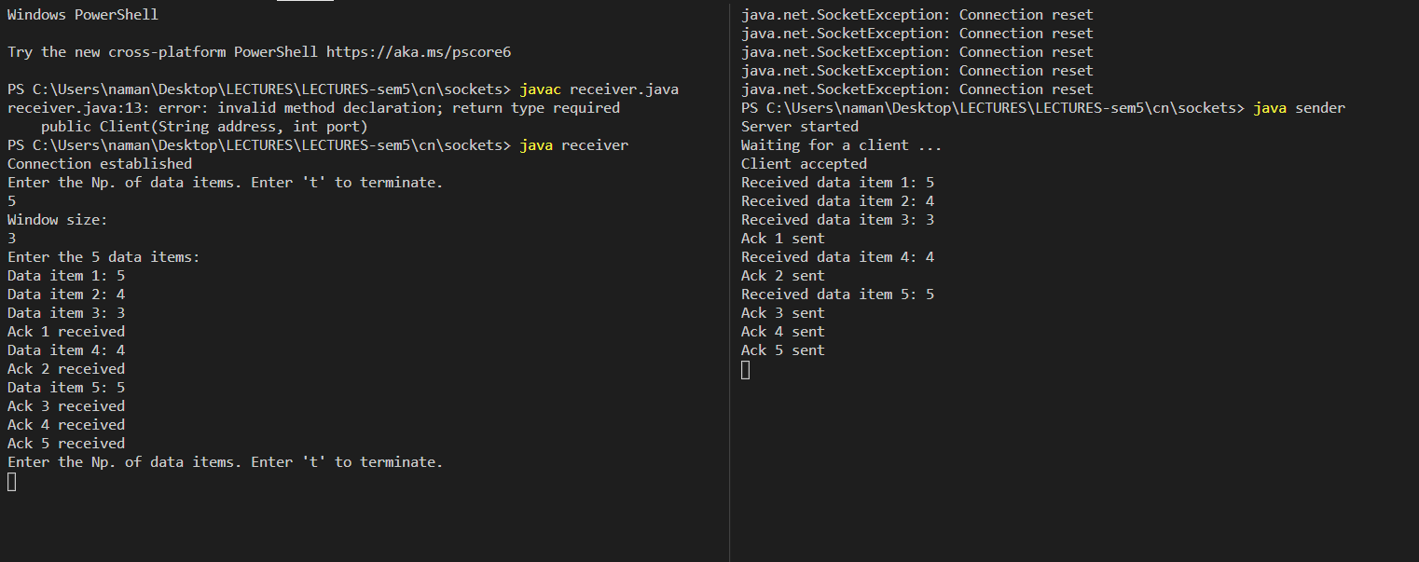

B.2: Observations and Learning’s:
- Sliding window protocol is a flow control protocol.
- It allows the sender to send multiple frames before needing the acknowledgements.
- Sender slides its window on receiving the acknowledgements for the sent frames.
- This allows the sender to send more frames.
- It is called so because it involves sliding of sender’s window.
- Maximum number of frames that sender can send without acknowledgement = Sender window size

B.3: Conclusion:
- Wrote A network-based program using java socket programming.
- Demonstrated the functioning of sliding window protocol.

B.4: Questions of Curiosity:
- Explain in brief the two variations of Sliding window protocol?
The Sliding Window protocols can be categorized in 2 ways:

Go – Back – N ARQ
provides for sending multiple frames before receiving the acknowledgment for the first frame. It uses the concept of sliding window, and so is also called sliding window protocol. The frames are sequentially numbered and a finite number of frames are sent. If the acknowledgment of a frame is not received within the time period, all frames starting from that frame are retransmitted.
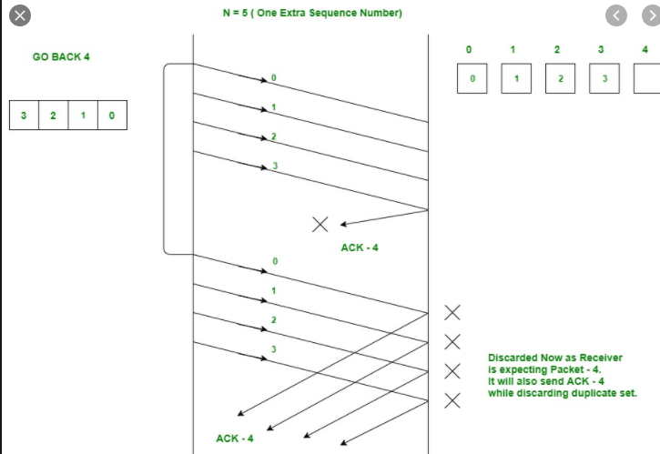

Selective Repeat ARQ
This protocol also provides for sending multiple frames before receiving the acknowledgment for the first frame. However, here only the erroneous or lost frames are retransmitted, while the good frames are received and buffered.
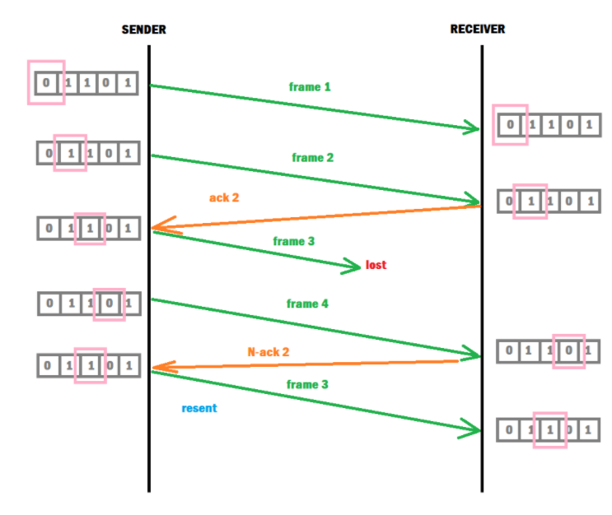

Go-Back-N ARQ | Selective Repeat ARQ
If a frame is corrupted or lost in it,all subsequent frames have to be sent again. | In this, only the frame is sent again, which is corrupted or lost.
If it has a high error rate,it wastes a lot of bandwidth. | There is a loss of low bandwidth.
It is less complex. | It is more complex because it has to do sorting and searching as well. And it also requires more storage.
It does not require sorting. | In this, sorting is done to get the frames in the correct order.
It does not require searching. | The search operation is performed in it.
It is used more. | It is used less because it is more complex.

- What decides the optimal size of the window in Sliding window protocol?
Optimal window size = 1 + 2a
Where a = Propagation delay/ Transmission dela.

