PART A
(PART A: TO BE REFFERED BY STUDENTS) Experiment No.03

A.1—Aim:
Study of Packet sniffing using Wireshark network protocol analyzer tool

A.2--- Prerequisite:
Basic understanding of OSI layers and protocols

A.3--- Outcome:
After successful completion of this experiment, students will be able to:
- Understand the structure of the packet sniffer
- Familiarity of the Wireshark tool
- Analyze the details of the captured packets

A.4--- Tasks:

- Download and install Wireshark from https://www.wireshark.org/

- Explore the tool and cover the following points:
- What is Wireshark?
- Uses of Wireshark
- What is Packet Sniffer and Give its structure with brief explanation
- Details of Wireshark Interface
- Color coding features
- Filtering options/analysis (add screenshots to support the different filtering options that you will try)

Save the file and name it as CN_EXP3_your Roll no_Batch No.

(PART - B)

(TO BE COMPLETED BY STUDENTS)

(Students must submit the soft copy as per following segments within two hours of the practical.
The soft copy must be uploaded on the Blackboard or emailed to the concerned lab in charge faculties at the end of the practical in case there is no Black board access available)

Roll.No. : B032 | Name: Naman Garg
Sem/Year : 5 | Batch: B2
Date of Experiment : | Date of Submission:
Grade --

A1.)
Wireshark is a network packet analyser. A network packet analyser presents captured packet data in as much detail as possible. You could think of a network packet analyser as a measuring device for examining what is happening inside a network cable. In the past, such tools were either very expensive, proprietary, or both. However, with the advent of Wireshark, that has changed. Wireshark is available for free, is open source, and is one of the best packet analysers available today. Common problems that Wireshark can help troubleshoot include dropped packets, latency issues, and malicious activity on your network.
It lets you put your network traffic under a microscope and provides tools to filter and drill down into that traffic, zooming in on the root cause of the problem. Administrators use it to identify faulty network appliances that are dropping packets, latency issues caused by machines routing traffic halfway around the world, and data exfiltration or even hacking attempts against your organization. Wireshark intercepts traffic and converts that binary traffic into human-readable format. This makes it easy to identify what traffic is crossing your network, how much of it, how frequently, how much latency there is between certain hops, and so forth.

A2.)
Uses of Wireshark are:
- Network administrators use it to troubleshoot network problems
- Network security engineers use it to examine security problems
- QA engineers use it to verify network applications
- Developers use it to debug protocol implementations
- People use it to learn network protocol internals

A3.)

Packet sniffing is the practice of gathering, collecting, and logging some or all packets that pass through a computer network, regardless of how the packet is addressed. In this way, every packet, or a defined subset of packets, may be gathered for further analysis. You as a network administrator can use the collected data for a wide variety of purposes like monitoring bandwidth and traffic.
A packet sniffer, sometimes called a packet analyser, is composed of two main parts. First, a network adapter that connects the sniffer to the existing network. Second, software that provides a way to log, see, or analyse the data collected by the device.

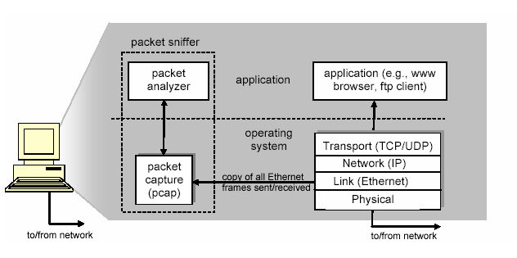

A4.)

The available interfaces on Wireshark are shown below and the network activity of each of them can be seen. Wireshark isn’t limited to just network interfaces —on most systems you can also capture USB, Bluetooth, and other types of packets.

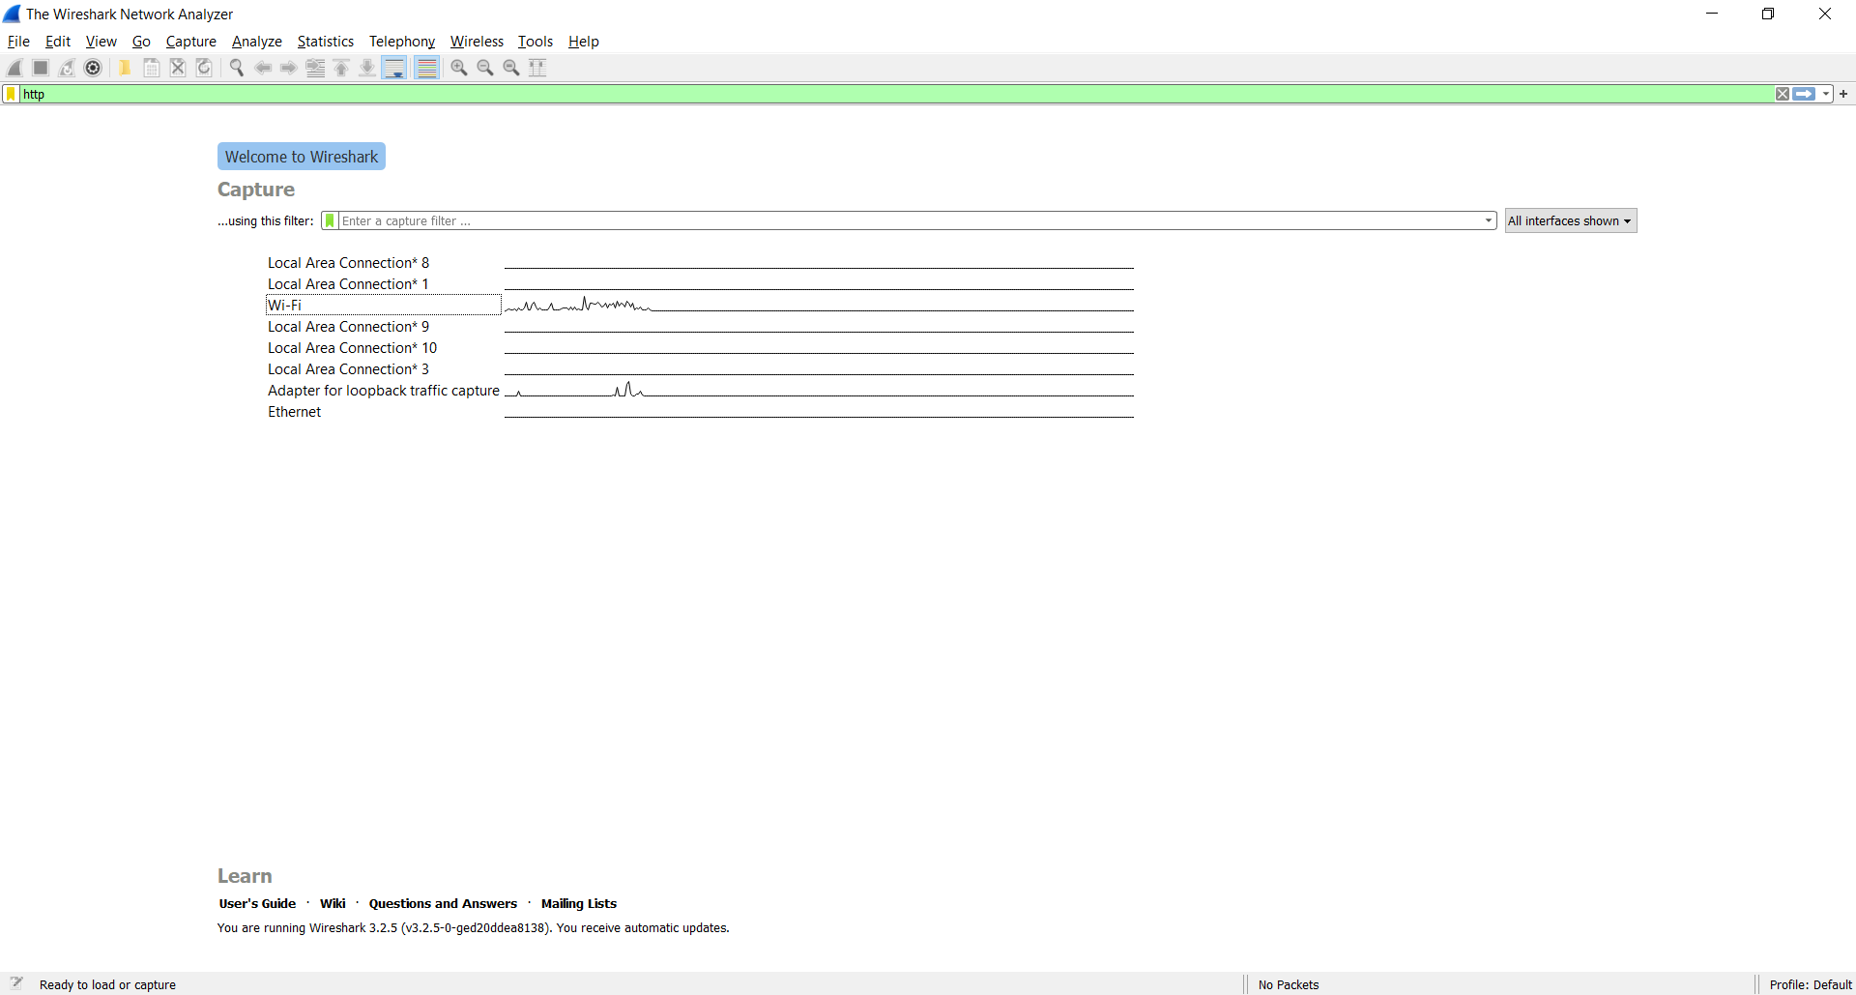

When you open Wireshark without starting a capture or opening a capture file it will display the “Welcome Screen,” which lists any recently opened capture files and available capture interfaces. Network activity for each interface will be shown in a sparkline next to the interface name. It is possible to select more than one interface and capture from them simultaneously.
Before capturing packets, configure Wireshark to interface with an 802.11 client device; otherwise, you’ll get an alert “No capture interface selected!” when starting a packet capture. To select an interface, click the Capture menu, choose Options, and select the appropriate interface. For example, here I have chosen Wi-Fi as the interface. Wireshark will continue capturing and displaying packets until the capture buffer fills up. The buffer is 1 Mbytes by default. This size is generally good enough, but to change it click the Capture menu, choose Options, and adjust the Buffer size value accordingly. When you’re done capturing packets, click the Capture menu and choose Stop.
The top panel of the window identifies each packet’s source and destination nodes, protocol implemented, and information about each packet. You can select a specific packet to display more details.
The middle panel displays information about this packet, and you can choose a specific field of the packet (such as Duration field shown in the figure), and the contents of that field are displayed in hex and ASCII format in the bottom panel. As a result, you’re able to analyze the flow and view each field (including data field payloads) of all packets.

A5.)

The packets are highlighted in green, blue, and black. Wireshark uses colours to help you identify the types of traffic briefly. By default, green is TCP traffic, dark blue is DNS traffic, light blue is UDP traffic, and black identifies TCP packets with problems.

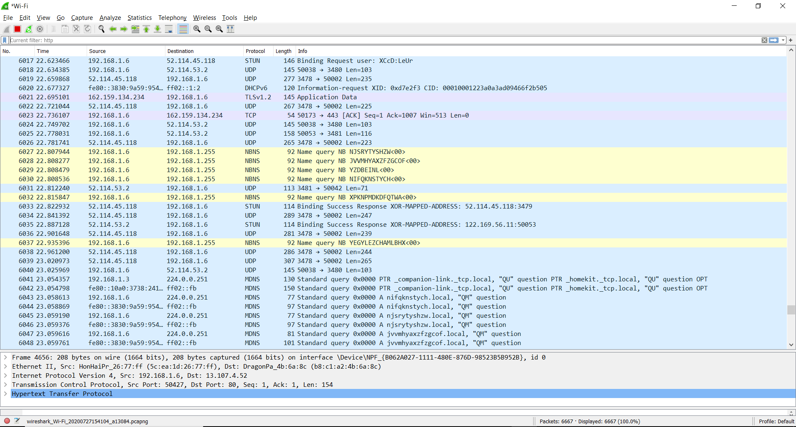

Temporary rules can be added by selecting a packet and pressing the Ctrl key together with one of the number keys. This will create a colouring rule based on the currently selected conversation. It will try to create a conversation filter based on TCP first, then UDP, then IP and at last Ethernet. Temporary filters can also be created by selecting the Colorize with Filter → Colour X menu items when right-clicking in the packet detail pane.

A6.)

The filtering analysis can be seen below as I’ve filtered all packets bases on HTTP protocol so only the relevant packets are shown.
Display filters are used for filtering which packets are displayed and are discussed below.

Display filters allow you to concentrate on the packets you are interested in while hiding the currently uninteresting ones. They allow you to only display packets based on:
• Protocol
• The presence of a field
• The values of fields
• A comparison between fields
To only display packets containing a particular protocol, type the protocol name in the display filter toolbar of the Wireshark window and press enter to apply the filter

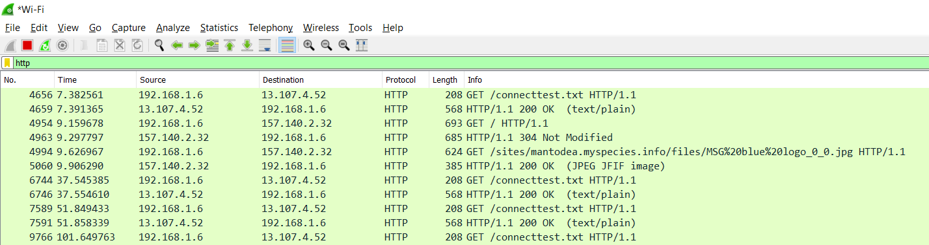

A7.)

One additional feature I found was Packet Lengths. This Shows the distribution of packet lengths and related information.

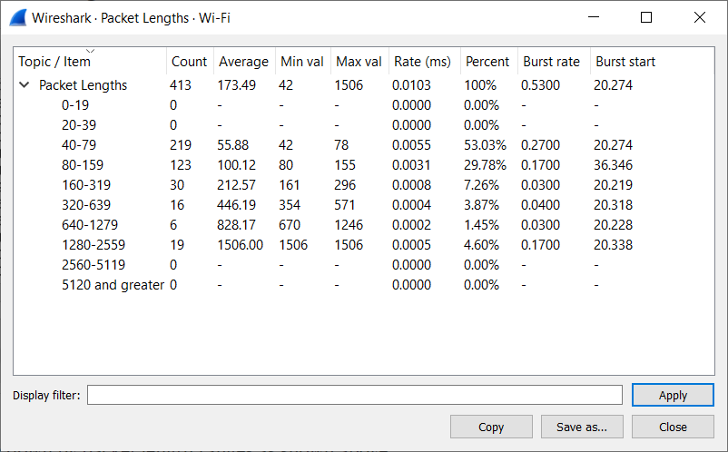

The information is broken down by packet length ranges as shown above.
There is a lot of categorized data given such as:
- Count: The number of packets that fall in this range
- Average: The arithmetic mean length of the packets in this range
- Min/Max Val: The minimum and maximum lengths in this range.
- Rate(ms): The average packets per millisecond for the packets in this range.
- Percent: The percentage of packets in this range, by count.
- Burst Rate: Packet bursts are detected by counting the number of packets in a given time interval and comparing that count to the intervals across a window of time.
- Burst Stat: The start time, in seconds from the beginning of the capture, for the interval with the maximum number of packets.

B.2: Observations and Learning’s:
(Students are expected to comment on the output obtained with clear observations and learning for each task/ sub part assigned)

I learnt what is Wire Shark and the use of it in real life. . I understood the difference between a packet analyser and a packet sniffer. Then I used and explored Wireshark, its interface, features, filtering options etc. I understood how to analyse the captured packets.

B.3: Conclusion:
(Students must write the conclusion as per the attainment of individual outcome listed above and learning/observation noted in section B.2)

- Understand the structure of the packet sniffer
- Familiarity of the Wireshark tool
- Analyze the details of the captured packets

B.4: Questions of Curiosity:

- If a packet is highlighted by black, what does it mean?
- List up to 10 different protocols that you see in the un-filtered packet listing pane.
- Use an appropriate filter to see how many packets contain your IP address.

A1.)

To see packets from a particular host (like in this case I’ve chosen the website http://e-m-b.org/) so the filter request is:

http.host==e-m-b.org

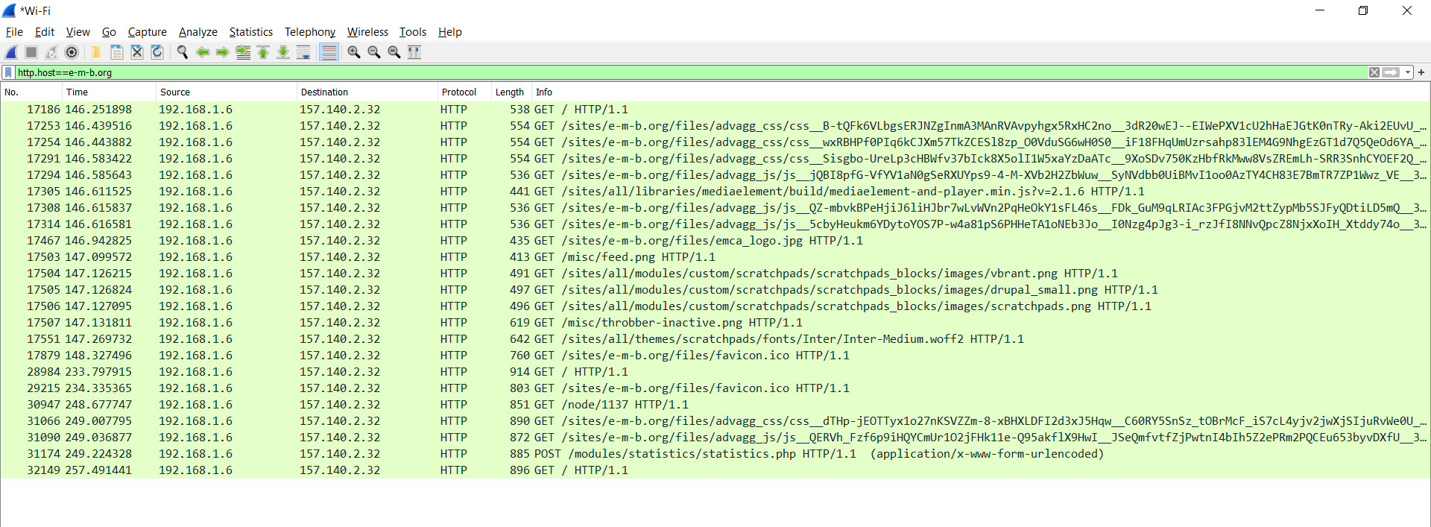

A2.)

10 different protocols are:
- Transmission Control Protocol (TCP)
- Internet Protocol (IP)
- User Datagram Protocol (UDP)
- Post office Protocol (POP)
- Simple mail transport Protocol (SMTP)
- File Transfer Protocol (FTP)
- Hyper Text Transfer Protocol (HTTP)
- Hyper Text Transfer Protocol Secure (HTTPS)
- Telnet
- Gopher

A3.)

For filtering packets to show only my ip address in source I used the following filter:
img.src == 192.168.1.6
