**Computer Networks**

**Assignment-1**

**Name:: Naman Garg**

**Roll no:: B032**

**Class:: `Btech CS B**

**Q.1 How Information travels over from our computer to the Internet?**

1. The Internet works by chopping data into chunks called packets. Each packet then moves through the network in a series of hops.
2. Wireless Router

A router connects networks together. Routers operate at the networking level of the TCP/IP protocol stack.

On Home networks the router is responsible for connecting the home network to the Internet and provides several important networking services like:

DHCP

DNS

1. Modem

This converts digital signals into analogue signals that are suitable for sending over a telephone line. It is usually built into the Internet/broadband router and not normally purchased as a separate component.

1. Each packet hops to a local Internet service provider (ISP), a company that offers access to the network -An ISP (Internet service provider) is a company that provides individuals and other companies’ access to the Internet and other related services such as Web site building and virtual hosting.
2. The next hop delivers the packet to a long-haul provider
3. These providers use the Border Gateway Protocol to find a route across the many individual networks that together form the Internet.

Border Gateway Protocol (BGP) is the routing protocol for the Internet.

**7.**This journey often takes several more hops, which are plotted out one by one as the data packet moves across the Internet.

For the system to work properly, the BGP information shared among routers cannot contain lies or errors that might cause a packet to go off track – or get lost altogether.

1. Recipient’s ISP

The information reaches to the recipient’s ISP after which the information has travelled successfully over the internet and received by the user.

1. The final hop takes a packet to the recipient, which re-assembles all of the packets into a coherent message. A separate message goes back through the network confirming successful delivery.

**Q.2 Give details as follows for OSI reference model:**

|  |  |  |  |
| --- | --- | --- | --- |
| Layer Name | What does the layer do? | Protocols at this layer | Hardware |
|  |  |  | used at this |
|  |  |  | layer |
|  |  |  |  |
|  |  |  |  |
| Application | It provides a set of interfaces | • Remote login to | Gateways, |
| Layer | for applications to obtain | hosts: Telnet | Firewalls, |

|  |  |  |  |  |  |
| --- | --- | --- | --- | --- | --- |
|  | access to networked services as | • | File transfer: File | all end |  |
|  | well as access to network |  | Transfer Protocol | devices |  |
|  | services that support |  | (FTP), Trivial File | like PC’s, |  |
|  | applications directly. This layer |  | Transfer Protocol | Phones, |  |
|  | also provides application |  | (TFTP) | Servers, |  |
|  | access security checking and | • | Electronic mail | Load |  |
|  | information validation. The |  | transport: Simple | Balancers. |  |
|  | Application Layer provides the |  | Mail Transfer |  |  |
|  | following functions- |  | Protocol (SMTP) |  |  |
|  | 1 File Transfer, Access and | • | Networking |  |  |
|  | Management (FTAM): |  | support: Domain |  |  |
|  | Provides handling services in |  | Name System |  |  |
|  | the network. This includes the |  | (DNS) |  |  |
|  | movement of files between | • | Host initialization: |  |  |
|  | different systems, |  | BOOTP |  |  |
|  | reading, writing and deletion of | • | Remote host |  |  |
|  | remote files, and management |  | management: |  |  |
|  | of remote file |  |  |  |
|  |  | Simple Network |  |  |
|  | storage. |  |  |  |
|  |  | Management |  |  |
|  | 2 Virtual Terminal (VT): |  |  |  |
|  |  | Protocol (SNMP), |  |  |
|  | Provides services to access |  |  |  |
|  |  | Common |  |  |
|  | applications in different |  |  |  |
|  |  | Management |  |  |
|  | remote computer systems |  |  |  |
|  |  | Information |  |  |
|  | through stimulating a real |  |  |  |
|  |  | Protocol over TCP |  |  |
|  | terminal. |  |  |  |
|  |  | (CMOT) |  |  |
|  | 3 Electronic Mail and |  |  |  |
|  |  |  |  |  |
|  | Messaging Handling (MHS): |  |  |  |  |
|  | Facilitates the electronic |  |  |  |  |
|  | exchange of documents. |  |  |  |  |
|  | 4 Directory Services (DS): |  |  |  |  |
|  | Provides services with the |  |  |  |  |
|  | ability to match names with |  |  |  |  |
|  | addressing information. |  |  |  |  |
|  | 5 Common management |  |  |  |  |
|  | Information Protocol (CMIP): |  |  |  |  |
|  | Provides services for |  |  |  |  |
|  | network management. |  |  |  |  |
|  |  |  |  |  |  |
| Presentation | The presentation layer is | • | Apple Filing | Gateways, |  |
| Layer | responsible for the format of |  | Protocol (AFP) | Firewalls, |  |
|  | the data transferred during | • | Independent | PC’s, Load |  |
|  | network communications. This |  | Computing | Balancers. |  |
|  | layer is concerned with the |  | Architecture (ICA), |  |  |
|  | syntax and semantics of the |  | the Citrix system |  |  |
|  | information transmitted. The |  | core protocol |  |  |
|  | presentation layer |  |  |  |  |
|  |  |  |  |  |  |
|  |  |  |  |  |  |

|  |  |  |  |  |  |
| --- | --- | --- | --- | --- | --- |
|  | provides common | • | Lightweight |  |  |
|  | communication services such |  | Presentation |  |  |
|  | as encryption, text |  | Protocol (LPP) |  |  |
|  | compression, and | • | NetWare Core |  |  |
|  | reformatting. |  | Protocol (NCP) |  |  |
|  | The presentation layer is also | • | Network Data |  |  |
|  | concerned with other aspects of |  | Representation |  |  |
|  | information |  | (NDR) |  |  |
|  | representation. Data | • | Telnet (a remote |  |  |
|  | compression can be used to |  | terminal access |  |  |
|  | reduce the number of bits that |  | protocol) |  |  |
|  | have | • | Tox, |  |  |
|  | to be transmitted. | • | Representation |  |  |
|  | Cryptography is frequently |  |  |
|  |  | (XDR) |  |  |
|  | required. for privacy and |  |  |  |
|  | • | X.25 Packet |  |  |
|  | authentication. |  |  |
|  |  | Assembler/Disasse |  |  |
|  |  |  |  |  |
|  |  |  | mbler Protocol |  |  |
|  |  |  | (PAD) |  |  |
|  |  |  |  |  |  |
| Session | The session layer provides the | • | PPTP, | Gateways, |  |
| Layer | mechanism for opening, | • | RPC, | Firewalls, |  |
|  | closing and managing a session | • | RTCP, | PC’s, Load |  |
|  | between end-user application | • | SMPP, | Balancers. |  |
|  | processes, i.e., a semi- | • | SCP, |  |  |
|  | permanent dialogue. |  |  |
|  | • | SOCKS, |  |  |
|  | Communication sessions |  |  |
|  | • | ZIP, |  |  |
|  | consist of requests and |  |  |
|  | • | SDP, |  |  |
|  | responses that occur between |  |  |
|  | • | ADSP, |  |  |
|  | applications. The session layer |  |  |
|  | • | ASP, |  |  |
|  | of the OSI model is responsible |  |  |
|  | • | H.245, |  |  |
|  | for session checkpointing and |  |  |
|  | • | ISO-SP, |  |  |
|  | recovery. It allows information |  |  |
|  | of different streams, perhaps | • | iSNS, |  |  |
|  | originating from different | • | L2F, |  |  |
|  | sources, to be properly | • | L2TP, |  |  |
|  | combined or synchronized. | • | NetBIOS, |  |  |
|  | Authentication, Authorization, | • | PAP |  |  |
|  | Session restoration |  |  |  |  |
|  | (checkpointing and recovery) |  |  |  |  |
|  | are basic services it provides. |  |  |  |  |
|  |  |  |  |  |  |
| Transport | The basic function of the | • | SCTP, | Gateways, |  |
| Layer | transport layer is to accept data | • | SPX, | Firewalls, |  |
|  | from the session layer, split it | • | SST, | Load |  |
|  | up into smaller units, pass it to | • | TCP, | Balancers. |  |
|  | the network layer, and ensure | • | UDP, |  |  |
|  | that the bits delivered are |  |  |
|  | • | UDP-Lite, |  |  |
|  |  |  |  |
|  |  |  |  |  |  |

|  |  |  |  |  |  |
| --- | --- | --- | --- | --- | --- |
|  | the same as the bits transmitted | • | µTP, |  |  |
|  | without modification, loss or | • | ATP, |  |  |
|  | duplication. The transport layer | • | CUDP, |  |  |
|  | is also responsible for Error | • | DCCP, |  |  |
|  | control. It provides services | • | FCP, |  |  |
|  | such as connection-oriented |  |  |
|  | • | IL, |  |  |
|  | communication, reliability, |  |  |
|  | • | MPTCP, |  |  |
|  | flow control, and multiplexing. |  |  |
|  | • | RDP, |  |  |
|  | The transport layer might |  |  |
|  | • | RUDP, |  |  |
|  | multiplex several transport |  |  |
|  |  |  |  |  |
|  | connections onto the same |  |  |  |  |
|  | network to reduce costs. |  |  |  |  |
|  |  |  |  |  |  |
| Network | The network layer is a portion | • | CLNS, | Routers, |  |
| Layer | of online communications that | • | DDP, | Brouters, |  |
|  | allows for the connection and | • | EGP, | 3-layer |  |
|  | transfer of data packets | • | EIGRP, | switches. |  |
|  | between different devices or | • | ICMP, |  |  |
|  | networks. |  |  |
|  | • | IGMP, |  |  |
|  | Logical connection setup, data |  |  |
|  | • | IPsec, |  |  |
|  | forwarding, routing, controlling |  |  |
|  | • | IPv4/IPv6, |  |  |
|  | the operation of a sub-net, |  |  |
|  | • | IPX, |  |  |
|  | congestion control and |  |  |
|  | • | OSPF, |  |  |
|  | accounting and delivery error |  |  |
|  | • | PIM, |  |  |
|  | reporting are the network |  |  |
|  | • | RIP, |  |  |
|  | layer’s primary responsibilities. |  |  |
|  | Layer 3 can be either able to | • | WireGuard. |  |  |
|  | support connection-oriented or |  |  |  |  |
|  | connectionless networks (but |  |  |  |  |
|  | not both of them at the same |  |  |  |  |
|  | time). |  |  |  |  |
|  |  |  | |  |  |
| Data link | The data link layer is used for | Ethernet, Token Ring, and | | Bridges, |  |
| Layer | the encoding, decoding and | ARCnet are examples of | | Modems, |  |
|  | logical organization of data | LAN data link protocols. | | Network |  |
|  | bits. Data packets are framed | If communication extends | | cards, 2- |  |
|  | and addressed by this layer, | beyond the LAN onto the | | layer |  |
|  | which has two sublayers. | Internet, the network | | switches. |  |
|  | The data link layer's first | might use other data link | |  |  |
|  | sublayer is the media access | protocols, such as Point- | |  |  |
|  | control (MAC) layer. It is used | to-Point Protocol (PPP) or | |  |  |
|  | for source and destination | Serial Line Internet | |  |  |
|  | addresses. The MAC layer | Protocol (SLIP). | |  |  |
|  | allows the data link layer to |  |  |  |  |
|  | provide the best data |  |  |  |  |
|  | transmission vehicle and |  |  |  |  |
|  | manage data flow control. |  |  |  |  |
|  |  |  |  |  |  |

|  |  |  |  |
| --- | --- | --- | --- |
|  | The data link layer's second |  |  |
|  | sublayer is the logical link |  |  |
|  | control. It manages error |  |  |
|  | checking and data flow over a |  |  |
|  | network. Error detection and |  |  |
|  | error checking is performed in |  |  |
|  | this layer using frames. |  |  |
|  |  |  |  |
| Physical | The physical layer is aimed at | Examples of protocols that | Copper |
| Layer | consolidating the hardware | use physical layers | Cables, |
|  | requirements of a network to | include: | Fiber |
|  | enable the successful |  | Cables, |
|  | transmission of data. Network | Digital Subscriber Line. | Wireless, |
|  | engineers can define different | Integrated Services Digital | Hubs, |
|  | bit-transmission mechanisms | Network. | Repeaters. |
|  | for the physical layer level, | Infrared Data Association. |  |
|  | including the shapes and types | Universal Serial Bus |  |
|  | of connectors, cables, and | (USB.) |  |
|  | frequencies for each physical | Bluetooth. |  |
|  | medium. | Controller Area Network. |  |
|  |  | Ethernet. |  |
|  |  |  |  |

**Q.3 What is framing? Discuss the different framing techniques with the help of a suitable example.**

Ans.

In the physical layer, data transmission involves synchronised transmission of bits from the source to the destination. The data link layer packs these bits into frames.

Data-link layer takes the packets from the Network Layer and encapsulates them into frames.

If the frame size becomes too large, then the packet may be divided into small sized frames.

Smaller sized frames make flow control and error control more efficient.

Then, it sends each frame bit-by-bit on the hardware. At receiver’s end, data link layer picks up signals from hardware and assembles them into frames.

This is known as Framing.

**Framing Techniques:**

Framing can be of two types,

1.fixed sized framing

2.variable sized framing.

**Fixed-sized Framing -**

Here the size of the frame is fixed and so the frame length acts as delimiter of the frame. Consequently, it does not require additional boundary bits to identify the start and end of the frame.

Example − ATM cells.

**Variable – Sized Framing -**

Here, the size of each frame to be transmitted may be different. So additional mechanisms are kept to mark the end of one frame and the beginning of the next frame.

It is used in local area networks.

Two ways to define frame delimiters in variable sized framing are −

* **Length Field** −Here, a length field is used that determines the size of the frame. It isused in Ethernet (IEEE 802.3).
* **End Delimiter** − Here, a pattern is used as a delimiter to determine the size of frame. Itis used in Token Rings. If the pattern occurs in the message, then two approaches are used to avoid the situation −

1. **Byte – Stuffing** − A byte is stuffed in the message to differentiate from thedelimiter. This is also called character-oriented framing.
2. **Bit – Stuffing** − A pattern of bits of arbitrary length isstuffed in the message todifferentiate from the delimiter. This is also called bit – oriented framing.

**Q.4 What is meant encoding in Physical Layer? Discuss the various encoding techniques with proper illustration.**

Encoding :

The bits in the encapsulated data link layer frame need to be grouped, or encoded, into patterns recognized by Layer 1 devices. After transmission, the receiving Layer

1 device decodes patterns and hands the frame up to the data link layer. It also does control information to indicate the start and end of frames.

Encoding is a method of converting a stream of data bits into a predefined code.

1- To provide a predictable pattern that can be recognized by both the sender and the received.

2- To distinguish data bits from control bits and provide better media error detection.

3- To provide codes for control purposes such as identifying the beginning and

end of a frame.

Encoding is grouping of bits prior to being presented to the media.

* To improve the efficiency at higher speed data transmission
* To detect errors.
* To represent more data across the media, by transmitting fewer bits. The stream of signals being transmitted needs to start in such a way that the receiver recognizes the beginning and end of the frame.

It uses two different voltage levels (one positive and one negative) as the signal elements for the two binary digits.

1. Non Return to Zero NRZ

NRZ Codes has 1 for High voltage level and 0 for Low voltage level. The main behavior of NRZ codes is that the voltage level remains constant during bit interval. The end or start of a bit will not be indicated and it will maintain the same voltage state, if the value of the previous bit and the value of the present bit are same. The following figure explains the concept of NRZ coding.

If the above example is considered, as there is a long sequence of constant voltage level and the clock synchronization may be lost due to the absence of bit interval, it becomes difficult for the receiver to differentiate between 0 and 1.

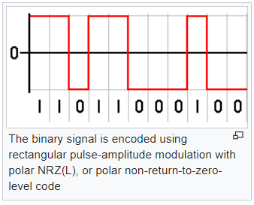

There are two variations in NRZ namely −

1. NRZ - L NRZ–LEVELNRZ–LEVEL

There is a change in the polarity of the signal, only when the incoming signal changes from 1 to 0 or from 0 to 1. It is the same as NRZ, however, the first bit of the input signal should have a change of polarity.

1. NRZ - I NRZ–INVERTEDNRZ–INVERTED

If a 1 occurs at the incoming signal, then there occurs a transition at the beginning of the bit interval. For a 0 at the incoming signal, there is no transition at the beginning of the bit interval.

NRZ codes has a disadvantage that the synchronization of the transmitter clock with the receiver clock gets completely disturbed, when there is a string of 1s and 0s. Hence, a separate clock line needs to be provided.

1. Bi-phase Encoding

The signal level is checked twice for every bit time, both initially and in the middle. Hence, the clock rate is double the data transfer rate and thus the modulation rate is also doubled. The clock is taken from the signal itself. The bandwidth required for this coding is greater. There are two types of Bi-phase Encoding.

* Bi-phase Manchester
* Differential Manchester

1. Bi-phase Manchester

In this type of coding, the transition is done at the middle of the bit-interval. The transition for the resultant pulse is from High to Low in the middle of the interval, for the input bit 1. While the transition is from Low to High for the input bit 0.

1. Differential Manchester

In this type of coding, there always occurs a transition in the middle of the bit interval. If there occurs a transition at the beginning of the bit interval, then the input bit is 0. If no transition occurs at the beginning of the bit interval, then the input bit is 1.

The following figure illustrates the waveforms of NRZ-L, NRZ-I, Bi-phase Manchester and Differential Manchester coding for different digital inputs.

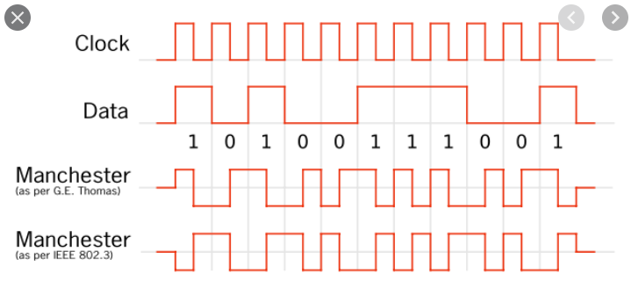

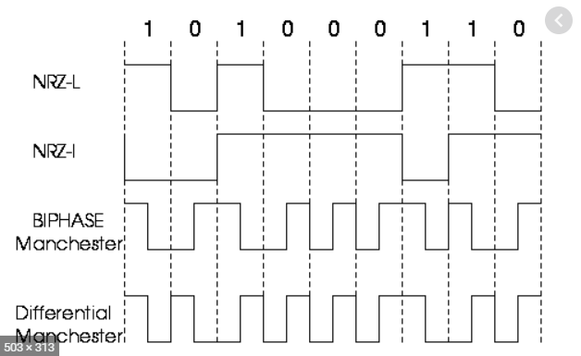

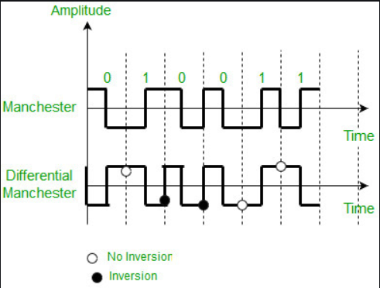

Block Coding

Among the types of block coding, the famous ones are 4B/5B encoding and 8B/6T encoding. The number of bits are processed in different manners, in both of these processes.

8B/6T Encoding

We have used two voltage levels to send a single bit over a single signal. But if we use more than 3 voltage levels, we can send more bits per signal. For example, if 6 voltage levels are used to represent 8 bits on a single signal, then such encoding is termed as 8B/6T encoding. Hence in this method, we have as many as 729 3636 combinations for signal and 256 2828 combinations for bits.

These are the techniques mostly used for converting digital data into digital signals by compressing or coding them for reliable transmission of data.

4B/5B Encoding

In Manchester encoding, to send the data, the clocks with double speed is required rather than NRZ coding. Here, as the name implies,

4 bits of code is mapped with 5 bits, with a minimum number of 1 bits in the group.

The clock synchronization problem in NRZ-I encoding is avoided by assigning an equivalent word of 5 bits in the place of each block of 4 consecutive bits. These 5-bit words are predetermined in a dictionary. The basic idea of selecting a 5-bit code is that, it should have one leading

0 and it should have no more than two trailing 0s. Hence, these words are chosen such that two transactions take place per block of bits.