**SVKM’s NMIMS**

**Mukesh Patel School of Technology Management & Engineering**

**Computer Engineering Department**

Program: B.Tech. Sem V

**Course: Design and Analysis of Algorithms**

**List of Experiments**

w.e.f. 1st Jul 2020

**Faculty:** Abhay Kolhe.

LAB Manual

**Experiment No.06**

PART B

|  |  |
| --- | --- |
| Roll No. B032 | Name: Naman Garg |
| Class : Btech CS B | Batch : B2 |
| Date of Experiment: 11-08-2020 | Date of Submission |
| Grade : | Time of Submission: |
| Date of Grading: |  |

**B.1 Software Code written by student:**

def find(i):

    while sel_matrix[i] != i:

        i = sel_matrix[i]

    return i

# Does union of i and j. It returns

# false if i and j are already in same

# set.

def unionfinder(i, j):

    a = find(i)

    b = find(j)

    sel_matrix[a] = b

# Finds MST using Kruskal's algorithm

def krushkals(cost):

    mincost = 0  # Cost of min MST

    # Initialize sets of disjoint sets

    for i in range(v):

        sel_matrix[i] = i

    # Include minimum weight edges one by one

    edge_count = 0

    while edge_count < v - 1:

        min = 999999        # inf high value for min initally

        a = -1

        b = -1

        for i in range(v):

            for j in range(v):

                if find(i) != find(j) and cost[i][j] < min:

                    min = cost[i][j]

                    a = i

                    b = j

        unionfinder(a, b)

        print(f'Edge {edge_count}:({a}, {b}) cost:{min}')

        edge_count += 1

        mincost += min

    print(f"Minimum cost= {mincost}")

if __name__ == "__main__":

        # Taking input from user

    v = int(input("no of vertices"))

    G = []

    # Input weights

    for i in range(v):

        G.append(

            list(map(int, input(f'vertex {i+1}: ').split())))

    print("Input Matrix")

    for i in range(v):

        for j in range(v):

            print(f"{G[i][j]}", end=" ")

        print("")

    sel_matrix = [0 for i in range(v)]

    no_edges = 0

    # Find set of vertex i

    krushkals(G)

**B.2 Input and Output:**

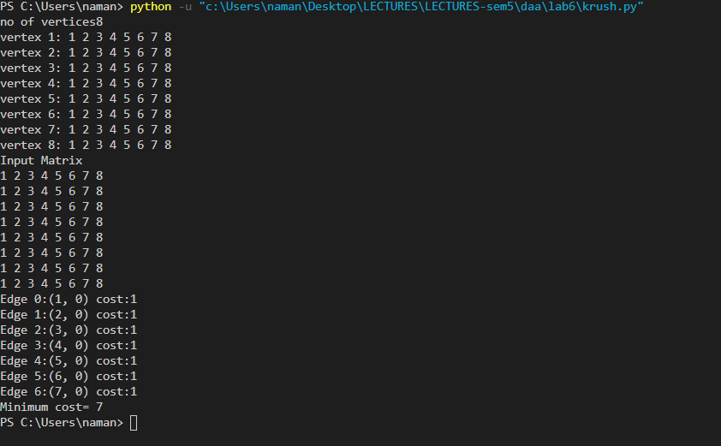**B.3 Observations and learning:**

**B.4 Conclusion:**

**B.5 Question of Curiosity**

Q.1 Identify & discuss in detail the real life applications Kruskal’s Algorithm.

Q.2 Compare the performance of Kruskal’s and Prim’s algorithm.

Q.3 Discuss the time and space complexity of Kruskal’s algorithm.

************************