IBM Machine learning course

Lab 1: Basics of python

**Name: Naman Garg**

**Program and year: BTech CS**

**Roll No. B032**

1. **Program to find if the number is divisible by three.**

**Code:**

num = 9

if num % 3 == 0:

    print("num is divisible by 3")

else:

    print("num is not divisible by 3")

**Output:**



1. **Program to find if the number is divisible by 3 by taking input from user.**

**Code:**

num = int(input("ENTER YOUR NUMBER"))

if num % 3 == 0:

    print("num is divisible by 3")

else:

    print("num is not divisible by 3")

**Output:**



1. **Program for calculator to perform basic operations of addition, subtraction, multiplication and division.**

**Code:**

def add(x, y):

    return x + y

def subtract(x, y):

    return x - y

def multiply(x, y):

    return x * y

def divide(x, y):

    return x / y

print("Select operation.")

print("1.Add")

print("2.Subtract")

print("3.Multiply")

print("4.Divide")

while True:

    choice = input("Enter choice(1/2/3/4): ")

    if choice in ('1', '2', '3', '4'):

        num1 = float(input("Enter first number: "))4

        num2 = float(input("Enter second number: "))

        if choice == '1':

            print(num1, "+", num2, "=", add(num1, num2))

        elif choice == '2':

            print(num1, "-", num2, "=", subtract(num1, num2))

        elif choice == '3':

            print(num1, "*", num2, "=", multiply(num1, num2))

        elif choice == '4':

            print(num1, "/", num2, "=", divide(num1, num2))

        break

    else:

        print("Invalid Input")

**Output:**

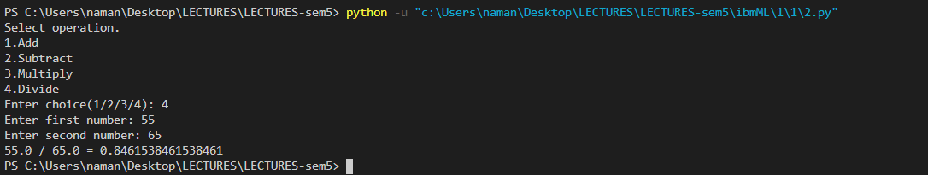

1. **Program to change case of a string**

**Code:**

a = input()

print(a.swapcase())

**Output:**

1. **To print the last character in a string.**

**Code:**

a = input()

print(a[-1])

**Output:**



1. **Program to display class based on marks**

**Code:**

avg = int(input("Enter avg marks: "))

if(avg >= 90):

    print("Grade: A")

elif(avg >= 80 & avg < 90):

    print("Grade: B")

elif(avg >= 70 & avg < 80):

    print("Grade: C")

elif(avg >= 60 & avg < 70):

    print("Grade: D")

else:

    print("Grade: F")

**Output:**



1. **Find the slope of a line, given the coordinates of two points on the line.**

**Code:**

def slope(x1, y1, x2, y2):

    return (float)(y2-y1)/(x2-x1)

if __name__ == '__main__':

    x1 = int(input("\npt x1\t"))

    y1 = int(input("\npt y1\t"))

    x2 = int(input("\npt x2\t"))

    y2 = int(input("\npt y2\t"))

    print("Slope is :", slope(x1, y1, x2, y2))

**Output:**

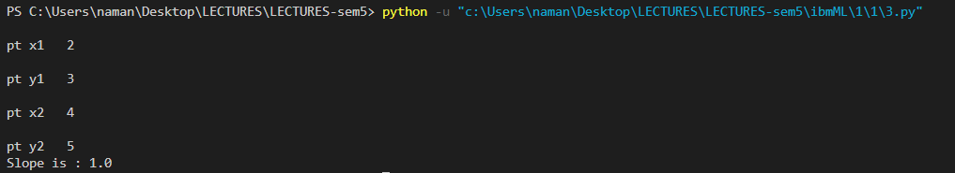

1. **Using NumPy package, prepare an array called as income for 6 employees. Let the expenses be 65% of the income. Print the savings of the employees as an array.**

**Code:**

import numpy as np

income = np.array([25000, 20000, 30000, 40000, 50000, 45000])

expenses = 0.65*income

savings = income-expenses

print(savings)

**Output:**



1. **Plot a scatter plot of two random variables having normal distribution. Use numpy package.**

**Code:**

import matplotlib.pyplot as plt

import numpy as np

list1 = np.random.randn(500)

list2 = np.random.randn(500)

plt.scatter(list1, list2)

plt.show()

**Output:**

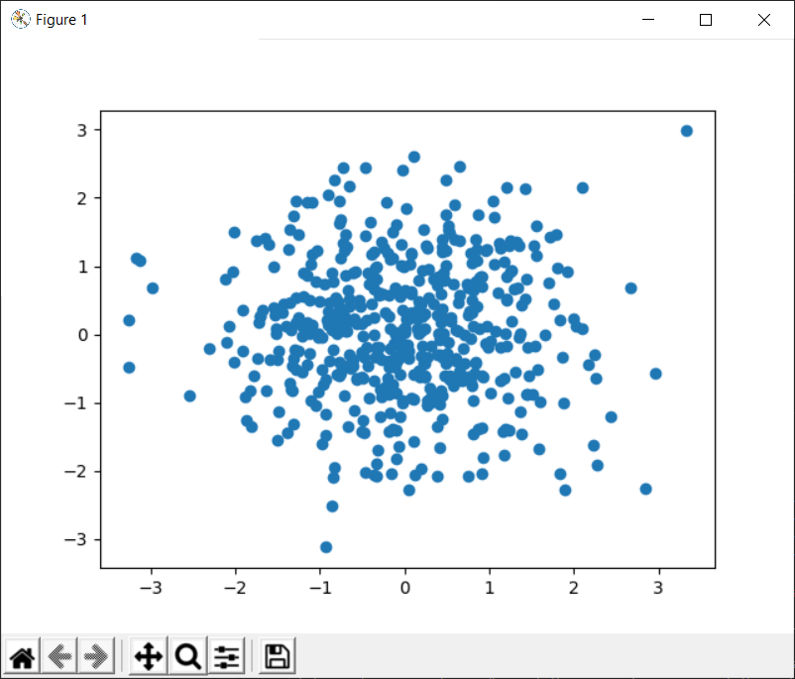

1. **Show a scatter plot of the following points of 5 points in two dimensional space**

**Code:**

import matplotlib.pyplot as plt

import numpy as np

list1 = np.random.rand(5)

list2 = np.random.rand(5)

plt.scatter(list1, list2)

plt.show()

**Output:**

