Q1.

The KL Transform is also known as the Hoteling transform or the Eigen Vector transform. The KL Transform is based on the statistical properties of the image and has several important properties that make it useful for image processing particularly for image compression.

The main purpose of image compression is to store the image in fewer bits as compared to original image, now data from neighboring pixels in an image are highly correlated. More image compression can be achieved by de-correlating this data. The KL transform does the task of de-correlating the data thus facilitating higher degree of compression

There are four major steps in order to find the KL transform :-

(I) Find the mean vector and covariance matrix of the given image x

(II) Find the Eigen values and then the eigen vectors of the covariance matrix

(III) Create the transformation matrix T, such that rows of T are eigen vectors

(IV) Find the KL Transform

Some important properties of KL:

1. The generalized coordinate system defined by the eigenfunctions of the correlation matrix is optimal in the sense that the mean-square error resulting from a finite representation of the process is minimized. That is for any fixed L:

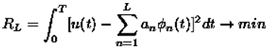

2. The random variables appearing in an expansion of the kind are orthonormal if and only if the orthonormal functions and the constants are respectively the eigenfunctions and the eigenvalues of the correlation matrix.

3. In addition to the mean-square error minimizing property, the Karhunen-Loève expansion has some additional desirable properties. Of these, the minimum representation entropy property is worth mentioning.

4. KL expansion is optimal not only in terms of minimizing mean-square error between the signal and it's truncated representation, but also minimizes a number of modes to describe the signal for a given error.

5. The optimality of KL reduces the amount of information required to represent statistically dependent data to a minimum. This crucial feature explains the wide usage of KL in a process of analyzing data.

Q2.

Homomorphic filtering is a generalized technique for signal and image processing, involving a nonlinear mapping to a different domain in which linear filter techniques are applied, followed by mapping back to the original domain. Homomorphic filter is sometimes used for image enhancement.

It simultaneously normalizes the brightness across an image and increases contrast. Homomorphic filtering is one such technique for removing multiplicative noise that has certain characteristics.

Homomorphic filtering is most commonly used for correcting non-uniform illumination in images. Homomorphic filtering can be used for improving the appearance of a grayscale image by simultaneous intensity range compression (illumination) and contrast enhancement (reflection).

Q3.

The discrete Fourier transform (DFT) is the primary transform used for numerical computation in digital signal processing. It is very widely used for spectrum analysis, fast convolution, and many other applications.

Properties :

1. Periodicity

The periodicity property states that



1. Symmetry

The symmetry property states that

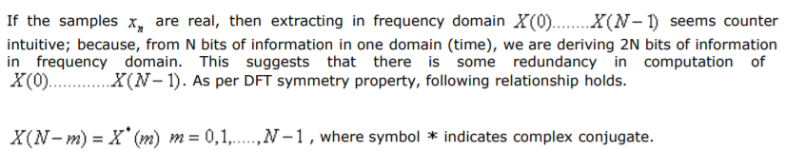

1. Linearity

The linearity property states that 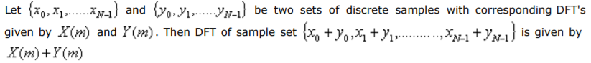

1. Phase Shifting

DFT shifting property states that, for a periodic sequence with periodicity N i.e.

x(m)= x(m+lN) ,l an integer, an offset in sequence manifests itself as a phase shift in the frequency domain. In other words, if we decide to sample x(n) starting at n equal to some integer K, as opposed to n = 0, the DFT of those time shifted sequence, 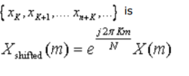

Q4.

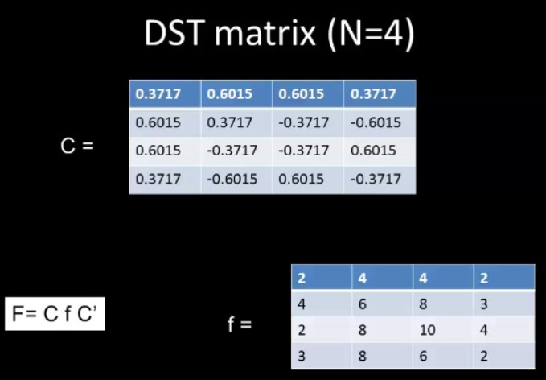

C\*f =

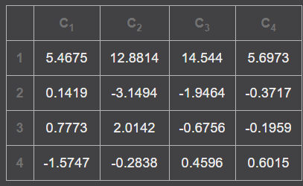

Transpose (C’)–

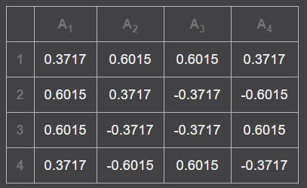

F = C\*f\*C’

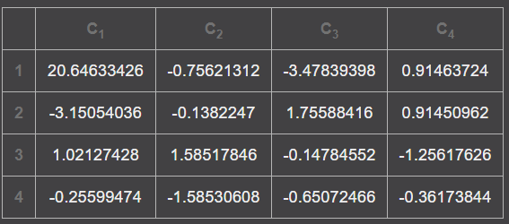

Q5.

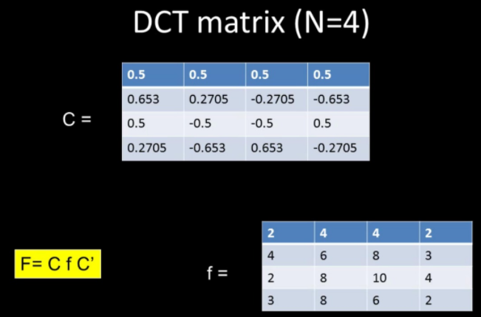

C\*f =

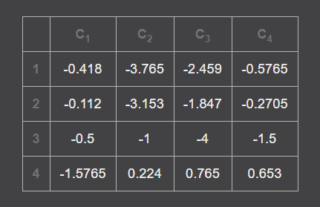

Transpose (C’) –

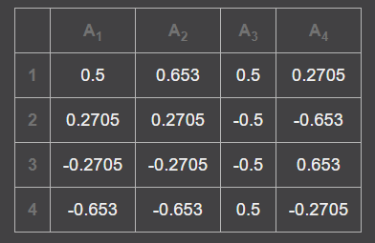

F = C\*f\*C’

